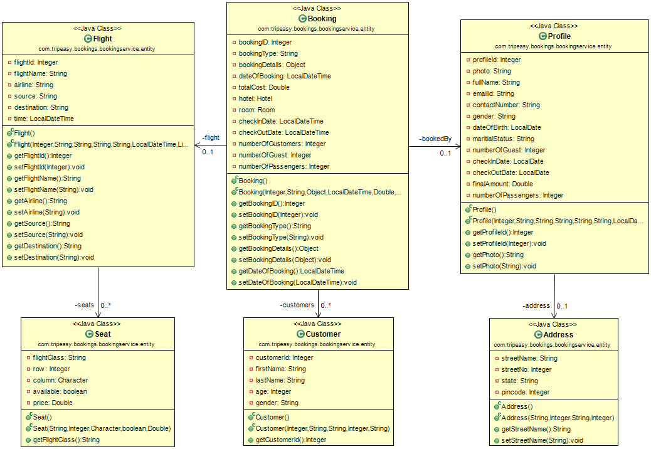

Booking Service POJO Class Diagram