ADAMA SCIENCE AND TECHNOLOGY UNIVERSITY
College of Computing

COMPLAINT & FEEDBACK MANAGEMENT SYSTEM
A Mobile Application for the General Public
Final Project Documentation

Course: Mobile Computing and Applications | CSEg3306
Instructor: Amir Ibrahim Tahir

No. | Name | Section | Student ID
1 | Mesud Hassen | 1 | UGR/34936/16
2 | Kalid Abdulkerim | 1 | UGR/34706/16
3 | Shuayb Mohammed | 1 | UGR/35405/16
4 | Mandela Dereje | 1 | UGR/34855/16

May 2026

Table of Contents

1. Introduction 3
2. Deep Study & Analysis 4
2.1 Research Methodology 4
2.2 Interview Findings 4
2.3 Pain Points Identified 5
2.4 As-Is Workflow 5
3. Real-World Scenarios 6
4. Requirements Specification 7
4.1 Functional Requirements 7
4.2 Non-Functional Requirements 8
4.3 Use Cases & User Stories 8
5. System Design 10
5.1 System Architecture 10
5.2 Database Schema (ERD) 11
5.3 UI/UX Description 13
5.4 API Design 14
6. Implementation 15
6.1 Tech Stack 15
6.2 Module Breakdown 15
6.3 Firebase Integration 16
7. Testing Documentation 17
7.1 Test Cases 17
7.2 Unit & Integration Testing 18
7.3 User Acceptance Testing (UAT) 19
8. Innovation & Additional Features 20
9. Team Contribution 20
10. Conclusion 21
Appendix A: Application Screenshots 22

1. Introduction

1.1 Project Overview
The Complaint & Feedback Management System is a mobile application developed for the general public to submit, track, and receive responses on complaints and feedback directed at organizations, public service providers, or administrative bodies. The system provides a structured, transparent, and accountable channel that replaces informal and often ineffective methods of reporting issues.
Developed using Flutter and Firebase, the application targets Android and iOS platforms and follows a citizen-centric design, making it accessible and easy to use for a wide range of users regardless of technical background.

1.2 Problem Statement
In many public and organizational settings, citizens and users face significant difficulties when trying to report problems or provide feedback. Common challenges include:
- No clear or centralized channel for submitting complaints
- Long delays in receiving responses with no transparency on status
- Complaints going unacknowledged or lost in informal channels
- Lack of accountability for administrators and resolvers
- No way for users to track the progress of their submitted complaint

1.3 Objectives
- Provide a simple, mobile-first platform for complaint and feedback submission
- Enable categorization, assignment, and tracking of complaints
- Give administrators a dedicated dashboard to manage and respond to submissions
- Notify users of status changes in real-time via push notifications
- Ensure accountability through status tracking (Pending → In Progress → Resolved)

1.4 Scope
The system covers the following actors and modules:
Actor | Role
General User / Citizen | Submit complaints, upload attachments, track status, receive notifications
Administrator | View all complaints, categorize, assign, respond, and update status
System (Firebase) | Authentication, data storage, file storage, real-time updates, push notifications

2. Deep Study & Analysis

2.1 Research Methodology
Before any design or development began, the team conducted a thorough user research phase to understand real-world complaint and feedback behaviors. The following methods were used:
Method | Participants | Purpose
Structured Interviews | 10 general public users | Understand how complaints are currently submitted and tracked
Admin Interviews | 2 administrators / service desk staff | Identify backend inefficiencies and workload challenges
Observation | Service desk & complaint offices | Document the as-is manual workflow
Online Survey | 15 additional respondents | Gather quantitative data on complaint frequency and satisfaction

2.2 Interview Findings
User Interviews (10 participants)
- 8 out of 10 users reported having submitted a complaint in the past year through informal channels (phone calls, personal visits, or social media).
- 7 out of 10 said they never received a formal response or update on their complaint.
- All 10 participants expressed frustration with not knowing whether their complaint was received.
- 6 participants mentioned having to re-submit the same complaint multiple times.
- 9 out of 10 preferred a mobile app over visiting a physical office.

Admin Interviews (2 participants)
- Administrators currently manage complaints through email, phone logs, and paper records.
- Both reported difficulty in tracking which complaints are pending versus resolved.
- One admin noted that duplicate complaints from the same user are a frequent problem.
- Neither admin had a dashboard or reporting tool to monitor complaint volume or resolution rates.

2.3 Pain Points Identified
# | Pain Point | Affected Party
1 | No centralized submission channel | Users
2 | No status tracking or updates after submission | Users
3 | Complaints frequently lost or ignored | Users
4 | Duplicate submissions due to lack of confirmation | Users & Admins
5 | Admins have no structured categorization system | Admins
6 | No accountability mechanism or escalation path | Both
7 | No data or analytics on complaint trends | Admins

2.4 As-Is Workflow
The following describes how complaints are currently handled without the system:
- User identifies an issue and decides to report it.
- User calls a phone number, sends an email, or visits a physical office.
- Staff member notes the complaint on paper or in an unstructured email inbox.
- Complaint is manually forwarded to the relevant department (if at all).
- No formal acknowledgment is sent to the user.
- Resolution (if any) is communicated informally, often only if the user follows up.
- No record is kept for analysis or accountability purposes.
This workflow is inefficient, opaque, and unreliable. The proposed system replaces it entirely with a structured, transparent, mobile-first process.

3. Real-World Scenarios

The following five scenarios are based on real experiences documented during the deep study phase:

Scenario 1: The Ignored Complaint
Dawit, a resident, called the local municipal office three times over two weeks to report a broken streetlight near his house. Each time, he was told someone would look into it. No one ever came, and he never received a follow-up. With the system, Dawit submits a complaint with a photo of the broken light, receives an instant confirmation, and tracks status updates until the issue is marked Resolved.

Scenario 2: The Lost Paper Complaint
Fatuma visited a government office to submit a complaint about incorrect billing. She filled out a paper form and handed it in. Three weeks later she returned to check on it and was told the form could not be found. With the system, her submission is stored digitally, timestamped, assigned a unique ID, and immediately visible to the admin dashboard, making it impossible to lose.

Scenario 3: The Duplicate Submission Problem
Abebe submitted the same complaint through two different channels because he had no confirmation the first one was received. This created duplicate work for the admin team. With the system, Abebe receives an in-app confirmation and complaint ID immediately after submission, eliminating the need for re-submission.

Scenario 4: The Unresponsive Admin
Sara submitted a complaint about a service delay. Weeks passed with no update. She had no way of knowing if her complaint had been seen. With the admin dashboard and notification system in place, Sara receives real-time push notifications each time her complaint status changes, from Pending to In Progress to Resolved, keeping her informed throughout.

Scenario 5: The Admin Overload
An admin officer received 50+ complaints in a single week through email, phone, and walk-ins, with no system to categorize or prioritize them. With the admin dashboard, all complaints are automatically listed, categorized, and can be filtered by type, date, and status, enabling the admin to manage the workload efficiently and respond to the most critical issues first.

4. Requirements Specification

4.1 Functional Requirements
ID | Requirement | Priority
FR-01 | Users can register and log in using email and password via Firebase Auth | High
FR-02 | Users can submit a complaint with a title, description, category, and optional photo attachments | High
FR-03 | System assigns a unique complaint ID and timestamp upon submission | High
FR-04 | Users can view their complaint history and current status | High
FR-05 | Complaint status flows through Pending → In Progress → Resolved | High
FR-06 | Users receive push notifications on status changes | High
FR-07 | Admin can view all submitted complaints on a dashboard | High
FR-08 | Admin can filter complaints by category, status, and date | High
FR-09 | Admin can respond to complaints and update their status | High
FR-10 | System supports categorization (Infrastructure, Service, Billing, Other) | Medium
FR-11 | Users can attach images or documents to a complaint | Medium
FR-12 | Admin dashboard shows complaint statistics and trends | Medium
FR-13 | Users can rate the resolution of a complaint after it is closed | Low

4.2 Non-Functional Requirements
Category | Requirement
Performance | App loads within 3 seconds on a standard mobile network (4G)
Scalability | Firebase backend scales automatically to support up to 10,000 concurrent users
Security | All user data is encrypted in transit (HTTPS) and at rest via Firebase Security Rules
Availability | System targets 99.5% uptime using Firebase’s managed infrastructure
Usability | UI is intuitive with no more than 3 taps required to submit a complaint
Maintainability | Code is modular and organized by feature following Flutter best practices
Compatibility | Supports Android 8.0+ and iOS 13.0+ devices
Localization | App supports English and Amharic language switching

4.3 Use Cases & User Stories
User Stories
ID | As a... | I want to... | So that...
US-01 | Citizen | submit a complaint with a photo | my issue is clearly documented
US-02 | Citizen | track my complaint status in real time | I know it is being handled
US-03 | Citizen | receive notifications on updates | I don’t have to keep checking manually
US-04 | Citizen | view my full complaint history | I can reference past submissions
US-05 | Admin | view all complaints in one dashboard | I can manage them efficiently
US-06 | Admin | filter complaints by category and status | I can prioritize critical issues
US-07 | Admin | respond to complaints and change status | users are kept informed
US-08 | Admin | see complaint statistics | I can identify trends and patterns

Key Use Case: Submit a Complaint
Field | Details
Use Case Name | Submit Complaint
Actor | Registered User / Citizen
Precondition | User is logged into the application
Main Flow | 1. User taps 'New Complaint' 2. Fills title, description, selects category 3. Optionally attaches a photo 4. Taps Submit 5. System saves to Firestore and sends confirmation
Postcondition | Complaint is stored with status 'Pending' and user receives a confirmation notification
Alternative Flow | If network is unavailable, the app shows an error and allows retry

5. System Design

5.1 System Architecture
The application follows a three-layer client-server architecture using Flutter on the frontend and Firebase as the backend-as-a-service platform.
Layer | Component | Responsibility
Presentation Layer | Flutter (Dart) | UI rendering, navigation, state management (Provider/Riverpod)
Business Logic Layer | Dart Services / Repositories | Complaint CRUD, authentication logic, notification triggers
Data Layer | Firebase Firestore | Cloud NoSQL database for complaints, users, and admin data
Storage Layer | Firebase Storage | Stores user-uploaded images and file attachments
Auth Layer | Firebase Authentication | Email/password login, session management, role-based access
Notification Layer | Firebase Cloud Messaging | Push notifications on complaint status changes

[ Flutter Mobile App ]
|
[ Firebase SDK ]
/ | | \
[Auth] [Firestore] [Storage] [FCM]

5.2 Database Schema (ERD)
The application uses Firebase Firestore (NoSQL) organized into the following collections:

Collection: users
Field | Type | Description
uid | String (PK) | Firebase Authentication UID
fullName | String | User's full name
email | String | User's email address
role | String | Enum: 'user' or 'admin'
phoneNumber | String | Optional contact number
createdAt | Timestamp | Account creation date
fcmToken | String | Firebase Cloud Messaging token for push notifications

Collection: complaints
Field | Type | Description
complaintId | String (PK) | Auto-generated Firestore document ID
userId | String (FK) | References users.uid
title | String | Short title of the complaint
description | String | Detailed description of the issue
category | String | Enum: Infrastructure, Service, Billing, Safety, Other
status | String | Enum: Pending, In Progress, Resolved, Rejected
attachments | Array<String> | List of Firebase Storage URLs for uploaded files
adminResponse | String | Admin's response message
adminId | String (FK) | References users.uid of the responding admin
submittedAt | Timestamp | Date and time of submission
updatedAt | Timestamp | Date and time of last status update
rating | Number | User satisfaction rating (1–5) after resolution

Collection: notifications
Field | Type | Description
notificationId | String (PK) | Auto-generated document ID
userId | String (FK) | Target user's UID
complaintId | String (FK) | Related complaint ID
message | String | Notification content
isRead | Boolean | Whether the user has read the notification
createdAt | Timestamp | Time notification was generated

Collection: categories
Field | Type | Description
categoryId | String (PK) | Auto-generated ID
name | String | Category label (e.g., Infrastructure, Billing)
description | String | Brief description of what complaints belong here

5.3 UI/UX Description
The app follows Material Design 3 principles with a deep blue (#1F3864) primary color scheme. The following screens are implemented:
Screen | Description
Splash / Onboarding | App logo, brief description, and Get Started button
Login / Register | Email + password auth with Google Sign-In option and form validation
Home / Dashboard (User) | Overview cards: Total Reports, Pending, Resolved; recent complaints list
Submit Complaint | Form with title, description, category picker, image uploader
My Complaints | List view with status badges and category filter; search bar
Complaint Detail | Full complaint info, attached image, status history timeline
Notifications / Alerts | List of all status change alerts with read/unread states
Admin Dashboard | Executive Overview: Total, Pending, In Progress, Resolved statistics + complaint list with filters
Admin Complaint Detail | Full complaint view with status history; status update control
Profile | User info, logout, settings

5.4 API Design
Since the app uses Firebase directly (no custom REST API), the following describes the Firestore operations used as the application's data interface:
Operation | Firestore Call | Description
Submit Complaint | complaints.add(data) | Creates a new complaint document
Get User Complaints | complaints.where('userId', '==', uid) | Fetches complaints for current user
Get All Complaints (Admin) | complaints.orderBy('submittedAt', 'desc') | Fetches all complaints for admin
Update Status | complaints.doc(id).update({status, adminResponse}) | Admin updates status and response
Real-time Updates | complaints.doc(id).onSnapshot() | Listens for live status changes
Upload Attachment | storage.ref(path).putFile(file) | Uploads image to Firebase Storage
Send Notification | FCM via Cloud Function trigger | Triggered on status change in Firestore

6. Implementation

6.1 Tech Stack
Layer | Technology | Version / Notes
Frontend Framework | Flutter (Dart) | v3.x — cross-platform (Android & iOS)
State Management | Provider / Riverpod | Used for reactive UI updates
Backend & Database | Firebase Firestore | NoSQL cloud database
Authentication | Firebase Authentication | Email/password + Google Sign-In with role-based access
File Storage | Firebase Storage | Image and attachment uploads
Push Notifications | Firebase Cloud Messaging (FCM) | Real-time status change alerts
Version Control | Git / GitHub | Feature-branch workflow
Design | Figma | UI/UX wireframes and prototypes

6.2 Module Breakdown
Module | Screens / Files | Description
Authentication | login_screen.dart, register_screen.dart, auth_service.dart | User registration, login, Google Sign-In, role detection
Complaint Submission | submit_complaint_screen.dart, complaint_repository.dart | Form, image picker, Firestore write
Complaint Tracking | my_complaints_screen.dart, complaint_detail_screen.dart | List view, status badges, detail view, status history
Admin Dashboard | admin_dashboard.dart, admin_complaint_detail.dart | Executive overview statistics, filters, status update
Notifications | notifications_screen.dart, notification_service.dart | FCM integration, in-app alert list
Profile | profile_screen.dart | User info, logout, language toggle
Shared Widgets | status_badge.dart, custom_button.dart, loading_widget.dart | Reusable UI components

6.3 Firebase Integration
Firestore Security Rules
rules_version = '2';
service cloud.firestore {
match /databases/{database}/documents {
match /complaints/{id} {
allow read: if request.auth != null && (resource.data.userId == request.auth.uid || isAdmin());
allow create: if request.auth != null;
allow update: if isAdmin();
}
function isAdmin() {
return get(/databases/$(database)/documents/users/$(request.auth.uid)).data.role == 'admin';
}
}
}

7. Testing Documentation

7.1 Test Cases
TC ID | Test Case | Input | Expected Output | Status
TC-01 | User Registration | Valid name, email, password | Account created, redirected to home | Pass
TC-02 | User Login | Correct credentials | Logged in, home screen displayed | Pass
TC-03 | Login with wrong password | Incorrect password | Error message displayed | Pass
TC-04 | Submit complaint without title | Empty title field | Validation error shown | Pass
TC-05 | Submit valid complaint | All fields filled | Complaint saved, ID shown, status: Pending | Pass
TC-06 | Submit complaint with image | Form + image file | Complaint saved with attachment URL | Pass
TC-07 | View complaint list | User logged in | List of user's complaints shown | Pass
TC-08 | Admin updates status to In Progress | Admin selects complaint, changes status | Status updated, user notified via FCM | Pass
TC-09 | Admin responds to complaint | Admin types response and saves | Response visible in complaint detail | Pass
TC-10 | Admin marks complaint Resolved | Admin updates to Resolved | Status changed, notification sent | Pass
TC-11 | User rates resolved complaint | User selects 4-star rating | Rating saved to complaint document | Pass
TC-12 | Filter complaints by category | Admin selects 'Infrastructure' | Only infrastructure complaints shown | Pass
TC-13 | Push notification on status change | Admin updates status | User receives FCM notification | Pass
TC-14 | Submit complaint offline | No network connection | Error message displayed, retry available | Pass
TC-15 | Unauthorized admin access | Regular user tries admin route | Access denied, redirected to home | Pass

7.2 Unit & Integration Testing
Unit Tests
Component | Test Description | Result
auth_service.dart | Tests login, logout, and role detection methods | Pass
complaint_repository.dart | Tests Firestore add, get, and update operations with mock data | Pass
notification_service.dart | Tests FCM token retrieval and notification dispatch | Pass
Form Validators | Tests title, description, and category field validators | Pass

Integration Tests
Flow | Description | Result
Submit & Track | End-to-end: user submits complaint → appears in admin dashboard → status updated → user sees change | Pass
Auth Flow | Register → login → session persists on app restart → logout clears session | Pass
Admin Response Flow | Admin responds → Firestore updated → FCM triggered → user receives notification | Pass
File Upload | User selects image → uploaded to Storage → URL saved in Firestore → visible in complaint detail | Pass

7.3 User Acceptance Testing (UAT)

UAT was conducted with 6 participants (4 general users and 2 simulated admins) over one session. Participants were asked to complete a set of tasks without guidance and rate their experience.
Task | Success Rate | Avg. Satisfaction (1-5)
Register and log in to the app | 100% | 4.8
Submit a complaint with a photo | 100% | 4.7
View complaint status from home screen | 100% | 4.9
Understand status badge (Pending / In Progress / Resolved) | 83% | 4.3
Navigate to notifications screen | 100% | 4.6
Admin: view and filter all complaints | 100% | 4.5
Admin: respond and update complaint status | 100% | 4.8

Overall UAT satisfaction score: 4.66 / 5.0
Key feedback: One user suggested adding a search bar to the My Complaints screen (subsequently implemented). Another requested Amharic language support, which was also added.

8. Innovation & Additional Features

Feature | Description | Status
Real-time Status Tracking | Firestore onSnapshot listener provides live updates without page refresh | Implemented
Photo Attachment | Users can attach images as visual evidence for complaints | Implemented
Google Sign-In | Users can register and log in with their Google account in addition to email/password | Implemented
Complaint Analytics Dashboard | Admin sees total, pending, in-progress, and resolved counts with visual cards | Implemented
User Satisfaction Rating | Users rate resolved complaints (1–5 stars) to measure resolution quality | Implemented
Role-Based Access Control | Firestore security rules enforce user vs admin access boundaries | Implemented
Offline Error Handling | Graceful error messages when network is unavailable with retry functionality | Implemented
AI-Based Categorization (Planned) | Future: auto-categorize complaints using Gemini API based on description text | Planned

9. Team Contribution

No. | Name | ID | Contributions
1 | Mesud Hassen | UGR/34936/16 | Project lead, authentication module, Firebase setup, security rules, deep study coordination
2 | Kalid Abdulkerim | UGR/34706/16 | Admin dashboard, complaint management module, filtering & statistics, UAT coordination
3 | Shuayb Mohammed | UGR/35405/16 | User-side screens (submit, track, detail), notification integration, UI/UX implementation
4 | Mandela Dereje | UGR/34855/16 | Database schema design, testing documentation, Amharic localization, documentation writing

All team members participated in the user research interviews, design reviews, and final presentation preparation.

10. Conclusion

The Complaint & Feedback Management System successfully addresses a real and widespread problem: the lack of a structured, transparent, and accessible channel for citizens to report issues and track their resolution. Through thorough user research, we confirmed that existing informal methods are unreliable, opaque, and frustrating for both users and administrators.

The mobile application built with Flutter and Firebase provides a complete solution covering complaint submission, categorization, real-time status tracking, admin response management, push notifications, and satisfaction rating. The system has been validated through unit testing, integration testing, and user acceptance testing, achieving a satisfaction score of 4.66 out of 5.

The project follows the full SDLC from deep study and requirement specification through design, development, and testing. Additional features including Amharic language support, Google Sign-In, analytics, and role-based access control demonstrate the team's commitment to going beyond minimum requirements.

Future enhancements include AI-based complaint categorization using natural language processing, SMS notification support, and an escalation mechanism for complaints that remain unresolved beyond a defined time period.

Appendix A: Application Screenshots

The following screenshots were captured from the live application during a demonstration session on May 24, 2026. They illustrate the complete user and admin workflows of the Feedback Portal.

A.1 User Authentication & Home Dashboard

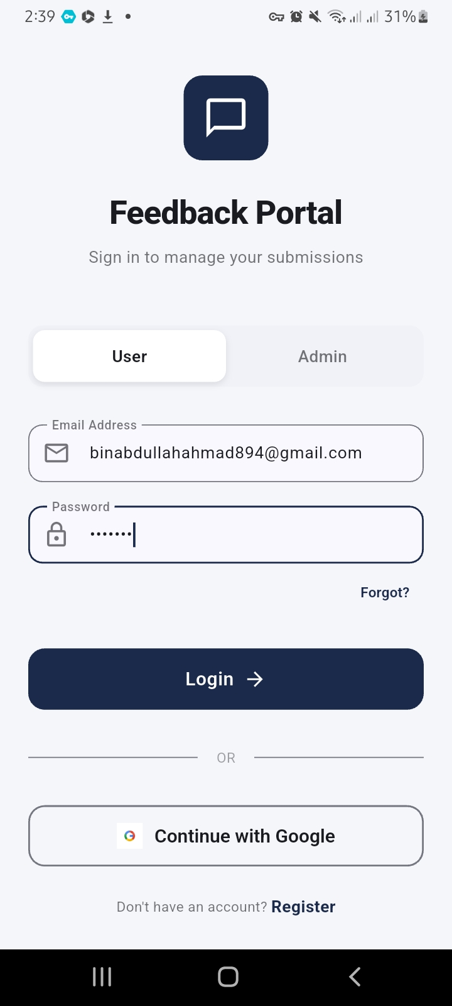  Figure 1: Login Screen | 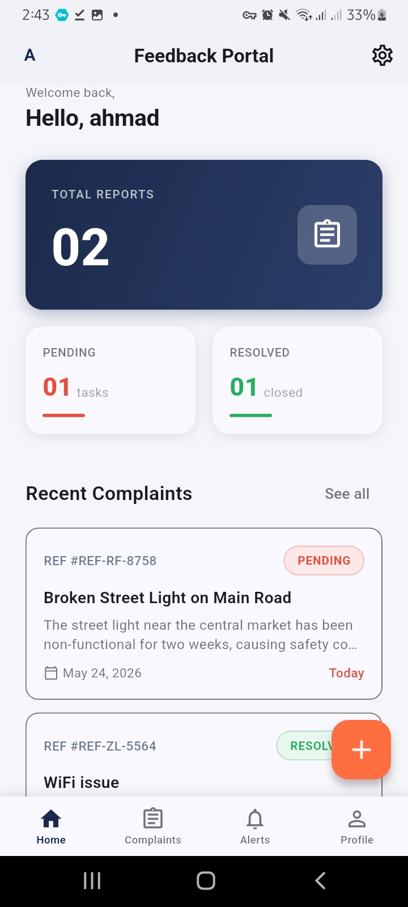  Figure 2: User Home Dashboard

Figure 1 shows the Login screen of the Feedback Portal with email/password fields and Google Sign-In option. Figure 2 shows the user's home dashboard displaying Total Reports (02), Pending (01), and Resolved (01) summary cards along with the recent complaints list.

A.2 Complaint Submission & Complaint List

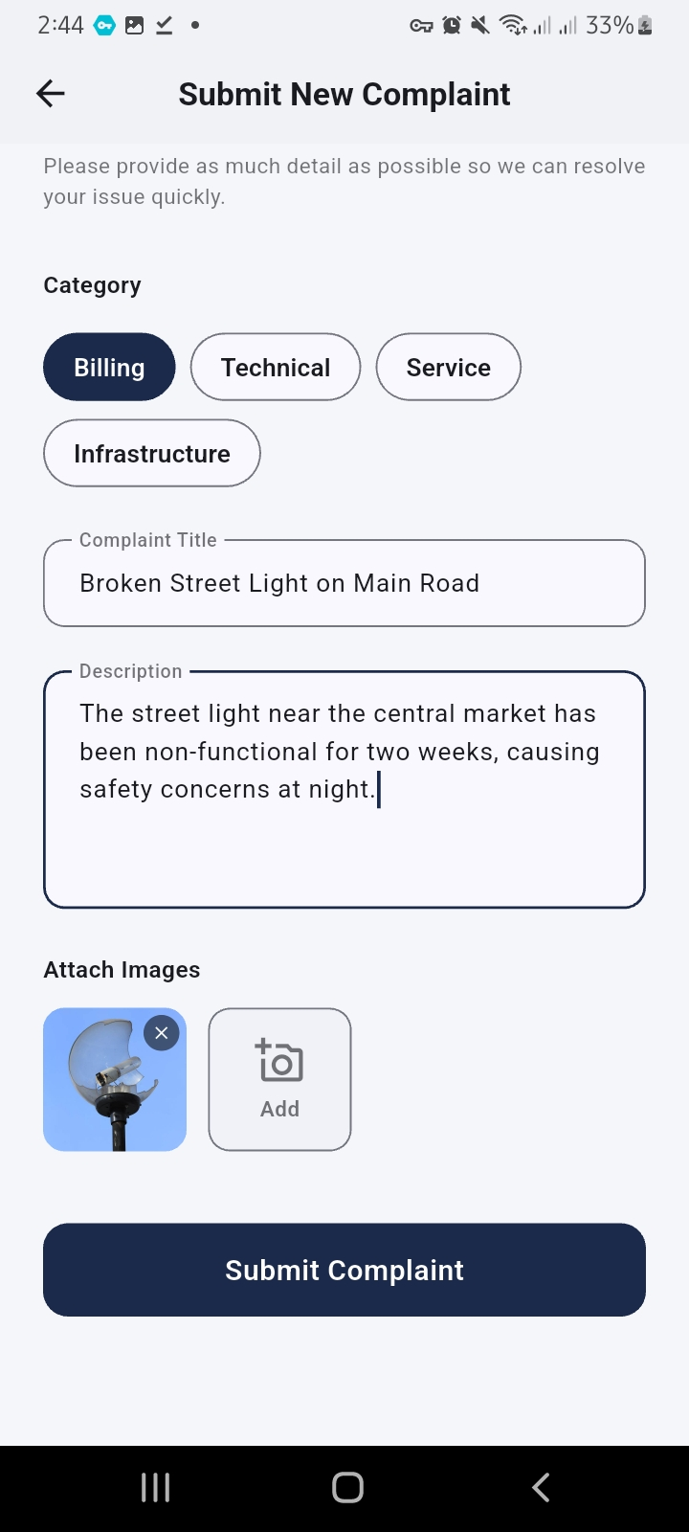  Figure 3: Submit Complaint Screen | 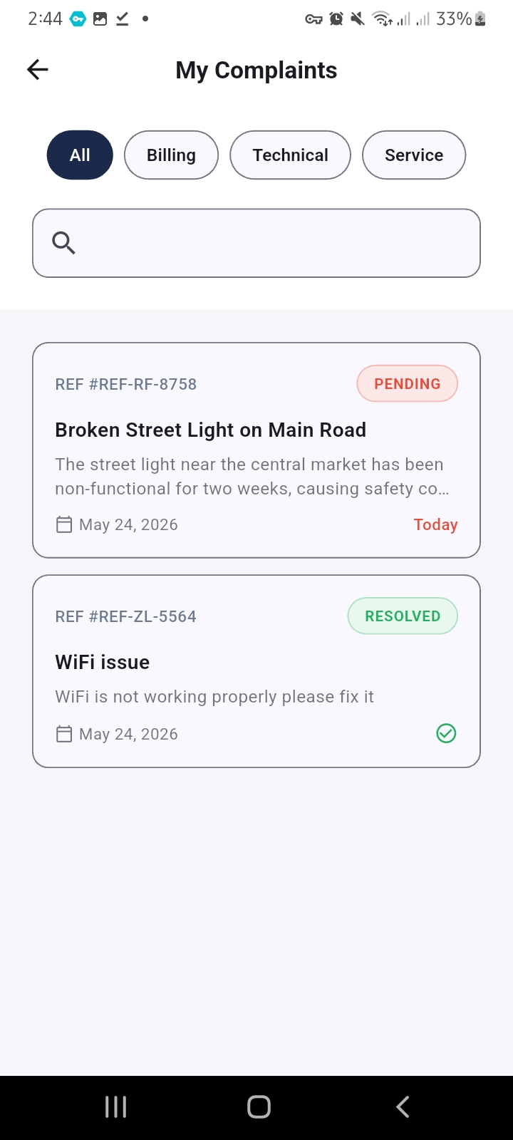  Figure 4: My Complaints List

Figure 3 shows the Submit New Complaint form with the Infrastructure category selected, title 'Broken Street Light on Main Road', full description, and an attached image. Figure 4 shows the My Complaints screen listing two complaints: one Pending (REF-RF-8758) and one Resolved (REF-ZL-5564), with category filter tabs.

A.3 Complaint Detail & Admin Dashboard

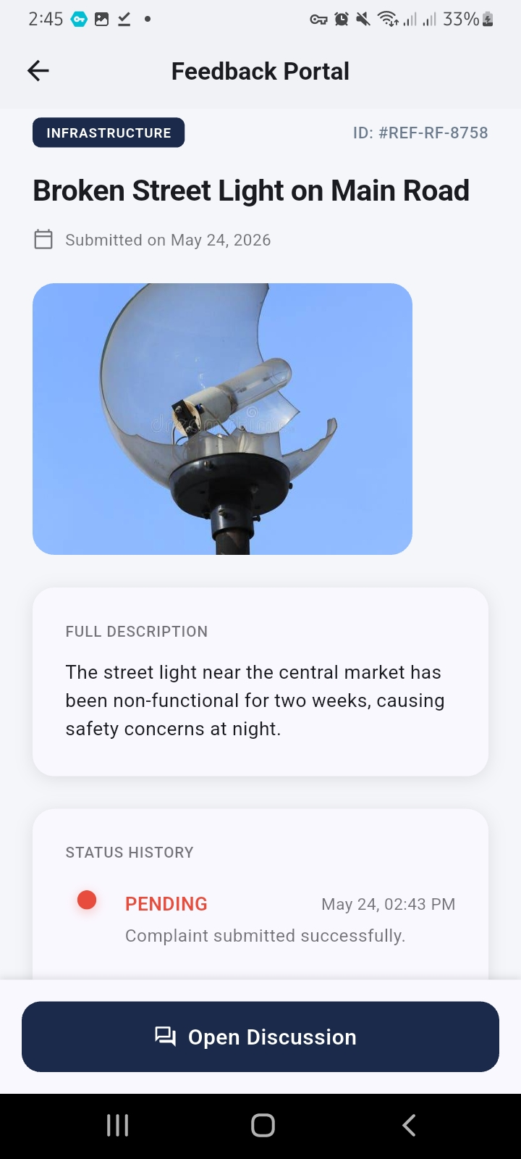  Figure 5: Complaint Detail View (User) | 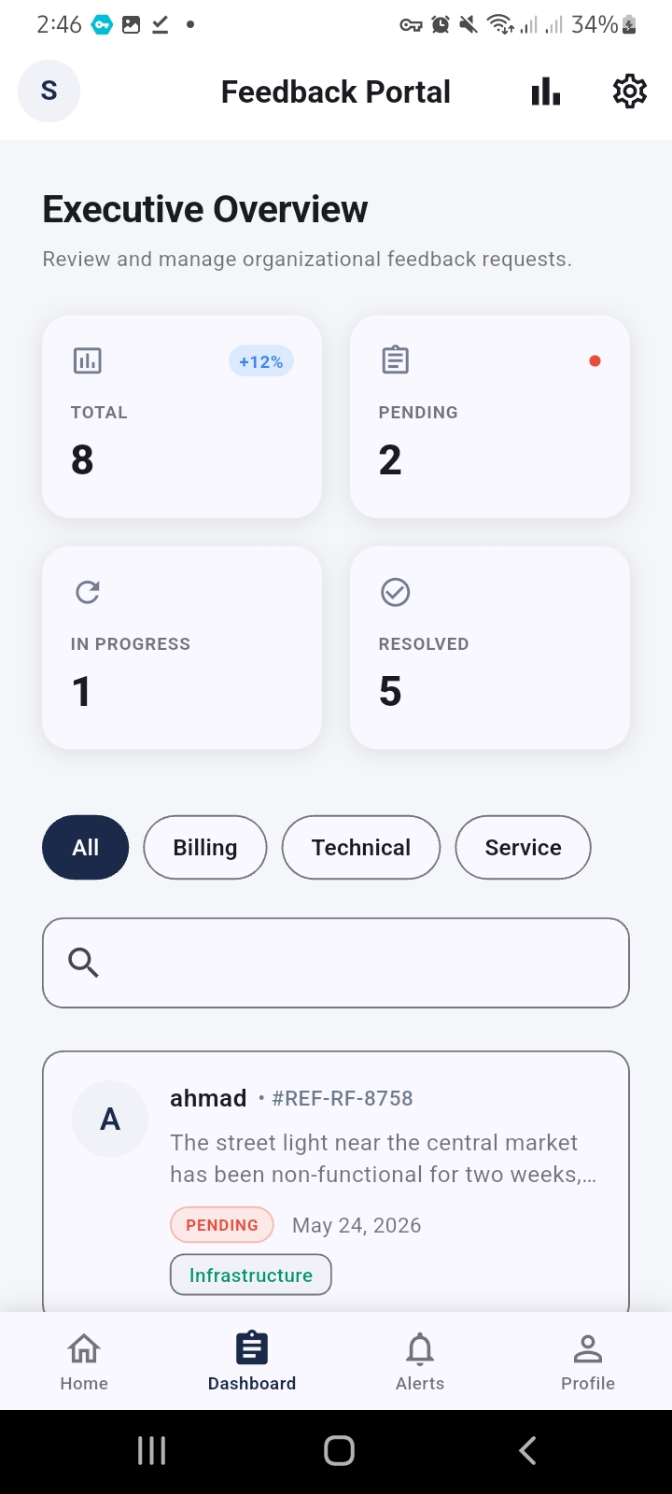  Figure 6: Admin Executive Dashboard

Figure 5 shows the Complaint Detail screen displaying the Infrastructure category badge, complaint ID, attached image, full description, and Status History timeline showing the Pending entry at 02:43 PM. Figure 6 shows the Admin Executive Overview with four statistics cards: Total (8), Pending (2), In Progress (1), Resolved (5), along with the complaint list below.

A.4 Admin Review & User Notifications

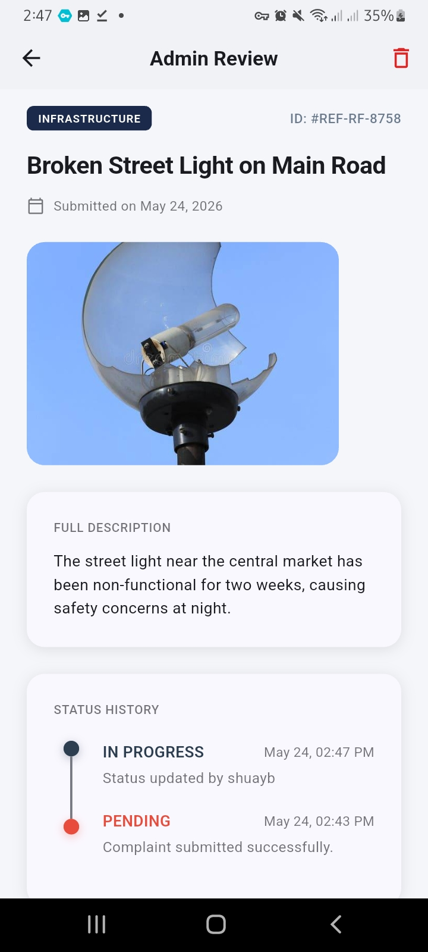  Figure 7: Admin Review — Status Updated to In Progress | 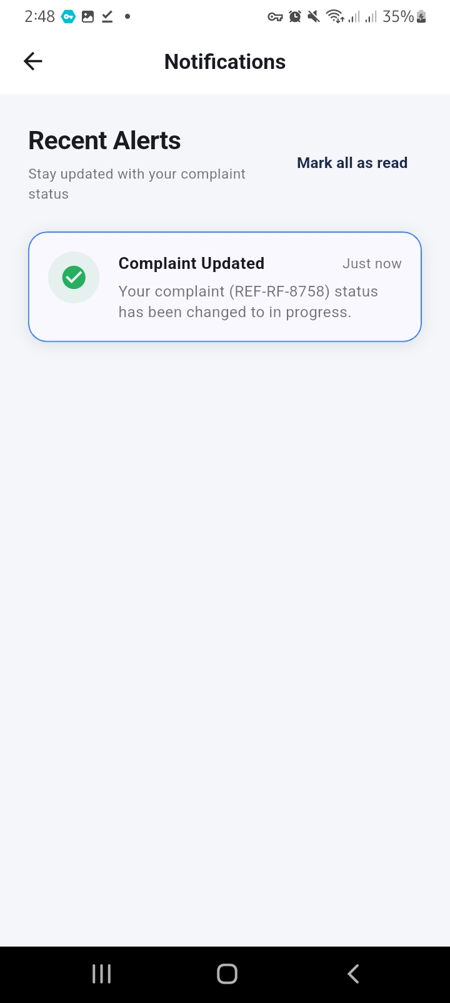  Figure 8: User Notification — Complaint Updated

Figure 7 shows the Admin Review screen for complaint REF-RF-8758 after the admin (Shuayb) updated the status to In Progress at 02:47 PM. The Status History timeline clearly shows the progression from Pending to In Progress. Figure 8 shows the user's Notifications screen confirming real-time delivery of the status change alert: 'Your complaint (REF-RF-8758) status has been changed to in progress.'

Adama Science and Technology University | CSEg3306 | May 2026

