Title
[govMeetings] PHP App Logs Not Formatted - Fields Not Extracted

Priority
High

Problem
PHP application logs (mmphp_logs, videosvcs_logs, peak_logs) are not in standard format matching other applications like Heracleus or N02_vphp [conversation_history].
Issues:
- Severity always shows "Notice" instead of actual level (INFO, ERROR, etc.)ppl-ai-file-upload.s3.amazonaws+1​
- host.hostname and process.name not extractedppl-ai-file-upload.s3.amazonaws​
- message field contains full raw log instead of clean messageppl-ai-file-upload.s3.amazonaws​

Example (from pr-govmeetings-prod-01)
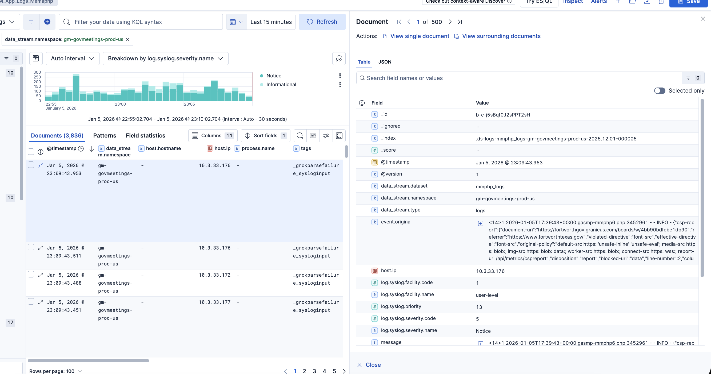
https://elastic.granicuslabs.com/s/govmeetings-prod/app/r/s/JGjMb event.original contains:
c1947-2026-01-06T17:38:41+00:00 gover.media prs-3082067 - INFO: c1 Test 'interviewer.prosono.com' path:'v2/gateway'
Expected extraction:
- host.hostname = gover.media
- process.name = prs-3082067
- log.syslog.severity.name = info
- message = c1 Test 'interviewer.prosono.com' path:'v2/gateway'
Actual (WRONG):
- host.hostname = NOT EXTRACTED ❌
- process.name = NOT EXTRACTED ❌
- log.syslog.severity.name = Notice ❌ (should be info)
- message = FULL RAW LOG ❌

Evidence
Working baseline (N02_vphp): 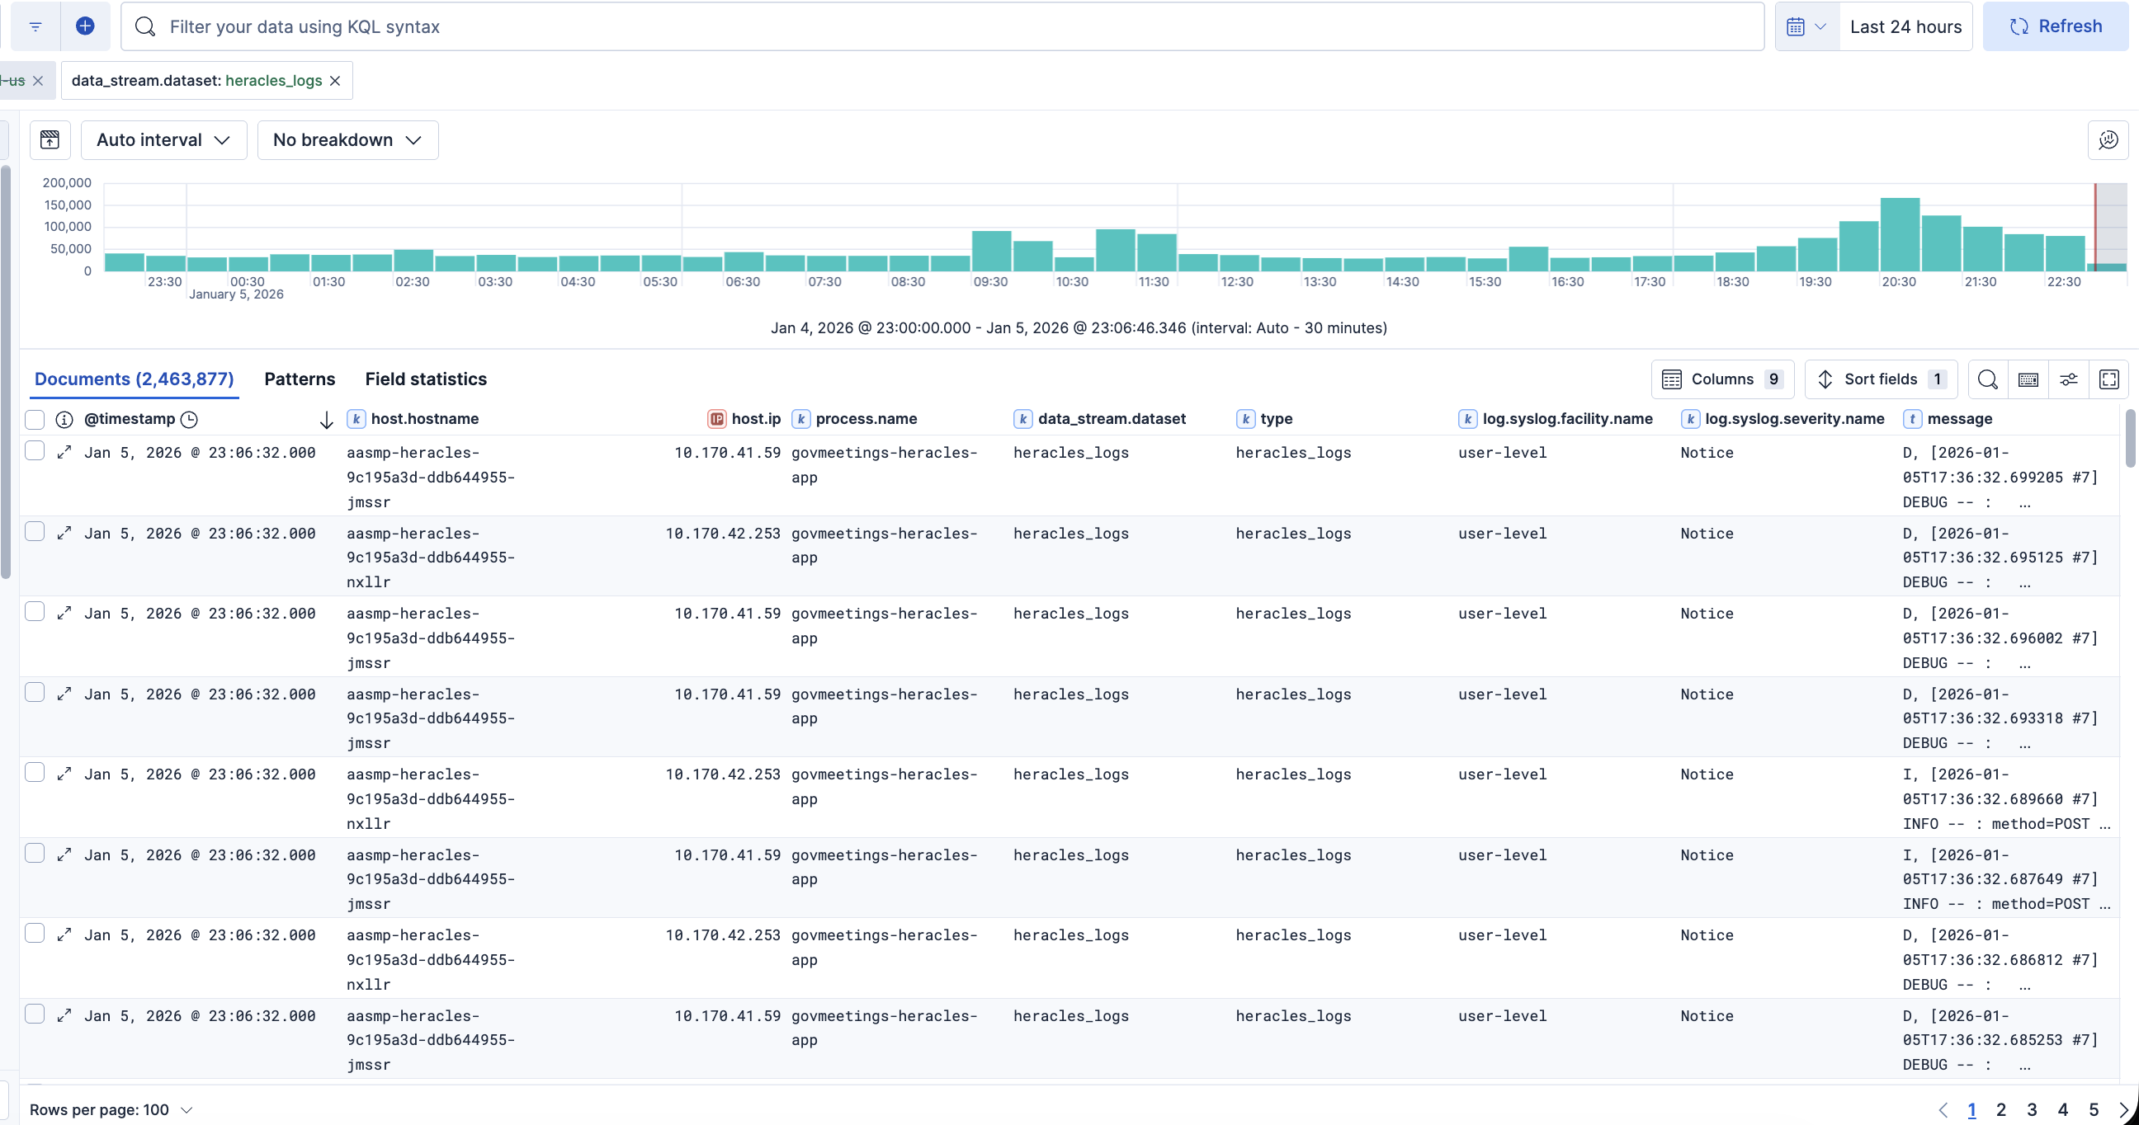
Broken - Severity issue: 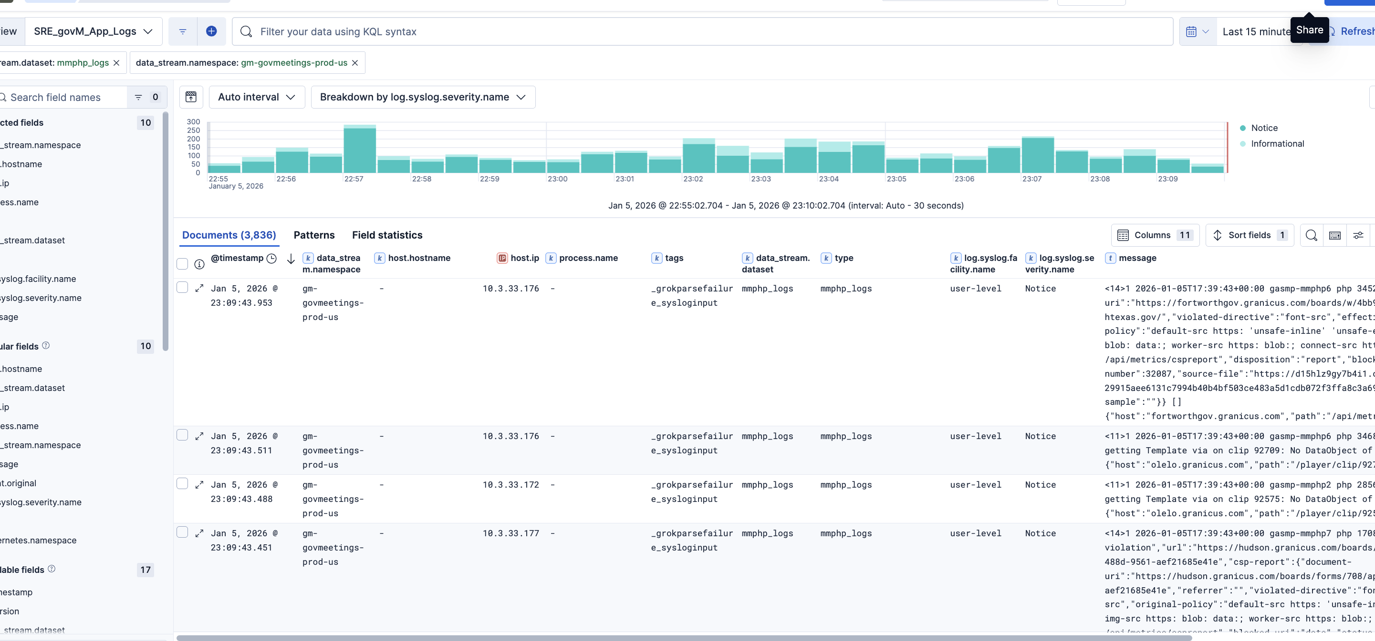
DAI_silverstreet_hrpeak_logs showing all as "Notice"
Broken - Field extraction: 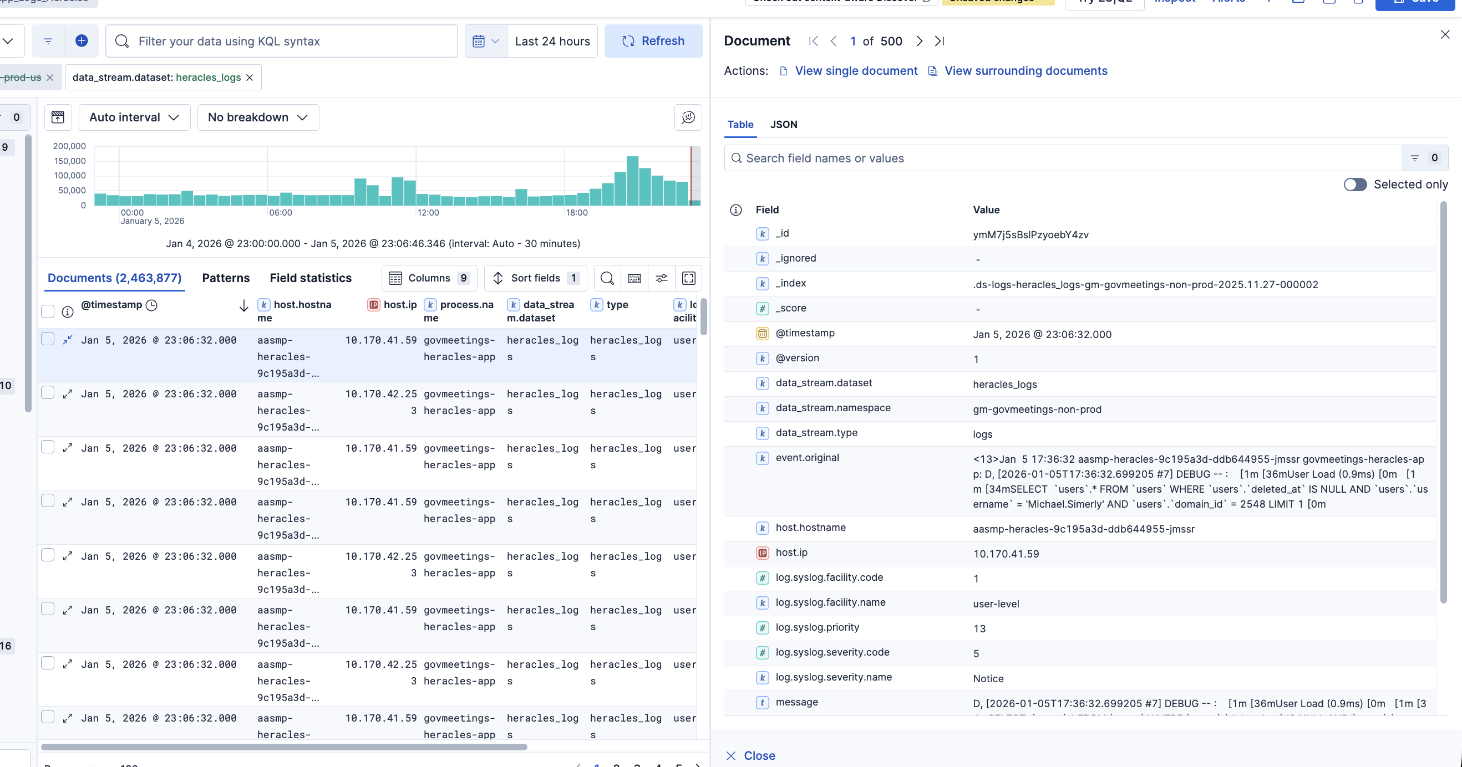 govmeetings log with fields not extracted

Acceptance Criteria
AC1: Given a log with "- INFO:" in event.original, when parsed, then log.syslog.severity.name = "info" (not "Notice")
AC2: Given event.original format TIMESTAMP HOSTNAME PROCESS - SEVERITY: message, when parsed, then host.hostname and process.name are extracted correctly
AC3: Given event.original with full log, when parsed, then message contains only the text after "SEVERITY:" (no timestamp/metadata)
AC4: Given logs from mmphp/videosvcs/peak after fix, when compared with N02_vphp, then field structure matches

Requested Action
Update YAML extraction rules / grok patterns in log aggregation service to parse PHP log format:
[correlation-id]-[TIMESTAMP] [HOSTNAME] [PROCESS] - [SEVERITY]: [message]

Definition of Done
- YAML rules updated to parse PHP format
- Test with Image 4 example: severity = "info" (not "Notice")
- All severity levels (DEBUG, INFO, WARNING, ERROR, CRITICAL) work
- Fields extracted for mmphp_logs, videosvcs_logs, peak_logs, pr-govmeetings-prod-01
- No regression in N02_vphp or Heracleus logs
- Verified in Kibana - all fields populated correctly

z

