**ABSTRACT**

The D-Ads service is a business listing that users can access online anywhere. The D-Ads is used to simplify the day to day activities of peoples who are in searching for shops and services. This makes it easy to locate and find detailed information about a particular shop or service. D-Ads the Local Search Engine provides comprehensive updated information of all the Business to business and business to customer products and services.

D-Ads help buyers to display advertising of their product/services on the platform and sellers to get in touch with each other and act as an intermediary between the buyer and the seller.

**Chapter 1**

**INTRODUCTION**

The D-Ads service is a business listing that users can access online anywhere. The D-Ads is used to simplify the day to day activities of peoples who are in searching for shops and services. This makes it easy to locate and find detailed information about a particular shop or service. D-Ads the Local Search Engine provides comprehensive updated information of all the Business to business and business to customer products and services.

D-Ads help buyers to display advertising of their product/services on the platform and sellers to get in touch with each other and act as an intermediary between the buyer and the seller

**1.1 Objective**

The main objective of this project is to make available the detailed information about the Product/Services at one place so that the user need not worry about the other resources to find the required information.

**Chapter 2**

**LITERATURE SURVEY**

**2.1 Existing system:**

As of now, there are no local platforms available for this kind of service to collaborate with the buyers and sellers together. When a client needs some services or needs to find some product on the local market he/she has to survey the local shops/services and fulfill the requirement that is time-consuming and sometimes takes the wrong decision. All the product/service details are not available online at this time.

**Disadvantages of Existing system**

* Time-consuming.
* Clients cannot get all the information in a short time.
* Clients have to travel for getting details about the Product/services.
* No Records are available online.

**2.2 Proposed system**

To overcome the disadvantages of the existing we are developing a new computerized system called **D-Ads** (Digital Ads)

With the help of this project, we will reduce tasks deployed for information collection to a large extent and promote the buyers online also can reduce client efforts and time during the searching of products/services. It makes available on the local shops/services online.

**Advantages of the proposed system**

* Customers can get full information about the business.
* Sellers can advertise their business to the Buyers.
* Buyers can rate the services provided by sellers (To verify the sellers and their services).
* All the records are stored in a secure database.
* If somehow data may be lost then we can restore it easily.
* We can get all the information in detail at our fingertips.

**2.3 Feasibility study**

A feasibility study is an analysis used to measure the ability expectation to complete a project successfully including all relevant factors that affect it such as operational, technical and economical.

A feasibility study is used to determine the positive and negative outcomes of the project.

**2.3.1 Operational feasibility**

Vendors are ready to use this application software for managing their information and it is acceptable by the administration as well to make available all the information in one place.

**2.3.2 Technical feasibility**

A number of issues we have to consider while doing a technical analysis.

* Understand the different technologies involved in the proposed system.

Before commencing the project, we have to be very clear about what are the technologies that are to be required for the development of the new system.

* Find out whether the organization currently processes the required technologies.

For this project we have used Dreamweaver as a front-end editor and MySQL as back-end.

**2.3.3 Economical feasibility**

In this study the cost and benefits of the proposed system are compared.

The cost of the proposed system is less as compared to the maintenance cost in the existing system in which more cost involved in maintenance. The system also reduces the administrative and other users to do various jobs that single software can do. So, this system is economically feasible.

**Chapter 3**

**SOFTWARE REQUIREMENT SPECIFICATION**

**3.1 Introduction**

This document describes the software requirements, hardware requirements, purpose, and the nature of the software which are developing.

**3.1.1 Purpose**

Those principle reasons this project may be on mechanizing the existing system of information in which data will get from the different data sources to reduce the time of data collection the proposed system came into existence.

**3.1.2 Scope**

Online Advertising Agency System is a system design for Reservation the advertisement. The scope of the system definition the system on which the system works. The system has a wide but out of the scope system is not work. The system is made up of web applications. But for web application computers must have a window operating system and APACHE server and flash player installed to run this system. This system is used by all types of users. Users can register online on this site. All his detail can also see by them. In this website you can create your login. Here u can show all advertisement.

**3.2 System Specification**

**3.2.1 Hardware requirements**

Processor : Pentium 4 or Above

RAM : 512 MB or Above

HDD : Minimum 20 GB

**3.2.2 Software requirements**

Operating System : Windows XP or above

IDE : Microsoft Visual Code

Designing Tools : HTML, CSS, Bootstraps

Server Side Programming language : PHP

Server : WAMP Server

Back End : MySQL

Web Browser : Google Chrome, Internet Explorer etc.

**3.3 Requirement specification**

**3.3.1 Functional requirements**

* **Administrative**
* **Visitors (Users)**
* **Vendor**
* **Administrative:**

Digital Ads in the role of administrator will manage all day to day business activities. As well as verify and organize the Sellers and their services.

**Responsibilities of Administrative**

* Add Verified Sellers and their Services to the Platform.
* Organize the sellers in the searched list as per their ratings.
* Ensure operations adhere to policies and regulations.
* Monitor day to day business activities.
* See all the feedbacks from the Vendors and Users and Make the user-friendly system.
* **Visitors (Users):**

Visitors as buyers can seek the product information available on the D-Ads portal if they want it for further clarification they can contact to the particular seller as related.

**Responsibilities of Visitors**

* Buyers can view the Products/services available on the D-Ads Platform.
* Check for the verified Sellers.
* Rate the sellers for their services.
* Contact the sellers from the platform for further information.
* Give genuine feedback that makes an even more useful system
* **Vender**

Visitor satisfaction depends on services provided by the system administrator.

**Role of Venders**

* Vender can have a separate panel to control advertise their product/service.
* Vender can add their product information.
* Vender panel has different plans with different features.
* Registered users can contact the vendor for more detail about the product/services.
* Vender can send promotional SMS to registered users for advertising their products/services.

**3.3.2 Nonfunctional requirements**

The non-functional requirements describe the aspects of the system that do not relate to the execution of the system.

Below are the nonfunctional requirements of the system.

* **Usability:** This defines how the system is used easily by the user. How the system will create a user-friendly relation with the user. Here in D-Ads, this software is a totally user-friendly GUI based system. Anyone can get an idea of how to use the system by seeing itself.
* **Security:** This gives surety about the system access security by the unauthorized person. This system provides different logins for all level of users.
* **Reliability:** It defines how the software will work without failure for a given time. D-Ads will respond properly with the time period.
* **Performance:** performance will measure the response time of a system and the accuracy of the result. D-Ads will respond at the accurate time of request.
* **Modifiability:** this required to make the changes into the system accordingly. D-Ads is modifiable software, it can modify as required.

**3.4 Tools and Technologies used**

**3.4.1 Tool**

**Microsoft Visual Code:**

[Visual Studio Code](https://code.visualstudio.com/Docs) is a lightweight but powerful source code editor that runs on your desktop and is available for Windows, macOS and Linux. It comes with built-in support for JavaScript, Typescript, and Node.js.

* Developers can use VS Code to build web applications in JavaScript, Typescript, [ASP.NET 5](https://www.talkingdotnet.com/category/asp-net/asp-net-5/), [Node.js](https://nodejs.org/en/), and others.
* Support for debugging: Debugging support for Node.js (JavaScript and Typescripts) on all platforms and experimental support for Mono (C# and F#) on OS X and Linux.
* Intelligence support. See below image for list of language supported and for intelligence support
* Customizable editor: You can change themes, keyboard shortcuts, and workspace settings.
* Create your own snippets and it also allows you to work with up to 3 files side by side.
* Editing features
  + Bracket matching
  + Parameter hints for methods
  + Selection and multi cursor
  + Go to definition and Go to Symbol support
  + Shows errors and warnings in status bar

**3.4.2 Technologies**

**PHP:**

PHP is a server-side scripting language. That is used to develop Static websites or Dynamic websites or Web applications. PHP stands for Hypertext Pre-processor. It is designed for web development. It is the general pretension programming language. PHP code can use with the HTML code.

* PHP meaning Hypertext Preprocessor.
* It used as middleware in programming language.
* PHP code is encaged within <? PHP….?> tag.
* It is a server-side programming language.
* It develops the web pages.

**Features of PHP**

* Supports Standard, Fast CGI, and Apache module- The PHP is a standardized CGI program. It can run on any UNIX machine. As it supports the apache module, PHP is a fast and powerful programming language.
* Access Logging- PHP has the capability to access logging. User can maintain their logging. It stipulates the real-time accessing to the user.
* Access Control- PHP consists of a web screen configuration that handles the access control. In PHP, pages are protected with passwords.
* HTTP-based authentication control- To create the HTTP authentication for the Apache server.
* Extended Regular Expressions- Regular expressions used in PHP for pattern matching, string manipulation, etc. PHP supports all common regular expressions.
* HTTP Header Control- PHP contains the HTTP headers. It uses a higher-level website design. It is mainly used to send a Location. URL header is to redirect the calling client to the other URL.

**3.4.3 Database**

**MySQL:**

This is the database for developing web applications. It meaning a structured query language. It is being widely used database in web applications.

MYSQL is defined as an open-sourced database management system. It writes the queries. It is distributed, developed by Oracles Corporation. It supports all operating systems. It is used as a backend for a database to accumulate the data. MySQL runs on virtually all platforms including Linux, UNIX, and Windows. Although it can be used in a wide range of applications. MySQL is most often associated with web applications.

**XAMP Server:**

XAMPP is an open-source software developed by [Apache Friends](https://www.apachefriends.org/download.html). XAMPP software package contains Apache distributions for Apache server, MariaDB, PHP, and Perl. And it is basically a localhost or a local server. This local server works on your own desktop or laptop computer. The use of XAMPP is to test the clients or your website before uploading it to the remote web server. This XAMPP server software gives you a suitable environment for testing MYSQL, PHP, Apache and Perl projects on the local computer.

It can also be used to create and configure with databases written in MySQL and/or SQLite. And since XAMPP is designed as a cross-platform server package, it is available for a variety of operating systems and platforms like Microsoft Windows, Mac OS X, Linux, and Solaris.

**3.4.4 Designing Tools**

**HTML:**

Html is benchmark markup language that creates different web pages. The code in html is in the pattern of tags. It uses tags fenced in brackets like <html>. HTML tags commonly written in duo like <h1> and </h1>. Here first is wont to open the tag and second one is to close the tag.

To read the HTML files we use browsers, called as web pages. Browsers are not displaying the HTML tags. It executes the HTML files. HTML does an important role in web development. It represents the websites semantically and represents the structure.

What is HTML?

* HTML is Hypertext Markup Language.
* HTML renders the web pages.
* It includes a group of different various tags.
* Tags are used to create pages in web development.

**CSS:**

CSS stands for Cascading Style Sheets. It is a style sheet language that is used to describe the look and formatting of a document written in a markup language. It provides an additional feature to HTML. It is generally used with HTML to change the style of web pages and user interfaces. CSS brings style to your web pages by interacting with HTML elements. Elements are the individual HTML components of a web page.

* CSS was created to work in conjunction with markup languages like HTML. It is used to stylize a page.
* There are three styles of implementing CSS, and you can use the External style to accord multiple pages at once.
* You won’t go far without seeing some kind of CSS implementation nowadays since it’s as much of a requirement as the markup language itself.

**JavaScript:**

JavaScript is a dynamic computer programming language. It is lightweight and most commonly used as a part of web pages, whose implementations allow client-side script to interact with the user and make dynamic pages. It is an interpreted programming language with object-oriented capabilities.

* JavaScript is a lightweight, interpreted programming language.
* Designed for creating network-centric applications.
* Complementary to and integrated with Java.
* Complementary to and integrated with HTML.
* Open and cross-platform.

**\**

**Bootstrap:**

Bootstrap is a [free and open-source](https://whatis.techtarget.com/definition/Free-and-open-source-software-FOSS-or-free-libre-open-source-software-FLOSS) [front end](https://whatis.techtarget.com/definition/front-end) development framework for the creation of websites and [web apps](https://searchsoftwarequality.techtarget.com/definition/Web-application-Web-app). The Bootstrap framework is built on [HTML](https://www.theserverside.com/definition/HTML-Hypertext-Markup-Language), [CSS](https://www.theserverside.com/definition/cascading-style-sheet-CSS), and JavaScript ([JS](https://www.theserverside.com/definition/JavaScript)) to facilitate the development of [responsive](https://whatis.techtarget.com/definition/responsive-design), [mobile-first](https://searchmobilecomputing.techtarget.com/definition/mobile-first) sites and apps.

Bootstrap includes user interface components, layouts, and JS tools along with the framework for implementation.

* Bootstrap is the most popular HTML, CSS, and JavaScript framework for developing a responsive and mobile-friendly website.
* It is absolutely free to download and use.
* It is a front-end framework used for easier and faster web development.
* It includes HTML and CSS based design templates for typography, forms, buttons, tables, navigation, modals, image carousels, and many others.
* It can also use JavaScript plug-ins.
* It facilitates you to create responsive designs.

**Chapter 4**

**DESIGN DOCUMENTS**

**4.1 ER-Diagram**

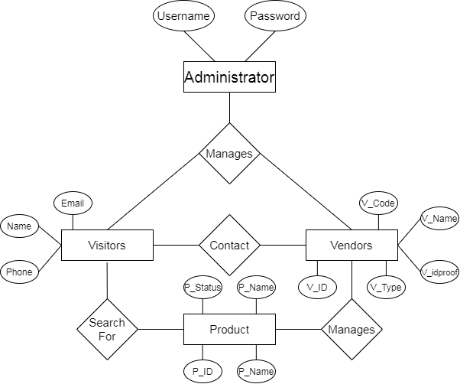

**Fig.1 ER-Diagram: Entity relationship diagram**

**4.2 Data-flow-diagram**

The Data Flow Diagram routes the flow of information for the system, by using the symbols like rectangle, circle and arrows, short text labels to show the data flow routes between each destination.

The data flow diagrams are functionally divided into, Zero level, First level, and Second level data flow diagrams.

1. **Zero level DFD**

**Registration Details Check-in**

**Administrative**

**Vendors**

**Users**

**Database**

**Main page**

**Check-out**

**Login Details Authentication**

**Fig.2 Zero level data flow diagram**

1. **One level DFD**

**Admin**

**Vendors**

**Users**

**Database**

**Database**

**Database**

**Manages**

**Deals with**

**Can**

**Fig.3 One level data flow diagram**

1. **Two-level DFD**

* **Administrative two-level DFD**

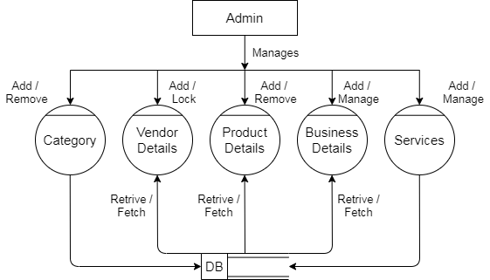

**Fig.4 Two-level data flow diagram**

* **Vendors two-level DFD**

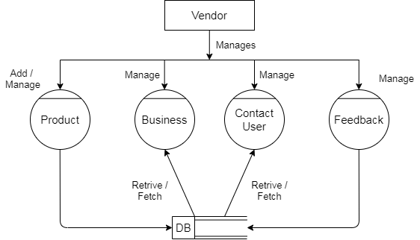

**Fig.5 Two-level data flow diagram**

* **Users two-level DFD**

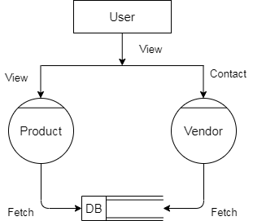

**Fig.6 Two-level data flow diagram**

**4.3 DATA DICTIONARY**

After carefully understanding the requirements of the client the entire data storage requirements are divided into the below tables.

1. **b_Category**

|  |  |  |
| --- | --- | --- |
| **Fields** | **Type** | **Description** |
| c_id | int(100) | Primary key |
| c_name | varchar(100) |  |
| c_desc | varchar(255) |  |
| is_Active | int(10) |  |
| Created_dt | varchar(100) |  |

1. **b_details**

|  |  |  |
| --- | --- | --- |
| **Fields** | **Type** | **Description** |
| b_id | int(100) | Primary key |
| sc_id | int(100) | Foreign key |
| b_name | varchar(100) |  |
| b_desc | varchar(225) |  |
| b_estdate | varchar(100) |  |
| b_mobile | varchar(100) |  |
| b_altmob | varchar(100) |  |
| b_email | varchar(100) |  |
| b_website | varchar(100) |  |
| b_address | varchar(100) |  |
| b_city | varchar(100) |  |
| created_dt | varchar(100) |  |

1. **b_photos**

|  |  |  |
| --- | --- | --- |
| **Fields** | **Type** | **Description** |
| bp_id | int(100) | Primary key |
| b_id | int(100) | Foreign key |
| Bp_photolink | varchar(100) |  |
| Bp_slider1 | varchar(100) |  |
| Bp_slider2 | varchar(100) |  |
| Bp_slider3 | varchar(100) |  |
| created_dt | varchar(100) |  |

1. **b_subcat**

|  |  |  |
| --- | --- | --- |
| **Fields** | **Type** | **Description** |
| sc_id | int(100) | Primary key |
| c_id | varchar(100) | Foreign key |
| sc_name | varchar(100) |  |
| sc_desc | varchar(100) |  |
| sc_icon | varchar(100) |  |
| is_Active | int(10) |  |
| created_dt | varchar(100) |  |

1. **contact_us**

|  |  |  |
| --- | --- | --- |
| **Fields** | **Type** | **Description** |
| cs_id | int(100) | Primary key |
| b_id | int(100) | Foreign key |
| p_name | varchar(100) |  |
| p_desc | varchar(100) |  |
| p_photos | varchar(100) |  |
| p_status | varchar(100) |  |
| created_dt | varchar(100) |  |

1. **faq**

|  |  |  |
| --- | --- | --- |
| **Fields** | **Type** | **Description** |
| Id | int(100) | Primary key |
| faq_question | varchar(300) |  |
| faq_answer | varchar(1500) |  |
| created_dt | varchar(20) |  |
| last_updated | varchar(20) |  |
| Status | varchar(10) |  |

1. **feedback_details**

|  |  |  |
| --- | --- | --- |
| **Fields** | **Type** | **Description** |
| f_id | int(100) | Primary key |
| feedback_id | varchar(100) | Foreign key |
| Fname | varchar(100) |  |
| Lname | varchar(100) |  |
| Email | varchar(100) |  |
| Phone | varchar(100) |  |
| Msg | varchar(100) |  |
| Status | varchar(20) |  |
| created_dt | varchar(100) |  |

1. **feedback_reply**

|  |  |  |
| --- | --- | --- |
| **Fields** | **Type** | **Description** |
| feedback_id | varchar(100) | Primary key |
| Name | varchar(100) |  |
| Email | varchar(100) |  |
| Phone | varchar(100) |  |
| Msg | varchar(1000) |  |
| Status | varchar(20) |  |
| created_dt | varchar(100) |  |

1. **lgn_tbl**

|  |  |  |
| --- | --- | --- |
| **Fields** | **Type** | **Description** |
| lgn_id | int(100) | Primary key |
| Username | varchar(100) |  |
| Password | varchar(100) |  |
| Email | varchar(100) |  |
| u_type | varchar(100) |  |
| s_ques | varchar(100) |  |
| s_ans | varchar(100) |  |
| u_status | varchar(100) |  |

**10. Login_info**

|  |  |  |
| --- | --- | --- |
| **Fields** | **Type** | **Description** |
| Id | int(10) | Primary key |
| Name | varchar(100) |  |
| Timestamp | varchar(100) |  |
| ip_address | varchar(100) |  |
| mac_address | varchar(100) |  |
| Status | varchar(50) |  |

1. **otp**

|  |  |  |
| --- | --- | --- |
| **Fields** | **Type** | **Description** |
| Id | int(10) | Primary key |
| Username | varchar(100) |  |
| Otp | int(10) |  |
| Status | varchar(50) |  |
| Timestamp | varchar(50) |  |
| Hashvalue | varchar(100) |  |

1. **product_details**

|  |  |  |
| --- | --- | --- |
| **Fields** | **Type** | **Description** |
| p_id | int(100) | Primary key |
| b_id | int(100) | Foreign key |
| p_name | varchar(100) |  |
| p_desc | varchar(100) |  |
| p_photos | varchar(100) |  |
| p_status | varchar(100) |  |
| created_dt | varchar(100) |  |

1. **vender_details**

|  |  |  |
| --- | --- | --- |
| **Fields** | **Type** | **Description** |
| v_id | int(100) | Primary key |
| v_code | varchar(100) |  |
| v_fname | varchar(100) |  |
| v_lname | varchar(100) |  |
| v_email | varchar(100) |  |
| v_mobile | varchar(100) |  |
| v_alt_mob | varchar(100) |  |
| v_idproof | varchar(100) |  |
| v_photos | varchar(100) |  |
| v_reg_date | varchar(100) |  |
| v_type | varchar(100) |  |
| v_status | int(10) |  |

1. **Vender_type**

|  |  |  |
| --- | --- | --- |
| **Fields** | **Type** | **Description** |
| v_id | int(10) | Primary key |
| v_type | varchar(100) |  |
| Vtype_desc | varchar(225) |  |
| Created_dt | varchar(100) |  |
| Status | int(10) |  |

**4.4 Use case diagram**

* **Use case diagram**

**Administrative**

**User**

**Vendors**

**Fig. 7 System use case diagram**

* **Administrative use case diagram**

**Administrative**

**Fig. 8 Administrative level use case diagram**

* **Users use case diagram**

**Users**

**Fig. 9 Users level use case diagram**

* **Vendors use case diagram**

**Vendors**

**Fig. 10 Vendors level use case diagram**

**4.5 Activity diagram**

* **Registration page activity diagram**

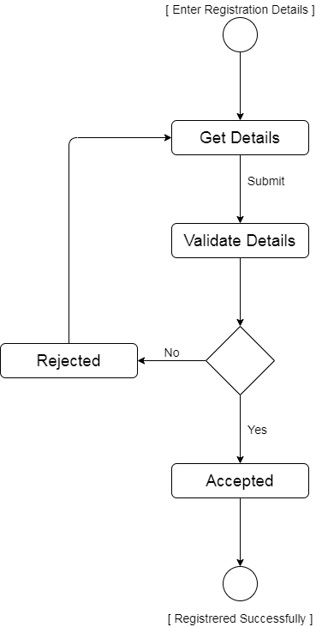

**Fig. 11 Registration page activity diagram**

* **Login page activity diagram**

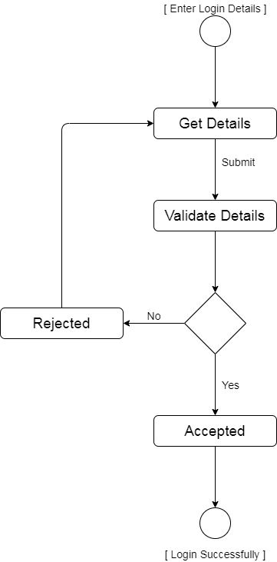

**Fig. 12 Login page activity diagram**

* **Administrative activity diagram**

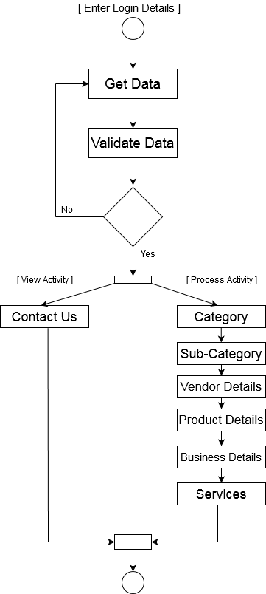

**Fig. 13 Administrative activity diagram**

* **Vendors activity diagram**

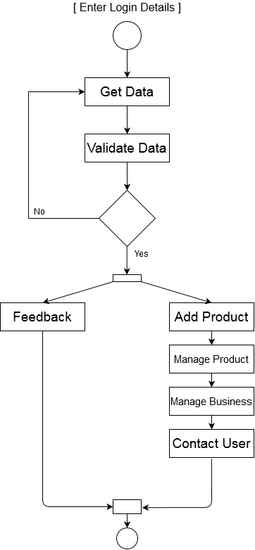

**Fig. 14 Vendors activity diagram**

* **Users activity diagram**

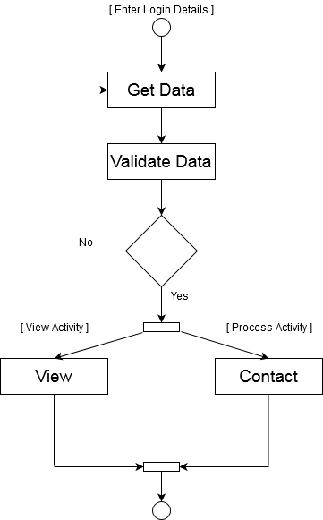

**Fig. 15 Users activity diagram**

**4.6 Relational Schema**

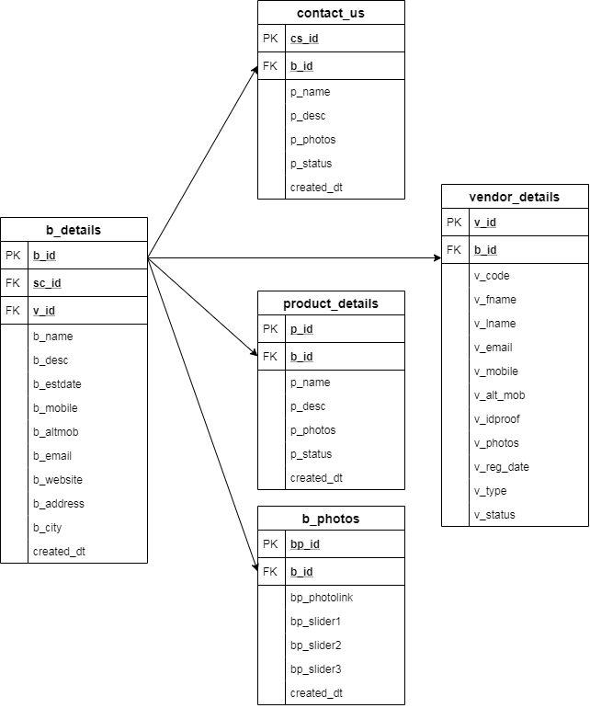

**Fig. 16 Relational Schema**

**Chapter 5**

**VERIFICATION AND VALIDATION**

**5.1 Introduction**

The verification and validation can also be referred to as software quality control. It is the process of checking whether the software fulfills its purpose and meets all the requirements.

**5.2 Methodology used**

**Agile methodology**

While each of the agile mythologies is unique in its specific approach, they all share a common vision and core values. They all fundamentally incorporate iterations and the continuous feedback that it provides to successively refine and deliver a software system. They all involve continuous planning, continuous testing, continuous integration, and other forms of continuous evolution of software. They are lightweight, especially compared to traditional waterfall-style processes, and inherently adaptable. What is more important about the agile method is that they all focus on empowering people to collaborate and make decisions together quickly and effectively.

* Test first programming
* Refactoring
* Continues iterations
* Simple design
* Coding standards

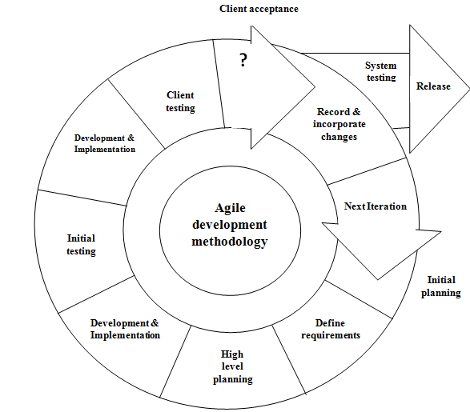

**Fig. 17 Agile model.**

**5.3 Testing technology**

**Black Box Testing**

Black Box Testing is one of the approaches to the testing scenario or we can call it as the type of testing. In black-box testing will do the test engineers, where the framework functionality will be checked. In the black box testing code will not visible to the test engineers. Here we are checking the missing function if any interface error, we will be checking the performance of the software and its behaviors. Here we also check any external error regarding the database access, etc.

**White Box Testing**

White Box Testing is also called as Code testing. This testing is done by the developer while developing the code for the software. This testing is concerned with the developer where the code will be visible to perform the testing, this testing involves step by step procedure to perform the testing. In this testing, we check all the independent condition and also the path in the code whether all the related path is executed at least once or not.

We also check whether the necessary loop and the condition were checked are not, here we are checking the boundaries of the possibilities for the logical condition or decision for the true and false .here we will check the data structure is valid or not.

Ensure whether the possible validity check and validity lookups have been provided validate data entry.

**Testing Strategies:**

**Levels of testing:**

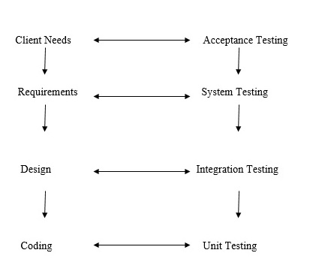

**Fig. 18 Levels of testing.**

The different testing is carried out which reflects its effectiveness and Efficiency of different phases of the software development where these tests help to uncover the error in the corresponding phase.

There are two general strategies for testing software. There are as follows

**Code Testing:**

Code Testing where we will check the program logic is correct or not. To do this we are using the test case which is developed by the tester in order to check each and every path of the code logic as well as the flow of the program.

**Specification Testing:**

In this testing approach, we are using for the specification that is required to test the various behaviors of the application in various conditions. To perform the specification testing developer writes the test case with all the combinations of conditions to perform the specification testing.

**Integration Testing:**

Integration Testing is performed after the unit testing, where the testing can involve the integration i.e. all the units which are done with the testing those will be combined, integrated with the other entire module and performs the testing order to maintain the consistency.

**Chapter 6**

**IMPLEMENTATION RESULT**

1. **Home page**
2. **Login page**
3. **Admin page**

**Chapter 6**

**CONCLUSION AND FUTURE SCOPE**

**REFERENCES**

1. [www.google.com](http://www.google.com)
2. [www.googleScholar.com](http://www.googleScholar.com)
3. [www.softwareadvice.com](http://www.softwareadvice.com)
4. <https://projectsgeek.com>
5. <https://www.academia.edu>
6. <https://www.slideshare.net>