

GITHUB EXERCISE

Submitted to,

Prof. Christelle Scharff



November 7, 2016

Shubham gadewar

Pace University

Q.1. What is GitHub? When was it created? Why? By who? What similar platforms exist? Why would you use such a platform?

Answer:

* Git is a command-line tool, but the center around which all things involving Git revolve – effectively, the Hub, is GitHub.com, where developers can store their projects and network with likeminded people.
* GitHub was co-founded by Thomas Preston-Werner, Chris Wanstrath and PJ Hyett.
* BitBucket.com, GitLab, SVN (Subversion Repository) are similar web-based repository hosting services.
* There are few reasons why we should GitHub:

1. The world is moving towards open source.
2. Our team can learn from each other’s work.
3. We can request other developers to contribute their knowledge if needed.

**Tutorial steps:**

Step 1:

Initializing Git

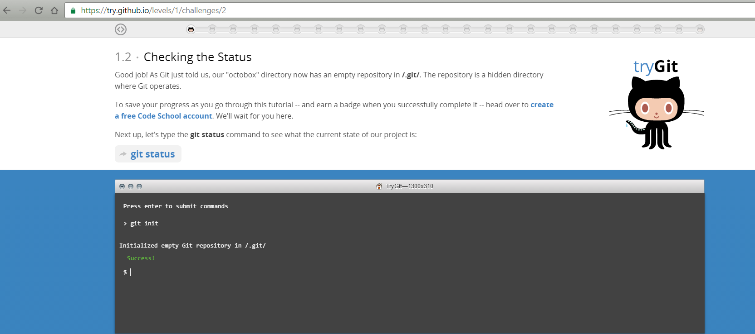

Step 2:

Checking the status

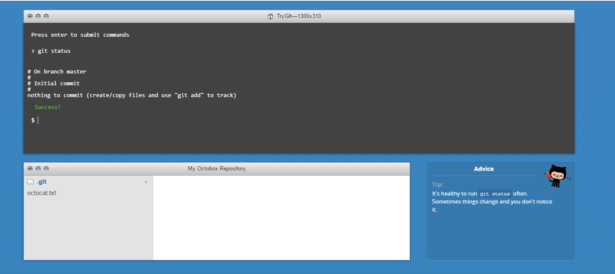

Step 3:

Adding and committing

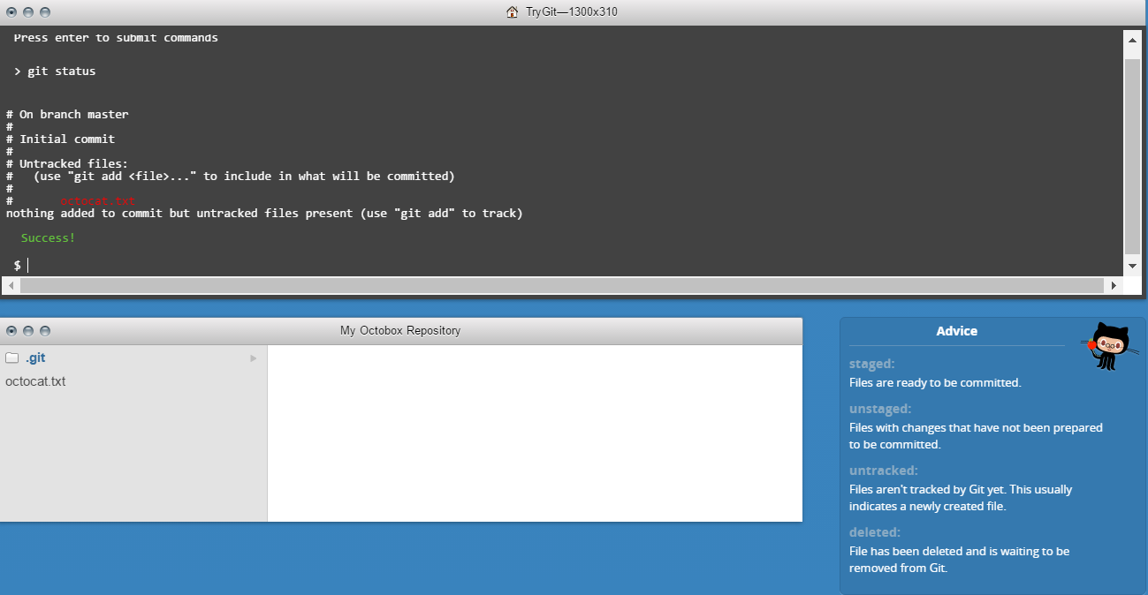

Step 4:

Adding Changes

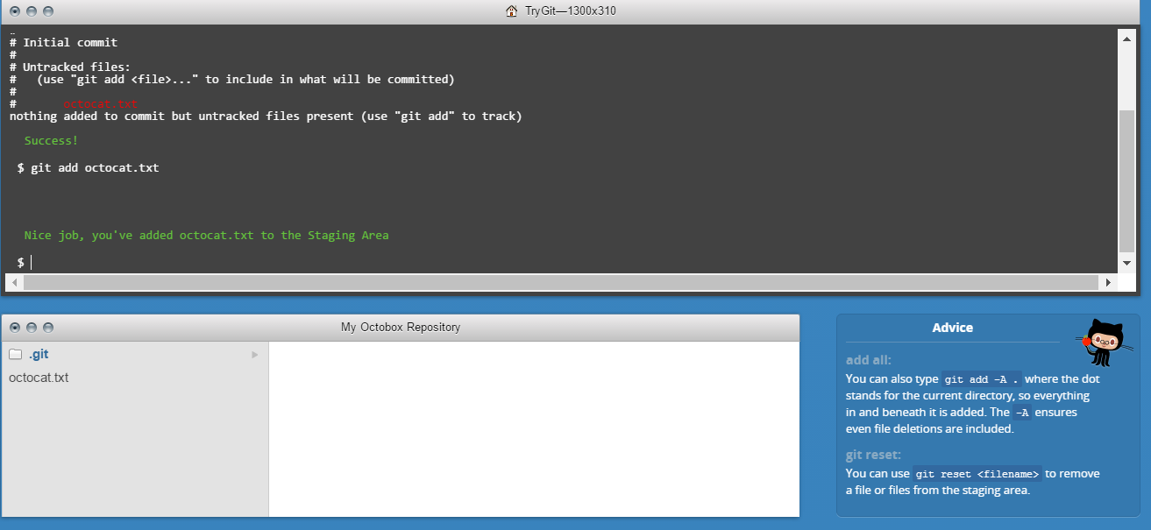

Step 5:

Checking for changes

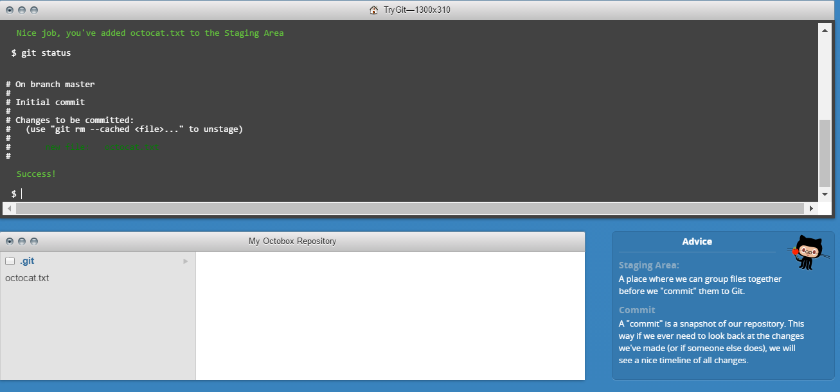

Step 6:

Committing

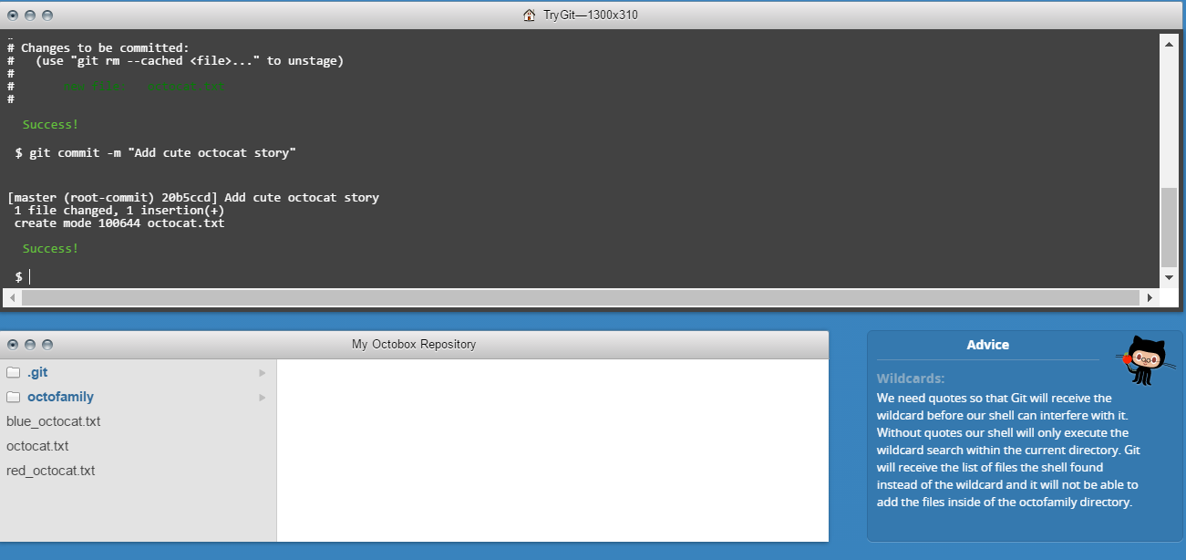

Step 7:

Adding all changes

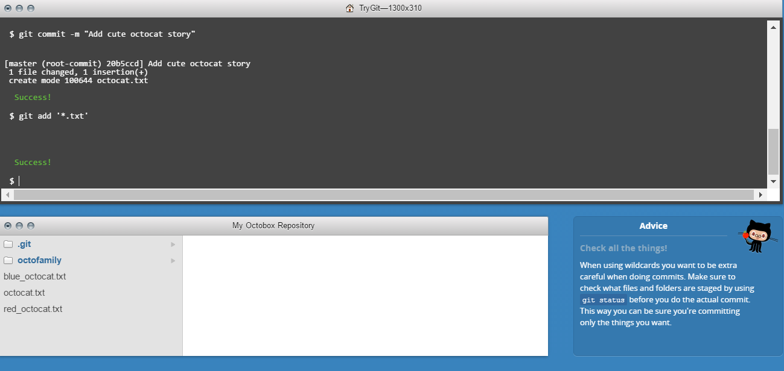

Step 8:

Committing all changes

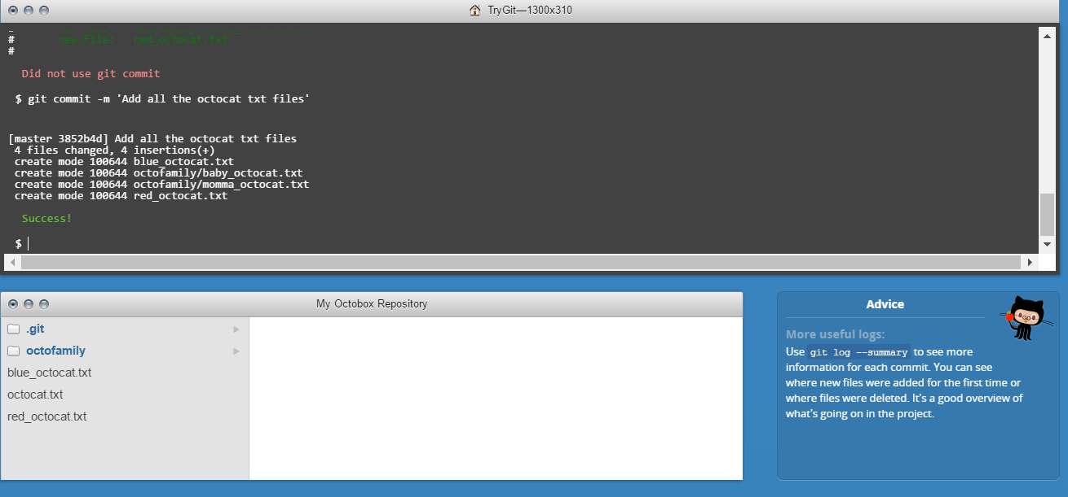

Step 9:

History

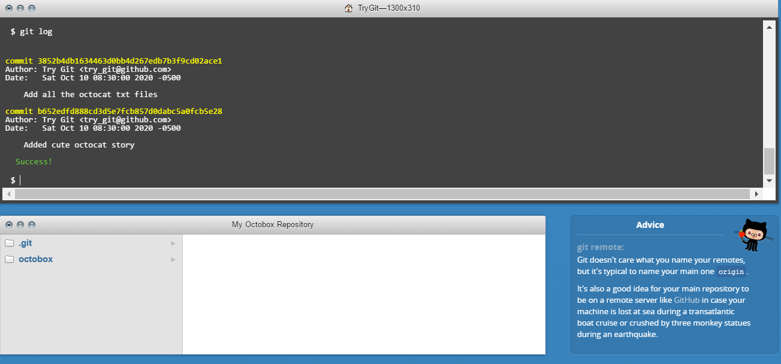

Step 10:

Remote Repositories

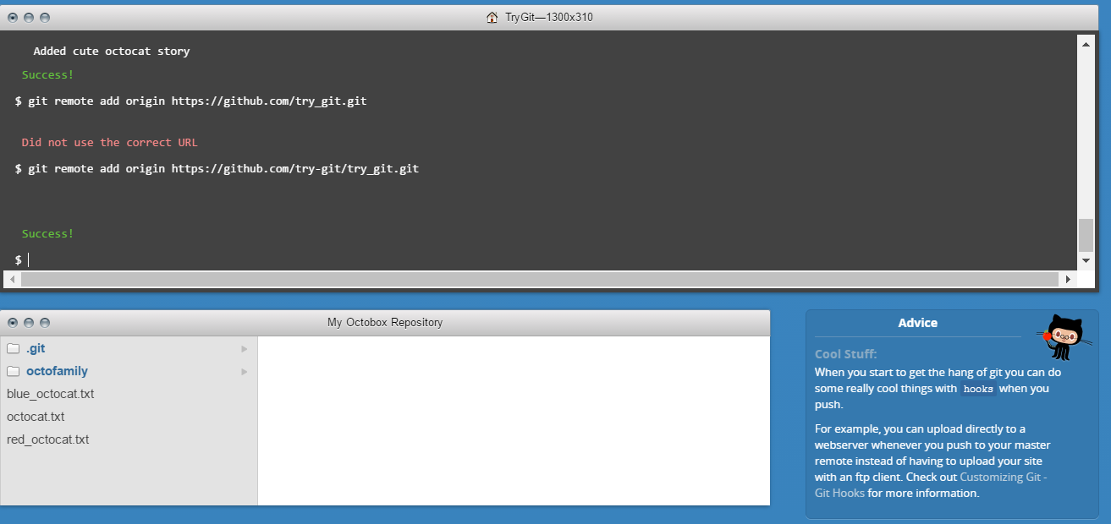

Step 11:

Pushing Remotely

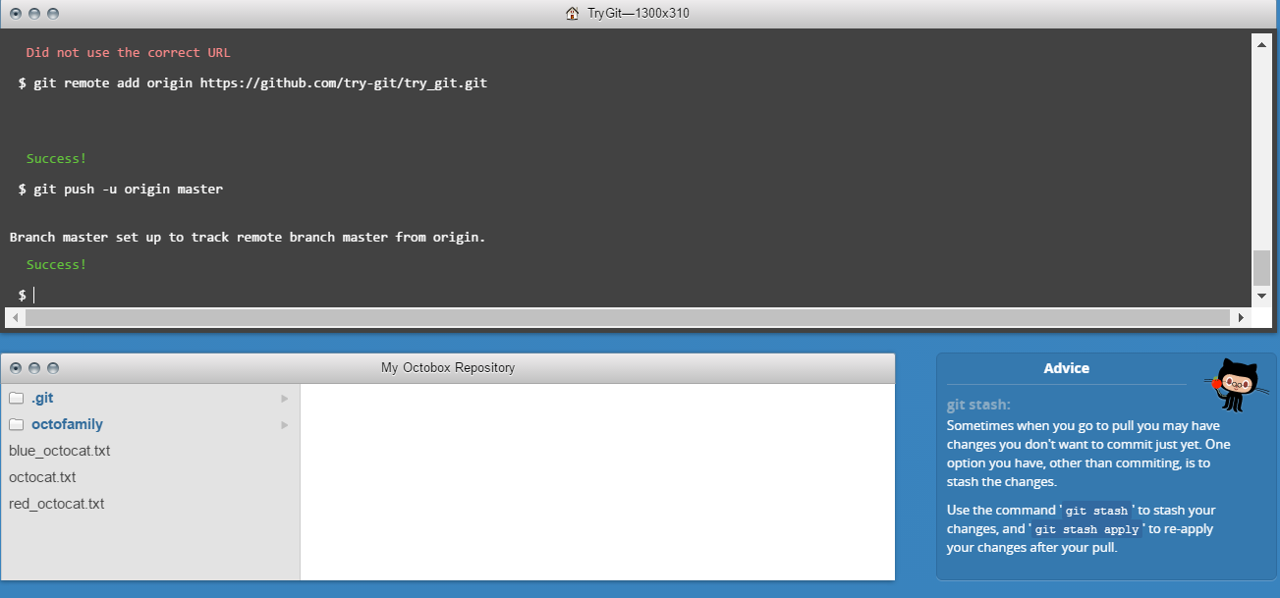

Step 12:

Pulling Remotely

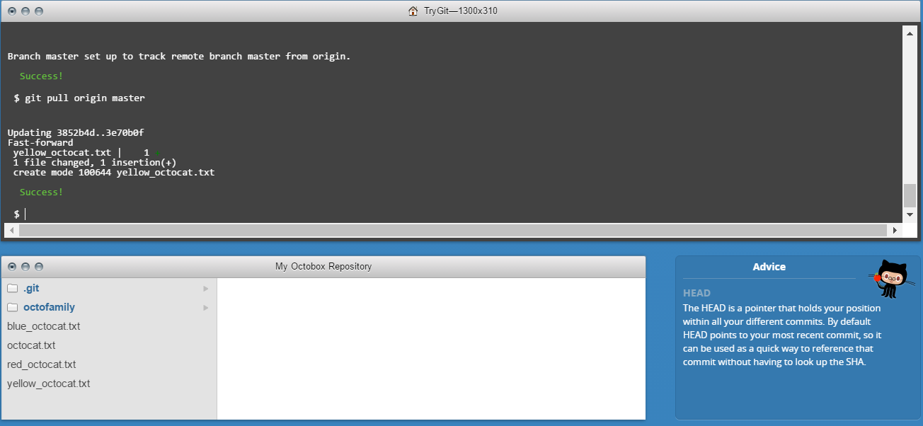

Step 13:

Differences

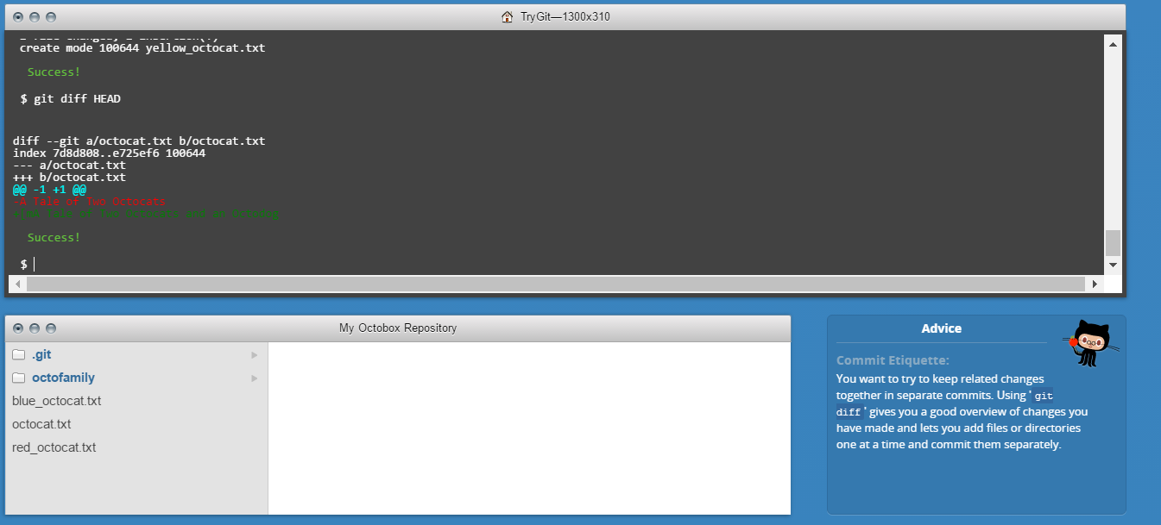

Step 16:

Staged Difference

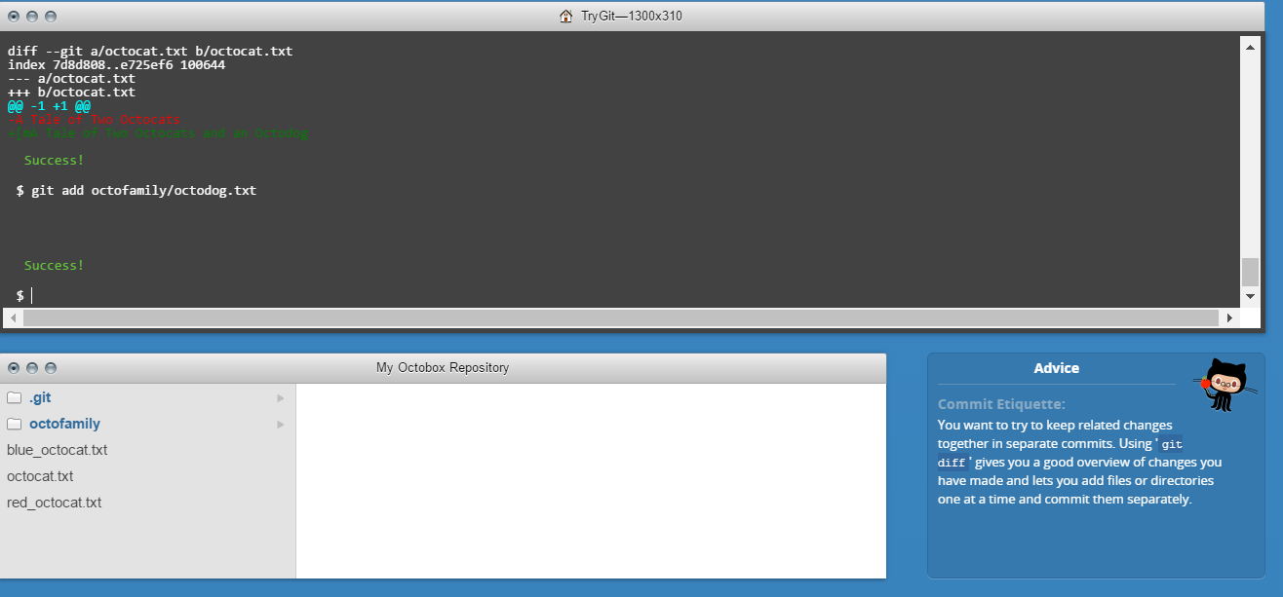

Step 17:

Staged Difference (Cont’d)

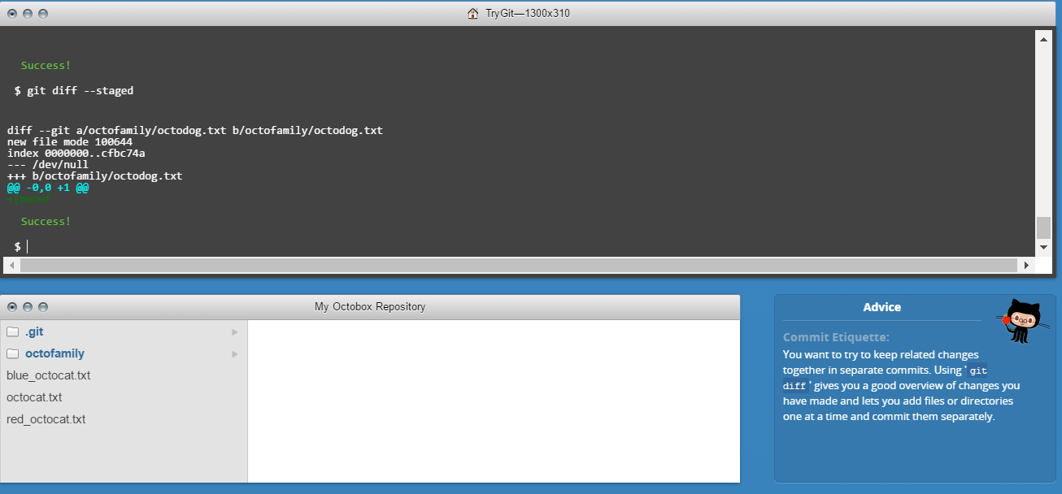

Step 18:

Resetting the stage

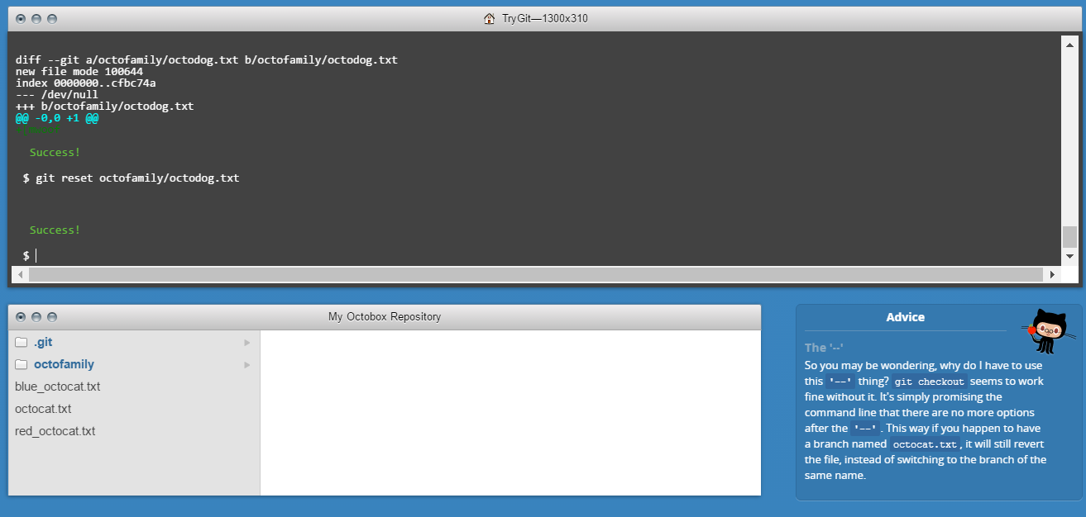

Step 19:

Undo

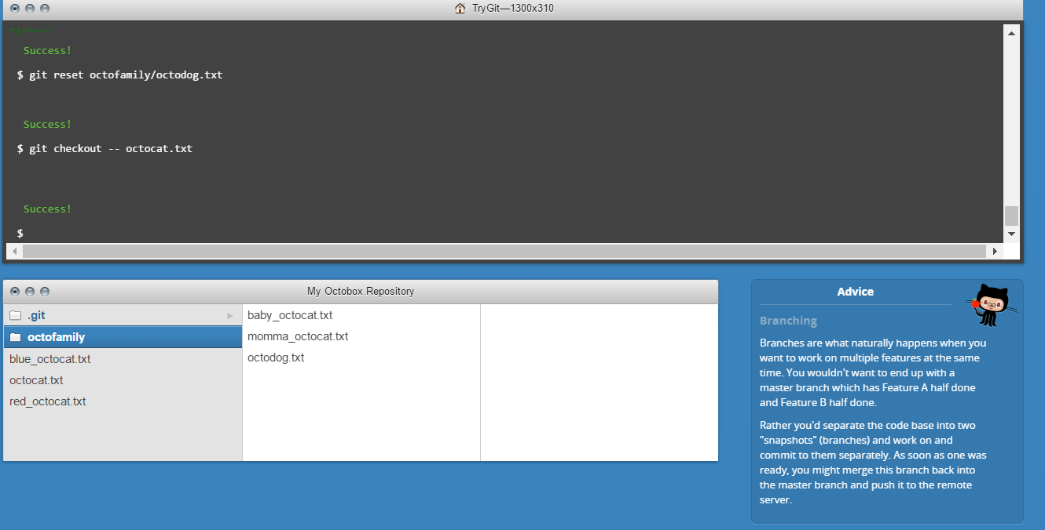

Step 20:

Branching out

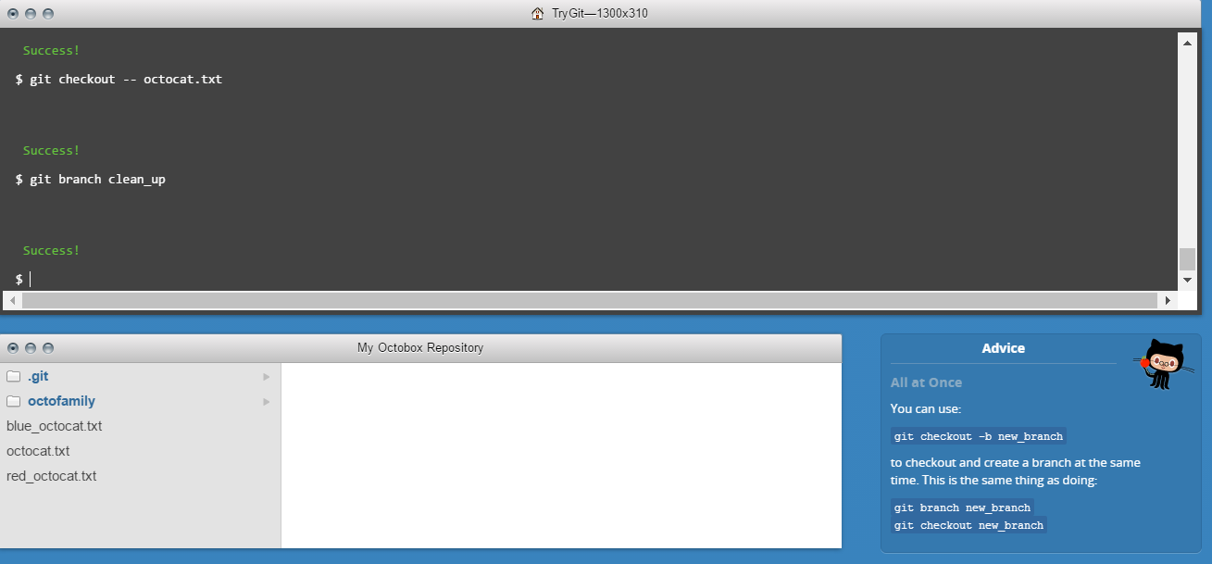

Step 21:

Switching Branches

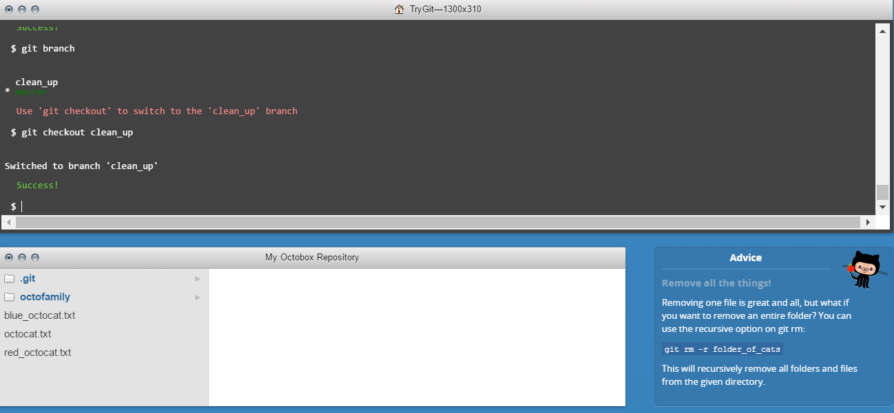

Step 22:

Removing all things

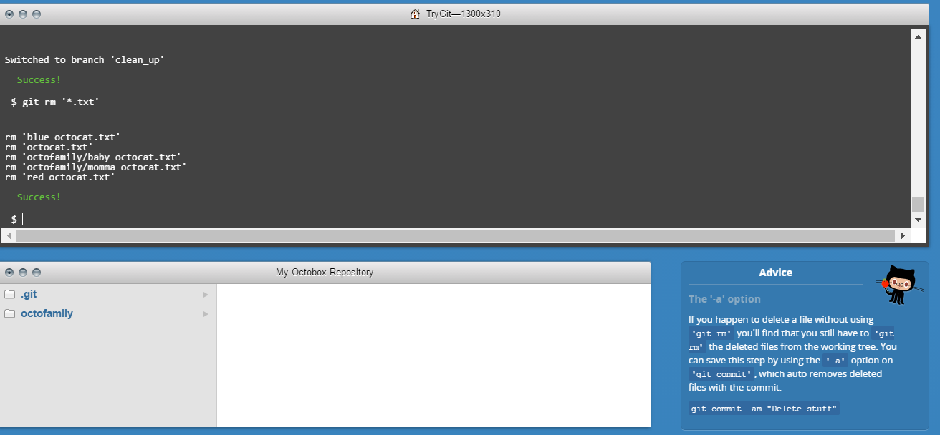

Step 23:

Committing Branch Changes

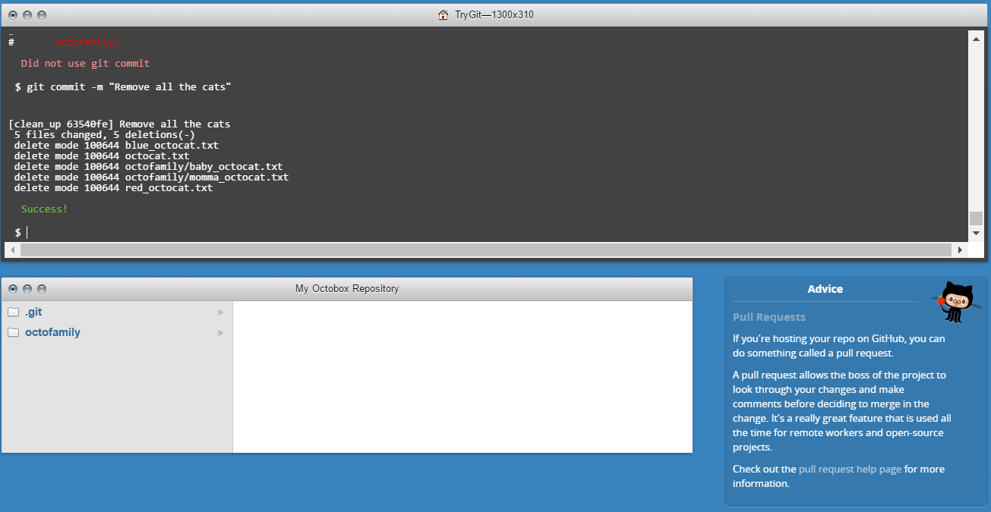

Step 24:

Switching back to master

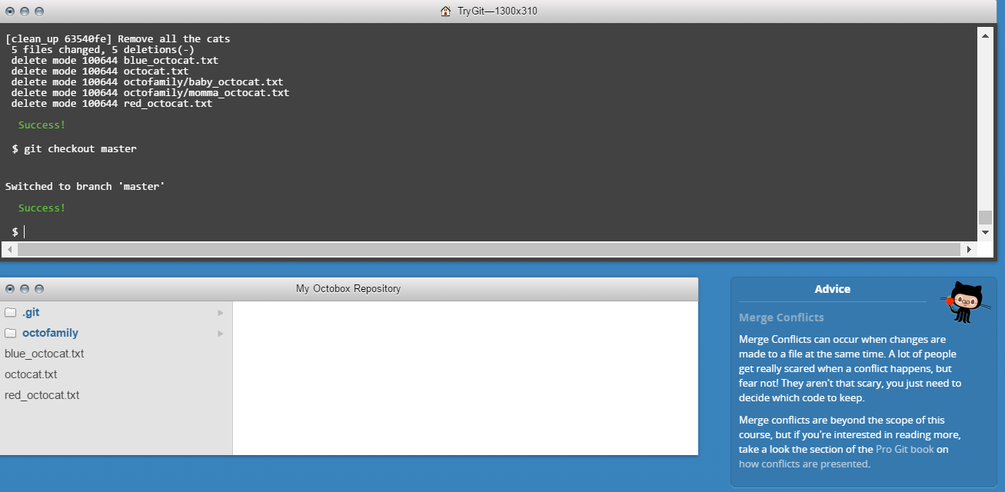

Step 25:

Preparing to merge

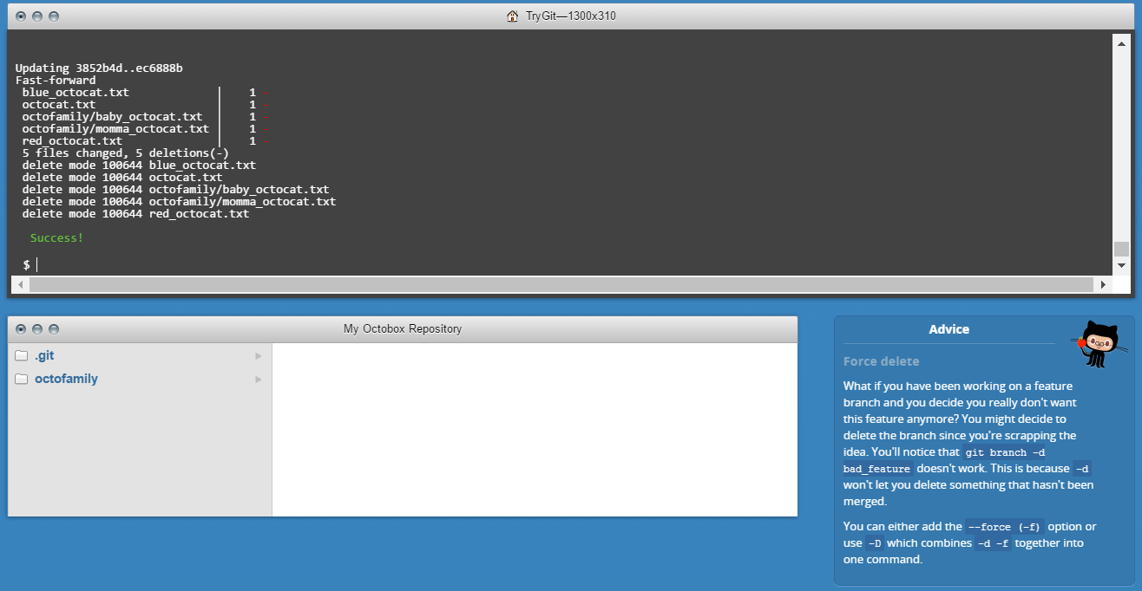

Step 26:

Keeping things clean

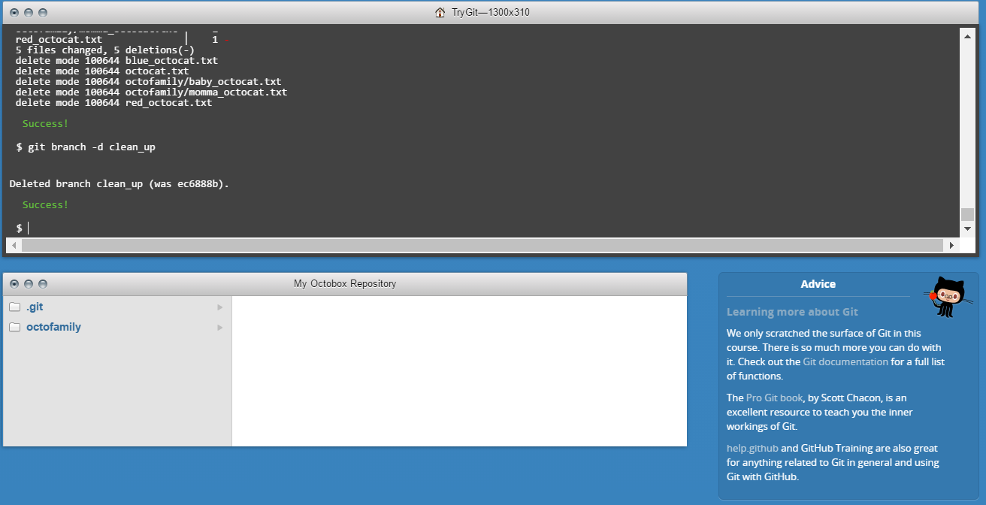

Step 27:

The final push

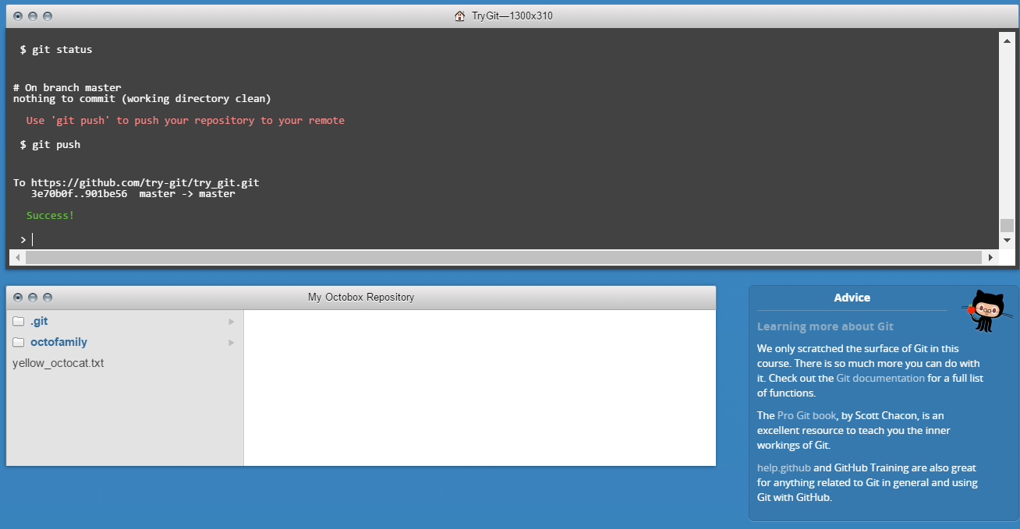

Define the following terms in the context of Git (2 lines maximum):

Answer:

1. Repository: A repository is a central place in which information is aggregated and is maintained in a organized way.
2. Commit: Commits the tracked changes and prepares the data to be pushed to a remote repository. Makes sure the changes made to the repo are saved.
3. Push: Pushes the changes into your local repositories up to the remote repository you specified as the origin.
4. Branch: It is a lightweight movable pointer to all the commits performed while developing a project. The main branch is called as the Master Branch and a clone can also be created where all the bug fixes and features can be tested.
5. Fork: It is a copy of repository. If you want to make changes in repositories without effecting the master repo, you can create a copy using fork to do the same.
6. Merge: If you think that the bug fixes or features applied on a branch are up and running without any warnings or errors, you can merge it with the master. i.e. Applying changes to master branch.
7. Clone: Cloning a repo can be called as, “Creating a copy of a repo provided by developer”. By doing this, anyone can make changes on the clone and check for desired output.
8. Pull: Incorporates changes from a remote repo into the current branch. In its default mode, git pull is short hand for *git fetch*.
9. Pull request: Pull request let others know about the changes you made to a GitHub repo. A revision history can be checked via a Pull request.

**Part 7:**

1. I created a **fork** of the file in **mypseudo/courses** to make certain changes in the file without modifying the master file.
2. I changed the file in my fork to update changes.
3. Later, I **pulled** **request** to update it in the master file.
4. Changes can be only seen when the owner of the master file **merges** it.
5. When the pull request was merged, the changes are visible in the master file.