GHOSTPASS
Tokenization System for Secure ID Verification

Chetan Kar - 22CSB0F05
Rashwin Musuku - 22CSB0F07
Shubham Pahilwani - 22CSB0F08

- Introduction
i. Problems Addressed
In today’s digital landscape, verifying identity documents like Aadhaar, passports, or driver’s licenses is crucial for online services such as banking, e-commerce, and government portals. However, traditional identity verification methods expose users' personal data to third parties, raising concerns about privacy, security, and misuse of sensitive information.
ii. Importance of the Problem
- Privacy Risks: Users often share entire documents (e.g., Aadhaar scans) with third parties, increasing the risk of data leaks and identity theft.
- Security Threats: Centralized databases storing user data are attractive targets for cyberattacks.
- Lack of User Control: Users have little to no control over how their shared documents are stored, accessed, or used by third parties.
iii. Existing Solutions
- Decentralized Identity (DID) Solutions: Blockchain-based systems allow self-sovereign identity management but face challenges in adoption due to complexity and infrastructure requirements.
- Tokenization in Payments: Financial systems use tokenization to replace card details with secure tokens, but similar methods are not widely applied to identity verification.
iv. Key Contributions of GhostPass
GhostPass introduces a cryptographic token-based verification system designed to enhance security, privacy, and user control in document verification. Key contributions include:
- Minimizing Data Exposure – Users share only encrypted verification tokens instead of full documents, reducing the risk of data leaks.
- Enhancing Security – Uses digital signatures and encryption to ensure document authenticity and prevent tampering.
- Providing User Control – Enables users to approve or deny verification requests, ensuring transparency and consent in document sharing.

- Objectives
- Secure and Privacy-Preserving Verification – Develop a token-based cryptographic system that enables document verification without revealing actual user data, minimizing exposure to breaches and unauthorized access.
- User-Centric Access Control – Empower users with full control over their document verification process, ensuring that hird parties third parties can only access the necessary validation without direct access to personal documents.

- Implementation and Results analysis

Diagrams
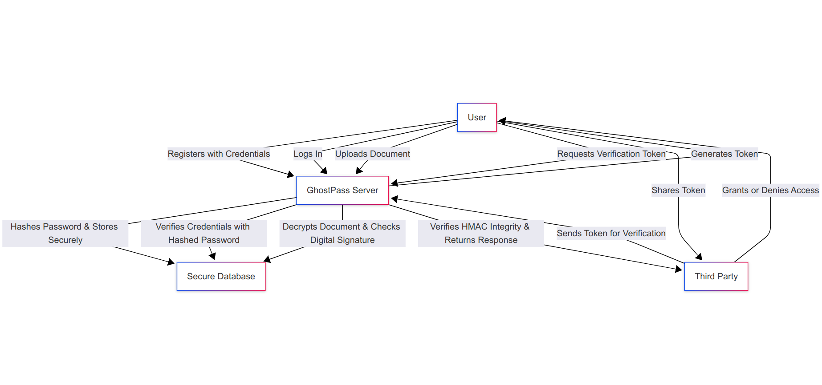
Conceptual Diagram

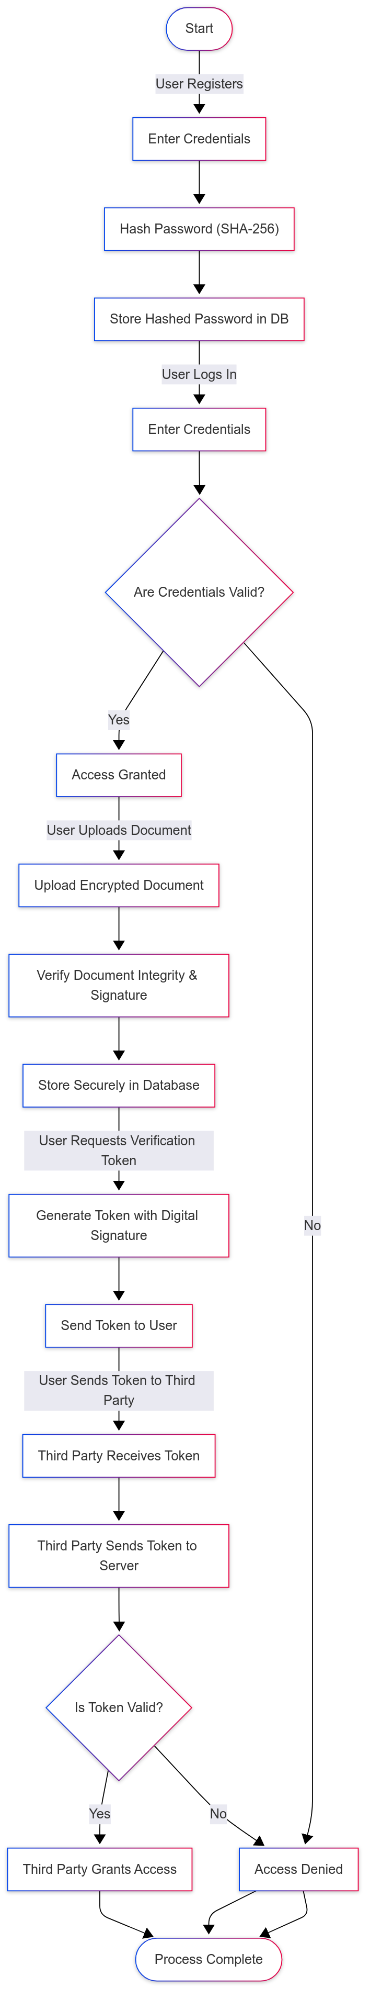

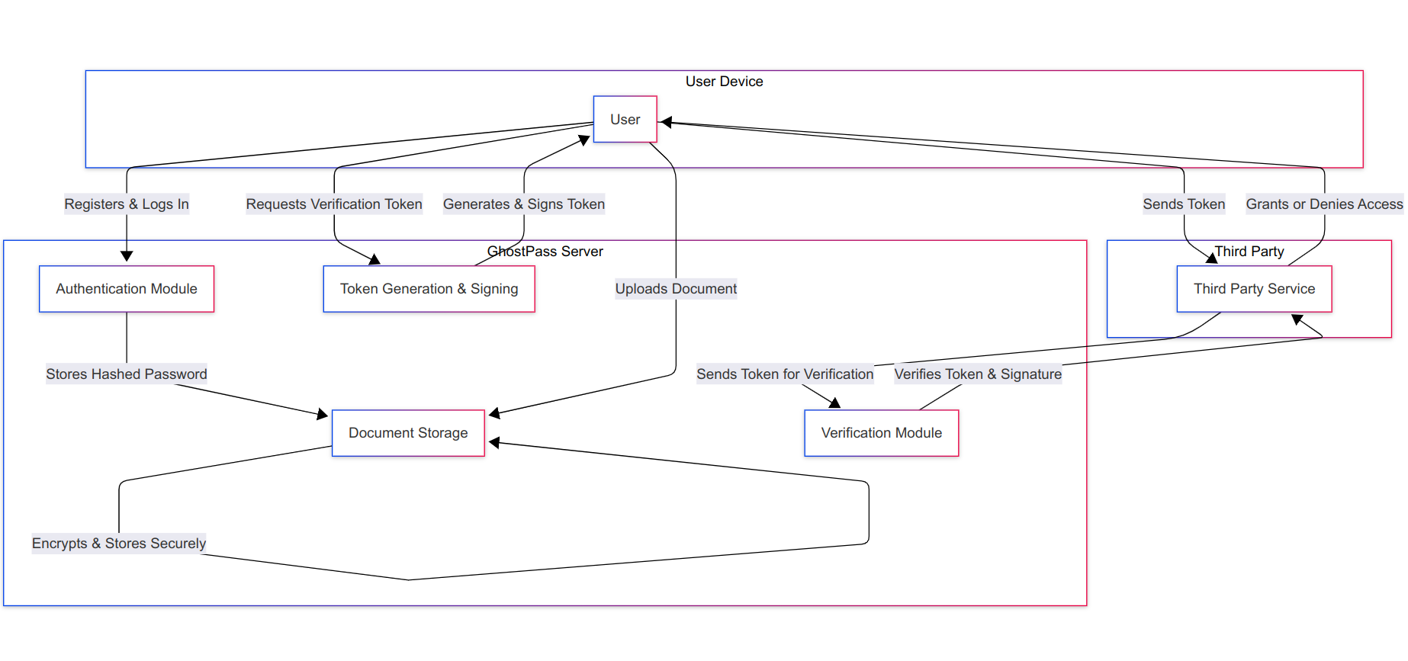

Block Diagram

Flow Chart

Algorithms

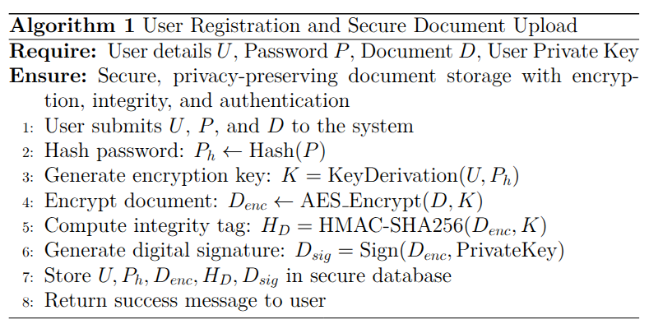
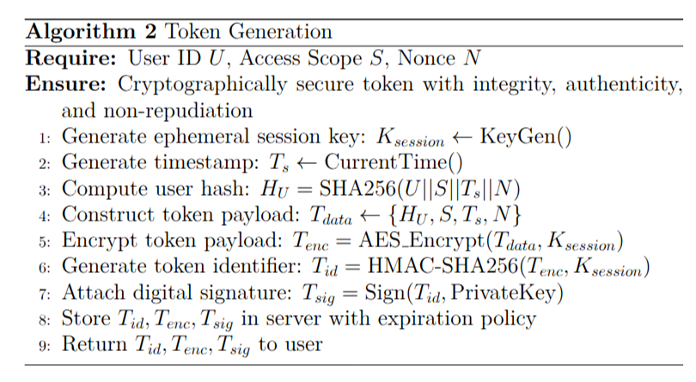

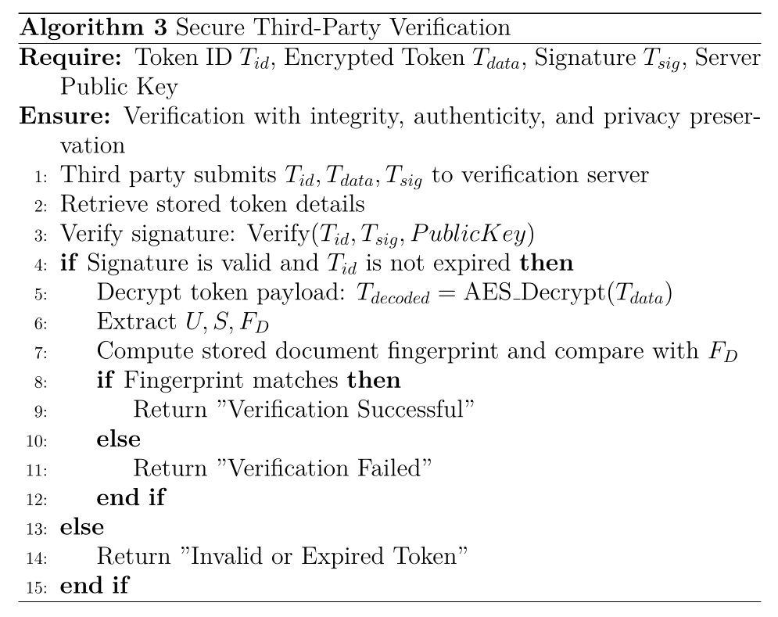
Output

Registration
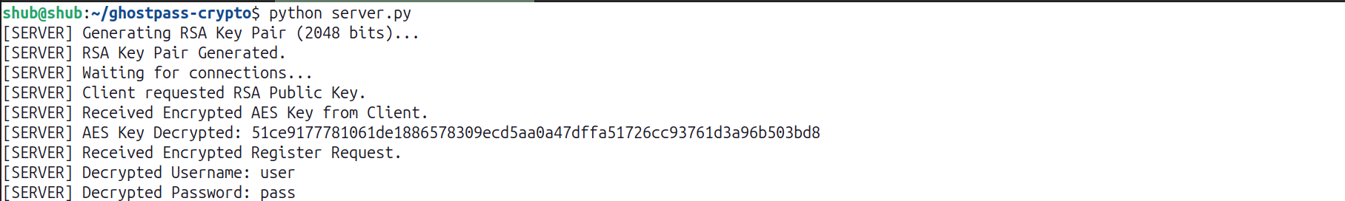

Uploading Documents
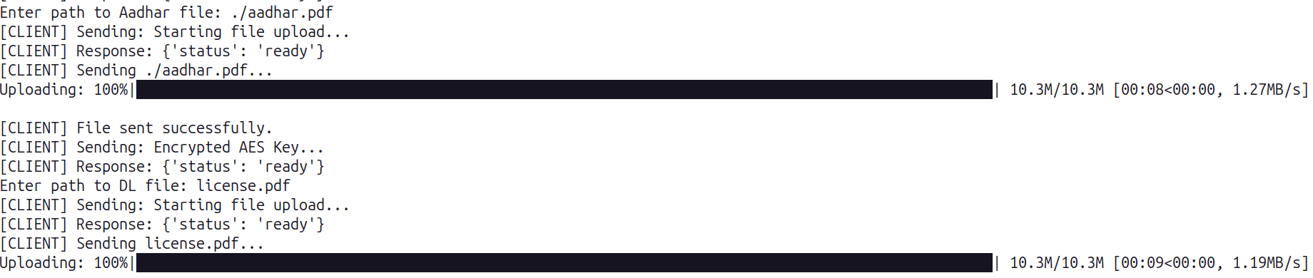

Token Generation & Verification
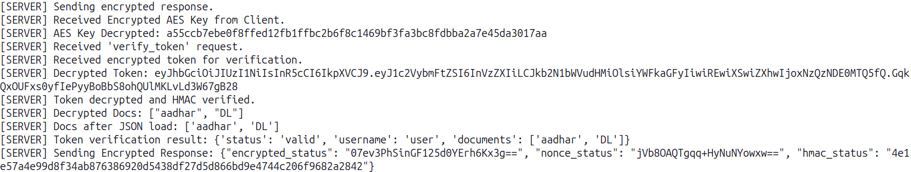

Token Request & Response
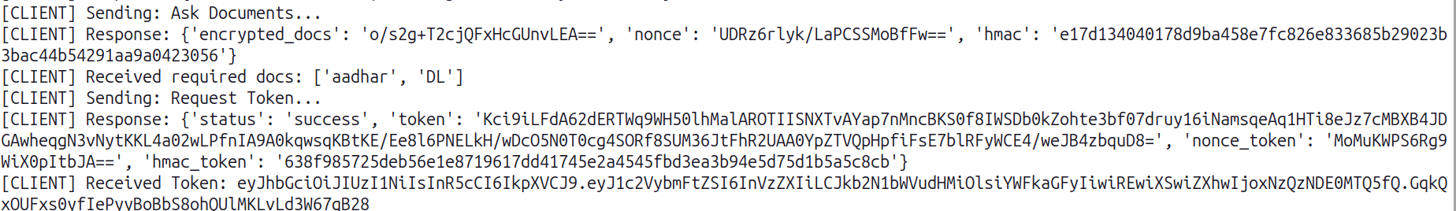

Third Party Token Submission & Verification Response

- Conclusion
GhostPass introduces a cryptographic token-based verification system designed to enhance security, privacy, and user control in digital identity verification. Traditional methods require users to share entire documents, increasing the risk of data leaks and identity theft. GhostPass mitigates this by replacing direct document sharing with encrypted tokens, ensuring that sensitive information is not exposed to third parties.
The system employs digital signatures to guarantee the authenticity of verification tokens, preventing unauthorized modifications or tampering. This ensures that the verification process remains secure and reliable. Additionally, GhostPass provides users with full control over their data by allowing them to approve or deny verification requests, maintaining transparency and consent in document sharing.
Unlike blockchain-based identity solutions, which can be complex and difficult to implement, GhostPass strikes a balance between security and usability without requiring specialized infrastructure. By offering a privacy-focused, efficient, and user-centric approach, GhostPass strengthens trust in digital identity verification, making online interactions safer and more reliable.

- Learning Outcomes
- Understanding Cryptographic Tokenization – Gained insights into how tokenization can be applied to secure identity verification while minimizing data exposure.
- Implementation of Digital Signatures – Learned how to use cryptographic techniques like digital signatures to ensure the authenticity and integrity of verification tokens.
- Enhanced Knowledge of Secure Authentication – Explored secure authentication mechanisms that balance user privacy with system security.
- Privacy-Preserving Verification – Understood how to design a system that verifies user identity without revealing personal information.
- User-Centric Security Design – Learned how to build a system that gives users control over their data and verification requests.
- Comparison of Identity Verification Solutions – Analyzed existing solutions like DigiLocker and decentralized identity systems to identify their strengths and limitations.
- Efficient System Design – Developed an optimized verification flow that ensures both security and ease of use without relying on complex blockchain infrastructure.

- Source code:
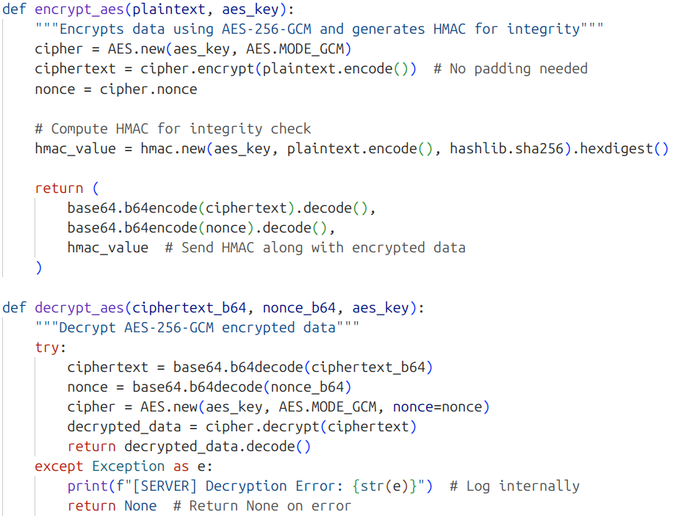

AES Encryption & Decryption

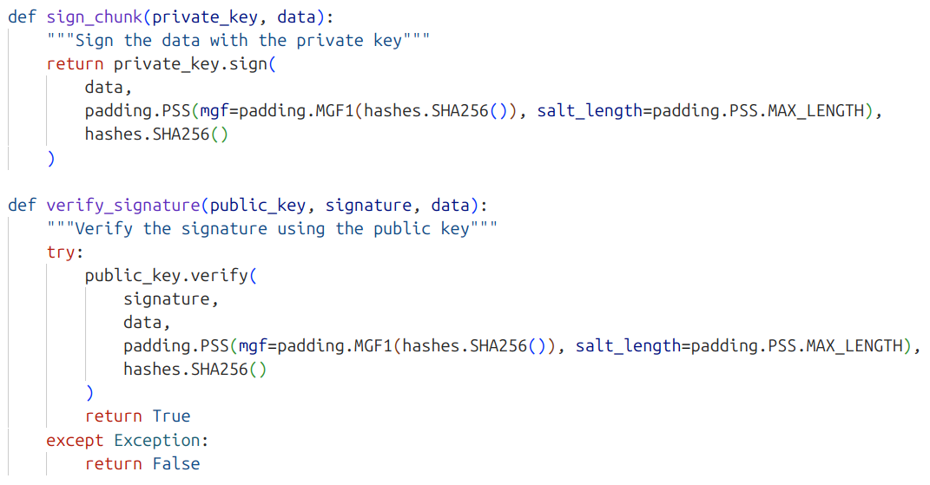

Digital Signature Generation & Verification

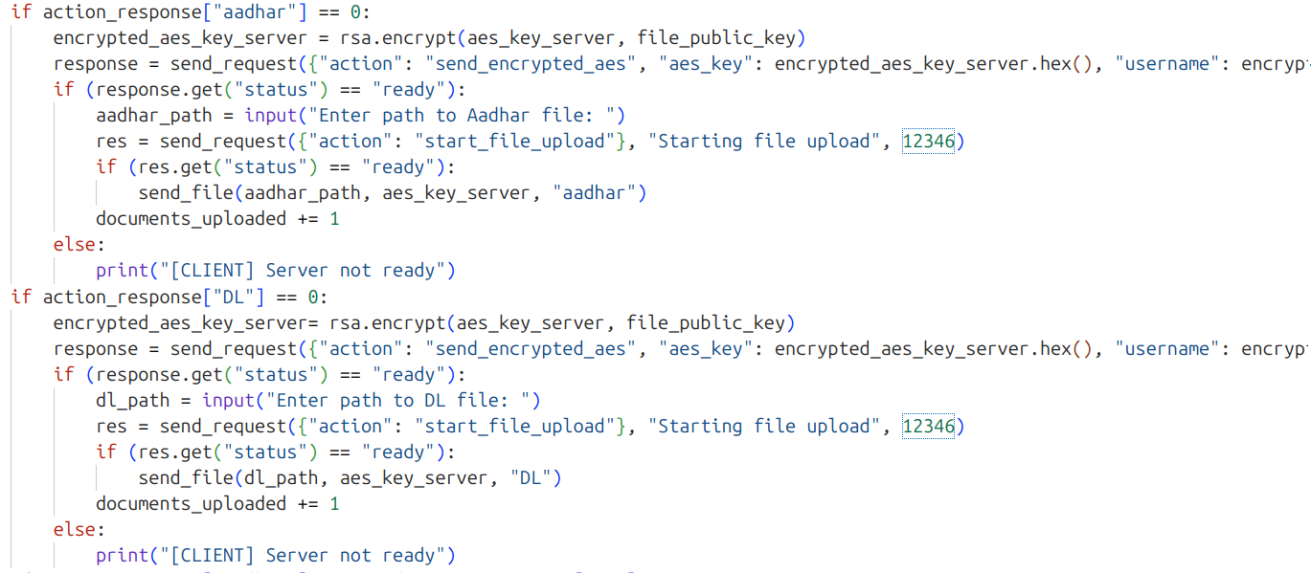

Document Uploading

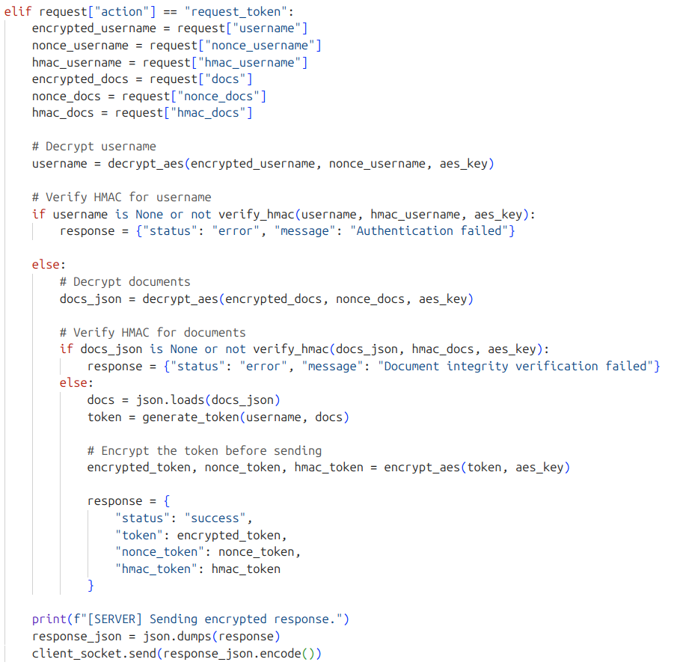

Token Generation

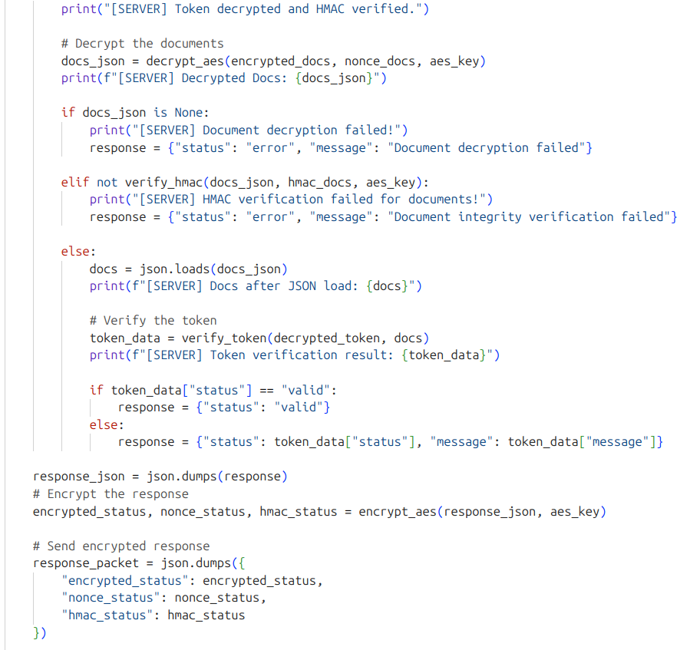

Token Verification

- References
- Diffie-Hellman Key Exchange Implementation – Secure cryptographic key exchange protocol. Used for secure key exchange in our system. Available at:
https://www.geeksforgeeks.org/implementation-diffie-hellman-algorithm
- RSA Encryption Implementation – Public-key cryptosystem for secure data transmission. Used for encrypting verification tokens. Available at:
https://github.com/ibiscp/RSA-Algorithm
- AES and DES Encryption Techniques – Used for encrypting sensitive data in our system. Available at:
https://www.airtribe.live/resource-sheets/computer-networks/resource/types-of-encryption-rsa-des-aes-diffie-hellman
- Tokenization in Payments – Concept of tokenization applied in our verification system. Available at:
https://stripe.com/resources/more/payment-tokenization-101
- JSON Web Token (JWT) Documentation – Used for generating and managing verification tokens. Available at:
https://jwt.io/introduction
- DigiLocker – India’s digital document verification platform. Available at:
https://www.digilocker.gov.in
- UAE Pass – United Arab Emirates' digital identity and signature system. Available at:
https://uaepass.ae
- Aadhaar Authentication – Biometric and demographic verification system in India. Available at:
https://uidai.gov.in

