* The <!DOCTYPE html> declaration defines this document to be HTML5.The <!DOCTYPE> declaration represents the document type, and helps browsers to display web pages correctly.
* The <html> element is the root element of an HTML page
* The <head> element contains meta information about the document
* The <title> element specifies a title for the document
* The <body> element contains the visible page content
* The <h1> element defines a large heading
* The <p> element defines a paragraph
* <!DOCTYPE html>  
  <html>  
  <head>  
  <title>Page Title</title> //it is like a website name  
  </head>  
  <body> //body tag  
    
  <h1>This is a Heading</h1> //header tag  
  <p>This is a paragraph.</p> //paragraph tag  
    
  </body>  
  </html>
* **OUTPUT:**

# This is a Heading

This is a paragraph.

**HTML heading:**

HTML headings are defined with the <h1> to <h6> tags.<h1> defines the most important heading. <h6> defines the least important heading.

* **Example:**

<!DOCTYPE html>  
 <html>  
 <body> //body tag  
 <h1>This is a heading 1</h1>

<h2>This is a heading 2</h2>

<h3>This is a heading 3</h3>

<h4>This is a heading 4</h4>

<h5>This is a heading 5</h5>

<h6>This is a heading 6</h6>

</body>  
</html>

* **OUTPUT:**

# This is heading 1

## This is heading 2

### This is heading 3

#### This is heading 4

##### This is heading 5

###### This is heading 6

The <hr> tag defines a thematic break in an HTML page, and is most often displayed as a horizontal rule.

The <hr> element is used to separate content (or define a change) in an HTML page

* **Example:**

<html>  
 <body>

<h1>This is heading 1</h1>  
<p>This is some text.</p>  
<hr>  
<h2>This is heading 2</h2>  
<p>This is some other text.</p>  
<hr>

</body>

</html>

* **OUTPUT:**

# This is heading 1

This is some text.

## This is heading 2

This is some other text.

**HTML paragraph:**

HTML paragraphs are defined with the <p> tag

* **Example:**

<!DOCTYPE html>

<html>

<body>

<p>This is a paragraph.</p>

<p>This is a paragraph.</p>

<p>This is a paragraph.</p>

</body>

</html>

* **OUTPUT:**

This is a paragraph.

This is a paragraph.

This is a paragraph.

The HTML <br> element defines a **line break**.Use <br> if you want a line break (a new line) without starting a new paragraph

* **Example:**

<!DOCTYPE html>

<html>

<body>

<p>This is<br>a paragraph<br>with line breaks</p>

</body>

</html>

* **OUTPUT:**

This is  
a paragraph  
with line breaks

The HTML <pre> element defines preformatted text.

The text inside a <pre> element is displayed in a fixed-width font (usually Courier), and it preserves both spaces and line breaks

* **Example:**

<!DOCTYPE html>

<html>

<body>

<p>The pre tag preserves both spaces and line breaks:

<pre>  
  My Bonnie lies over the ocean.  
  
  My Bonnie lies over the sea.  
  
  My Bonnie lies over the ocean.  
  
  Oh, bring back my Bonnie to me.  
 </pre>

</p>

</body>

</html>

* **OUTPUT:**

The pre tag preserves both spaces and line breaks:

My Bonnie lies over the ocean.

My Bonnie lies over the sea.

My Bonnie lies over the ocean.

Oh, bring back my Bonnie to me.

**HTML Links:**

HTML links are defined with the <a> tag.The link's destination is specified in the href attribute.

* **Example:**

<!DOCTYPE html>

<html>

<body>

<a href="https://www.w3schools.com">This is a link</a>

</body>

</html>

* **OUTPUT:**

[This is a link](https://www.w3schools.com/)

**Target attribute:**

The **target** attribute specifies where to open the linked document.

The target attribute can have one of the following values:

* _blank - Opens the linked document in a new window or tab
* _self - Opens the linked document in the same window/tab as it was clicked (this is default)
* _parent - Opens the linked document in the parent frame
* _top - Opens the linked document in the full body of the window
* framename - Opens the linked document in a named frame
* **Example:**

<!DOCTYPE html>

<html>

<body>

<a href="https://www.w3schools.com" target=”_blank”>This is a link </a>

</body>

</html>

**Image as a link:**

* **Example:**

<!DOCTYPE html>

<html>

<body>

<h2>Image Links</h2>

<p>The image is a link. You can click on it.</p>

<a href="default.asp">

<img src="smiley.gif" alt="HTML tutorial" style="width:42px;height:42px;border:0">

</a>

<p>We have added "border:0" to prevent IE9 (and earlier) from displaying a border around the image.</p>

</body>

</html>

* **OUTPUT:**

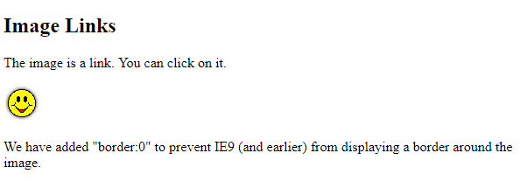

**Link titles:**

The title attribute specifies extra information about an element. The information is most often shown as a tooltip text when the mouse moves over the element.

* **Example:**

<!DOCTYPE html>

<html lang="en-US">

<body>

<h2>Link Titles</h2>

<a href="https://www.w3schools.com/html/" title="Go to W3Schools HTML section">Visit our HTML Tutorial</a>

</body>

</html>

* **OUTPUT:**

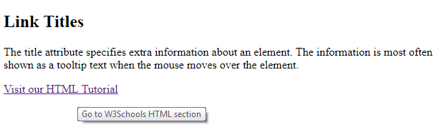

**Creating a bookmark:**

To make a bookmark, you must first create the bookmark, and then add a link to it.When the link is clicked, the page will scroll to the location with the bookmark.

* **Example:**

<!DOCTYPE html>

<html>

<body>

<p><a href="#C4">Jump to Chapter 4</a></p>

<h2>Chapter 1</h2>

<p>This chapter explains ba bla bla</p>

<h2>Chapter 2</h2>

<p>This chapter explains ba bla bla</p>

<h2>Chapter 3</h2>

<p>This chapter explains ba bla bla</p>

<h2 id="C4">Chapter 4</h2>

<p>This chapter explains ba bla bla</p>

</body>

</html>

* **OUTPUT:**

[Jump to Chapter 4](https://www.w3schools.com/html/tryit.asp?filename=tryhtml_links_bookmark" \l "C4)

## Chapter 1

This chapter explains ba bla bla

## Chapter 2

This chapter explains ba bla bla

## Chapter 3

This chapter explains ba bla bla

## Chapter 4

This chapter explains ba bla bla

**HTML Images:**

HTML images are defined with the <img> tag.The source file (src), alternative text (alt), width, and height are provided as attributes

* Use the **HTML** <img> element to define an **image**.
* Use the **HTML** src attribute to define the URL of the **image**.
* Use the **HTML** alt attribute to define an alternate text for an **image**, if it cannot be displayed.
* Use the **HTML** width and height attributes to define the size of the **image**.
* **Example:**

<!DOCTYPE html>

<html>

<body>

<img src="w3schools.jpg" alt="W3Schools.com" width="104" height=142">

</body>

</html>

* **OUTPUT:**



**HTML Buttons:**

HTML buttons are defined with the <button> tag

* **Example:**

<!DOCTYPE html>

<html>

<body>

<button>Click me</button>

</body>

</html>

* **OUTPUT:**



**HTML Links:**

* HTML lists are defined with the <ul> (unordered/bullet list) or the <ol> (ordered/numbered list) tag, followed by <li> tags (list items)
* **Example:**

<!DOCTYPE html>

<html>

<body>

<h2>An Unordered HTML List</h2>

<ul>  
   <li>Coffee</li>  
   <li>Tea</li>  
   <li>Milk</li>  
 </ul>

<h2>An Ordered HTML List</h2>

< ol>  
   <li>Coffee</li>  
   <li>Tea</li>  
   <li>Milk</li>  
 </ol>

</body>

</html>

* **OUTPUT:**

1. Coffee //ordered list
2. Tea
3. Milk

* Coffee //unordered list
* Tea
* Milk

**HTML Attributes:**

|  |  |
| --- | --- |
| **Attribute** | **Description** |
| alt | Specifies an alternative text for an image, when the image cannot be displayed |
| disabled | Specifies that an input element should be disabled |
| href | Specifies the URL (web address) for a link |
| id | Specifies a unique id for an element |
| src | Specifies the URL (web address) for an image |
| style | Specifies an inline CSS style for an element |
| title | Specifies extra information about an element (displayed as a tool tip) |

**HTML styles:**

**Syntax:**

<tagname style="property:value;">

**Background colour:**

* **Example:**

<!DOCTYPE html>

<html>

<body style="background-color:powderblue;">  
  
<h1>This is a heading</h1>  
<p>This is a paragraph.</p>  
  
</body>

</html>

* **OUTPUT:**

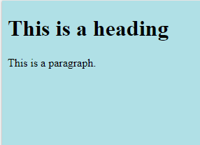

**Text colour:**

* **Example:**

<!DOCTYPE html>

<html>

<body>

<p>I am normal</p>

<p style="color:red;">I am red</p>

<p style="color:blue;">I am blue</p>

<p style="font-size:50px;">I am big</p>

</body>

</html>

* **OUTPUT:**

I am normal

I am red

I am blue

I am big

**Font:**

* **Example:**

<!DOCTYPE html>

<html>

<body>

<h1 style="font-family:verdana;">This is a heading</h1>

<p style="font-family:courier;">This is a paragraph.</p>

</body>

</html>

* **OUTPUT:**

# This is a heading

This is a paragraph.

**Text size:**

* **Example:**

<!DOCTYPE html>

<html>

<body>

<h1 style="font-size:300%;">This is a heading</h1>

<p style="font-size:160%;">This is a paragraph.</p>

</body>

</html>

* **OUTPUT:**

# This is a heading

This is a paragraph.

**Text Alignment:**

* **Example:**

<!DOCTYPE html>

<html>

<body>

<h1 style="text-align:center;">Centered Heading</h1>

<p style="text-align:center;">Centered paragraph.</p>

</body>

</html>

* **OUTPUT:**

# Centered Heading

Centered paragraph.

**Border colour:**

* **Example:**

<!DOCTYPE html>

<html>

<body>

<h1 style="border: 2px solid Tomato;">Hello World</h1>

<h1 style="border: 2px solid DodgerBlue;">Hello World</h1>

<h1 style="border: 2px solid Violet;">Hello World</h1>

</body>

</html>

* **OUTPUT:**

# Hello World

# Hello World

# Hello World

**Summary of styles:**

* Use the style attribute for styling HTML elements
* Use background-color for background color
* Use color for text colors
* Use font-family for text fonts
* Use font-size for text sizes
* Use text-align for text alignment

**HTML Formatting:**

* <b> - Bold text
* <strong> - Important text
* <i> - Italic text
* <em> - Emphasized text
* <mark> - Marked text
* <small> - Small text
* <del> - Deleted text
* <ins> - Inserted text
* <sub> - Subscript text
* <sup> - Superscript text
* **Example:**

<!DOCTYPE html>

<html>

<body>

<p>This text is normal.</p>

<p><b>This text is bold.</b></p>

<p><strong>This text is strong.</strong></p>

<p><i>This text is italic.</i></p>

<p><em>This text is emphasized.</em></p>

</body>

</html>

* **OUTPUT:**

This text is normal.

**This text is bold.**

**This text is strong.**

*This text is italic.*

This text is emphasized.

 Browsers display <strong> as <b>, and <em> as <i>. However, there is a difference in the meaning of these tags: <b> and <i> defines bold and italic text, but <strong> and <em> means that the text is "important".

**HTML small and mark element:**

The HTML <small> element defines smaller text

The HTML <mark> element defines marked or highlighted text

* **Example:**

<!DOCTYPE html>

<html>

<body>

<h2>HTML <small>Small</small> Formatting</h2>

<h2>HTML <mark>Marked</mark> Formatting</h2>

</body>

</html>

* **OUTPUT:**

## HTML Small Formatting

## HTML Marked Formatting

**HTML del, ins, sub and sup element:**

The HTML <del> element defines ~~deleted~~ (removed) text.

The HTML <ins> element defines inserted (added) text

The HTML <sub> element defines subscripted text.

The HTML <sup> element defines superscripted text.

* **Example:**

<!DOCTYPE html>

<html>

<body>

<p>The del element represents deleted (removed) text.</p>

<p>My favorite color is <del>blue</del> red.</p>

<p>My favorite <ins>color</ins> is red.</p>

<p>This is <sub>subscripted</sub> text.</p>

<p>This is <sup>superscripted</sup> text.</p>

</body>

</html>

* **OUTPUT:**

The del element represents deleted (removed) text.

My favorite color is ~~blue~~red.

My favorite color is red.

This is subscripted text.

This is superscripted text.

**HTML Quotations:**

**Short quote and block quote:**

The HTML <q> element defines a short quotation.

The HTML <blockquote> element defines a section that is quoted from another source.

Browsers usually indent <blockquote> elements.

* **Example:**

<!DOCTYPE html>

<html>

<body>

<p>Browsers usually insert quotation marks around the q element.</p>

<p>WWF's goal is to: <q>Build a future where people live in harmony with nature.</q></p>

<blockquote cite="http://www.worldwildlife.org/who/index.html">

For 50 years, WWF has been protecting the future of nature.

The world's leading conservation organization,

WWF works in 100 countries and is supported by

1.2 million members in the United States and

close to 5 million globally.

</blockquote>

</body>

</html>

* **OUTPUT:**

Browsers usually insert quotation marks around the q element.

WWF's goal is to: ”Build a future where people live in harmony withnature”.

For 50 years, WWF has been protecting the future of nature. The world's leading conservation organization, WWF works in 100 countries and is supported by 1.2 million members in the United States and close to 5 million globally.

**HTML <abbr>:**

The HTML <abbr> element defines an abbreviation or an acronym.

* **Example:**

<!DOCTYPE html>

<html>

<body>

<p>The <abbr title="World Health Organization">WHO</abbr> was founded in 1948.</p>

<p>Marking up abbreviations can give useful information to browsers, translation systems and search-engines.</p>

</body>

</html>

* **OUTPUT:**

The WHO was founded in 1948.

Marking up abbreviations can give useful information to browsers, translation systems andsearch-engines.

**HTML <addr>:**

The HTML <address> element defines contact information (author/owner) of a document or an article.

The <address> element is usually displayed in italic. Most browsers will add a line break before and after the element

* **Example:**

<!DOCTYPE html>

<html>

<body>

<p>The HTML address element defines contact information (author/owner) of a document or article.</p>

<address>

Written by John Doe.<br>

Visit us at:<br>

Example.com<br>

Box 564, Disneyland<br>

USA

</address>

</body>

</html>

* **OUTPUT:**

The HTML address element defines contact information (author/owner) of a document or article.

Written by John Doe.  
Visit us at:  
Example.com  
Box 564, Disneyland  
USA

**HTML <cite>:**

The HTML <cite> element defines the title of a work.

Browsers usually display <cite> elements in italic.

* **Example:**

<!DOCTYPE html>

<html>

<body>

<p>The HTML cite element defines the title of a work.</p>

<p>Browsers usually display cite elements in italic.</p>

<img src="img_the_scream.jpg" width="220" height="277" alt="The Scream">

<p><cite>The Scream</cite> by Edvard Munch. Painted in 1893.</p>

</body>

</html>

* **OUTPUT:**

The HTML cite element defines the title of a work.

Browsers usually display cite elements in italic.

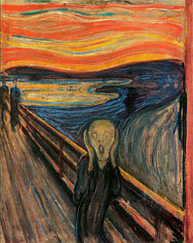

The Scream by Edvard Munch. Painted in 1893.

**HTML <bdo>:**

The HTML <bdo> element defines bi-directional override.

The <bdo> element is used to override the current text direction

* **Example:**

<!DOCTYPE html>

<html>

<body>

<p>If your browser supports bi-directional override (bdo), the next line will be written from right to left (rtl):</p>

<bdo dir="rtl">This line will be written from right to left</bdo>

</body>

</html>

* **OUTPUT:**

If your browser supports bi-directional override (bdo), the next line will be written from right to left (rtl):

Tfle ot thgir morf nettirw eb lliw enil siht

**HTML Comment:**

<!-- Write your comments here -->

**HTML Tables:**

**Columns:**

To make a cell span more than one column, use the colspan attribute

* **Example:**

<!DOCTYPE html>

<html>

<body>

<table style="width:100%">

<tr>

<th>Name</th>

<th colspan="2">Telephone</th>

</tr>

<tr>

<td>Bill Gates</td>

<td>55577854</td>

<td>55577855</td>

</tr>

</table>

</body>

</html>

* **OUTPUT:**

|  |  |  |
| --- | --- | --- |
| **Name** | **Telephone** | |
| Bill Gates | 55577854 | 55577855 |

**Rows:**

To make a cell span more than one row, use the rowspan attribute

* **Example:**

<!DOCTYPE html>

<html>

<body>

<table style="width:100%">

<tr>

<th>Name:</th>

<td>Bill Gates</td>

</tr>

<tr>

<th rowspan="2">Telephone:</th>

<td>55577854</td>

</tr>

<tr>

<td>55577855</td>

</tr>

</table>

</body>

</html>

* **OUTPUT:**

Name: Bill Gates

Telephone: 55577854

55577855

**Form elements:**

The HTML <form> element defines a form that is used to collect user input

**Input element:**

|  |  |
| --- | --- |
| **Type** | **Description** |
| <input type="text"> | Defines a one-line text input field |
| <input type="radio"> | Defines a radio button (for selecting one of many choices) |
| <input type="submit"> | Defines a submit button (for submitting the form) |

**Text input:**

* **Example:**

<!DOCTYPE html>

<html>

<body>

<h2>Text Input</h2>

<form>

First name:<br>

<input type="text" name="firstname">

<br>

Last name:<br>

<input type="text" name="lastname">

</form>

<p>Note that the form itself is not visible.</p>

<p>Also note that the default width of a text input field is 20 characters.</p>

</body>

</html>

* **OUTPUT:**

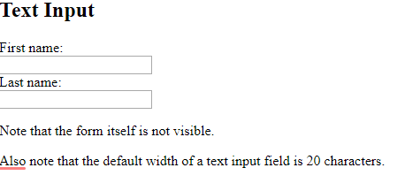

**Radio button and checkbox input:**

<input type="radio"> defines a **radio button**.

Radio buttons let a user select ONE of a limited number of choices

<input type="checkbox"> defines a checkbox **button**.

Check box buttons let a user select more than one choice

* **Example:**

<!DOCTYPE html>

<html>

<body>

<h2>Radio Buttons</h2>

<form>

<input type="radio" name="gender" value="male" > Male<br>

<input type="radio" name="gender" value="female"> Female<br>

<input type="radio" name="gender" value="other"> Other

</form>

</body>

</html>

* **OUTPUT:**

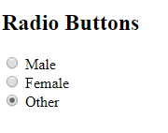

**Submit and reset button:**

<input type="submit"> defines a button for **submitting** the form data to a **form-handler**.

The form-handler is typically a server page with a script for processing input data.

The form-handler is specified in the form's **action** attribute

<input type="reset"> defines a **reset button** that will reset all form values to their default values

* **Example:**

<!DOCTYPE html>

<html>

<body>

<h2>Reset Button</h2>

<p>The <strong>input type="reset"</strong> defines a reset button that will reset all form values to their default values:</p>

<form action="/action_page.php">

First name:<br>

<input type="text" name="firstname" value="Mickey">

<br>

Last name:<br>

<input type="text" name="lastname" value="Mouse">

<br><br>

<input type="submit" value="Submit">

<input type="reset">

</form>

<p>If you change the input values and then click the "Reset" button, the form-data willbe reset to the default values.</p>

</body>

</html>

* **OUTPUT:**

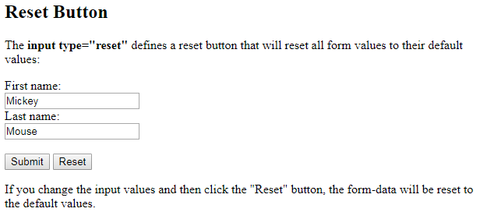

**Method attribute:**

The method attribute specifies the HTTP method (**GET**or **POST**) to be used when submitting the form data

**GET:**

The default method when submitting form data is GET.However, when GET is used, the submitted form data will be **visible in the page address field**:

/action_page.php?firstname=Mickey&lastname=Mouse

**Notes on GET:**

* Appends form-data into the URL in name/value pairs
* The length of a URL is limited (about 3000 characters)
* Never use GET to send sensitive data! (will be visible in the URL)
* Useful for form submissions where a user wants to bookmark the result
* GET is better for non-secure data, like query strings in Google

Always use POST if the form data contains sensitive or personal information. The POST method does not display the submitted form data in the page address field.

**POST:**

**Notes on POST:**

* POST has no size limitations, and can be used to send large amounts of data.
* Form submissions with POST cannot be bookmarked
* **Example:**

<!DOCTYPE html>

<html>

<body>

<h2>The method Attribute</h2>

<p>This form will be submitted using the GET method:</p>

<form action="/action_page.php" target="_blank" method="post">

First name:<br>

<input type="text" name="firstname" value="Mickey">

<br>

Last name:<br>

<input type="text" name="lastname" value="Mouse">

<br><br>

<input type="submit" value="Submit">

</form>

<p>After you submit, notice that the form values is visible in the address bar of the new browser tab.</p>

</body>

</html>

* **OUTPUT:**

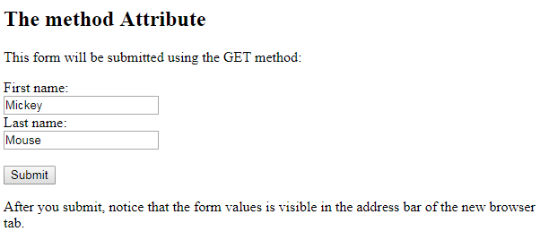

**Select element:**

The <select> element defines a **drop-down list**

* **Example:**

**<!DOCTYPE html>**

**<html>**

**<body>**

**<h2>The select Element</h2>**

**<p>The select element defines a drop-down list:</p>**

**<form action="/action_page.php">**

****<select name="cars">****

****<option value="volvo">Volvo</option>****

****<option value="saab">Saab</option>****

****<option value="fiat">Fiat</option>****

****<option value="audi">Audi</option>****

****</select>****

**<br><br>**

**<input type="submit">**

**</form>**

**</body>**

**</html>**

* ****OUTPUT:****

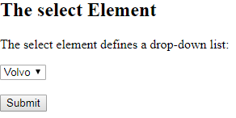

**Visible values:**

Use the size attribute to specify the number of visible values

* **Example:**

<form action="/action_page.php">

<select name="cars" size="3">

<option value="volvo">Volvo</option>

<option value="saab">Saab</option>

<option value="fiat">Fiat</option>

<option value="audi">Audi</option>

</select>

<br><br>

<input type="submit">

</form>

* **OUTPUT:**

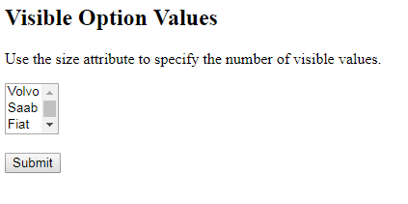

**Multiple selections:**

Use the multiple attribute to allow the user to select more than one value

* **Example:**

<form action="/action_page.php">

<select name="cars" size="4" multiple>

<option value="volvo">Volvo</option>

<option value="saab">Saab</option>

<option value="fiat">Fiat</option>

<option value="audi">Audi</option>

</select>

<br><br>

<input type="submit">

</form>

* **OUTPUT:**

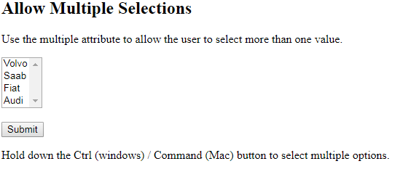

**Text area element:**

The <textarea> element defines a multi-line input field (**a text area**)

The rows attribute specifies the visible number of lines in a text area.

The cols attribute specifies the visible width of a text area.

* **Example:**

<form action="/action_page.php">

<textarea name="message" rows="10" cols="30">The cat was playing in the garden.</textarea>

<br>

<input type="submit">

</form>

* **OUTPUT:**

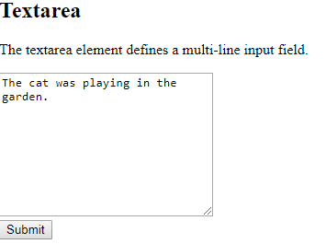

**Input type:**

**password:**

<input type="password"> defines a **password field**

The characters in a password field are masked (shown as asterisks or circles).

* **Example:**

<form action="">

User name:<br>

<input type="text" name="userid">

<br>

User password:<br>

<input type="password" name="psw">

</form>

* **OUTPUT:**

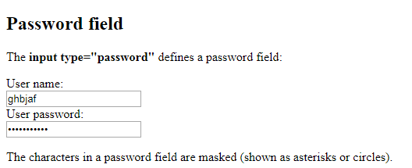

**Date:**

The <input type="date"> is used for input fields that should contain a date.

Depending on browser support, a date picker can show up in the input field.

* **Example:**

<form action="/action_page.php">

Enter a date before 1980-01-01:<br>

<input type="date" name="bday" max="1979-12-31"><br><br>

Enter a date after 2000-01-01:<br>

<input type="date" name="bday" min="2000-01-02"><br><br>

<input type="submit">

</form>

* **OUTPUT:**

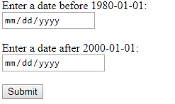

**Email:**

The <input type="email"> is used for input fields that should contain an e-mail address.

Depending on browser support, the e-mail address can be automatically validated when submitted.

Some smartphones recognize the email type, and adds ".com" to the keyboard to match email input.

* **Example:**

<form action="/action_page.php">

E-mail:

<input type="email" name="email">

<input type="submit">

</form>

* **OUTPUT:**

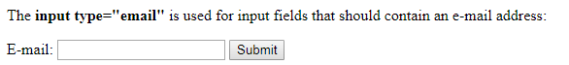

**File:**

The <input type="file"> defines a file-select field and a "Browse" button for file uploads.

* **Example:**

<form action="/action_page.php">

Select a file: <input type="file" name="myFile"><br><br>

<input type="submit">

</form>

* **OUTPUT:**

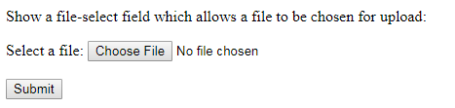

**Month:**

The <input type="month"> allows the user to select a month and year.

Depending on browser support, a date picker can show up in the input field.

* **Example:**

<form action="/action_page.php">

Select a file: <input type="file" name="myFile"><br><br>

<input type="submit">

</form>

* **OUTPUT:**

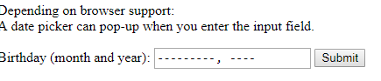

**Number:**

The <input type="number"> defines a **numeric** input field.

You can also set restrictions on what numbers are accepted.

The following example displays a numeric input field, where you can enter a value from 1 to 5

* **Example:**

<form action="/action_page.php">

Quantity (between 1 and 5):

<input type="number" name="quantity" min="1" max="5">

<input type="submit">

</form>

* **OUTPUT:**

