SVKM’s NMIMS Mukesh Patel School Of Technology Management & Engineering
Department of Computer Engineering
B.Tech CE | Division C
MINI PROJECT REPORT
on
MediTrack Pro: A Personal Health and Medication Management Android Application
Subject: Mobile Application Development

Submitted by
Name | Roll No.
Shubhankar Mohan Sharma | B090
Shreyashi Srivastava | B112
Khushi Shetty | B097

TABLE OF CONTENTS
Chapter 1: Introduction 4
1.1 Introduction to the Project 4
1.2 Problem Statement 4
1.3 Objectives of the Project 5
1.4 Scope of the Project 5
1.5 Proposed Solution 6
1.6 Organization of the Report 6
Chapter 2: System Analysis 8
2.1 Existing System 8
2.2 Limitations of the Existing System 8
2.3 Proposed System 8
2.4 Feasibility Study 9
2.5 Functional Requirements 9
2.6 Non-Functional Requirements 10
Chapter 3: System Requirements 11
3.1 Hardware Requirements 11
3.2 Software Requirements 11
3.3 Development Tools and Technologies 11
3.4 Emulator and Physical Device Requirements 12
Chapter 4: System Design 13
4.1 System Architecture 13
4.2 System Flowchart 14
4.3 Use Case Diagram 15
4.4 Database Design 16
4.5 Module Design 18
4.6 Screen Navigation and User Interface Design 18
Chapter 5: Implementation 20
5.1 Implementation Overview 20
5.2 Module-wise Implementation 20
5.3 Input Fields, Hints and Placeholders 23
5.4 Input Validation Rules 24
5.5 Error and Exception Handling 25
Chapter 6: Testing 26
6.1 Testing Strategy and Environment 26
6.2 Positive Test Cases 26
6.3 Negative Test Cases 27
6.4 Test Result Summary 27
Chapter 7: Results and Discussion 29
7.1 Screenshots of the Application 29
7.2 Emulator Execution Results 33
7.3 Physical Device Execution Results 34
7.4 Limitations of the Project 35
Chapter 8: Conclusion and Future Scope 36
8.1 Conclusion 36
8.2 Learning Outcomes 36
8.3 Future Enhancements 36
References 38

Chapter 1: Introduction

1.1 Introduction to the Project
MediTrack Pro is an Android application that helps a person keep to a medicine schedule, keeps their health records in one place, and automatically keeps a family caregiver informed. It is written in Java using Android Studio, follows the Model-View-ViewModel (MVVM) pattern, and stores its data on the phone in a local Room (SQLite) database. Firebase Authentication is used only for signing in.
The application has four main areas, reached from a bottom navigation bar: a Home dashboard that shows today's doses and progress, a Medications section for adding and managing medicines, a Health section for prescriptions, lab results, doctor visits and vaccinations, and a Profile section for health information, the caregiver, and settings. A separate Home Remedies and First Aid page, opened from the Home or Profile screen, gives fixed, hand-written tips for minor problems. In the background, the app schedules exact alarms for every dose, shows notifications, and sends text messages (SMS) to a saved caregiver when a dose is missed.
This project was developed as a mini project for the Mobile Application Development course. It applies the topics covered in the course: layouts and UI controls, activities and fragments, navigation, local persistence, background components (alarms and broadcast receivers), runtime permissions, and the use of device hardware such as the camera, location and biometric sensors.

1.2 Problem Statement
People who take medicine regularly, especially elderly people and patients with long-term conditions such as diabetes, high blood pressure or thyroid disorders, often find it hard to take every dose at the right time. The World Health Organization has reported that only about half of patients with chronic illnesses follow their prescribed treatment as advised. Missed doses reduce the effect of treatment and can lead to avoidable complications.
The problem has three parts. First, remembering several medicines at different times each day depends on memory alone, because paper charts and ordinary phone alarms do not know which medicine a reminder is for or whether it was taken. Second, prescriptions, lab reports and vaccination records are scattered as loose papers and photos, so they are hard to find when a doctor asks for them. Third, family members who look after a patient usually learn about a missed dose only after something has already gone wrong.
Problem in one line: There is a need for a simple mobile application that reminds the patient at the right time, records what was actually taken, stores health records in an organised way, and informs a caregiver automatically when a dose is missed.

1.3 Objectives of the Project
- To build an Android application that lets a user add medicines with a dose and one or more daily times.
- To remind the user at the exact scheduled time with a notification, repeated every day automatically.
- To record whether each dose was taken and show daily progress and an adherence percentage.
- To store health records (lab results, prescriptions, doctor visits, vaccinations) and read text from a photographed prescription using on-device text recognition.
- To inform a caregiver by SMS when a dose is missed, with a daily summary and an emergency alert.
- To let the patient optionally include their location, as a map link, in the caregiver's alerts.
- To protect personal data with account login, encrypted settings storage and an optional biometric lock.
- To give the user a built-in, static guide of common home remedies and first aid tips for minor problems.
- To provide a simple, consistent user interface with a dark and a light theme and adjustable text size.
- To validate every input field and show clear messages for missing or invalid data.

1.4 Scope of the Project

Within the scope
- Email and password sign up, sign in, password reset, sign out and account deletion.
- Adding, editing and deleting medicines; daily dose reminders; snooze; marking doses as taken.
- Health records with photo capture and text extraction; health information with BMI calculation.
- Caregiver alerts by SMS; location sharing through a Google Maps link and an in-app map.
- Notification, privacy, emergency contact and appearance settings; biometric lock.
- A static Home Remedies and First Aid guide (no AI or online lookup).
- Operation on Android 7.0 (API 24) and above, tested on an emulator and on a physical phone.

Outside the scope
- A separate app or login for the caregiver (the caregiver receives ordinary SMS messages).
- Cloud backup or synchronisation between devices; all medicine and record data stay on the phone.
- Personalised or AI-generated medical advice, drug-interaction checking, doctor appointments, and integration with wearable devices.
- Support for iOS or for languages other than English.

1.5 Proposed Solution
The proposed solution is a single native Android application with a local database and a background alarm engine. The user enters a medicine once. The application then creates one exact alarm for every dose time. When an alarm fires it shows a notification and schedules the same alarm for the next day. The user confirms a dose with one tap on the Home screen. If a dose is still not confirmed 30 minutes after its reminder, the application sends an SMS to the saved caregiver. At 9 PM every day it can also send a summary of the day. When location sharing is turned on, these messages include a link that opens the patient's location on a map.
Health records are stored in the same application. A prescription or report can be photographed and the application reads the text from the picture on the device itself, so no image is uploaded anywhere. Settings that contain personal details, such as the caregiver's phone number, are stored in an encrypted form. Access to the application can be restricted with the phone's fingerprint or face unlock.

1.6 Organization of the Report
Table 1.1: Organisation of the report
Chapter | Title | Contents
1 | Introduction | Overview, problem statement, objectives, scope and proposed solution.
2 | System Analysis | Existing system and its limitations, proposed system, feasibility, functional and non-functional requirements.
3 | System Requirements | Hardware, software, tools and technologies, emulator and physical device.
4 | System Design | Architecture, flowcharts, use cases, database design, modules and screen navigation.
5 | Implementation | Module-wise implementation, input fields and hints, validation rules and error handling.
6 | Testing | Test strategy, five or more positive and negative test cases with expected and actual results.
7 | Results and Discussion | Screenshots, emulator and physical device execution results, limitations.
8 | Conclusion and Future Scope | Conclusion, learning outcomes and future enhancements.

Chapter 2: System Analysis

2.1 Existing System
At present people manage their medicine in one or more of the following ways.
- Paper charts and memory. A printed schedule on the fridge, a pill box, or simply remembering.
- Phone alarms. A generic alarm labelled "Tablet" at a fixed time, set by hand for every medicine.
- General reminder apps. Apps that show a reminder but do not store health records or inform anyone else.
- Photos and files. Prescriptions and lab reports kept as pictures in the gallery or as paper in a folder.
- Phone calls. A family member phones the patient to ask whether the tablets were taken.

2.2 Limitations of the Existing System
Table 2.1: Limitations of existing methods
Existing method | Limitation
Paper chart / memory | Easy to forget; nothing alerts the patient; no record of what was actually taken.
Manual phone alarms | The alarm does not say which medicine or dose; every alarm must be created by hand and edited again when the prescription changes.
Reminder-only apps | No health records, no information for the caregiver, often complicated for older users.
Photos in the gallery | Not organised or searchable; the text inside a prescription cannot be searched.
Phone calls to the patient | Depends on the caregiver remembering to call; interrupts the patient; gives no history or daily summary.
All of the above | No single system connects the reminder, the confirmation, the records and the caregiver.

2.3 Proposed System
MediTrack Pro replaces these separate methods with one application. The proposed system is compared with the existing methods in Table 2.2.
Table 2.2: Existing system compared with the proposed system
Aspect | Existing system | Proposed system (MediTrack Pro)
Reminders | Manual alarms, same for every medicine | Automatic exact alarms per medicine and dose time, repeated daily, with the medicine name and dose
Dose confirmation | None | One tap on the Home screen; progress bar and adherence percentage
Caregiver | Phone calls | Automatic SMS for a missed dose, a daily summary and an emergency alert
Location | Not available | Optional map link in alerts and an in-app map
Health records | Paper and photos | Organised list by type, photo attachment and text extraction (OCR)
Data protection | Not applicable | Login, encrypted settings, local storage and optional biometric lock
Appearance | Not applicable | Dark and light themes with three text sizes
Self-care guidance | Searching the internet | Built-in static list of home remedies and first aid steps with safety notes

2.4 Feasibility Study
Table 2.3: Feasibility study
Type | Assessment
Technical | The required technology is available and free: Android Studio, the Android SDK, Room, CameraX, ML Kit, Firebase Authentication and the Google Maps SDK. The team had the Java and Android skills taught in the course. The application runs on ordinary phones (Android 7.0 and above).
Economic | Development used free tools and a free Maps key. Firebase Authentication and ML Kit on-device recognition need no payment for this scale. The only running cost is the SMS charge of the user's own mobile plan.
Operational | The interface is simple: four tabs and a one-tap confirmation. The caregiver needs no application because alerts arrive as normal text messages, so adoption is easy.
Schedule | The project was built in stages (login, medicines and alarms, records, caregiver alerts, location, interface redesign) so that each feature could be tested before the next was added.
Privacy and legal | Health data is kept on the device and is not uploaded to a server. Location is shared only when the user switches it on, and permissions are requested at the point of use.

2.5 Functional Requirements
Table 2.4: Functional requirements
ID | Requirement
FR-01 | The system shall allow a user to sign up with name, email, date of birth, gender and password.
FR-02 | The system shall allow sign in, password reset by email, sign out and account deletion.
FR-03 | The system shall allow an optional biometric lock when the app is opened.
FR-04 | The system shall allow adding, editing and deleting a medicine with dose, times and refill days.
FR-05 | The system shall show a notification at every scheduled dose time and repeat it daily.
FR-06 | The system shall allow a reminder to be snoozed for 10, 30 or 60 minutes.
FR-07 | The system shall allow each dose to be marked as taken (and unmarked) and show daily progress.
FR-08 | The system shall show a refill status for each medicine.
FR-09 | The system shall store, view, edit and delete health records of four types.
FR-10 | The system shall capture a photo and extract text from it on the device.
FR-11 | The system shall store blood type, height, weight, date of birth, gender and conditions, and calculate BMI.
FR-12 | The system shall allow a caregiver to be saved and notified by SMS about missed doses, a daily summary and an emergency.
FR-13 | The system shall optionally add the patient's location link to caregiver alerts and show the location on a map.
FR-14 | The system shall store two emergency contacts.
FR-15 | The system shall allow notification, privacy and appearance preferences to be changed.
FR-16 | The system shall validate all input and show a clear message for invalid or missing data.
FR-17 | The system shall provide a static Home Remedies and First Aid page with expandable tips, available from the Home and Profile screens, without needing internet.

2.6 Non-Functional Requirements
Table 2.5: Non-functional requirements
Attribute | Requirement
Usability | Simple, consistent screens; hints on all fields; large touch targets; adjustable text size; dark and light themes with readable contrast.
Performance | Screens open without noticeable delay; database work runs on a background thread so the interface stays responsive.
Reliability | Reminders continue after the phone restarts; failures in SMS, OCR or location are handled without a crash.
Security | Account login through Firebase; sensitive settings encrypted with AES-256; optional biometric lock.
Privacy | Health data stays on the device; location is shared only with the user's consent.
Compatibility | Runs on Android 7.0 (API 24) and above, on emulators and on physical phones.
Maintainability | MVVM structure, a repository layer, one colour palette and shared styles for all screens.
Portability of data | Room schema with versioned migrations so data survives app updates.

Chapter 3: System Requirements

3.1 Hardware Requirements
Table 3.1: Hardware requirements
Component | Development computer | Android phone (user)
Processor | Intel Core i5 / AMD Ryzen 5 or better (64-bit) | Any ARM or x86 processor running Android 7.0+
Memory (RAM) | 8 GB minimum, 16 GB recommended | 2 GB or more
Storage | 15 GB free (Android Studio, SDK, emulator images) | 100 MB free
Display | 1366 x 768 or higher | Any phone screen
Camera | Not required | Required for scanning prescriptions
SIM and network | Internet for Gradle and Firebase | SIM for SMS alerts; internet for login and map
Sensors | Not applicable | GPS for location; fingerprint or face sensor for the optional lock

3.2 Software Requirements
Table 3.2: Software requirements
Software | Requirement
Operating system (development) | Windows 10 or 11 (64-bit)
IDE | Android Studio (current stable release)
Language | Java 11
Build system | Gradle 8.13 with Android Gradle Plugin 8.11.2 (Kotlin DSL build files)
Android SDK | compileSdk 36, targetSdk 36, minSdk 24 (Android 7.0)
Backend services | Firebase Authentication (email and password); Google Maps SDK for Android (API key)
Operating system (device) | Android 7.0 or later with Google Play services
Version control | Git

3.3 Development Tools and Technologies
Table 3.3: Technologies and libraries used
Technology | Version | Purpose in the project
Android Studio / Android SDK | Current / API 36 | IDE, emulator, build and debugging
Java | 11 | Application language (with core library desugaring for java.time)
Room | 2.6.1 | Local SQLite database for medicines, dose logs and health records
ViewModel and LiveData | 2.7.0 | Lifecycle-aware data for the screens (MVVM)
Navigation Component | 2.7.7 | Bottom navigation between the four main screens
Material Components | 1.13.0 | Buttons, cards, switches, bottom navigation
RecyclerView and CardView | 1.3.2 / 1.0.0 | Lists of medicines, records and refill status
Firebase Authentication | BoM 33.7.0 | Sign up, sign in, password reset, account deletion
AndroidX Biometric | 1.1.0 | Optional fingerprint or face lock
AndroidX Security Crypto | 1.1.0-alpha06 | EncryptedSharedPreferences (AES-256) for settings
CameraX | 1.3.1 | Capturing prescription photos
ML Kit Text Recognition | 16.0.1 | On-device OCR of captured photos
Google Maps SDK and Fused Location | 18.2.0 / 21.3.0 | Map screen and the patient's location
AlarmManager and BroadcastReceiver | Android framework | Exact dose alarms, missed-dose checks, daily summary
SmsManager | Android framework | Sending caregiver alerts
Timber | 5.0.1 | Logging of errors and events

3.4 Emulator and Physical Device Requirements
The application was run on both an Android emulator and a physical Android phone, as required for the mini project.
Table 3.4: Emulator and physical device used for execution
Item | Emulator | Physical device
Device | Android Virtual Device "Medium Phone" with Google Play (x86_64) | Samsung SM-F971B
Android version | Recent Android release (API level 37 image) | Android 17
Services needed | Google Play services and internet access | Google Play services and internet access
Permissions to grant | Notifications, camera, location (set with the emulator's location tool) | Notifications, camera, location, SMS
Features that need the real device | SMS delivery (no SIM), fingerprint (simulated only) | SIM card for SMS, enrolled fingerprint or face for the biometric lock

Chapter 4: System Design

4.1 System Architecture
MediTrack Pro follows the Model-View-ViewModel (MVVM) pattern with a repository layer. The screens never read the database directly. Each layer talks only to the layer below it, which keeps the interface, the logic and the storage separate and easy to change. Figure 4.1 shows the layers and the services they use.
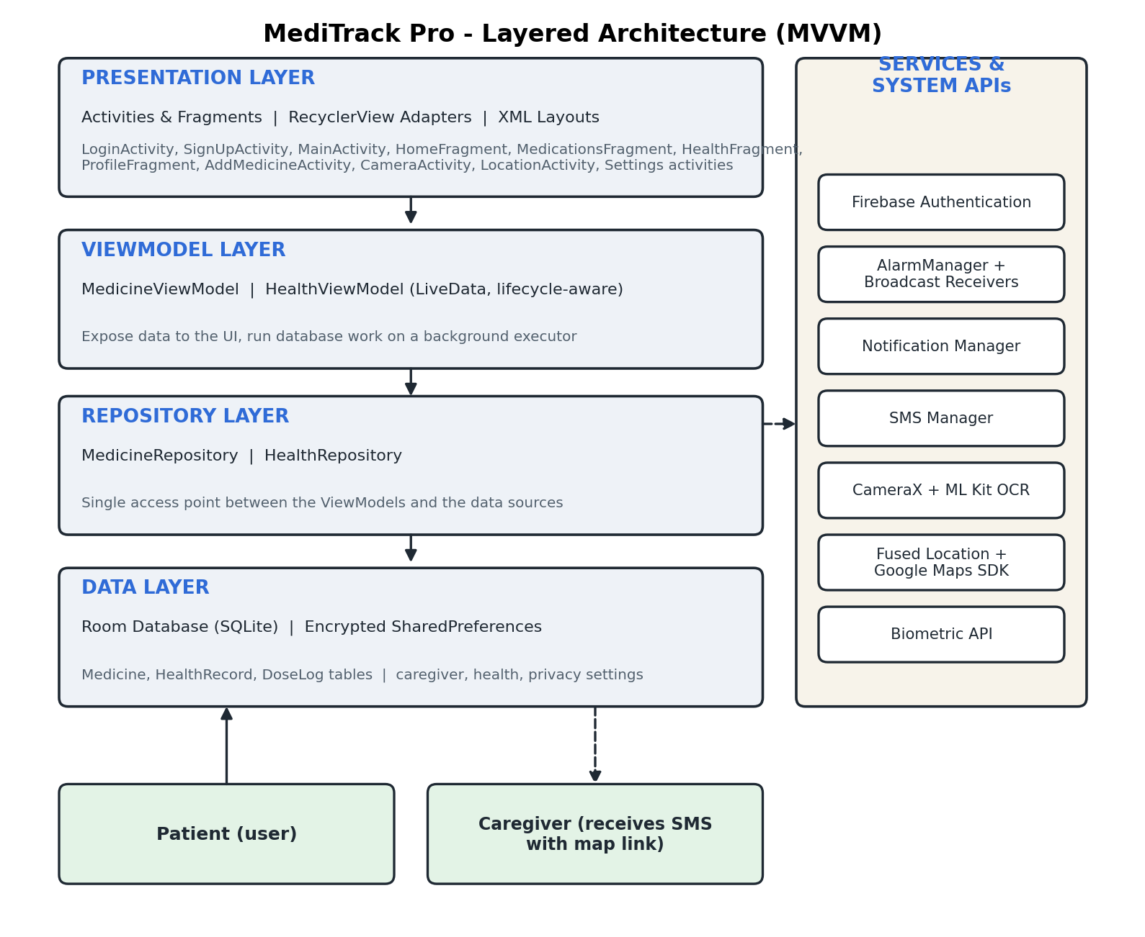
Figure 4.1: Layered architecture of MediTrack Pro
- Presentation layer: Activities, fragments, RecyclerView adapters and XML layouts. They show data and collect user input.
- ViewModel layer: MedicineViewModel and HealthViewModel hold data as LiveData so screens update automatically, and run database work on a background executor.
- Repository layer: MedicineRepository and HealthRepository give the ViewModels one access point to the data.
- Data layer: A Room database (three tables) and encrypted preference files for settings.
- Services: Firebase Authentication, AlarmManager with broadcast receivers, notifications, SmsManager, CameraX with ML Kit, Fused Location with the Maps SDK, and the biometric API.

4.2 System Flowchart
Figure 4.2 shows how the application starts and how the main screens lead to their operations. Figure 4.3 shows the background flow that produces reminders and caregiver alerts.
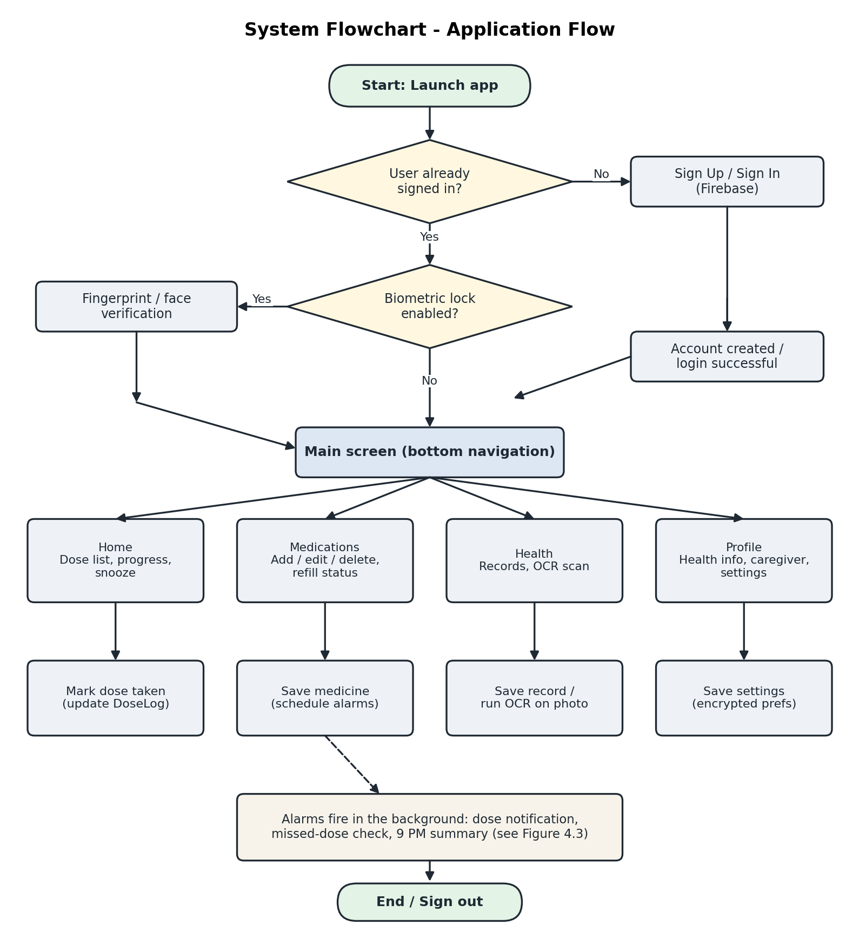
Figure 4.2: Application flow from launch to the main operations
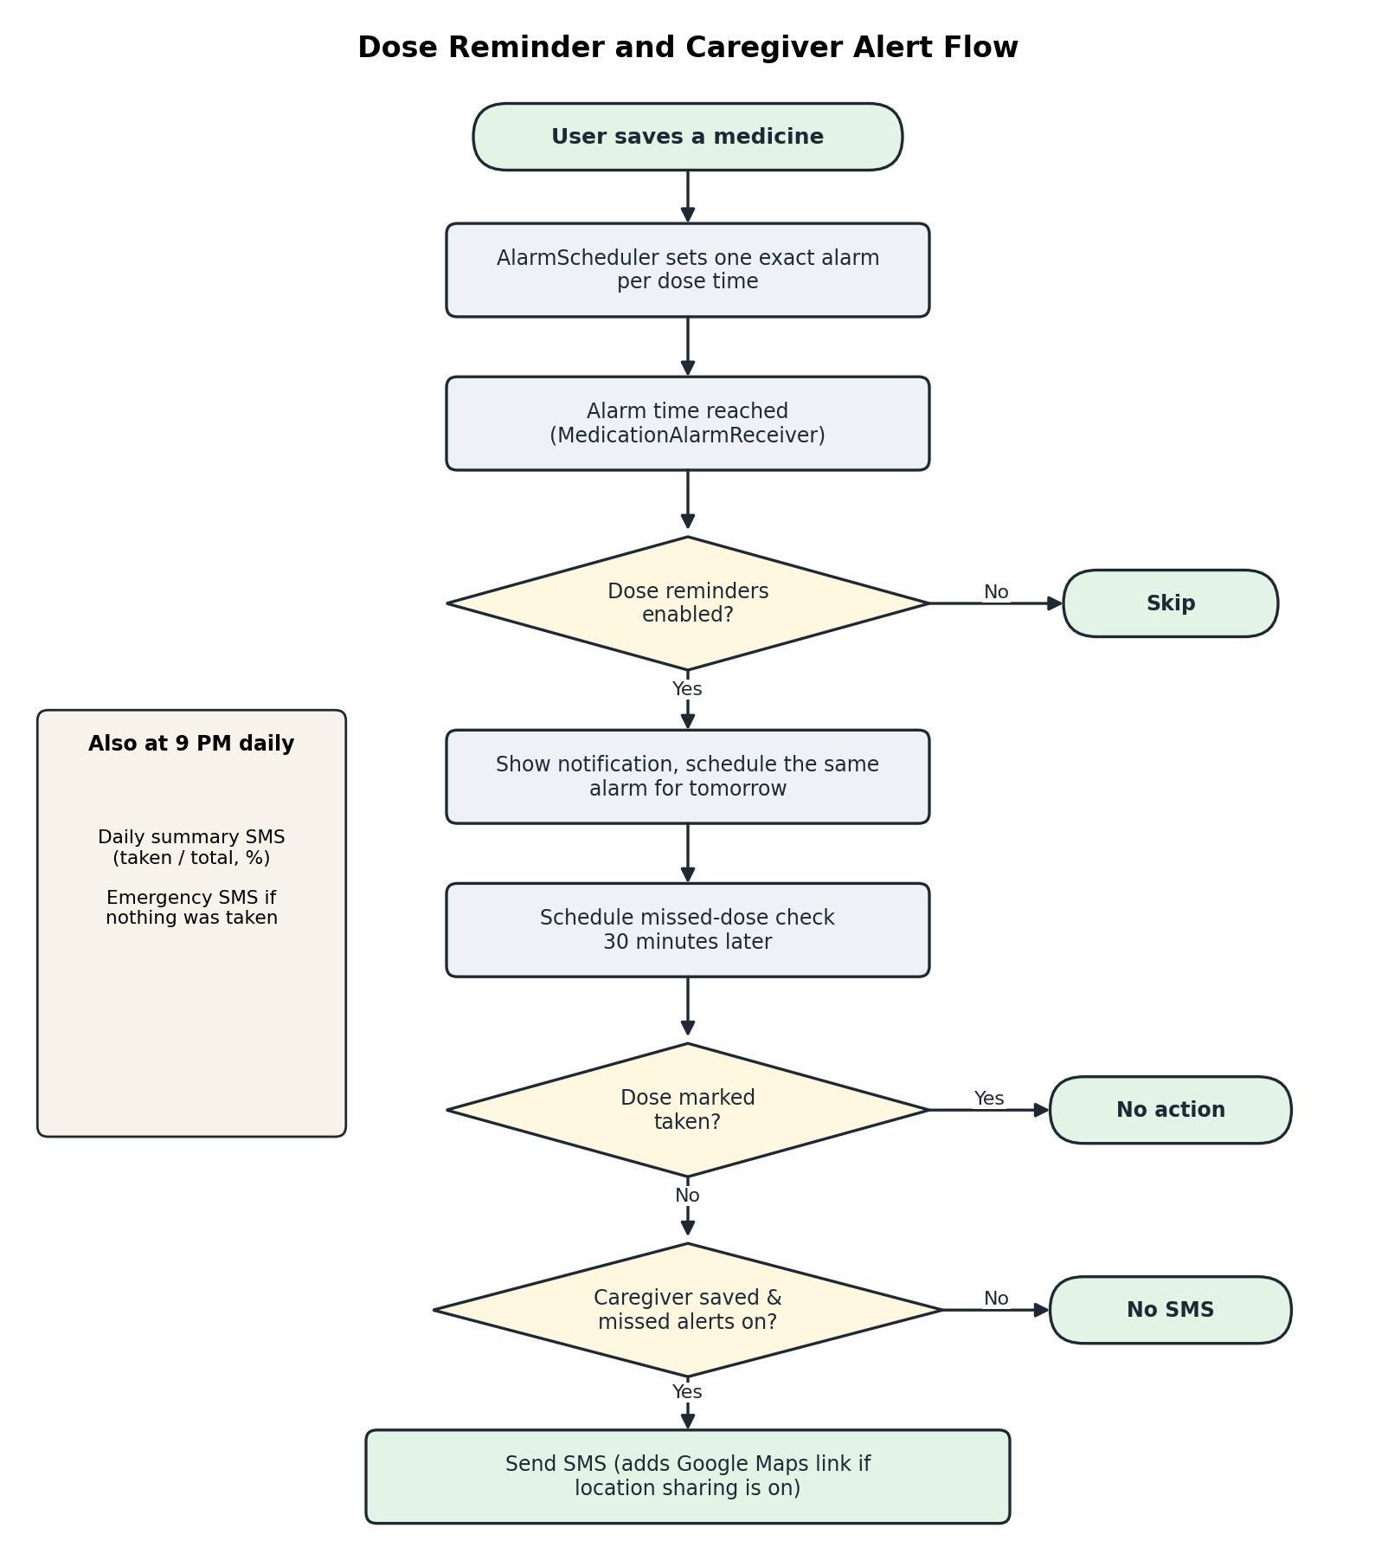
Figure 4.3: Dose reminder and caregiver alert flow

4.3 Use Case Diagram
There are two actors. The patient uses the application directly. The caregiver does not use the application; the caregiver only receives text messages and opens the location link.
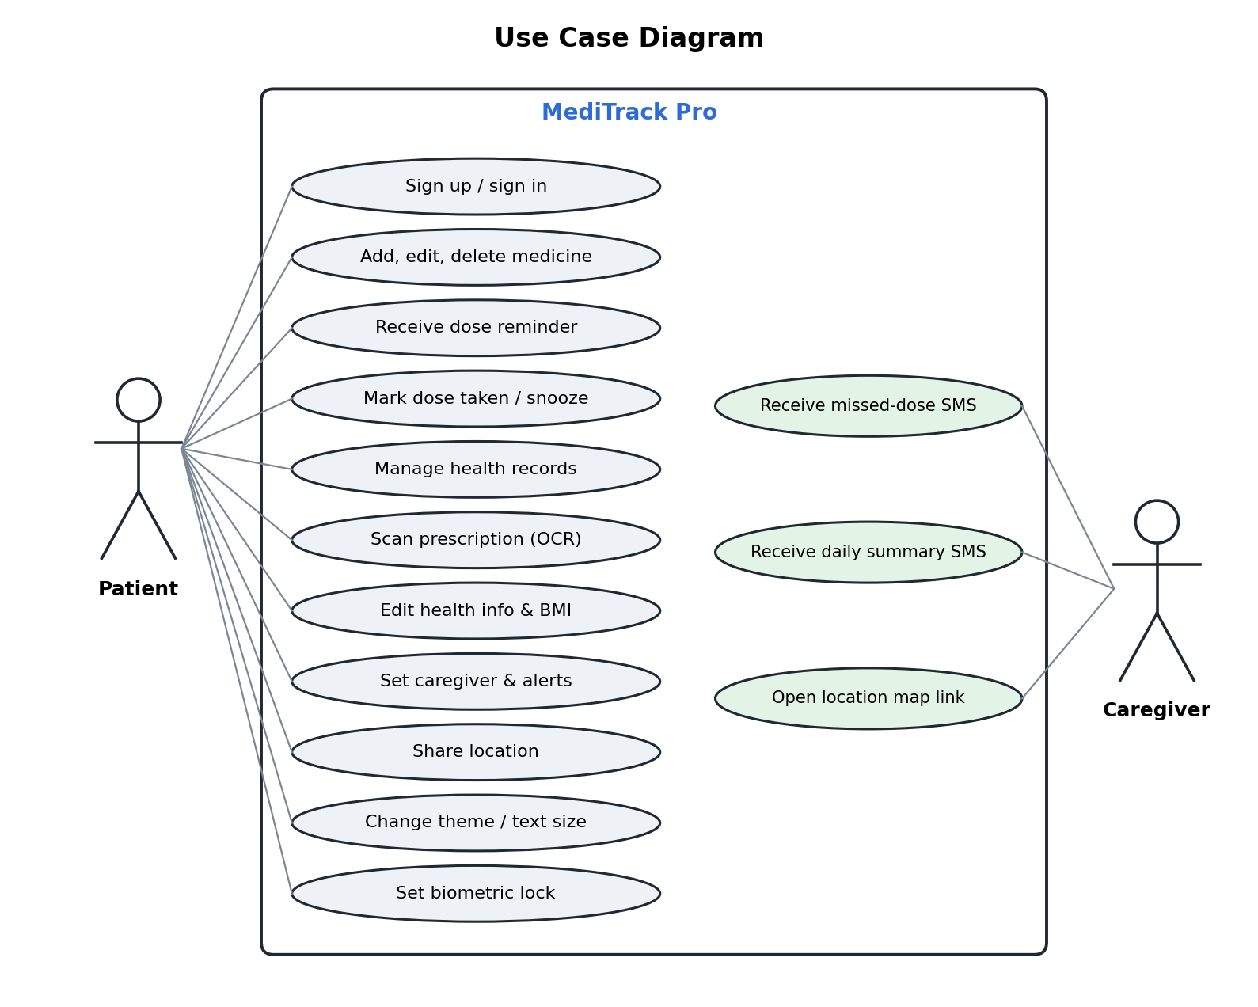
Figure 4.4: Use case diagram

4.4 Database Design
The Room database is named medicine_database and is at schema version 5. Migrations from version 2 to 5 are defined so that existing data is kept when the schema changes. Figure 4.5 shows the three tables.
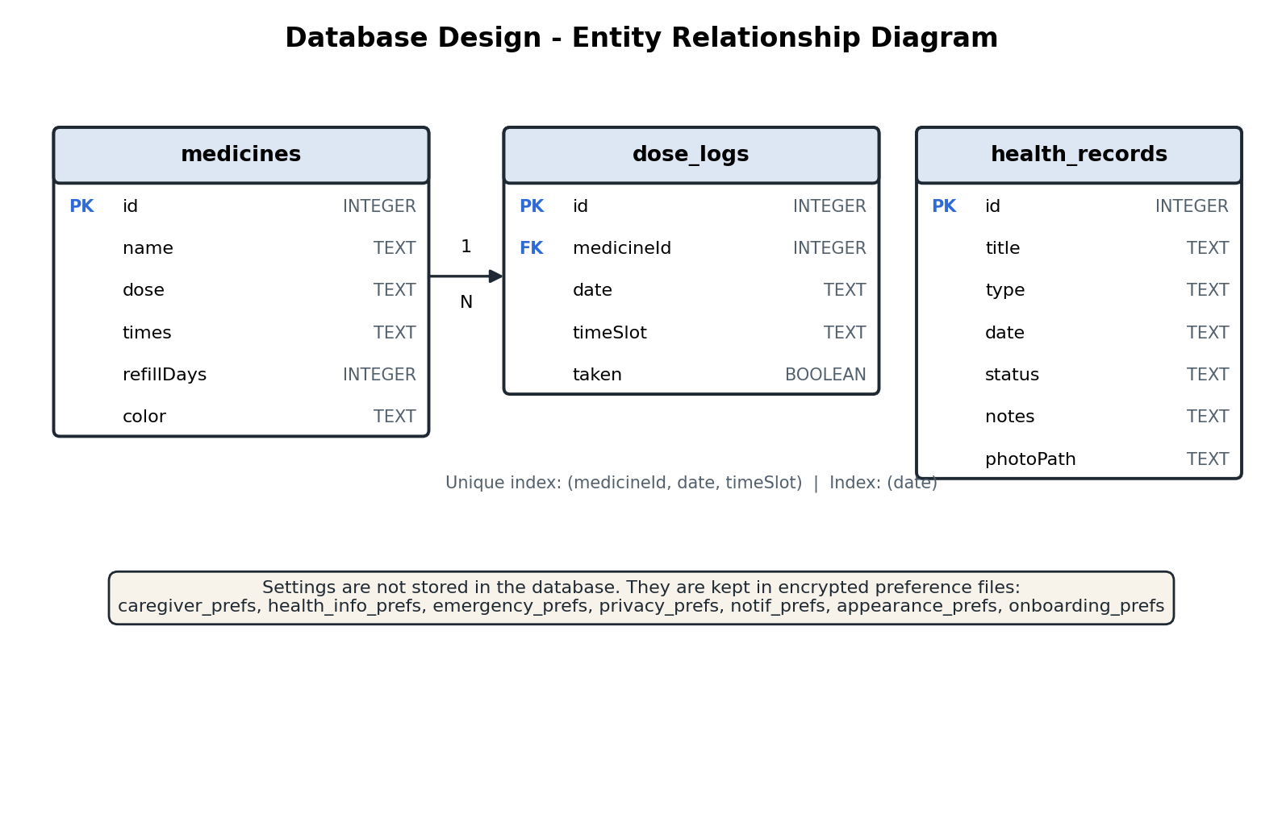
Figure 4.5: Entity relationship diagram
Table 4.1: Database tables and columns
Table | Column | Type | Description
medicines | id | INTEGER (PK) | Auto-generated identifier
 | name | TEXT | Medicine name
 | dose | TEXT | Dose, for example 500mg
 | times | TEXT | Comma-separated times, for example 08:00, 20:00
 | refillDays | INTEGER | Days of supply entered by the user
 | color | TEXT | Reserved tag (default value accent)
dose_logs | id | INTEGER (PK) | Auto-generated identifier
 | medicineId | INTEGER | Medicine that the dose belongs to
 | date | TEXT | Day of the dose, yyyy-MM-dd
 | timeSlot | TEXT | Time of the dose, for example 08:00
 | taken | BOOLEAN | True when the user has marked the dose as taken
health_records | id | INTEGER (PK) | Auto-generated identifier
 | title | TEXT | Title or test name
 | type | TEXT | Lab Result, Prescription, Doctor Visit or Vaccination
 | date | TEXT | Date the record was added
 | status | TEXT | Status such as Normal, Active or Done
 | notes | TEXT | Notes or text read from a scanned photo
 | photoPath | TEXT | Path of the attached photo (may be empty)

The dose_logs table has a unique index on (medicineId, date, timeSlot), so there can be only one log per dose per day, and an index on date to make the daily queries fast.
Table 4.2: Encrypted preference files (AES-256)
Preference file | Stores
caregiver_prefs | Caregiver name, relationship, phone, alert switches, location-sharing switch and the last known location
health_info_prefs | Blood type, height, weight, BMI, date of birth, gender, conditions
emergency_prefs | Two emergency contacts
privacy_prefs | Biometric lock and other privacy switches
notif_prefs | Notification switches (dose reminders and others)
appearance_prefs | Theme (dark, light or system) and text size
onboarding_prefs | Whether the welcome message has been shown

4.5 Module Design
Table 4.3: Modules and their classes
Module | Main classes | Responsibility
Authentication | LoginActivity, SignUpActivity | Sign up, sign in, password reset, biometric prompt
Medication management | MedicationsFragment, AddMedicineActivity, MedicineAdapter, RefillAdapter, MedicineViewModel, MedicineRepository | Add, edit, delete, list and refill status
Reminder engine | AlarmScheduler, MedicationAlarmReceiver, BootReceiver, NotificationHelper | Schedules alarms, shows notifications, re-arms after restart
Dose tracking | HomeFragment, DoseLog, DoseLogDao | Daily dose list, mark as taken, progress and snooze
Health records | HealthFragment, AddHealthRecordActivity, HealthRecordDetailActivity, HealthRecordAdapter, HealthViewModel | Store and manage records
Scan and OCR | CameraActivity, OcrHelper | Capture a photo and extract its text
Caregiver alerts | CaregiverSettingsActivity, CaregiverAlarmScheduler, MissedDoseCheckReceiver, DailySummaryReceiver, CaregiverSmsSender | Save the caregiver and send SMS alerts
Location | LocationActivity, LocationHelper | Find, store and share the patient's location
Profile and settings | ProfileFragment, EditHealthInfoActivity, EmergencyContactsActivity, NotificationSettingsActivity, PrivacySettingsActivity, AppAppearanceActivity | Health information and preferences
Home remedies and first aid | RemediesActivity, HealthTipsData | Shows a fixed list of remedies and first aid tips with steps and cautions
Common | BaseActivity, AppThemeHelper, UiHelper, SecurePrefs, PrefsConstants, MediTrackApp | Theme, text size, window insets, encrypted preferences, application start-up

4.6 Screen Navigation and User Interface Design
After sign in, the user moves between four tabs with the bottom navigation bar. Other screens open from these tabs and return with a Back link. Figure 4.6 shows how the screens are connected.
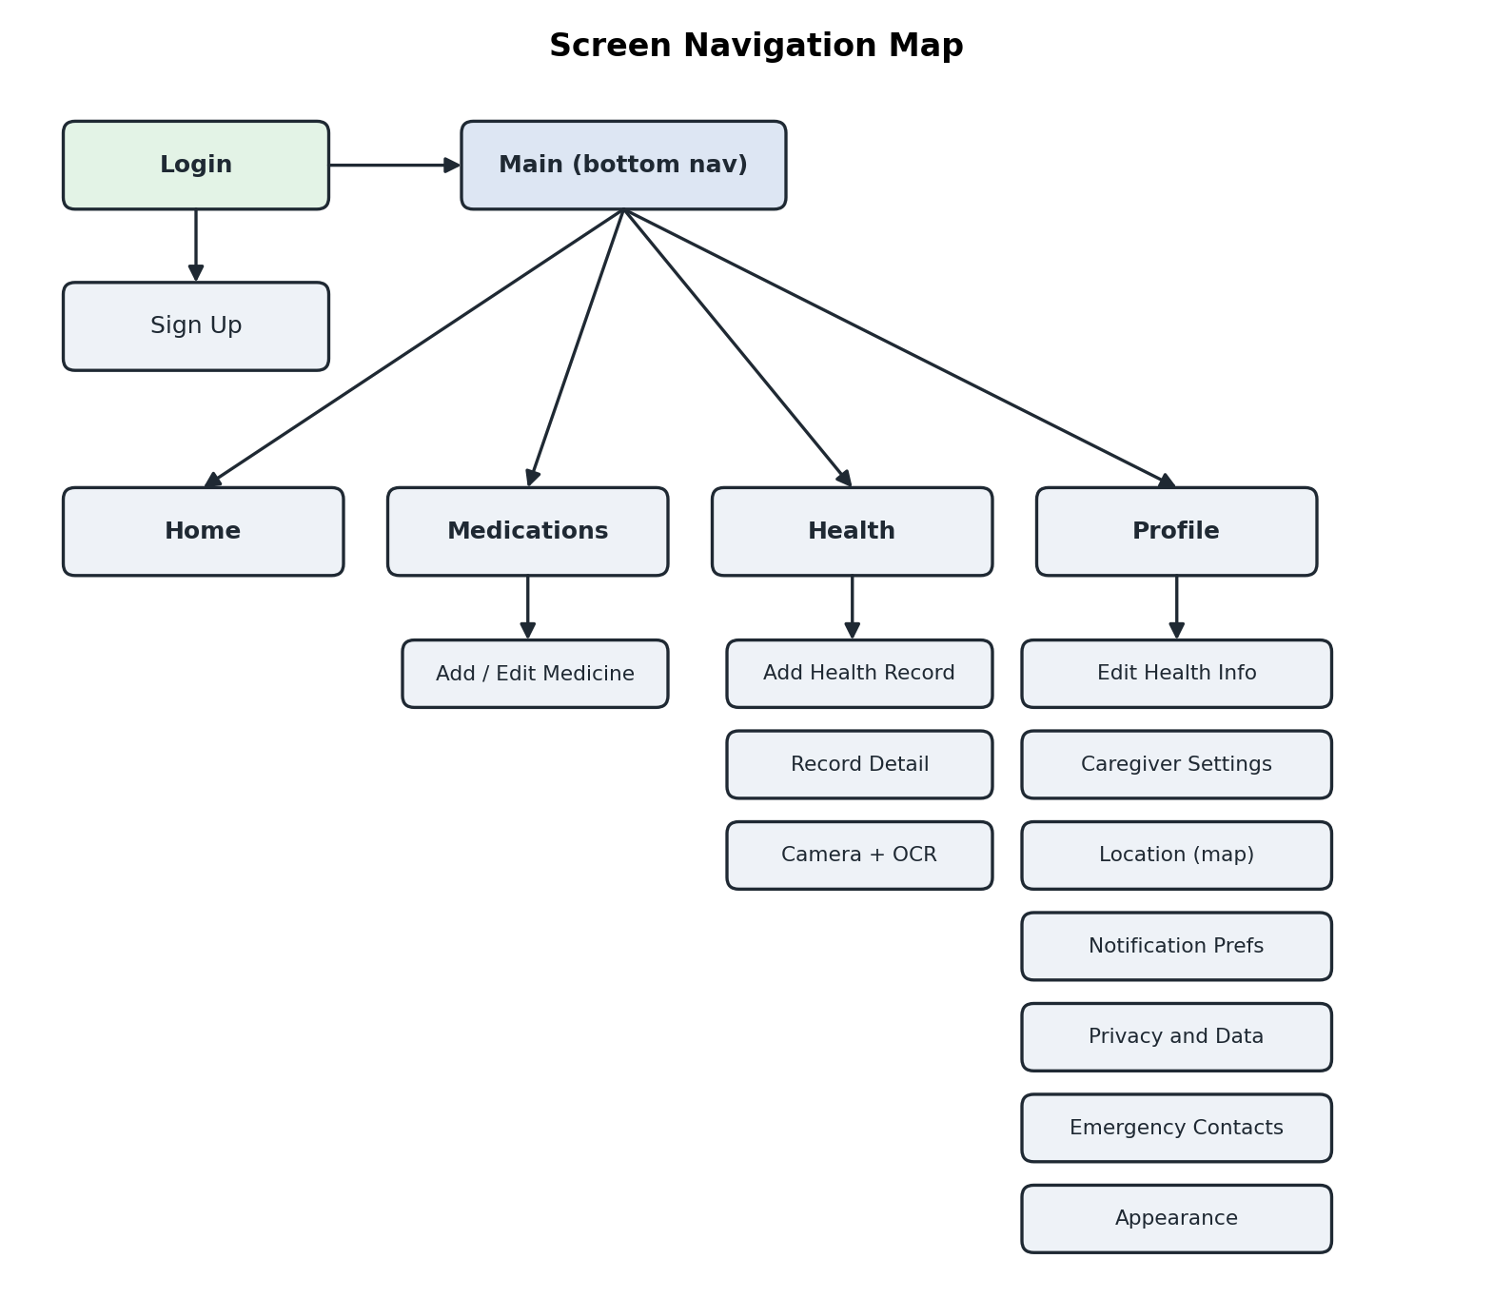
Figure 4.6: Screen navigation map

Interface design principles
- One palette is defined once for the dark theme and once for the light theme; every screen takes its colours from it, so text, buttons and cards stay readable in both themes.
- Dark is the default theme; the user can choose Light or System in Profile, then Appearance.
- All buttons use the same height, corner radius and spacing; selectable options (tabs, gender, blood type) use one shared selected and unselected look.
- Every input field has a label above it and a hint inside it, with a suitable keyboard type.
- Content is padded so it never sits under the status bar or navigation bar on newer Android versions.
Table 4.4: Colour palette
Colour role | Light theme | Dark theme
Background | #F4F5F7 | #101214
Card surface | #FFFFFF | #191C20
Primary text | #14181F | #E6E8EB
Secondary text | #566170 | #9BA3AD
Accent (buttons, links) | #2F6BD7 | #7AA7F7
Error / delete | #C23B34 | #F07178

Chapter 5: Implementation

5.1 Implementation Overview
The application is a single Gradle module. The Java source is in the package com.example.meditrackpro and contains about 50 classes. Layouts, drawables, colours, styles and the navigation graph are in the res folder. The AndroidManifest.xml declares the activities, the three broadcast receivers (dose alarm, missed-dose check, daily summary), the boot receiver, the permissions and the Maps key placeholder.
Table 5.1: Project structure
Folder / file | Content
java/com/example/meditrackpro | All Java classes (screens, data, alarms, helpers)
res/layout | 23 XML layouts for activities, fragments and list items
res/values and res/values-night | Light and dark colours, themes, styles, strings
res/navigation/nav_graph.xml | The four bottom-navigation destinations
res/color and res/drawable | State colour lists, input and badge backgrounds, icons
app/build.gradle.kts | Dependencies, SDK versions, build configuration
AndroidManifest.xml | Components, permissions and the Maps API key

5.2 Module-wise Implementation

Authentication
LoginActivity and SignUpActivity use FirebaseAuth. Sign up creates the account with createUserWithEmailAndPassword and saves the name with an update-profile request. Sign in uses signInWithEmailAndPassword. A network failure is detected and shown as "No internet connection". If the user is already signed in and the biometric lock is on, a BiometricPrompt is shown before the main screen opens.

Medication management
AddMedicineActivity collects the name, dose, refill days and one or more times. Times are chosen with a time picker, kept in sorted order and stored as one comma-separated text. When a medicine is saved, MedicineViewModel inserts it on a background executor and then asks AlarmScheduler to schedule its alarms. Editing cancels the old alarms, schedules new ones and clears today's dose logs so they are rebuilt with the new times. Deleting a medicine cancels its alarms and removes its dose history.

Reminder engine
AlarmScheduler creates one exact alarm for each dose time. Each alarm has its own request code so that it can be cancelled or rescheduled individually:
Table 5.2: Alarm request codes
Alarm type | Request code | Purpose
Dose alarm | medicineId x 100 + slot index (0 to 999,999) | Dose notification, repeated daily
Snooze | 1,000,000 and above | One-off reminder after 10, 30 or 60 minutes
Missed-dose check | 2,000,000 + medicineId x 100 + slot index | Runs 30 minutes after a dose alarm
Daily summary | 9,999,998 (fixed) | Runs every day at 9 PM

public static int requestCode(int medicineId, int slotIndex) {
return medicineId * SLOTS_PER_MEDICINE + slotIndex; // SLOTS_PER_MEDICINE = 100
}
When a dose alarm fires, MedicationAlarmReceiver checks the Dose reminders setting, shows the notification, schedules the same time for the next day and schedules the missed-dose check. If the exact-alarm permission is not available, the scheduler falls back to a normal alarm. BootReceiver re-creates all alarms after the phone restarts.

Dose tracking and the Home dashboard
HomeFragment observes the medicine list and today's dose logs. For every medicine and time it shows a card with a Take button. A tap marks the dose as taken; a second tap marks it as not taken. Progress is the number of taken doses divided by the total, shown as "taken/total" with a bar and a percentage.
DoseLog existing = repository.getLog(medicine.getId(), date, timeSlot);
if (existing == null) {
repository.insertLog(new DoseLog(medicine.getId(), date, timeSlot, true));
} else {
existing.setTaken(!existing.isTaken());
repository.updateLog(existing);
}

Health records and scanning
The Health tab lists records, newest first, with counts for vaccinations, lab results and doctor visits. A record can be added with a type, title, optional doctor name, status and notes. The record detail screen allows the status and notes to be edited and the record to be deleted. CameraActivity uses CameraX to preview and capture a photo, shows Retake and Use Photo, and then OcrHelper runs ML Kit text recognition on the device. The first useful line becomes the title and the whole text goes into the notes of a new Prescription record. Photos older than 30 days are deleted automatically.

Caregiver alerts
The caregiver screen stores the name, relationship, phone number and three alert switches in encrypted preferences. MissedDoseCheckReceiver runs 30 minutes after a dose alarm, looks up that dose in dose_logs and, if it is not taken, sends an SMS. DailySummaryReceiver runs at 9 PM and sends the day's totals, and sends an emergency message if doses were scheduled but none were taken. CaregiverSmsSender checks the SMS permission, normalises the phone number (a bare ten-digit number or a leading 0 becomes +91...) and sends the message in parts when it is long. The Send Test SMS button reports success or the reason for failure.

Location sharing
When the user turns on Include my location, LocationHelper asks the Fused Location Provider for a position and stores the latest one in encrypted preferences. Alerts append a Google Maps link and the age of the location. Alerts that are sent while the application is closed use the stored position unless the user has allowed location access all the time. LocationActivity shows the position as a marker on a Google Map, with a dark map style in dark mode, and has Refresh and Send to caregiver buttons.

Home remedies and first aid
RemediesActivity shows two choices, Home remedies and First aid. The content is stored as fixed text in the class HealthTipsData; each tip has a title, what it is for, numbered steps and a safety note. Nothing is generated, personalised or downloaded, so the page works offline and shows the same advice every time. Tapping a card expands or collapses its steps. A disclaimer at the top reminds the user that the tips do not replace a doctor and gives the emergency number. The page opens from a card on the Home screen and from a row in Profile. There are 11 home remedies (for example kadha for a sore throat, a warm towel for a headache, salt water gargle, ORS drink, steam inhalation) and 10 first aid topics (cuts, burns, nosebleed, choking, fainting, heat exhaustion, sprain, suspected fracture, stings, poisoning, heart attack signs).

Profile and settings
Edit Health Info stores blood type, height, weight, date of birth, gender and conditions, and calculates the BMI as weight divided by the square of the height in metres. Notification Preferences, Privacy and Data, Emergency Contacts and Appearance each read and write their own encrypted preference file. Changing the theme or text size restarts the application so that every screen is redrawn.

Security
All preference files are opened through one helper, SecurePrefs, which uses EncryptedSharedPreferences with AES-256-SIV for keys and AES-256-GCM for values. Account deletion asks for the password again before calling Firebase. The biometric lock uses BiometricManager to confirm that a fingerprint or face is enrolled before it can be switched on.

5.3 Input Fields, Hints and Placeholders
Every input field has a label above it, a hint inside it that disappears when typing starts, and an input type that opens a suitable keyboard.
Table 5.3: Hints and input types for each field
Screen | Field | Hint shown | Input type
Sign in | Email | you@example.com | Email address
 | Password | Enter your password | Password (hidden)
Sign up | Full name | Your full name | Person name, capitalised
 | Email | you@example.com | Email address
 | Date of birth | DD / MM / YYYY | Date
 | Password | At least 8 characters | Password (hidden)
 | Confirm password | Repeat your password | Password (hidden)
Add medication | Medicine name | e.g. Metformin | Text, words capitalised
 | Dose | e.g. 500mg | Text
 | Dose times | No times added yet | Time picker
 | Refill in (days) | e.g. 30 | Number
Add health record | Title / test name | e.g. Blood CBC panel | Text, sentences capitalised
 | Doctor name | e.g. Dr. Sharma | Person name
 | Status | e.g. Normal, Active, Done | Text
 | Notes | Additional notes | Multi-line text
Edit health info | Height (cm) | e.g. 165 | Decimal number
 | Weight (kg) | e.g. 62 | Decimal number
 | Date of birth | Tap to select date | Date picker
 | Medical conditions | e.g. Type 2 Diabetes, Hypertension | Multi-line text
Caregiver / emergency contacts | Name | e.g. Amit Roy | Person name
 | Relationship | e.g. Spouse, Parent, Friend | Text, words capitalised
 | Phone number | +91 XXXXX XXXXX | Phone

5.4 Input Validation Rules
Validation is performed when the user presses the action button. If a rule fails, the data is not saved and a message is shown. The rules implemented in the application are listed in Table 5.4.
Table 5.4: Validation rules and messages
Screen | Rule | Message shown
Sign in | Email must not be empty | Enter your email
 | Password must not be empty | Enter your password
 | Wrong credentials or no network | Message from Firebase; "No internet connection. Please check your network."
Forgot password | Email must be entered first | Enter your email first
Sign up | Name must not be empty | Enter your name
 | Email must not be empty | Enter your email
 | Date of birth must not be empty | Enter your date of birth
 | A gender must be selected | Select your gender
 | Password must not be empty | Enter a password
 | Password must have at least 8 characters | Password must be 8+ characters
 | Password and confirmation must match | Passwords do not match
 | Email format and duplicates | Checked by Firebase; its message is shown
Add medication | Name must not be empty | Enter medicine name
 | Dose must not be empty | Enter dose
 | At least one time must be added | Add at least one dose time
 | Refill days must not be empty | Enter refill days
 | The same time cannot be added twice | 08:00 already added (shows the time)
Add health record | Title must not be empty | Please enter a title
 | Empty status is replaced by a default | Status is saved as "Added"
Edit health info | Height must be between 50 and 300 cm | Please enter a valid height (50-300 cm)
 | Weight must be between 1 and 700 kg | Please enter a valid weight (1-700 kg)
Caregiver | Name must not be empty | Please enter caregiver name
 | Phone required for the test SMS | Enter a phone number first
 | SMS permission required | SMS permission not granted - save the caregiver first to grant it
Emergency contacts | Primary name and phone required | Please fill in the primary contact
Edit name (Profile) | Name must not be empty | Name cannot be empty
Delete account | Password must be entered | Please enter your password
 | Account must have an email | Cannot delete account: no email on file
Biometric lock | Hardware and enrolled fingerprint needed | No biometric hardware found / No fingerprints enrolled
Camera | Camera permission required | Camera permission is required to scan documents

5.5 Error and Exception Handling
- Database operations run inside try and catch blocks in the ViewModels; errors are logged with Timber and do not stop the application.
- Opening the encrypted preferences is wrapped so that a key-store problem on first run is ignored instead of crashing the welcome dialog; in the SMS sender it is logged and the send is skipped.
- Alarm scheduling catches SecurityException and falls back to a normal alarm when exact alarms are not allowed.
- If text recognition fails, the application still opens the new-record screen with the photo and empty text.
- Firebase failures are turned into readable messages, including a separate message for no internet.
- SMS sending reports success or a specific failure (no service, radio off, null PDU or other) through a toast.
- Location lookups use a timeout and fall back to the last stored location.
- Null checks are used for intents, intent extras, the signed-in user and records that may have been deleted.

Chapter 6: Testing

6.1 Testing Strategy and Environment
Testing was planned as black-box functional testing of every screen. Each test case has an identifier, a scenario, the input data, the expected result, the actual result and a status (Pass or Fail). Positive test cases use valid input and check that the operation succeeds. Negative test cases use missing, invalid or boundary input and check that the application rejects it with a clear message and does not save the data. The same cases are run on the Android emulator and on the physical phone described in Chapter 3.
The expected results below are taken from the validation rules and messages in Chapter 5. The Actual Result and Status columns are completed from the observed behaviour while the case is executed.

6.2 Positive Test Cases
Table 6.1: Positive test cases
TC ID | Test scenario | Input data | Expected result | Actual result | Status
PT-01 | Sign up with valid details | Name: Test User; email: test@example.com; DOB: 01/01/2000; gender: Male; password: Test@1234; confirm: Test@1234 | Account is created, message "Welcome Test User!" appears and the main screen opens
PT-02 | Sign in with valid credentials | Email: test@example.com; password: Test@1234 | Message "Welcome back!" appears and the main screen opens
PT-03 | Add a medicine with two times | Name: Metformin; dose: 500mg; times: 08:00 and 20:00; refill: 30 | Message "Metformin saved!"; medicine appears in the All tab; two dose cards appear on Home
PT-04 | Mark a dose as taken | Tap Take on the 08:00 Metformin card | Button changes to Taken; progress shows 1/2 doses and 50%
PT-05 | Add a health record | Type: Lab result; title: Blood CBC panel; status: Normal | Message "Record saved!"; record appears in the list; Total records and Lab results counts increase by 1
PT-06 | Save health information and BMI | Height: 165; weight: 62; blood type: O+; gender: Male | Message "Health info saved!"; Profile shows O+, 165 cm, 62 kg and BMI 22.8
PT-07 | Snooze a reminder | Tap Remind me, then choose In 10 minutes | Message "Reminder set for in 10 minutes" appears and a notification is delivered after 10 minutes
PT-08 | Save a caregiver | Name: Amit Roy; relationship: Parent; phone: 9876543210; SMS permission granted | Message "Caregiver saved! SMS alerts are active."; Profile shows the caregiver as Active
PT-09 | Change the theme | Appearance: select Light, then Save | Message "Appearance saved"; the application restarts in the light theme with readable text
PT-10 | Open Home Remedies and First Aid | Tap the Home remedies and first aid card on Home, then Kadha for sore throat | Page opens with a disclaimer; tapping the card expands numbered steps and a note; First aid tab lists 10 topics
PT-11 | Show location on the map | Profile, Location sharing; allow location | The map shows a marker at the current position with coordinates and accuracy

6.3 Negative Test Cases
Table 6.2: Negative test cases
TC ID | Test scenario | Input data | Expected result | Actual result | Status
NT-01 | Sign in with an empty email | Email: (empty); password: Test@1234 | Message "Enter your email"; no sign-in attempt
NT-02 | Sign in with a wrong password | Email: test@example.com; password: wrong123 | Firebase error message is shown; the Sign In button is enabled again
NT-03 | Sign up with a short password | Password: abc12; confirm: abc12 (other fields valid) | Message "Password must be 8+ characters"; account not created
NT-04 | Sign up with different passwords | Password: Test@1234; confirm: Test@9999 | Message "Passwords do not match"; account not created
NT-05 | Add a medicine without a name | Name: (empty); dose: 500mg; time: 08:00; refill: 30 | Message "Enter medicine name"; medicine not saved
NT-06 | Add a medicine without any time | Name: Aspirin; dose: 75mg; no time added; refill: 30 | Message "Add at least one dose time"; medicine not saved
NT-07 | Add the same time twice | Add 08:00, then add 08:00 again | Message "08:00 already added"; the list still has one 08:00
NT-08 | Add a health record without a title | Type: Prescription; title: (empty) | Message "Please enter a title"; record not saved
NT-09 | Height outside the allowed range | Height: 20; weight: 62 | Message "Please enter a valid height (50-300 cm)"; nothing saved
NT-10 | Weight outside the allowed range | Height: 165; weight: 800 | Message "Please enter a valid weight (1-700 kg)"; nothing saved
NT-11 | Save a caregiver without a name | Name: (empty); phone: 9876543210 | Message "Please enter caregiver name"; nothing saved
NT-12 | Save emergency contacts without the primary phone | Name 1: Amit Roy; phone 1: (empty) | Message "Please fill in the primary contact"; nothing saved

6.4 Test Result Summary
Table 6.3: Test result summary
Category | Number of cases | Passed (emulator) | Failed (emulator) | Passed (phone) | Failed (phone)
Positive test cases | 11
Negative test cases | 12
Total | 23

Chapter 7: Results and Discussion

7.1 Screenshots of the Application
The screenshots below show the main screens of the implemented application. The screenshots were taken on the physical Android phone in the default dark theme.
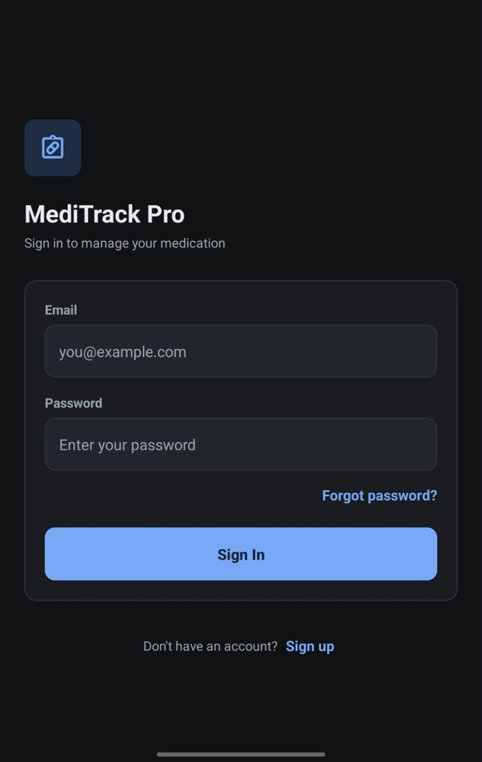 | 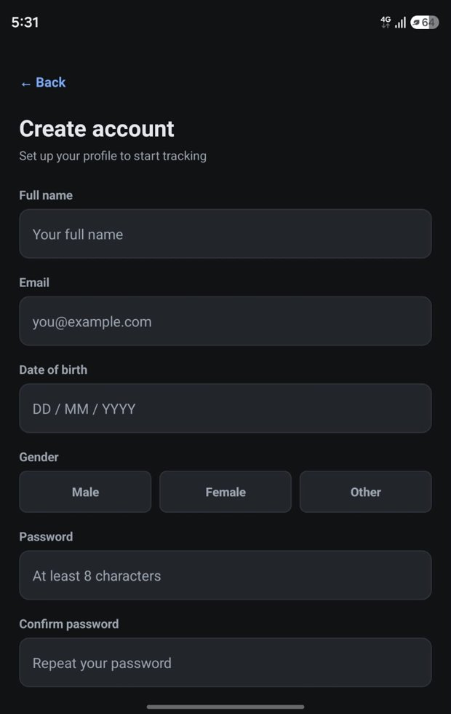
Figure 7.1: Sign in screen | Figure 7.2: Sign up screen

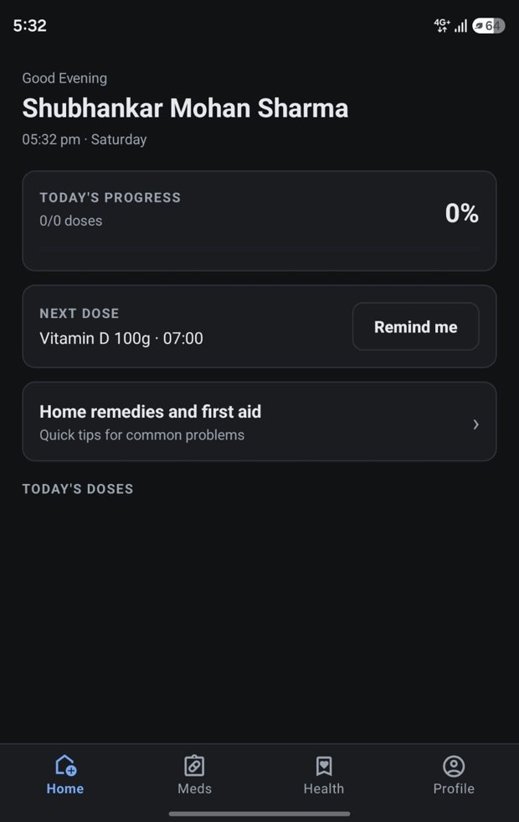 | 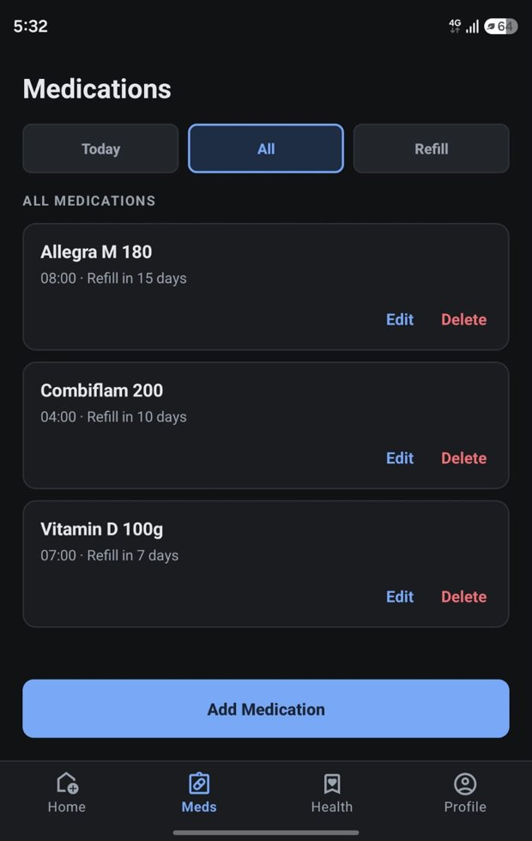
Figure 7.3: Home dashboard | Figure 7.4: Medications: All tab

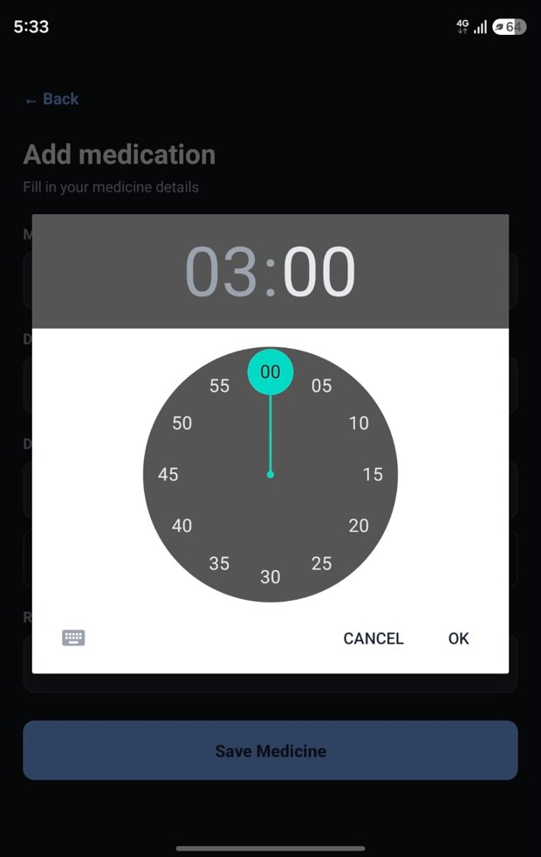 | 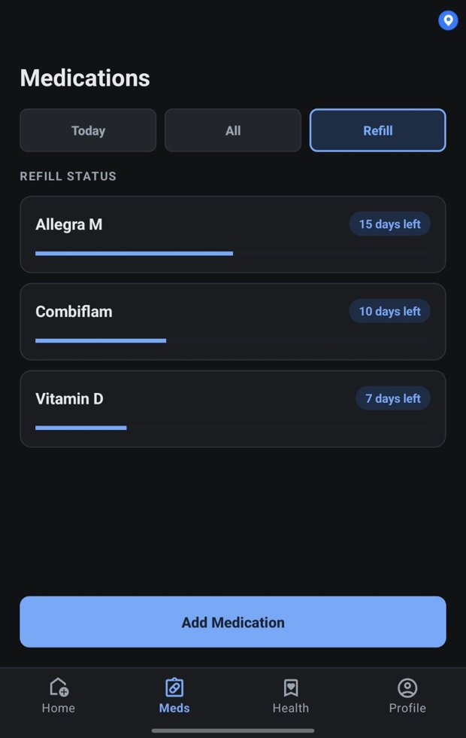
Figure 7.5: Add medication: time picker | Figure 7.6: Medications: Refill tab

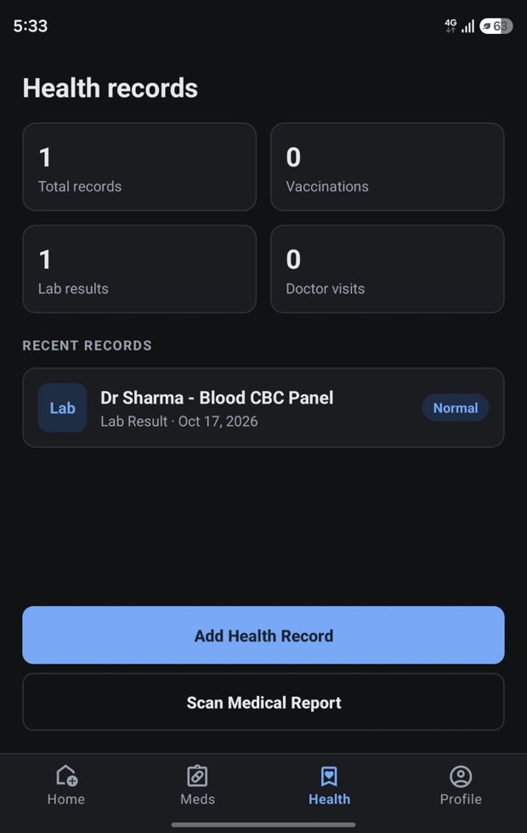 | 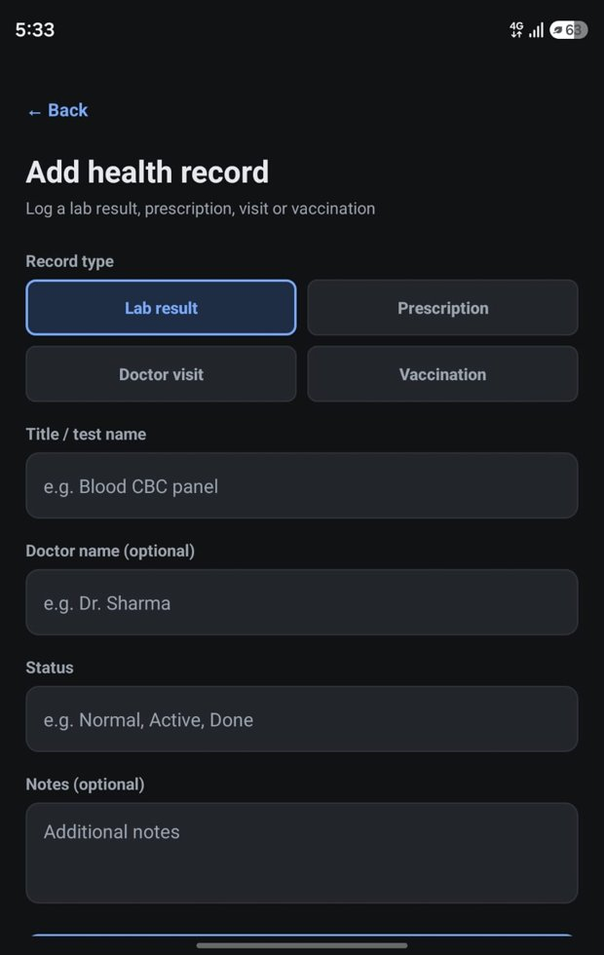
Figure 7.7: Health records tab | Figure 7.8: Add health record

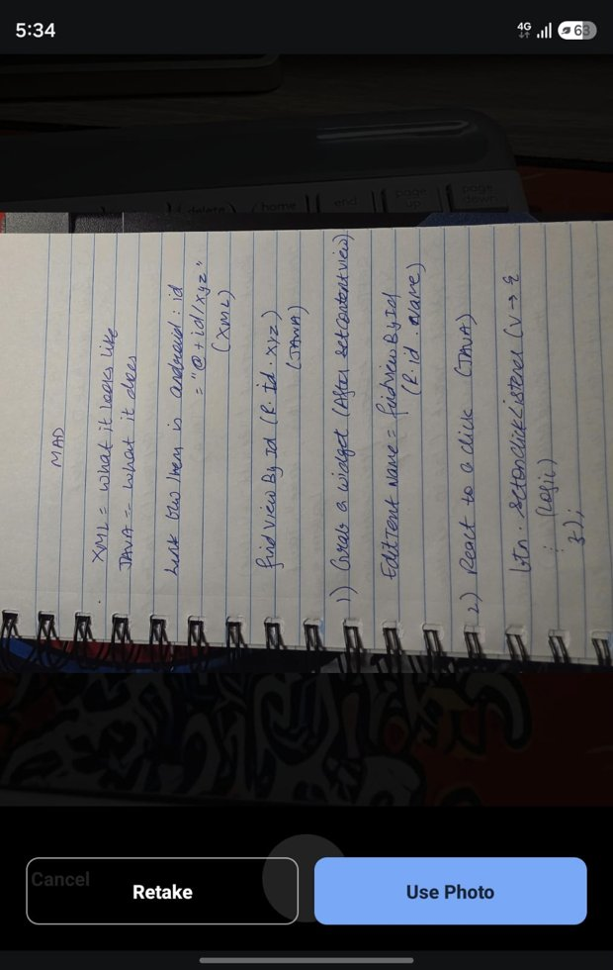 | 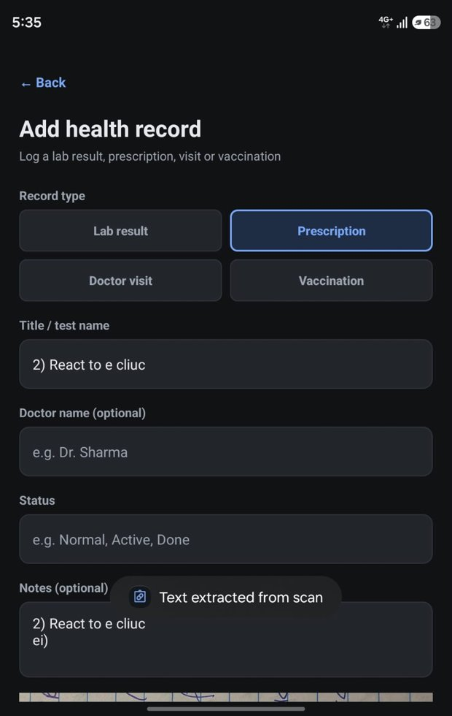
Figure 7.9: Camera: captured photo | Figure 7.10: Record filled from scanned text

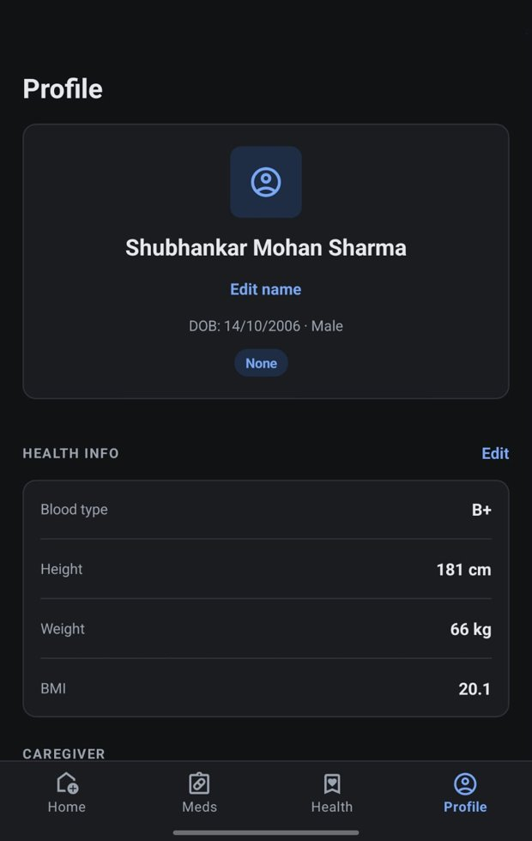 | 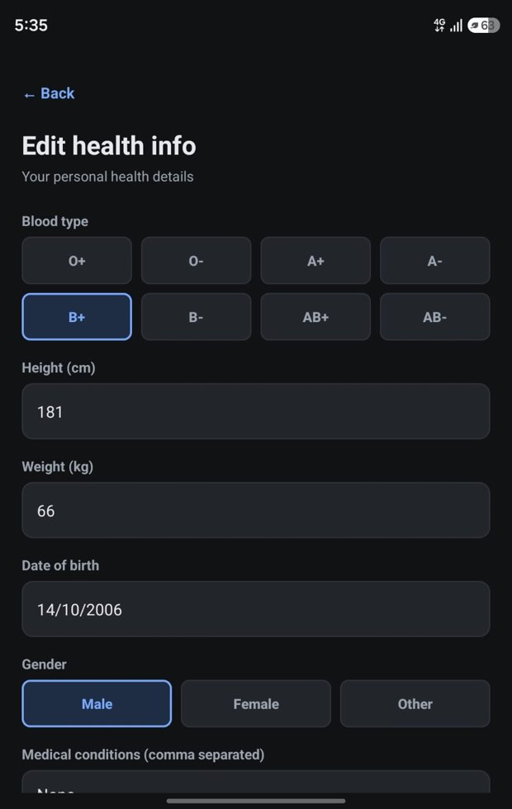
Figure 7.11: Profile and health info | Figure 7.12: Edit health info

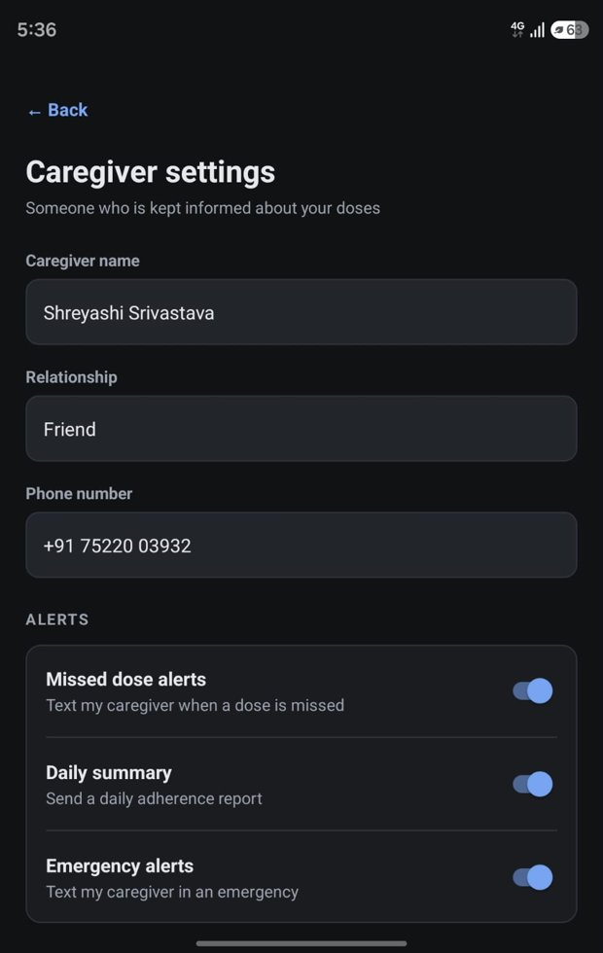 | 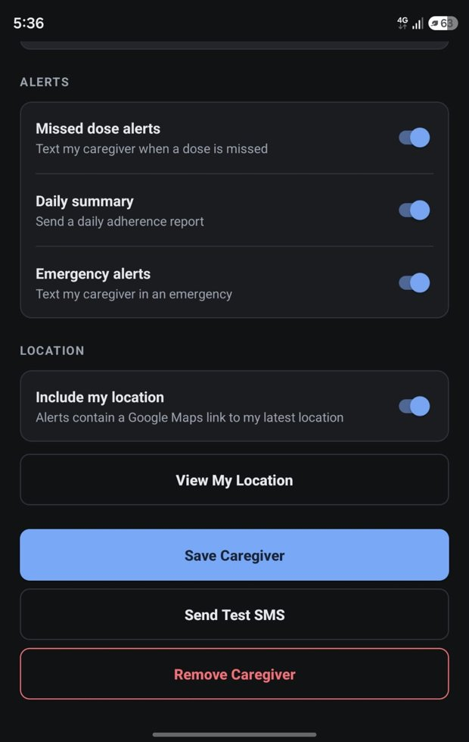
Figure 7.13: Caregiver settings: details and alerts | Figure 7.14: Caregiver settings: location and actions

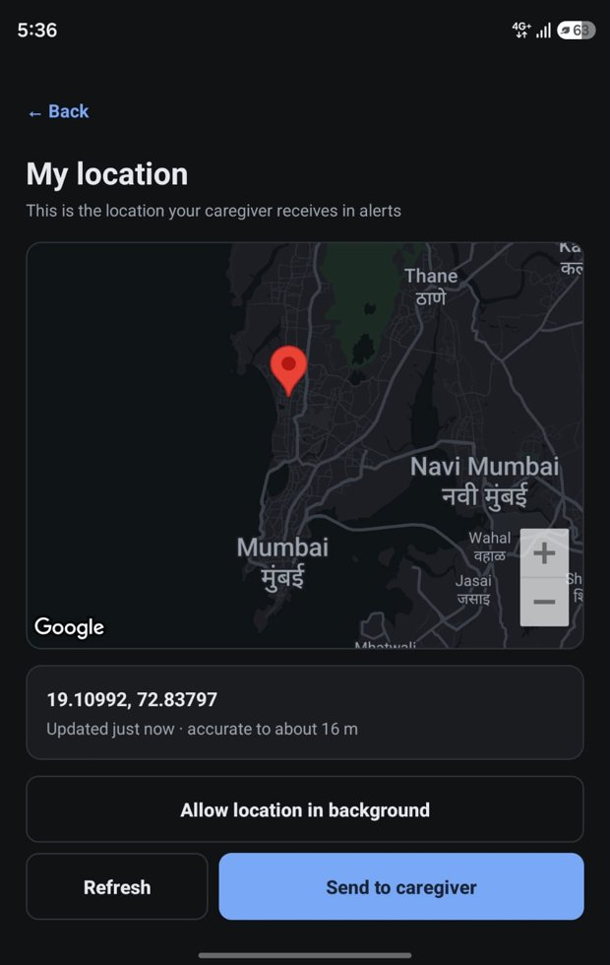 | 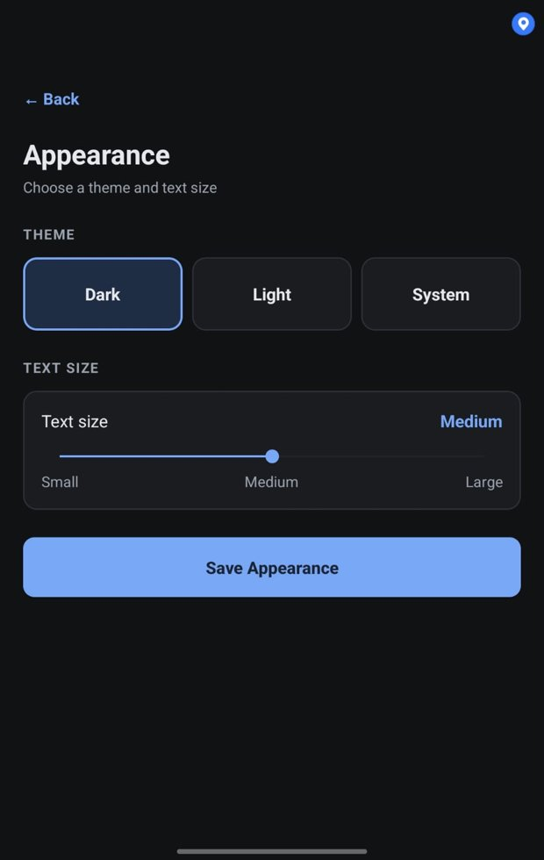
Figure 7.15: My location map | Figure 7.16: Appearance: theme and text size

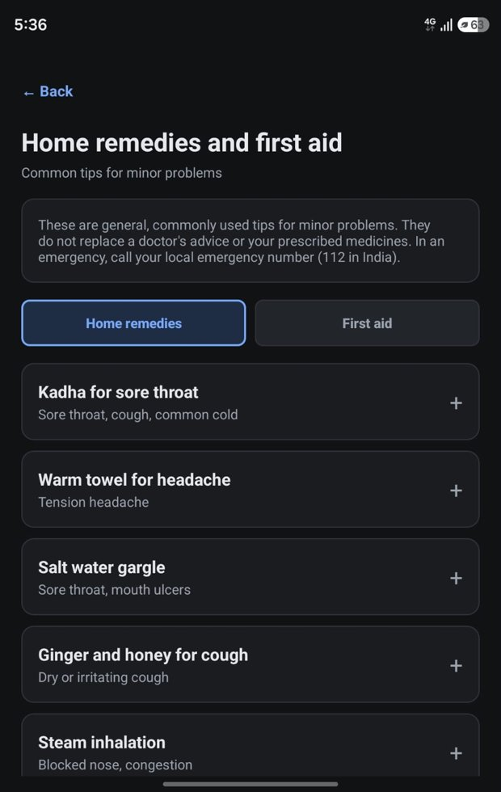 | 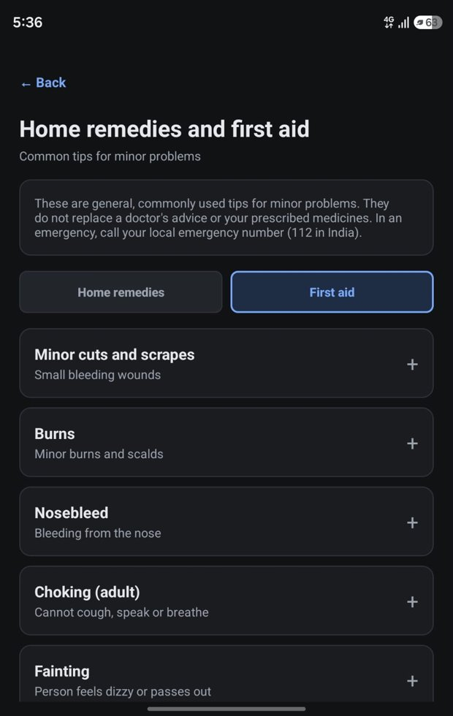
Figure 7.17: Home remedies tab | Figure 7.18: First aid tab

7.2 Emulator Execution Results
The application was installed and run on the Android emulator described in Table 3.4. The table below records the result of each area that was checked. A screen passes when it opens without a crash, its controls respond and its output matches the expected behaviour.
Table 7.1: Execution results on the emulator
Area checked | Expected behaviour | Result (Pass / Fail) | Remarks
Application launch and sign in | Opens without error; sign in and sign up work
Home dashboard | Greeting, clock, progress bar and dose cards display correctly
Add, edit and delete medicine | Saved medicines appear in the lists; edits and deletes take effect
Dose reminder notification | Notification appears at the scheduled time
Mark dose taken and snooze | Card state and progress update; snooze confirmation shown
Health records | Add, view, edit and delete a record
Camera and text recognition | Photo captured; text appears in the new record
Profile, health info and BMI | Values saved and displayed; BMI correct
Caregiver settings | Details saved; validation messages appear
Location map | Map and marker appear after setting a location
Theme and text size | Dark and light themes both readable; text size changes
Home remedies and first aid page | Both tabs open; cards expand and collapse; text readable in both themes
Layout and alignment | No overlapping or cut-off text or buttons

7.3 Physical Device Execution Results
The application was also installed on a physical Android phone (Samsung SM-F971B). The same areas were checked, plus the features that need real hardware: SMS delivery to the caregiver, the fingerprint or face lock, the camera, and the real GPS location.
Table 7.2: Execution results on the physical device
Area checked | Expected behaviour | Result (Pass / Fail) | Remarks
Application launch and sign in | Opens without error; sign in and sign up work
Home dashboard | Greeting, clock, progress bar and dose cards display correctly
Add, edit and delete medicine | Saved medicines appear in the lists; edits and deletes take effect
Dose reminder notification | Notification appears at the scheduled time
Mark dose taken and snooze | Card state and progress update; snooze confirmation shown
Health records | Add, view, edit and delete a record
Camera and text recognition | Photo captured; text appears in the new record
Profile, health info and BMI | Values saved and displayed; BMI correct
Caregiver settings | Details saved; validation messages appear
Location map | Map and marker appear after setting a location
Theme and text size | Dark and light themes both readable; text size changes
Home remedies and first aid page | Both tabs open; cards expand and collapse; text readable in both themes
Layout and alignment | No overlapping or cut-off text or buttons
SMS to caregiver (needs SIM) | Test SMS and missed-dose SMS are delivered
Biometric lock | Prompt appears on launch and unlocks the app
Location in SMS | Message contains a map link that opens the position

7.4 Limitations of the Project
- The remedies and first aid tips are a fixed list written into the app; they are general guidance, are not personalised, and cannot be updated without releasing a new version.
- SMS alerts need a phone with a SIM card and SMS permission; they cannot be delivered from an emulator.
- The caregiver receives only text messages and a map link. There is no caregiver application, so the caregiver cannot see a live location or the dose history.
- Alerts sent while the application is closed use the last stored location unless the user allows location access all the time.
- Notification Preferences: only the Dose reminders switch changes behaviour. The switches for missed dose, refill, caregiver and sound are saved but not yet used, and there is no refill reminder.
- Refill days are a number entered by the user and do not count down automatically.
- The Cloud backup and Share analytics options are placeholders; data is stored only on the device.
- Email format and duplicate accounts are checked by Firebase rather than by the application, and phone numbers are not checked for length beyond being entered.
- The Next dose card shows the first medicine in the list, not the nearest one in time.
- Clear all health data removes medicines and settings but not health records or dose history.
- Reminders depend on the phone allowing exact alarms and not restricting background activity.

Chapter 8: Conclusion and Future Scope

8.1 Conclusion
MediTrack Pro was designed and implemented as a native Android application in Java that brings together medicine reminders, dose tracking, health records and caregiver alerts. A user can add a medicine once and receive an exact reminder every day, confirm the dose with one tap, store prescriptions and reports, and have a caregiver informed by SMS when a dose is missed, with an optional map link to the patient's location. The application uses the MVVM pattern with Room for storage, encrypted preferences for settings and Firebase only for authentication, so health data stays on the device.
All functional requirements in Chapter 2 are implemented. Every input field has a hint and a suitable input type, mandatory fields and ranges are validated with clear messages, and the interface follows a single palette with a dark and a light theme. The test cases in Chapter 6 and the execution results in Chapter 7 record how the application behaved on an emulator and on a physical phone. The limitations in Section 7.4 describe the parts that are not yet complete.

8.2 Learning Outcomes
- Designing Android screens with XML layouts, Material components, styles and themes, including a dark and a light theme.
- Structuring an application with activities, fragments, ViewModels, LiveData and a repository layer.
- Storing data locally with Room, including entities, DAOs, indexes and migrations.
- Using background components: AlarmManager, broadcast receivers, notifications and boot handling.
- Handling runtime permissions for notifications, camera, location and SMS.
- Using device features: CameraX, ML Kit text recognition, the Fused Location Provider, the Maps SDK and biometrics.
- Protecting data with Firebase Authentication and encrypted preferences.
- Validating input, handling errors and writing test cases with expected and actual results.
- Working as a team with Git and testing on both an emulator and a physical device.

8.3 Future Enhancements
- Caregiver application: a companion app or web view where the caregiver can see doses and live location.
- Cloud backup and sync: optional backup so data can be restored on a new phone.
- Complete notification settings: make the missed-dose, refill, caregiver and sound switches effective, and add refill reminders with an automatic countdown.
- Stronger validation: email and phone number format checks and a date-of-birth format check inside the app.
- Wearable integration: bring heart rate and other vitals into the health record.
- Drug-interaction and allergy warnings: check a new medicine against the user's existing medicines.
- Medicine barcode scanning: fill in a medicine's name and dose by scanning its package.
- More tip content: add more conditions, search, and Hindi and regional-language versions of the remedies.
- More languages: translate the interface for wider use.

References
- Android Developers, "Room persistence library", developer.android.com/training/data-storage/room.
- Android Developers, "Schedule alarms" and "Notifications overview", developer.android.com.
- Android Developers, "Guide to app architecture" (MVVM, ViewModel, LiveData), developer.android.com/topic/architecture.
- Android Developers, "CameraX overview", developer.android.com/media/camera/camerax.
- Google, "ML Kit Text Recognition (on-device)", developers.google.com/ml-kit/vision/text-recognition.
- Google, "Maps SDK for Android" and "Fused Location Provider", developers.google.com/maps and developer.android.com/training/location.
- Firebase, "Authentication on Android", firebase.google.com/docs/auth/android.
- Google, "Material Design 3 guidelines", m3.material.io.
- World Health Organization, "Adherence to Long-Term Therapies: Evidence for Action", 2003.

