Connect html to mysql using node
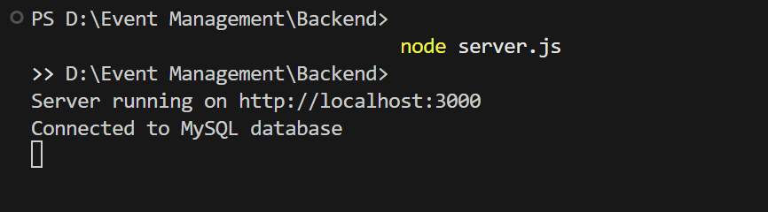

PWA: http://localhost:3000/
Mobile: http://10.143.203.210:3000/login.html
Same hotspot

