DOMAIN PROJECT-1

SYNOPSIS
ON

Topic Name: A Multimodal Deep Learning Framework for Non-Invasive Neonatal Jaundice (Bilirubin) Estimation Using Skin Images and Clinical Parameters

Submitted By:

Shubh Bhateja | Soumya Jain
500123387 | 500119436

Under the guidance of
Dr. Sanoj Kumar
Associate Professor
Department of Data Science


Department of AIML
School of Computer Science

UNIVERSITY OF PETROLEUM AND ENERGY STUDIES

Dehradun-248007

Jan-May, 2026

Index

Contents Page Number
Chapter 1: Abstract 3
Chapter 2: Introduction 4
Chapter 3: Problem Statement 5
Chapter 4: Literature Review 6
Chapter 5: Objectives 9
Chapter 6: Methodology 10
Chapter 7: System Requirement 11
Chapter 8: PERT Chart 12
Chapter 9: References 13

Chapter 1: Abstract
Neonatal jaundice is a common yet potentially severe medical condition in newborns, caused by elevated bilirubin levels in the blood. Early detection is essential to prevent neurological complications; however, conventional diagnostic methods such as Total Serum Bilirubin (TSB) testing are invasive and may not be readily accessible in low-resource settings. This research proposes a non-invasive, multimodal framework for estimating bilirubin levels by combining calibrated skin image analysis with relevant clinical parameters including age, weight, and gestational age. The methodology incorporates image preprocessing, color calibration using a reference color card, skin Region of Interest (ROI) extraction, and feature learning through a neural network-based regression model. By integrating visual and structured clinical data, the proposed system aims to enhance prediction accuracy, robustness to illumination variations, and practical usability. The outcome of this research contributes toward developing an AI-assisted, scalable screening tool that can support early diagnosis and improve neonatal healthcare delivery, particularly in resource-constrained environments.
Keywords: research, readers, journal, neonatal jaundice, bilirubin estimation, deep learning, multimodal analysis.

Chapter 2: Introduction
Neonatal jaundice is a frequently occurring clinical condition affecting a large proportion of newborns within the first week of life. It is primarily caused by elevated levels of bilirubin in the bloodstream due to immature liver function and increased breakdown of fetal hemoglobin. Although physiological jaundice is generally self-limiting, abnormally high bilirubin concentrations can cross the blood-brain barrier and lead to severe neurological complications such as acute bilirubin encephalopathy and kernicterus. Early detection and timely intervention are therefore essential to prevent irreversible damage.
The standard diagnostic method for bilirubin estimation is Total Serum Bilirubin (TSB) measurement through blood sampling. While clinically reliable, this approach is invasive, may cause discomfort to neonates, and requires laboratory infrastructure. In resource-constrained or rural healthcare environments, repeated blood testing is often impractical. Although transcutaneous bilirubinometers provide a non-invasive alternative, they are expensive and can be affected by variations in skin pigmentation and ambient lighting conditions, limiting their widespread accessibility.
With the rapid advancement of artificial intelligence, computer vision, and deep learning, image-based medical analysis has emerged as a promising non-invasive diagnostic solution. Several research studies have explored the correlation between skin color characteristics and bilirubin levels using digital imaging techniques. However, many existing approaches rely solely on image features without incorporating clinical parameters that significantly influence bilirubin concentration, such as postnatal age, gestational age, and birth weight. Ignoring these factors may limit predictive accuracy and generalizability.
The aim of this research is to develop a multimodal framework for non-invasive bilirubin estimation by integrating calibrated skin image features with relevant clinical metadata. The proposed methodology includes systematic data acquisition, color calibration using a reference color card, white balancing, skin Region of Interest (ROI) extraction, feature representation in perceptually meaningful color spaces, and neural network-based regression modeling. By combining visual and structured data, the system seeks to enhance robustness against illumination variability and demographic differences.
This chapter establishes the background and motivation for the study, outlines the research objectives, and provides a conceptual overview of the proposed approach. The subsequent chapters detail the methodology, experimental design, results, and evaluation of the proposed system, followed by discussion and conclusions drawn from the findings.

Chapter 3: Problem Statement

Neonatal jaundice remains a significant clinical concern due to the risk of severe neurological complications if elevated bilirubin levels are not detected and managed promptly. Although Total Serum Bilirubin (TSB) testing is the clinical gold standard for diagnosis, it is invasive, resource-intensive, and requires laboratory infrastructure that may not be consistently available in low-resource or rural healthcare settings. Frequent blood sampling can also cause discomfort and stress to newborns.
Existing non-invasive alternatives, such as transcutaneous bilirubinometers, are costly and sensitive to variations in skin pigmentation, lighting conditions, and device calibration. Moreover, many image-based research approaches for bilirubin estimation rely solely on visual features extracted from skin images without adequately addressing illumination variability or integrating relevant clinical parameters. This limits model robustness, generalization, and real-world applicability.
The core problem addressed in this research is the lack of an accessible, accurate, and robust non-invasive system for early bilirubin estimation that can function reliably across diverse environmental and demographic conditions. There is a need for a scalable solution that minimizes dependency on expensive hardware, reduces invasiveness, and improves predictive accuracy by incorporating both image-derived features and clinical metadata.
Therefore, this study seeks to develop a multimodal artificial intelligence-based framework that integrates calibrated skin image analysis with structured clinical parameters to estimate bilirubin levels effectively. The objective is to bridge the gap between clinical reliability and practical accessibility, thereby enabling early screening and improved neonatal healthcare outcomes, particularly in resource-constrained environments.

Chapter 4: Literature Review

Neonatal jaundice, caused by elevated bilirubin levels in newborns, remains a critical clinical concern due to its potential to cause severe neurological damage if not diagnosed and treated early. Traditional Total Serum Bilirubin (TSB) measurement methods are invasive and unsuitable for frequent monitoring, particularly in resource-constrained settings. Consequently, extensive research has been conducted on non-invasive, image-based, and AI-driven approaches for neonatal jaundice detection and bilirubin estimation. The following section reviews key contributions in this domain, highlighting methodologies, results, and limitations.

4.1 Review and Survey-Based Studies
Salami et al. (2025) presented a comprehensive review of artificial intelligence-based non-invasive techniques for neonatal jaundice detection, covering hyperspectral imaging (HSI), smartphone-based imaging, and wearable sensors. Their analysis showed that neural network-based approaches consistently achieved accuracies exceeding 90%. However, the study emphasized that most existing models lack transparency and explainability, which limits clinical trust and adoption.
Similarly, Karim et al. (2023) conducted a systematic review of non-invasive neonatal jaundice detection and monitoring methods, benchmarking 51 diverse studies. Their work highlighted the rapid evolution of imaging-based techniques and machine learning models while identifying lighting conditions and skin tone variability as persistent challenges affecting robustness and generalizability.

4.2 Deep Learning and CNN-Based Approaches
Recent studies have increasingly explored deep learning models for bilirubin estimation. Chakraborty et al. (2025) proposed an explainable deep learning framework using a 2D Convolutional Neural Network (CNN) combined with Segment Anything Model (SAM) and CLAHE preprocessing on uncalibrated smartphone images. The incorporation of Explainable AI (XAI) techniques improved interpretability and clinician confidence; however, the classification accuracy remained relatively low (0.78), indicating a trade-off between explainability and performance.
Makhlough et al. (2025) introduced a non-invasive bilirubin prediction model using a 1D CNN with RGB and HSV color space fusion. This approach eliminated the need for manual feature engineering and demonstrated efficient learning of color-based patterns. Despite its effectiveness, the model was validated on a single dataset, raising concerns about its generalizability across diverse populations.

4.3 Machine Learning and Traditional Methods
Khanam et al. (2025) developed a non-contact, automatic neonatal jaundice detection system using Random Forest (RF) classifiers integrated with a MATLAB GUI. The system automatically detected the forehead region of interest (ROI), reducing manual intervention. However, the reliance on internet-sourced and 3D baby images limited the real-world clinical applicability of the study.
Earlier works relied heavily on traditional machine learning techniques. Hardalç et al. (2016) proposed a smartphone-based jaundice detection system using k-NN and Support Vector Regression (SVR), achieving accuracies between 85% and 92% across different body parts. Despite promising results, the method required a physical color calibration card and was sensitive to skin tone variations.

4.4 Smartphone and Eye-Based Imaging Techniques
Several studies explored eye and sclera-based bilirubin estimation due to minimal melanin interference. Outlaw et al. (2017) utilized raw RGB pixel values from scleral images captured via smartphones, demonstrating reduced bias from skin pigmentation. However, practical challenges such as infants frequently keeping their eyes closed limited usability.
Leung et al. (2015) introduced the Sclera Color Index (JECI) computed from digital photography, achieving a correlation coefficient of 0.75 with TSB values. While effective, the approach required a DSLR camera and exhibited low specificity (0.50), restricting its deployment in low-resource settings.
Althnian et al. (2021) proposed a hybrid approach combining eye, skin, and fused features using VGG-16 transfer learning. The model improved diagnostic capability by leveraging multiple visual cues, but the final dataset size was limited to only 68 samples, affecting statistical reliability.

4.5 Image-Based Screening and Monitoring Systems
Rong et al. (2016) developed a cloud-based automated image-based (AIB) screening system for neonatal hyperbilirubinemia, achieving a detection rate of 96% with immediate result delivery. However, the system required manual ROI selection and exhibited low specificity.
De Greef et al. (2014) introduced BiliCam, a mobile phone-based neonatal jaundice monitoring system using an ensemble of five regression algorithms. The system enabled low-cost home monitoring but depended on a physical calibration card for color correction.
Mansor et al. (2013) proposed a color detection-based neonatal jaundice monitoring scheme using facial region extraction and skin hue analysis. The system achieved over 90% accuracy by analyzing multiple body parts but struggled to accurately separate eyebrows in premature infants, affecting segmentation reliability.

4.6 Summary and Research Gap
From the reviewed literature, it is evident that image-based and AI-driven methods show strong potential for non-invasive neonatal jaundice detection. However, existing approaches face several limitations:
- Sensitivity to lighting conditions and skin tone variations
- Dependence on calibration cards or specialized equipment
- Limited dataset diversity and lack of multimodal integration
- Insufficient explainability and clinical interpretability
These gaps highlight the need for a robust multimodal deep learning framework that integrates skin images with clinical data, ensures color calibration, improves generalization across populations, and balances accuracy with explainability—which directly motivates the proposed work in this project.

Chapter 5: Objective
The primary objective of this research is to develop a reliable, non-invasive, and scalable system for estimating neonatal bilirubin levels using artificial intelligence techniques. The study aims to address the limitations of invasive laboratory testing and the accessibility challenges of existing non-invasive devices by leveraging image processing and multimodal data fusion.
The specific objectives of this research are:
- To design a non-invasive bilirubin estimation framework that utilizes calibrated skin images of neonates for predictive analysis.
- To implement robust image preprocessing techniques, including color calibration using a reference color card, white balancing, illumination normalization, and accurate skin Region of Interest (ROI) extraction to minimize environmental variability.
- To extract meaningful color and visual features from processed images using perceptually relevant color spaces suitable for medical analysis.
- To integrate relevant clinical parameters such as postnatal age, gestational age, and birth weight with image-derived features to enhance predictive accuracy through multimodal learning.
- To develop and train a neural network-based regression model capable of estimating bilirubin levels with improved robustness and generalization across diverse demographic and lighting conditions.
- To evaluate the performance of the proposed system using appropriate regression metrics and validate its effectiveness against clinical reference values.
- To contribute toward an accessible AI-assisted screening tool that can support early detection of neonatal jaundice, particularly in resource-limited healthcare environments.
These objectives collectively define the direction and scope of the research, ensuring that the study remains focused on developing a clinically relevant, technically robust, and practically deployable solution.

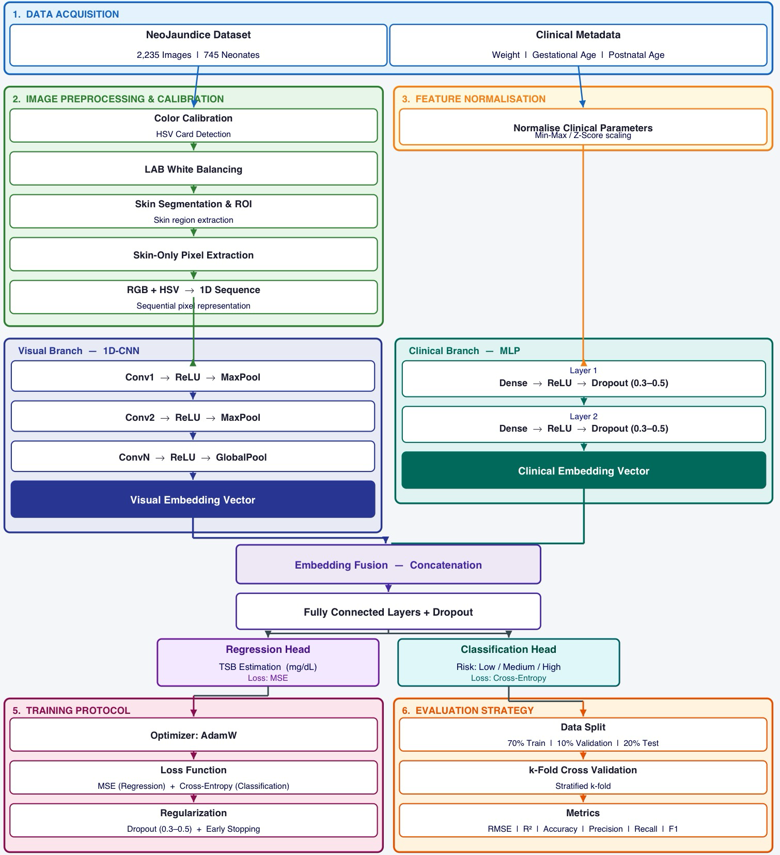
Chapter 6: Methodology
Chapter 7: System Requirement

1. Software Requirements
Operating System : Windows 10/11 (64-bit) or Ubuntu Linux (64-bit)
Software : Python 3.8 or above, Jupyter Notebook / VS Code, OpenCV, NumPy, Pandas, Scikit-learn, TensorFlow / PyTorch
Compiler : Python Interpreter

2. Hardware Requirements
Processor : Dual Core 2.7 GHz or better
RAM : 8GB or higher
Disk Space : 5GB minimum free space

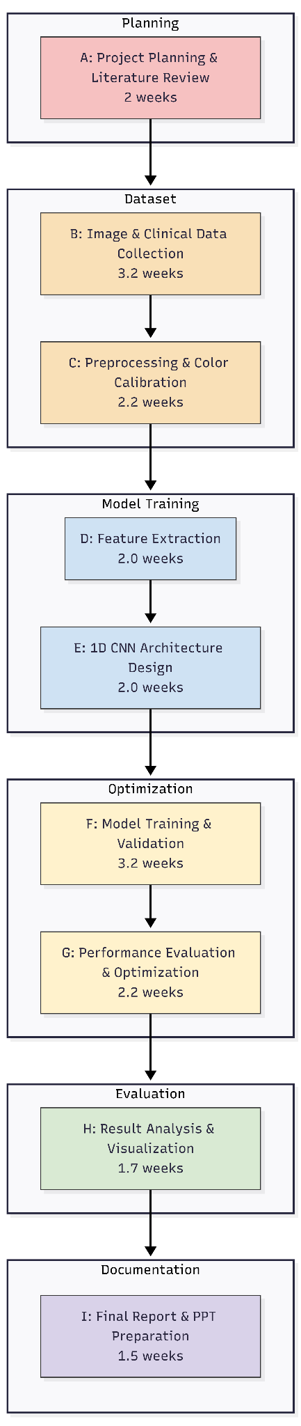
Chapter 8: PERT Chart

Chapter 9: References
[1] Khanam, F. T. Z., Al-Naji, A., Perera, A. G., Wang, D., & Chahl, J. (2023). Non-invasive and non-contact automatic jaundice detection of infants based on random forest. Computer Methods in Biomechanics and Biomedical Engineering: Imaging & Visualization, 11(6), 2516-2529.
https://www.tandfonline.com/doi/full/10.1080/21681163.2023.2244601
[2] Salami, F. O., Muzammel, M., Mourchid, Y., & Othmani, A. (2025). Artificial intelligence non-invasive methods for neonatal jaundice detection: A review. Artificial Intelligence In Medicine, 162, 103088.
https://doi.org/10.1016/j.artmed.2025.103088
[3] Chakraborty, A., Thota, Y., Luca, C., & van der Linde, I. (2025). Explainable Deep Learning for Neonatal Jaundice Classification Using Uncalibrated Smartphone Images. Machine Learning and Knowledge Extraction, 7(4), 136
https://doi.org/10.3390/make7040136
[4] Makhloughi, F. (2025). Artificial intelligence-based non-invasive bilirubin prediction for neonatal jaundice using 1D convolutional neural network. Scientific Reports, 15, 11571
https://doi.org/10.1038/s41598-025-96100-9
[5] Khanam, F. T. Z., Al-Naji, A., Perera, A. G., Wang, D., & Chahl, J. (2023). Non-invasive and non-contact automatic jaundice detection of infants based on random forest. Computer Methods in Biomechanics and Biomedical Engineering: Imaging & Visualization, 11(6), 2516–2529.
https://doi.org/10.1080/21681163.2023.2244601
[6] Karim, R., Zaman, M., & Yong, W. H. (2023). A Non-invasive Methods for Neonatal Jaundice Detection and Monitoring to Assess Bilirubin Level: A Review. Annals of Emerging Technologies in Computing (AETiC), 7(1), 15-29.
https://doi.org/10.33166/AETiC.2023.01.002
[7] Althnian, A., Almanea, N., & Aloboud, N. (2021). Neonatal Jaundice Diagnosis Using a Smartphone Camera Based on Eye, Skin, and Fused Features with Transfer Learning. Sensors, 21(21), 7038.
https://doi.org/10.3390/s21217038
[8] Outlaw, F., Meek, J., MacDonald, L. W., & Leung, T. S. (2017). Screening for Neonatal Jaundice with a Smartphone. DH '17: Proceedings of the 2017 International Conference on Digital Health, 241–242.
https://doi.org/10.1145/3079452.3079488
[9] Hashim, W., Al-Naji, A., Al-Rayahi, I. A., & Oudah, M. (2021). Computer vision for jaundice detection in neonates using graphic user interface. IOP Conference Series: Materials Science and Engineering, 1105(1), 012076.
https://doi.org/10.1088/1757-899X/1105/1/012076
[10] Hardalaç, F., Aydın, M., Kutbay, U., Ayturan, K., Akyel, A., Çağlar, A., ... & Mert, F. (2021). Classification of neonatal jaundice in mobile application with noninvasive image processing methods. Turkish Journal of Electrical Engineering and Computer Sciences, 29(4), 2116–2126. https://doi.org/10.3906/elk-2008-76
[11] Rizvi, M. R., Alaskar, F. M., Albaradie, R. S., Rizvi, N. F., & Al-Abdulwahab, K. (2019). A novel non-invasive technique of measuring bilirubin levels using BiliCapture. Oman Medical Journal, 34(1), 26–33. https://doi.org/10.5001/omj.2019.05
[12]Padidar, P., Shaker, M., Amoozgar, H., Khorraminejad-Shirazi, M., Hemmati, F., Najib, K. S., ... & Pourarian, S. (2019). Detection of neonatal jaundice by using an android OS-based smartphone application. Iranian Journal of Pediatrics, 29(2), e84397.
https://doi.org/10.5812/ijp.84397

