**MediaWiki Helm Automation**

***NOTE: As my free tier aws account limit has ended, I have spin up the own   
 managed kubernetes cluster to perform this assignment.***

1. Clone the repository <https://github.com/shubh-cs29/shubham-mediawiki-chart.git>
2. Go to the shubham-mediawiki-chartdirectory.
3. Run the helm command to create the chart   
   **helm install <chart-name-any> . --values mediawiki-values.yaml**

(it will installs the required kubernetes objects like mediawiki application and mariadb database and its services)

If you have to change any parameter then edit the **mediawiki-values.yaml** file.

1. Note down the IP address of database service (**mediawiki-database-svc**)  
   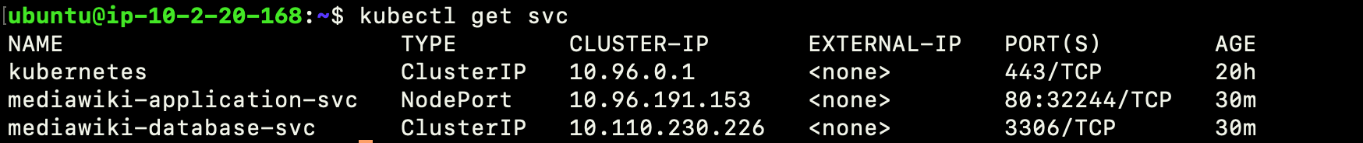
2. Allow the port **(32244)** of **mediawiki-application-svc** from **0.0.0.0/0** in the security group of kubernetes cluster.
3. Use the IP address of any kubernetes cluster node with **mediawiki-application-svc** port & hit it in the browser7.

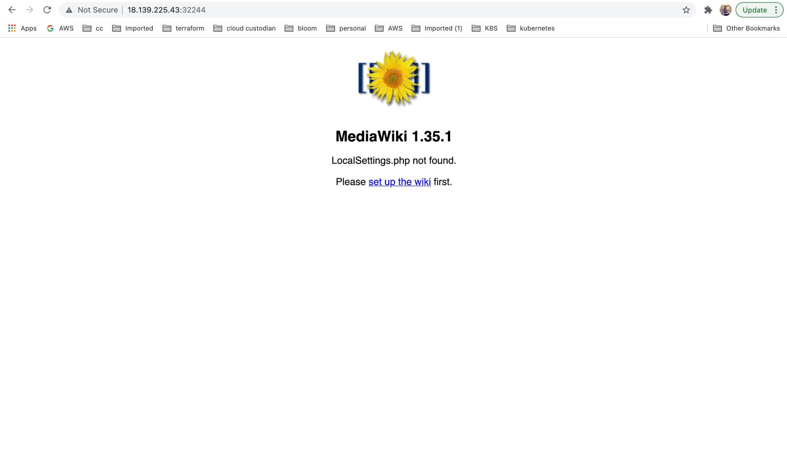

1. Click on the [set up the wiki](http://18.139.225.43:32244/mw-config/index.php) hyperlink.
2. Select the languages as per convenient and click on continue  
   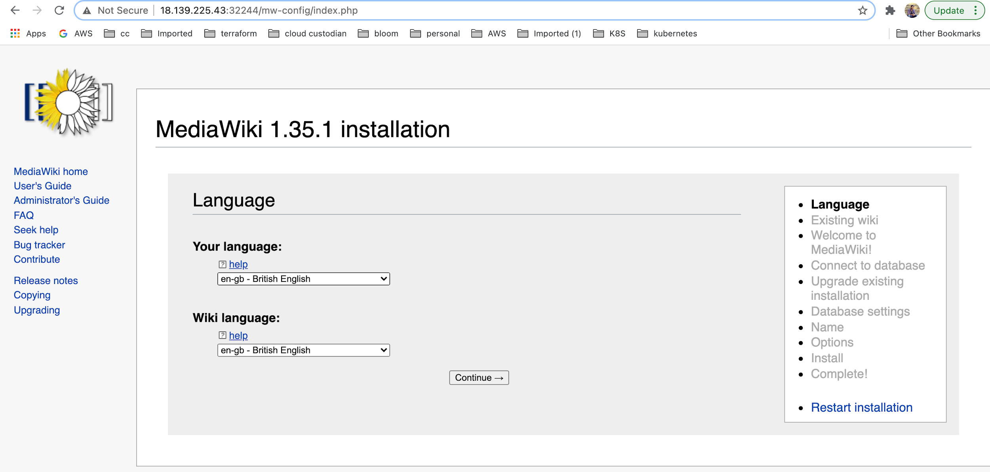
3. After it shows one instruction page click on continue there.
4. Now we have to set up database connectivity with the mediawiki application.  
   Database type: MariaDB  
   Database host: ClusterIP of **mediawiki-database-svc** (see the step 4)  
   Database name: my_wiki (see the **mediawiki-values.yaml**)  
   Database table prefix: keep it as blank  
   Database username: wikiuser  
   Database password: example  
   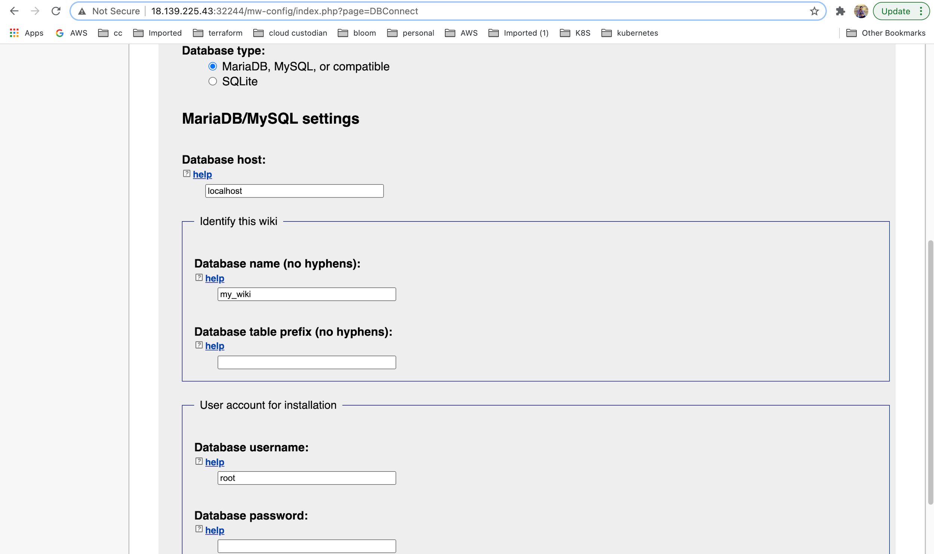
5. Click on continue.  
   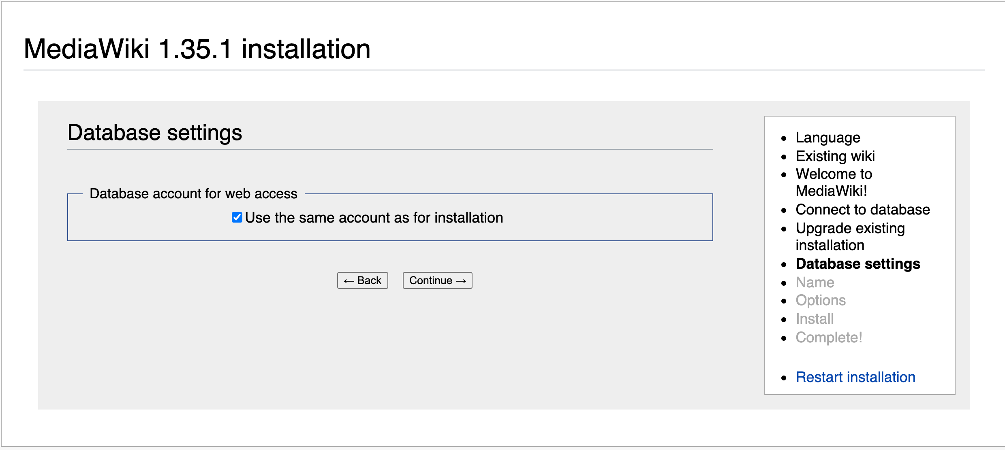
6. Fill the information and click on continue.  
   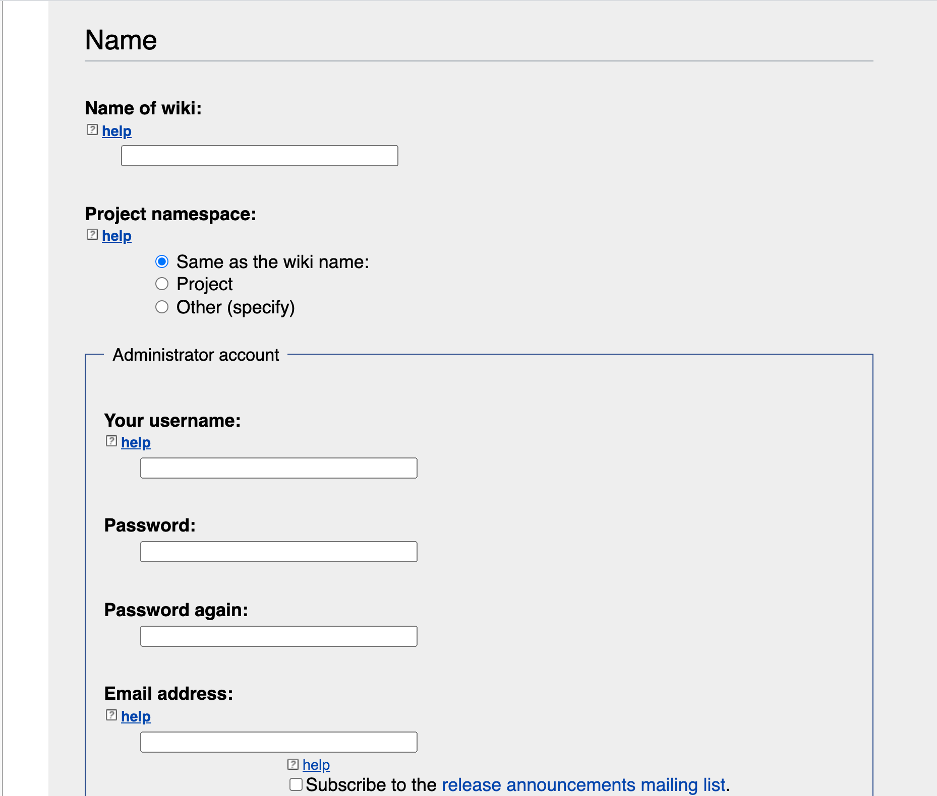
7. Click on continue.  
   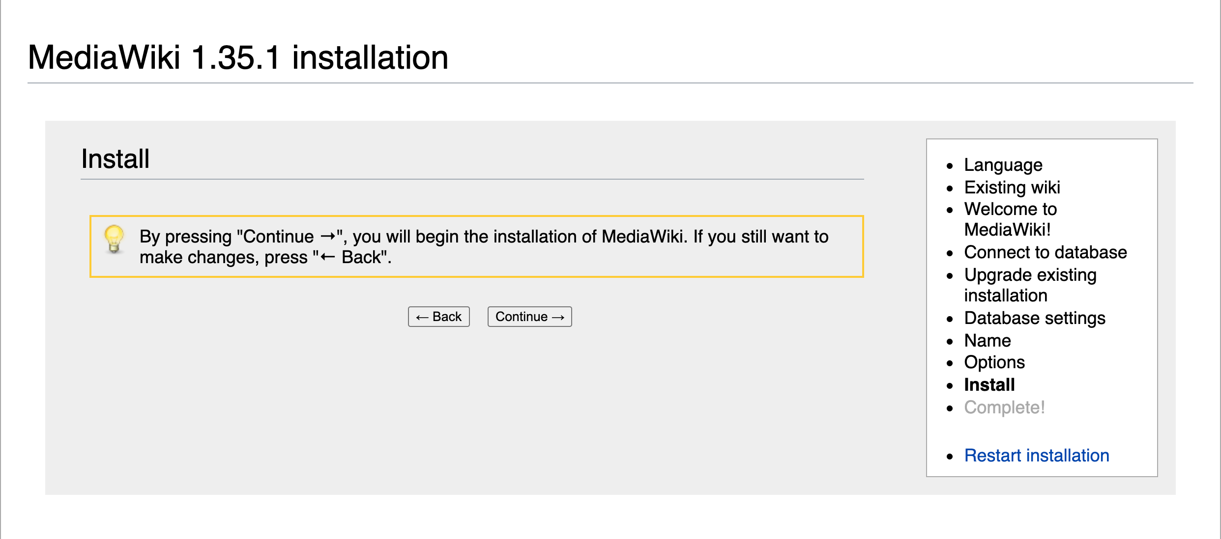
8. Finally last step of installation.  
   