Game Design Document

Fill up the Following document

1. Write the title of your project.

Space simulator

1. What is the goal of the game?

To reach the moon, mars and to clear debris

1. Write a brief story of your game?

Our mission has failed and now we have money to launch only one

Mission now we have to complete some to make money to launch

A debris mission to clean the space.

1. Which are the playing characters of this game?

* Playing characters are the ones which respond to the user based on the input from the user
* Cars, monkeys, dinos, wizards etc, are the playing characters in the game.

|  |  |  |
| --- | --- | --- |
| Number | Character Name | What can this character do? |
| 1 | Rocket | Move left-right |
| 2 |  |  |
| 3 |  |  |
| 4 |  |  |
| 5 |  |  |
| 6 |  |  |
| 7 |  |  |
| 8 |  |  |

1. Which are the Non Playing Characters of this game?

* Non Playing characters are the ones which don't have an action or a behaviour when the user interacts with the game.
* Hurdles, stones, bananas, coins, etc are non playing characters in the game.

|  |  |  |
| --- | --- | --- |
| Number | Character Name | What can this character do? |
| 1 | Asteroid | Can destroy the rocket |
| 2 | Debris(waste satellites) | Can go backwards |
| 3 | Comets | Destroy the rocket |
| 4 |  |  |
| 5 |  |  |
| 6 |  |  |
| 7 |  |  |
| 8 |  |  |

Draw your imagination of this game. What does this game look like?

* Draw the game either on your computer or on paper,
* Add images of scenes of the game to show each of the playing and non-playing characters at least once.

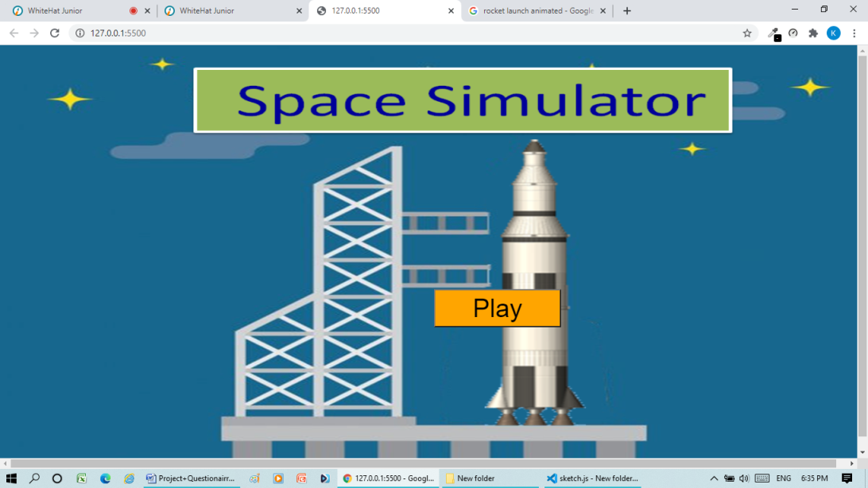

How do you plan to make your game engaging?

By adding asteroid and comets and debris.