Lab 04 – Multi-Table Queries and Views

# Objective:

The purpose of this lab is to introduce students to querying data from multiple tables. Relationships are used in relational databases to reduce redundant and repetitive data, but it is necessary to reconnect these tables when extracting data and obtaining information. Student will be able to:

* produce query results containing data from multiple tables using ANSI-92 joins and demonstrate their knowledge of inner, outer and full joins.
* To actively troubleshoot queries to handle potentially ambiguous fields across multiple tables through the use of aliases
* Students learn to create and modify views.

# Submission:

***Your submission will be a single WORD file with the solutions provided.***

Your submission needs to follow the same question order and clearly indicate the answers to each question. Make sure every SQL statement terminates with a semicolon.

**ALL questions must be answered using ANSI-92 JOINs unless otherwise stated**. ANSI-89 are obsolete and should not be used in new query derivations. We only teach them in case you see them in the workplace, that you know what they are and how they work.

# Tasks:

## Select data from multiple tables

1. Create a query that shows retail customers first name and last name along with their sales rep employee number and their first name, last name, city, phone numberand postal code for all retail customers who live in Singapore.
   1. Answer this question using an ANSI-89 Join

**SELECT CONTACTFIRSTNAME , CONTACTLASTNAME,EMPLOYEENUMBER, FIRSTNAME, LASTNAME,**

**city, phone, postalcode**

**FROM RETAILCUSTOMERS, RETAILEMPLOYEES**

**WHERE city = 'Singapore';**

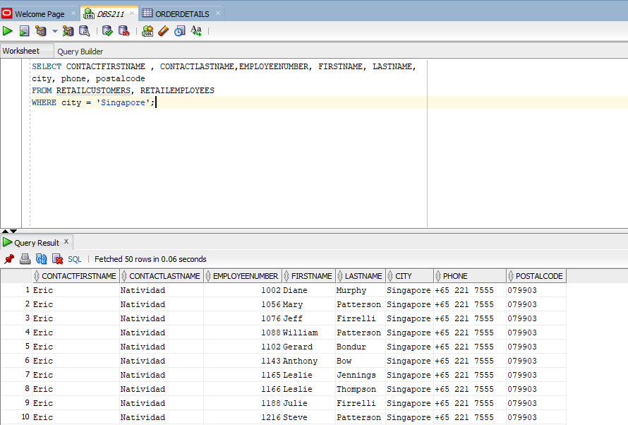

* 1. Answer this question using an ANSI-92 Join

**SELECT c.CONTACTFIRSTNAME , c.CONTACTLASTNAME,e.EMPLOYEENUMBER, e.FIRSTNAME, e.LASTNAME,**

**c.city, c.phone, c.postalcode**

**FROM RETAILCUSTOMERS c JOIN RETAILEMPLOYEES e**

**ON c.SALESREPEMPLOYEENUMBER = e.EMPLOYEENUMBER**

**WHERE c.city = 'Singapore';**

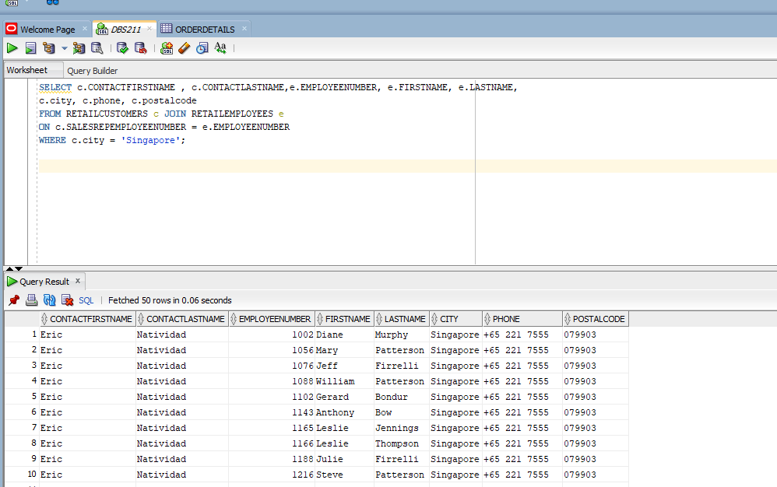

1. Create a query that displays all retail payments made by retail customers from USA.
   1. Sort the output by Customer Number.
   2. Only display the Customer Number, Customer Name,Country, Payment Date and Amount.
      1. Make sure the date is displayed clearly to know what date it is. (i.e. what date is 02-04-19??? – Feb 4, 2019, April 2, 2019, April 19, 2002, ….)

**SELECT RETAILCUSTOMERS.CUSTOMERNUMBER, CUSTOMERNAME, COUNTRY, TO_CHAR(PAYMENTDATE, 'MON DD, YYYY') AS PAYMENTDATE, AMOUNT**

**FROM RETAILCUSTOMERS JOIN RETAILPAYMENTS**

**ON RETAILCUSTOMERS.CUSTOMERNUMBER = RETAILPAYMENTS.CUSTOMERNUMBER**

**WHERE COUNTRY = 'USA'**

**ORDER BY CUSTOMERNUMBER**

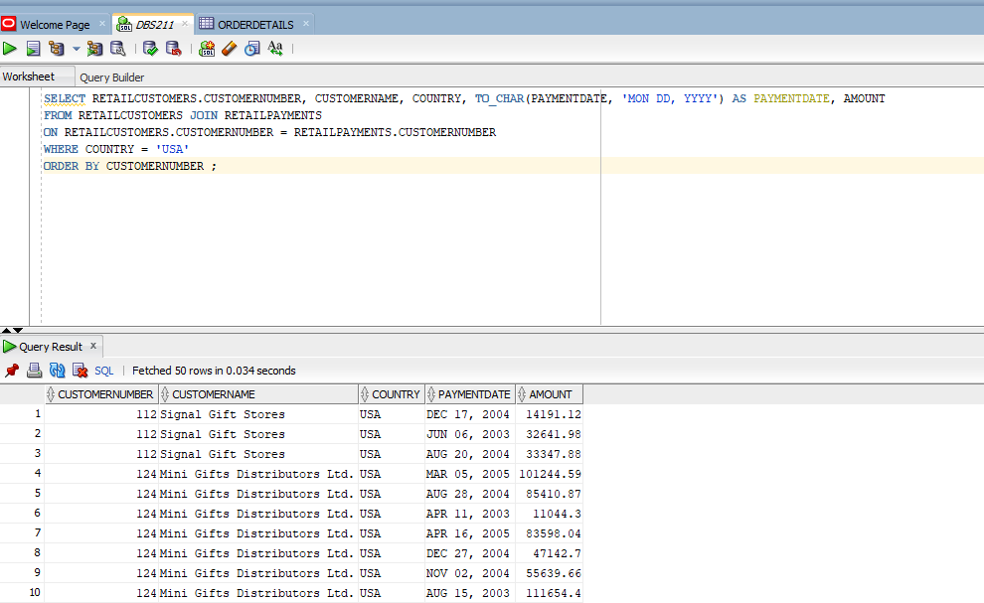

1. Create a query that shows all Canada customers who have not made a payment. Display only the customer number ,customer name, amount sorted by customer number.

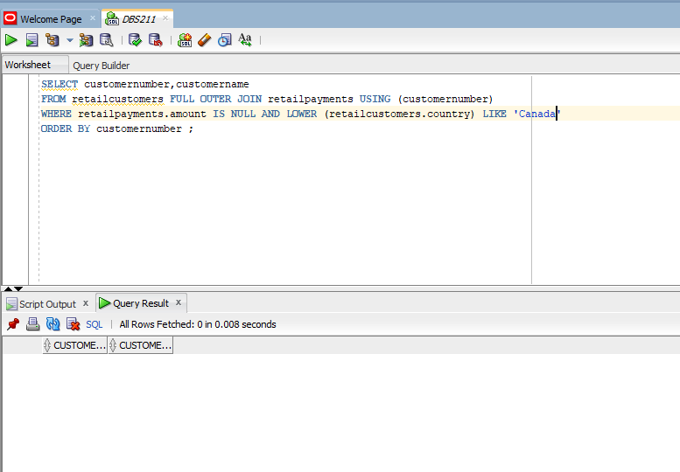

## Views and Joins

1. Display all the retail orders with quantity ordered, price of each item, who have their order shipped and who live in Denmark

**SELECT r.*, o.QUANTITYORDERED, o.PRICEEACH, c.CUSTOMERNAME,c.COUNTRY**

**FROM RETAILORDERS r JOIN ORDERDETAILS o**

**ON o.ORDERNUMBER = r.ORDERNUMBER**

**JOIN RETAILCUSTOMERS c**

**ON r.CUSTOMERNUMBER = c.CUSTOMERNUMBER**

**WHERE STATUS = 'Shipped' AND c.COUNTRY = 'Denmark'**

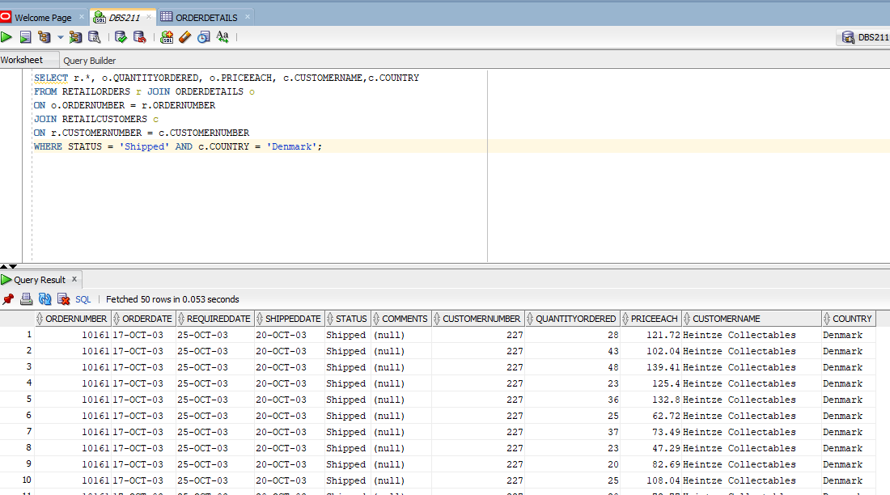

1. Create a view (***vwProductOrder***) to list all the retail products with the following data:

Product code, product name, msrp, buyprice, quantity ordered, andprice for each product in every order.

**CREATE VIEW vwProductOrder AS**

**SELECT p.PRODUCTCODE, p.PRODUCTNAME, p.MSRP, p.BUYPRICE, o.QUANTITYORDERED, o.PRICEEACH**

**FROM RETAILPRODUCTS p JOIN ORDERDETAILS o**

**ON p.PRODUCTCODE = o.PRODUCTCODE;**

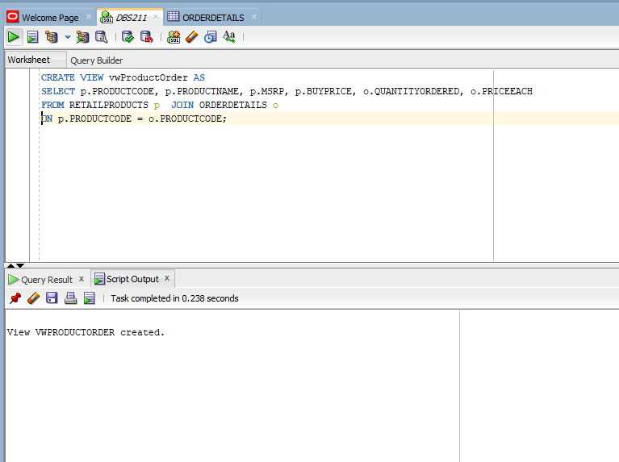

b) Write a statement to view the results of the view just created.

**SELECT * FROM vwProductOrder;**

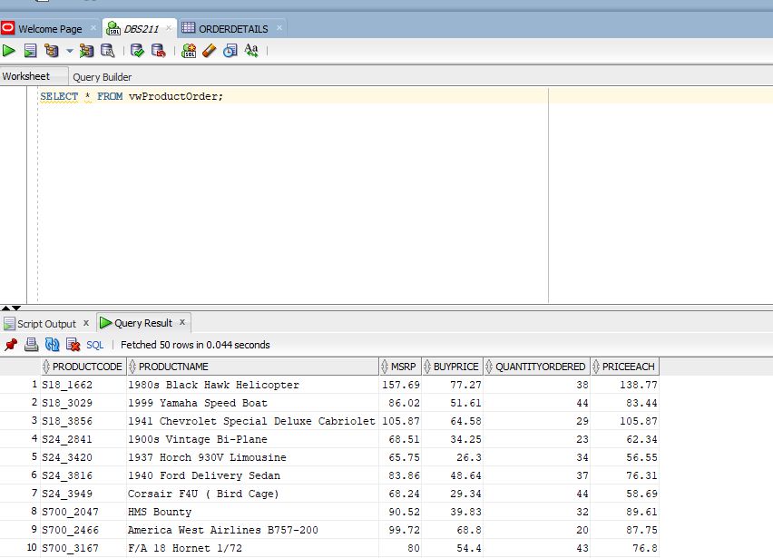

1. Using the ***vwProductOrder*** view, display the product order information with product name, buyprice ,order line number anwhose buy price is in the range from $30 to $40 and whose product code starts with ‘s32’. Sort the output based on product name and then buy price. (Hint: orderLineNumber is not in the view then how can you get in this query?)

**SELECT retailproducts.productname , retailproducts.buypricee , orderdetails.orderlinenumber**

**FROM retailproducts**

**JOIN orderdetails**

**ON retailproducts.productcode = orderdetails.productcode**

**WHERE orderdetails.buyprice BETWEEN 30 AND 40**

**AND retailproducts.productcode LIKE 's32%'**

**ORDER BY retailproducts.productname , orderdetails.buyprice ;**

1. Create a query that displays the customer order information with customer number, first name, last name, phone, and credit limits for all customers who do not have any orders.

**SELECT c.customernumber, c.contactfirstname, c.contactlastname, c.phone,c.creditlimit**

**FROM retailcustomers c**

**WHERE c.customernumber NOT IN (SELECT customernumber FROM retailorders);**

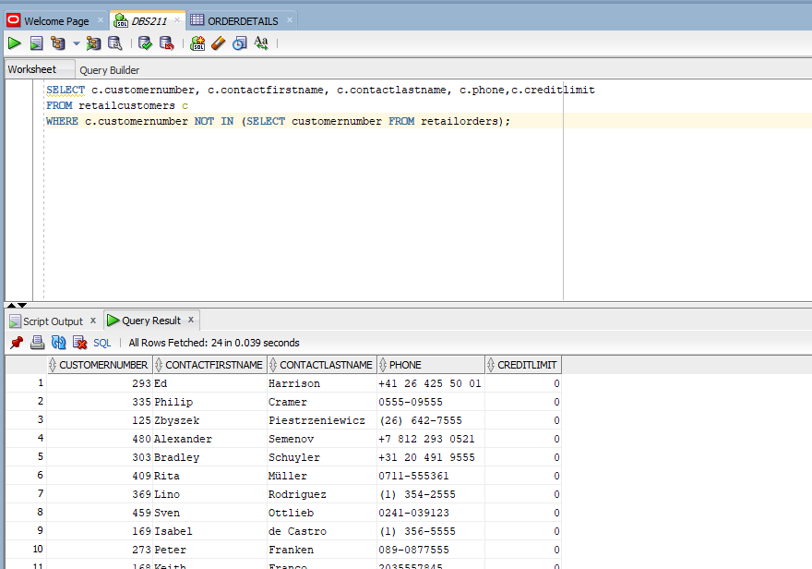

1. Create a view (***vwEmployeeManager***) to display the information of all retail employees first name and last name and their managers first name and managers last name if there is any manager that the employee reports to. Include all employees, including those who do not report to anyone.

**CREATE VIEW vwEmployeeManager AS**

**SELECT e.firstname,e.lastname,m.firstname as ManagerFirstName,m.lastname as ManagerLastName**

**FROM retailemployees e left outer JOIN retailemployees m**

**ON e.reportsto = m.employeenumber;**

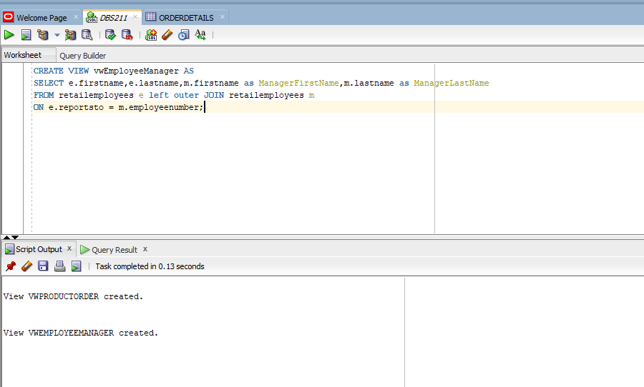

1. Modify the ***vwEmployeeManager*** view so the view returns only employee information foremployees who have a manager. Do not DROP and recreate the view – modify it. (Google is your friend).

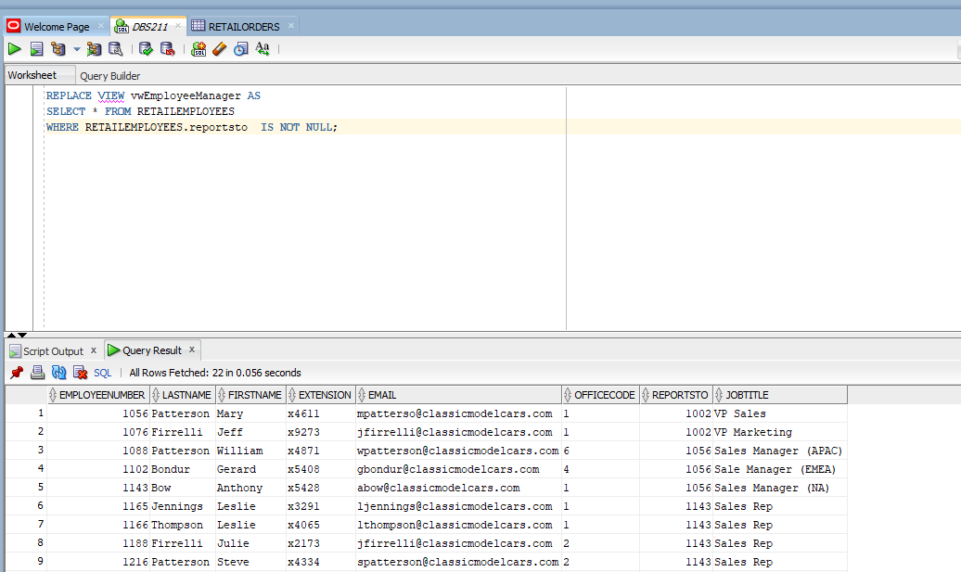

1. Drop both ***vwProductOrder*** and ***vwEmployeeManager*** views.

**DROP VIEW vwProductOrder;**

**DROP VIEW vwEmployeeManager;**

