Lab 7 (Stored Procedures/Iterative Statements)

**Submission**

***ON Blackboard***

Create a new Worksheet in SQL Developer. Save the file as L06_ID#_LASTNAME.txt

Your submission needs to be commented and include the question and the solutions in Word document

In this Lab, you create PL/SQL stored procedures to perform the following tasks. As you know, a stored procedure does not return any value. To send values back to the caller, you can use OUT parameters.

A parameter can be

* IN parameter
* OUT parameter
* IN OUT parameter

See the following template:

|  |
| --- |
| **CREATE** **OR REPLACE** *procedure_name*(**arg1** **IN**/**OUT/IN OUT** data_type, ...) AS  **BEGIN**  ....  **EXCEPTION**  **WHEN OTHERS**  **THEN**  DBMS_OUTPUT.PUT_LINE ('Error!');  **END** procedure_name; |

For all the stored procedures make sure you handle all exceptions such as

* TOO_MANY_ROWS
* NO_DATA_FOUND
* OTHERS
* . . .

Besides checking all required exceptions, have the OTHER exception checked just in case any error occurs that has not been anticipated at the time you write the code.

Tasks

1 The company wants to calculate what the new buy price of each retail product would be:

Write a stored procedure named ***calculate_newbuyprice*** which calculates the new buying price by multiplying the percentage increase for each othe productline given in the table. (Use CASE statements for each productline and FOR loop construct for each retail product).

|  |  |
| --- | --- |
| PRODUCTLINE | PERCENT OF BUYPRICE INCREASE |
| Trucks and Buses | 1.1 |
| Vintage Cars | 1.5 |
| Classic Cars | 1.2 |
| Ships | 1.3 |
| Motorcycles | 1.2 |
| Trains | 1.6 |
| Planes | 1.7 |

The procedure calculates and prints the product name, old buy price and new price.

Sample output:

Exception block should handle all error that might occur with custom messages for “If the buy price is 0” product does not exist, the procedure displays a proper message.

**CREATE OR REPLACE PROCEDURE calculate_newbuyprice AS**

**v_product_name retailproducts.productname%TYPE;**

**v_old_buy_price retailproducts.buyprice%TYPE;**

**v_new_buy_price NUMBER;**

**v_percentage NUMBER;**

**CURSOR product_cursor IS**

**SELECT productname, buyprice**

**FROM retailproducts;**

**BEGIN**

**dbms_output.put_line(**

**RPAD('Product Name', 25) ||**

**RPAD('Old Buy Price', 25) ||**

**RPAD('New Buy Price', 25)**

**);**

**dbms_output.put_line(**

**LPAD('-', 25, '-') ||**

**LPAD('-', 25, '-') ||**

**LPAD('-', 25, '-')**

**);**

**OPEN product_cursor;**

**LOOP**

**FETCH product_cursor into v_product_name, v_old_buy_price;**

**EXIT WHEN product_cursor%notfound;**

**-- Calculate new buy price based on product line percentage increase**

**CASE v_product_name**

**WHEN 'Trucks and Buses' THEN v_percentage := 1.1;**

**WHEN 'Vintage Cars' THEN v_percentage := 1.5;**

**WHEN 'Classic Cars' THEN v_percentage := 1.2;**

**WHEN 'Ships' THEN v_percentage := 1.3;**

**WHEN 'Motorcycles' THEN v_percentage := 1.2;**

**WHEN 'Trains' THEN v_percentage := 1.6;**

**WHEN 'Planes' THEN v_percentage := 1.7;**

**ELSE v_percentage := 1; -- Default percentage if productline not found**

**END CASE;**

**v_new_buy_price := v_old_buy_price * v_percentage;**

**-- Display information**

**dbms_output.put_line(**

**RPAD(v_product_name, 25) ||**

**RPAD(TO_CHAR(v_old_buy_price, '99999.99'), 25) ||**

**RPAD(TO_CHAR(v_new_buy_price, '99999.99'), 25)**

**);**

**END LOOP;**

**CLOSE product_cursor;**

**EXCEPTION**

**WHEN ZERO_DIVIDE THEN**

**dbms_output.put_line('Error: Buy Price is 0.');**

**WHEN NO_DATA_FOUND THEN**

**dbms_output.put_line('No products found.');**

**WHEN OTHERS THEN**

**dbms_output.put_line('Error: ' || SQLERRM);**

**END calculate_newbuyprice;**

**BEGIN**

**calculate_newbuyprice;**

**END;**

**/**

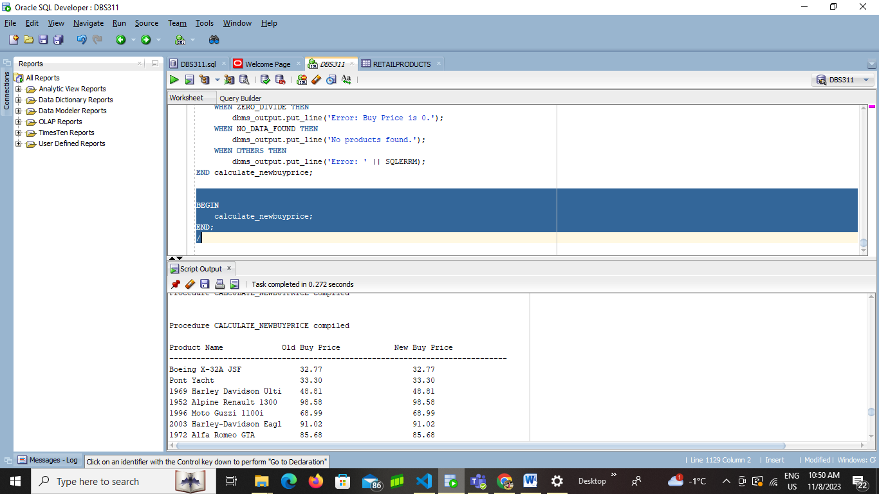

2 Write a stored procedure named **employee_works_here** to print the retail employee number, employee Last name and job title.(USING WHILE LOOP)

This is sample output

Employee # Last Name Job title

9999 Able Sales Rep

9998 Hostable Manager

If the value of the job title is null or does not exist, display “no job title”.

**CREATE OR REPLACE PROCEDURE employee_works_here AS**

**v_employee_number retailemployees.employeenumber%TYPE;**

**v_last_name retailemployees.lastname%TYPE;**

**v_job_title retailemployees.jobtitle%TYPE;**

**BEGIN**

**dbms_output.put_line(**

**RPAD('Employee #', 15) ||**

**RPAD('Last Name', 15) ||**

**RPAD('Job Title', 30)**

**);**

**dbms_output.put_line(**

**LPAD('-', 15, '-') ||**

**LPAD('-', 15, '-') ||**

**LPAD('-', 30, '-')**

**);**

**-- Cursor to fetch employee information**

**FOR employee_rec IN (**

**SELECT employeenumber, lastname, NVL(jobtitle, 'no job title') AS jobtitle**

**FROM retailemployees**

**)**

**LOOP**

**v_employee_number := employee_rec.employeenumber;**

**v_last_name := employee_rec.lastname;**

**v_job_title := employee_rec.jobtitle;**

**dbms_output.put_line(**

**RPAD(v_employee_number, 15) ||**

**RPAD(v_last_name, 15) ||**

**RPAD(v_job_title, 30)**

**);**

**END LOOP;**

**END employee_works_here;**

**BEGIN**

**employee_works_here;**

**END;**

**/**

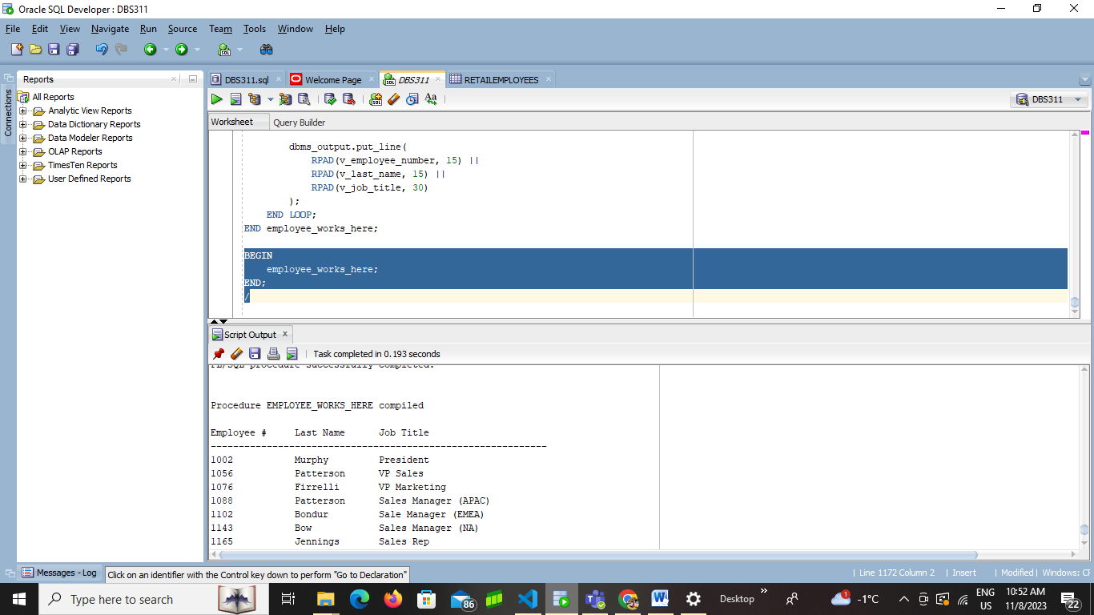

3. Write a stored procedure named CUSTOMER_credithistory to provide a list of retail customers name, credit limit and credit level using CURSORS.

If credit _limit is below $1000 display as “new customers” in credit level, if between 1000 to 5000 then display as” existing customers”. If above $4000 - $10,000 display as “credit approved for new increase” and others as “Waiting for Approval”

**CREATE OR REPLACE PROCEDURE CUSTOMER_credithistory AS**

**v_customer_name retailcustomers.customername%TYPE;**

**v_credit_limit retailcustomers.creditlimit%TYPE;**

**v_credit_level VARCHAR2(100);**

**CURSOR customer_cursor IS**

**SELECT customername, creditlimit**

**FROM retailcustomers;**

**BEGIN**

**dbms_output.put_line(**

**RPAD('Customer Name', 30) ||**

**RPAD('Credit Limit', 20) ||**

**RPAD('Credit Level', 30)**

**);**

**dbms_output.put_line(**

**LPAD('-', 30, '-') ||**

**LPAD('-', 20, '-') ||**

**LPAD('-', 30, '-')**

**);**

**OPEN customer_cursor;**

**LOOP**

**FETCH customer_cursor INTO v_customer_name, v_credit_limit;**

**EXIT WHEN customer_cursor%NOTFOUND;**

**-- Determine credit level based on credit limit**

**IF v_credit_limit < 1000 THEN**

**v_credit_level := 'New Customers';**

**ELSIF v_credit_limit BETWEEN 1000 AND 5000 THEN**

**v_credit_level := 'Existing Customers';**

**ELSIF v_credit_limit BETWEEN 4000 AND 10000 THEN**

**v_credit_level := 'Credit Approved for Increase';**

**ELSE**

**v_credit_level := 'Waiting for Approval';**

**END IF;**

**-- Display information**

**dbms_output.put_line(**

**RPAD(v_customer_name, 30) ||**

**RPAD(TO_CHAR(v_credit_limit, '99999.99'), 20) ||**

**RPAD(v_credit_level, 30)**

**);**

**END LOOP;**

**CLOSE customer_cursor;**

**EXCEPTION**

**WHEN NO_DATA_FOUND THEN**

**dbms_output.put_line('No customers found.');**

**WHEN OTHERS THEN**

**dbms_output.put_line('Error: ' || SQLERRM);**

**END CUSTOMER_credithistory;**

**BEGIN**

**CUSTOMER_credithistory;**

**END;**

**/**

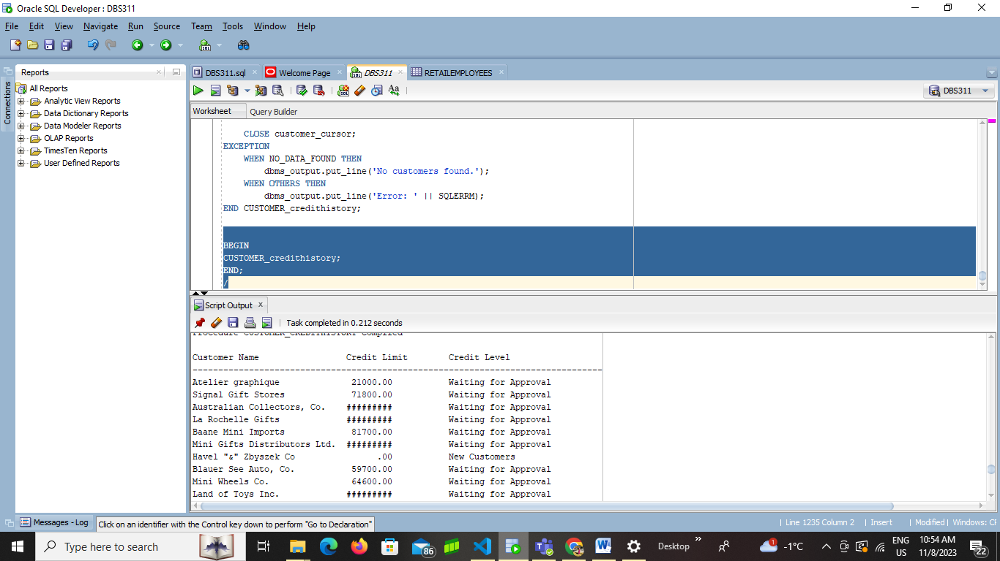

4.Write a PL/SQL stored procedure named order_status to provide a list of retail ORDERS with order id and status using WHILE loop structure.

**CREATE OR REPLACE PROCEDURE order_status AS**

**v_order_number retailorders.ordernumber%TYPE;**

**v_status retailorders.status%TYPE;**

**v_row_count NUMBER := 0;**

**BEGIN**

**dbms_output.put_line(**

**RPAD('OrderNUMBER', 15) ||**

**RPAD('Status', 30)**

**);**

**dbms_output.put_line(**

**LPAD('-', 15, '-') ||**

**LPAD('-', 30, '-')**

**);**

**-- Cursor to fetch order information**

**FOR order_rec IN (**

**SELECT ordernumber, status**

**FROM retailorders**

**)**

**LOOP**

**v_order_number := order_rec.ordernumber;**

**v_status := order_rec.status;**

**dbms_output.put_line(**

**RPAD(v_order_number, 15) ||**

**RPAD(v_status, 30)**

**);**

**v_row_count := v_row_count + 1;**

**END LOOP;**

**-- Check if no rows were fetched**

**IF v_row_count = 0 THEN**

**dbms_output.put_line('No orders found.');**

**END IF;**

**END order_status;**

**BEGIN**

**order_status;**

**END;**

**/**

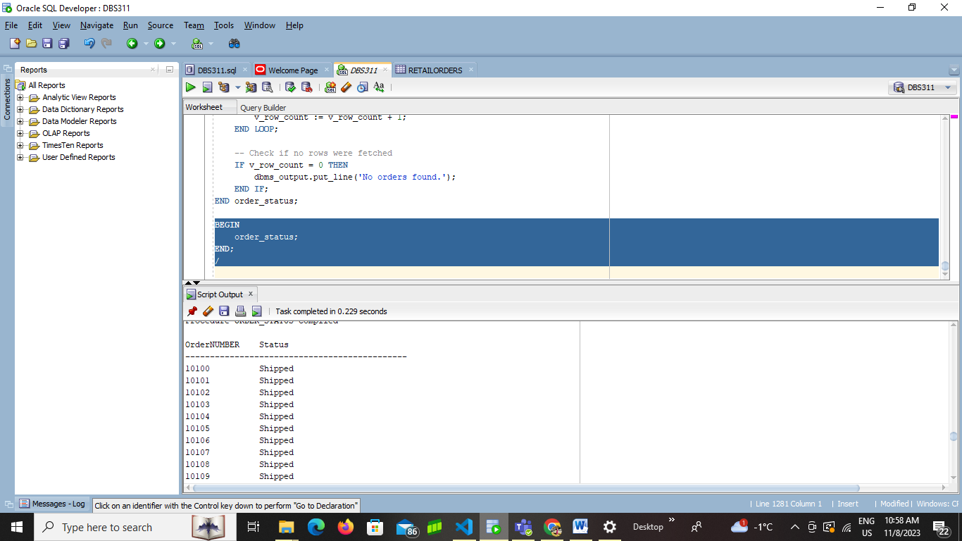

5 Create a new table OrderdetailsTmp from orderdetails. Add a new column called new_price. Write a PL/SQL stored procedure named orders_newprice. Using CURSORS update the new column in the orderdetailstmp table called new_price (it is the updated price). Fill the new_price column by the following calculation.

If price of each item is below $50 then add $30, if price of each item is between 50 to 100 then add $50, if it is between 200 to 500 then add $150 else add $200. Remember to display the price of each item, new_price and ordernumber before the update happens. Use cursors and case statement.

**CREATE OR REPLACE PROCEDURE orders_newprice AS**

**v_order_number OrderdetailsTmp.ordernumber%TYPE;**

**v_price_each OrderdetailsTmp.priceeach%TYPE;**

**v_new_price OrderdetailsTmp.new_price%TYPE;**

**v_increase NUMBER;**

**CURSOR order_cursor IS**

**SELECT ordernumber, priceeach**

**FROM OrderdetailsTmp;**

**BEGIN**

**dbms_output.put_line(**

**RPAD('Order Number', 20) ||**

**RPAD('Price Each', 20) ||**

**RPAD('New Price', 20)**

**);**

**dbms_output.put_line(**

**LPAD('-', 20, '-') ||**

**LPAD('-', 20, '-') ||**

**LPAD('-', 20, '-')**

**);**

**OPEN order_cursor;**

**LOOP**

**FETCH order_cursor INTO v_order_number, v_price_each;**

**EXIT WHEN order_cursor%NOTFOUND;**

**-- Calculate new price based on the given criteria**

**v_increase :=**

**CASE**

**WHEN v_price_each < 50 THEN 30**

**WHEN v_price_each BETWEEN 50 AND 100 THEN 50**

**WHEN v_price_each BETWEEN 200 AND 500 THEN 150**

**ELSE 200**

**END;**

**v_new_price := v_price_each + v_increase;**

**-- Display information before update**

**dbms_output.put_line(**

**RPAD(v_order_number, 20) ||**

**RPAD(v_price_each, 20) ||**

**RPAD(v_new_price, 20)**

**);**

**-- Update new_price column**

**UPDATE OrderdetailsTmp**

**SET new_price = v_new_price**

**WHERE ordernumber = v_order_number;**

**END LOOP;**

**CLOSE order_cursor;**

**dbms_output.put_line('Update complete.');**

**EXCEPTION**

**WHEN OTHERS THEN**

**dbms_output.put_line('Error: ' || SQLERRM);**

**END orders_newprice;**

**BEGIN**

**orders_newprice;**

**END;**

**/**

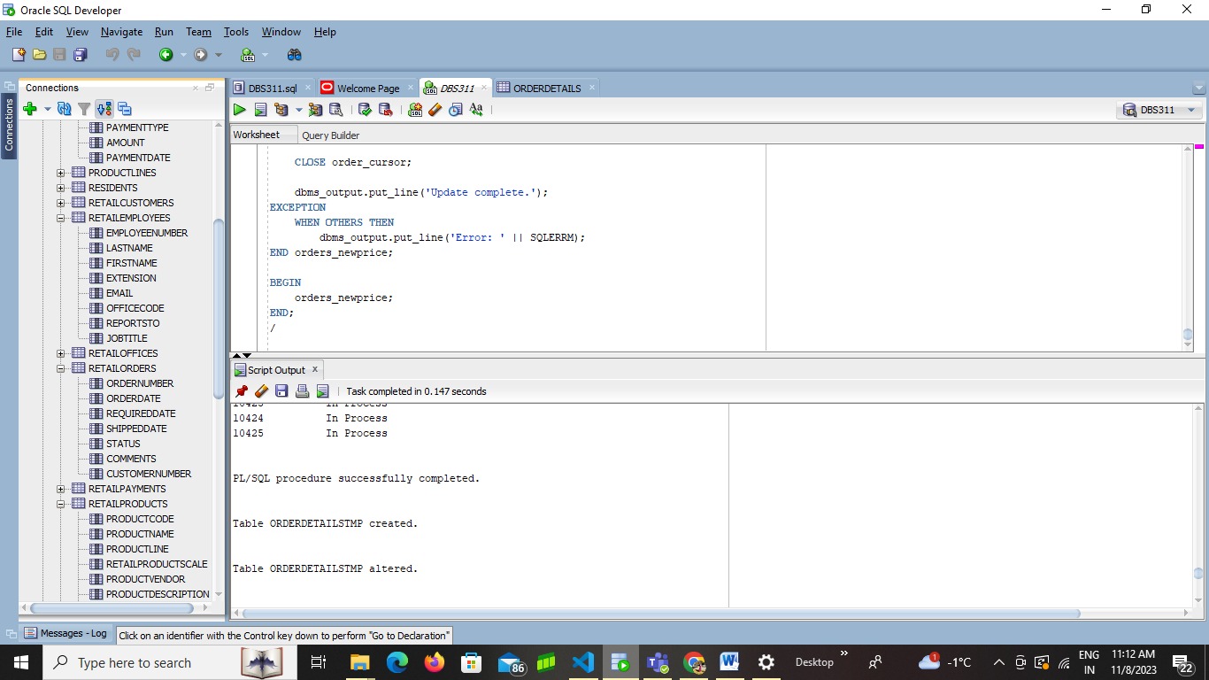

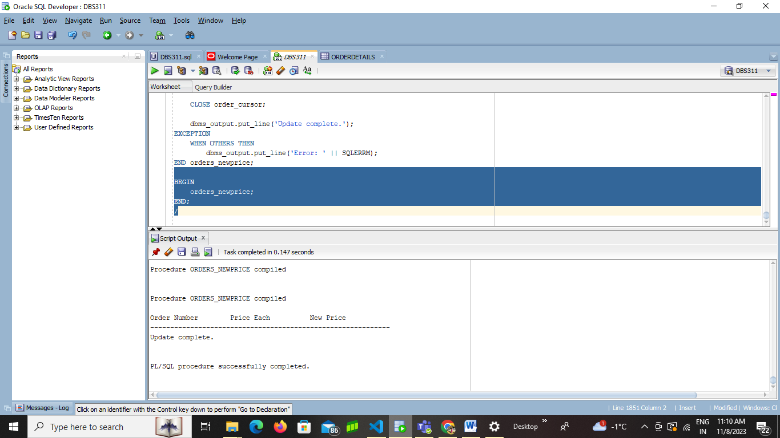

Go to next page to see sample submission

Example Submission

-- ***********************  
-- Name: Your Name  
-- ID: #########  
-- Date: The current date  
-- Purpose: Lab 7  
-- ***********************  
  
-- Question 1 – write a brief note about what the question is asking  
-- Q1 SOLUTION –

CREATE OR REPLACE procedure_name(arg1 data_type, ...) AS

BEGIN

....

EXCEPTION

WHEN OTHERS

THEN

DBMS_OUTPUT.PUT_LINE (Error!');

END procedure_name;

SAMPLE OUTPUT  
Begin

Procedurename

End

Connecting to the database TestDatabase.

*** OUTPUT update_low_prices STARTED ***

Number of updates: 22

--------ENDED---------

Process exited.

Disconnecting from the database TestDatabase.

-- Question 2 –

-- Q2 Solution –