Lab 03

# Objectives:

The purpose of this lab is to familiarize you with tables using multi-row functions, GROUPBY and ORDERBY.

# LAB 03 – SUBMISSION

You will be submitting a Word document with the questions listed followed by the answers with the SQL queries and screenshots of the results.

**In the Word document header you should have your Name, Student ID number, section,lab#. Give appropriate aliases for functions and have decimal values upto 2.**

**QUESTION 1**

Write a SQL statement using multi-row functions to display the total number of customers who have second address line and the total credit limit given to all RETAILCUSTOMERS.

**SELECT**

**COUNT(*) AS CustWith2ndAddress,**

**SUM(creditlimit) AS TotalCreditLimit**

**FROM**

**RETAILCUSTOMERS**

**WHERE**

**addressline2 IS NOT NULL;**

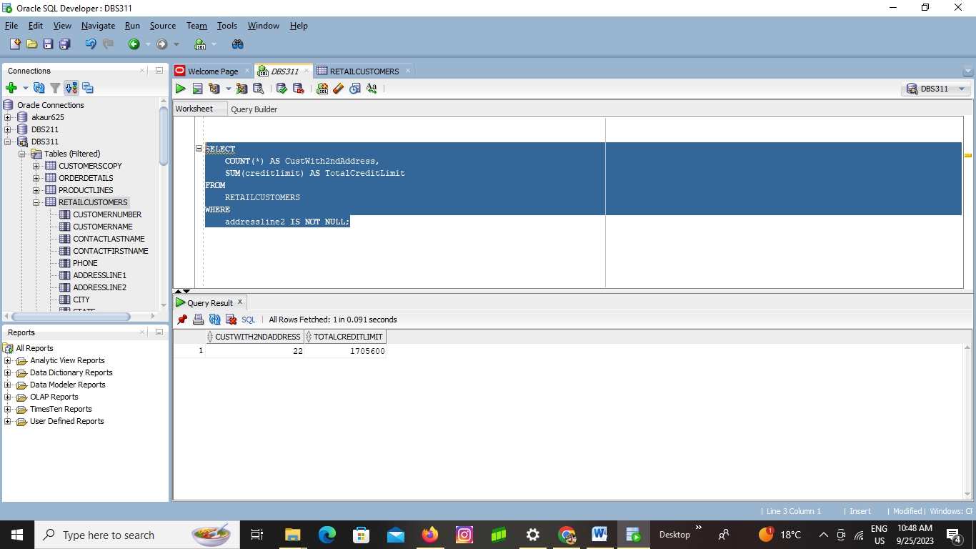

**QUESTION 2**

Write a SQL statement using multi-row functions to display the lowest MSRP, largest buy price and average quantity in stock for all RETAILPRODUCTS.

**SELECT**

**MIN(MSRP) AS LowestMSRP,**

**MAX(buyprice) AS LargestBuyPrice,**

**AVG(quantityinstock) AS AverageQuantityInStock**

**FROM**

**RETAILPRODUCTS;**

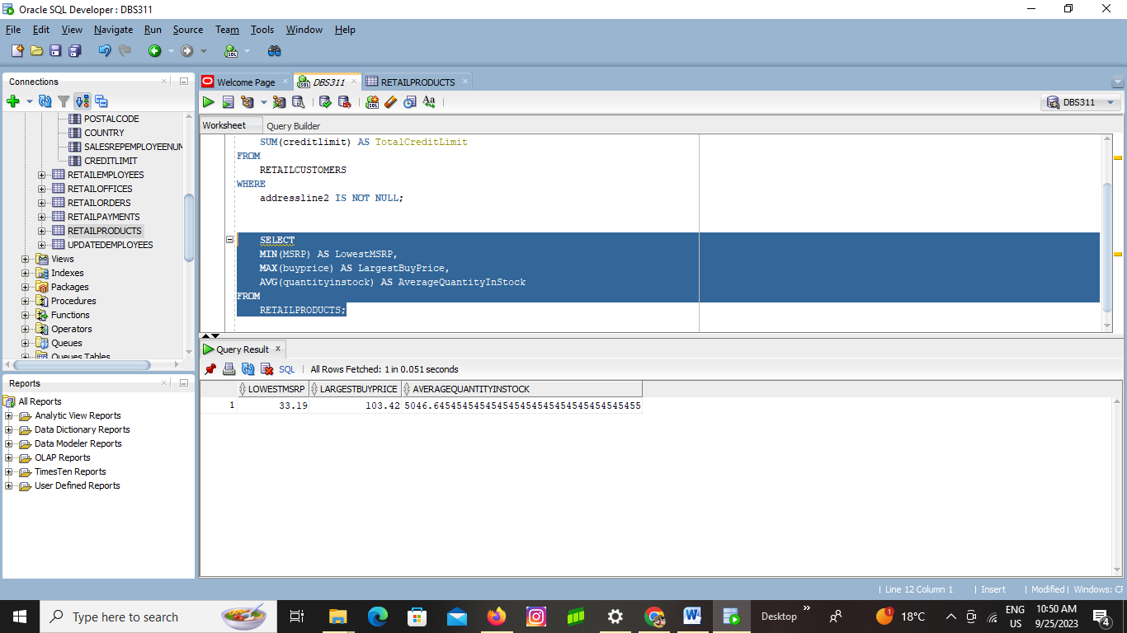

**QUESTION 3**

Write a SQL statements using multi-row functions to find the total of unique order dates and total number of comments given in RETAILORDERS table.

**SELECT**

**COUNT(DISTINCT OrderDate) AS TotalUniqueOrderDates,**

**COUNT(Comments) AS TotalComments**

**FROM RETAILORDERS;**

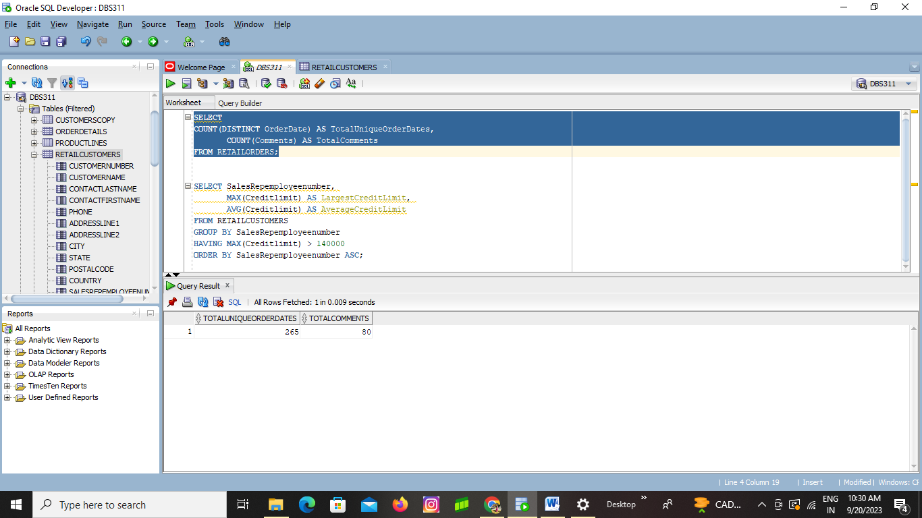

**QUESTION 4**

Write a SQL statement using multi-row functions to display the customer number and customer’s recent order date for each customer from RETAILORDERS table

**SELECT**

**o.customernumber,**

**MAX(o.orderdate) AS recent_order_date**

**FROM**

**RETAILORDERS o**

**GROUP BY**

**o.customernumber;**

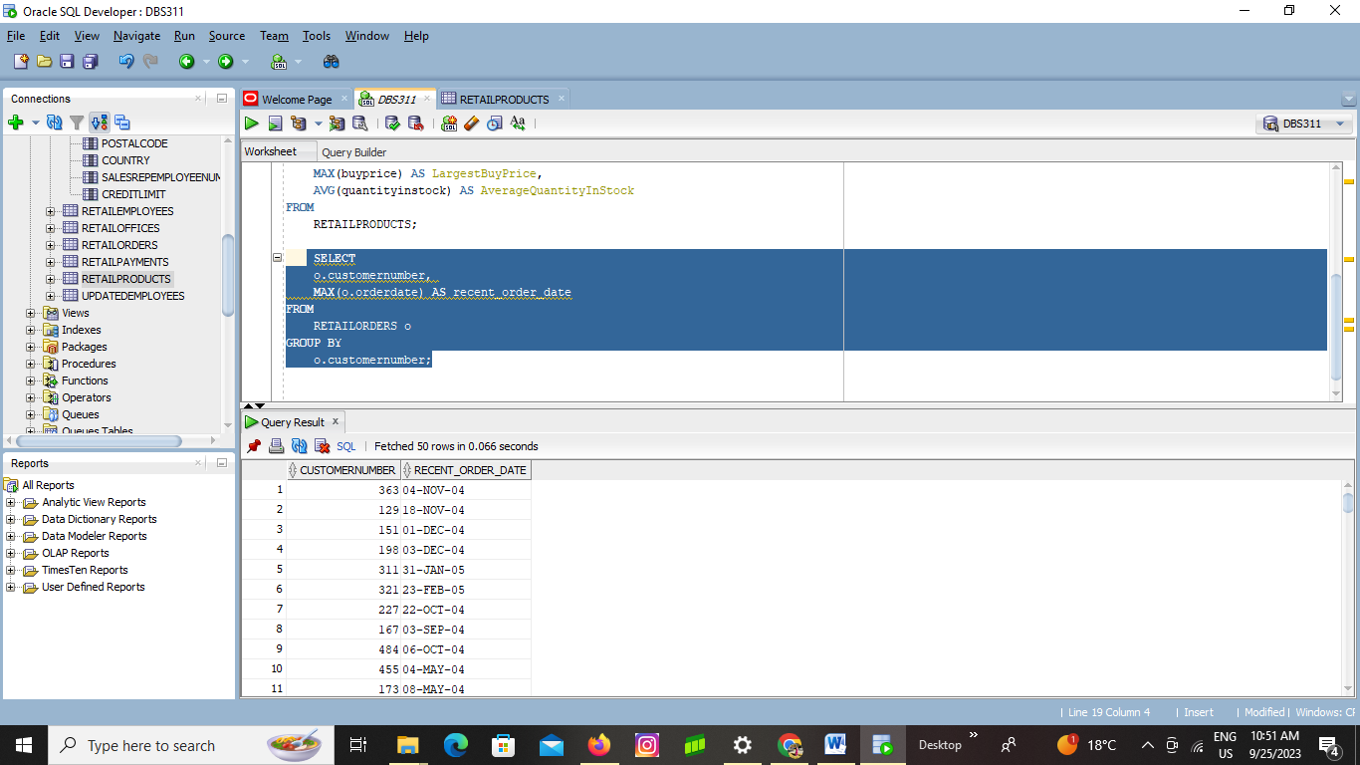

**QUESTION 5**

Write a SQL statement using multi-row functions to display RETAILEMPLOYEES who go first in line by firstname and last in line by firstname

**SELECT * FROM RETAILEMPLOYEES**

**WHERE firstname IN (**

**SELECT MIN(firstname)**

**FROM RETAILEMPLOYEES**

**UNION ALL**

**SELECT MAX(firstname)**

**FROM RETAILEMPLOYEES**

**);**

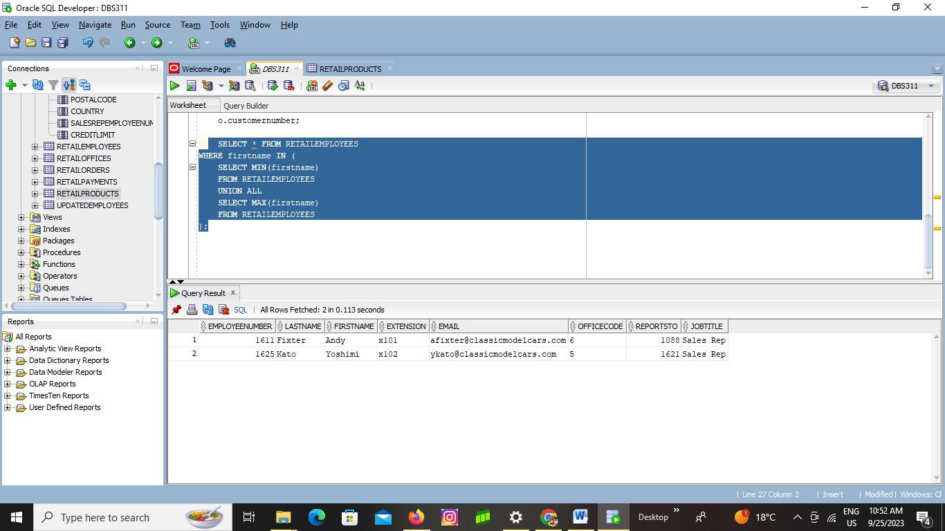

**QUESTION 6**

Write a SQL statement using multi-row functions to display the distinct first names in RETAILEMPLOYEES that end with letter ‘Y’ and also display the count of distinct lastnames that end with letter ‘Y’ in the same query using “Over () function”

**SELECT DISTINCT firstname,**

**COUNT(DISTINCT lastname) OVER () AS CountLastnamesEndingY**

**FROM RETAILEMPLOYEES**

**WHERE firstname LIKE '%Y'**

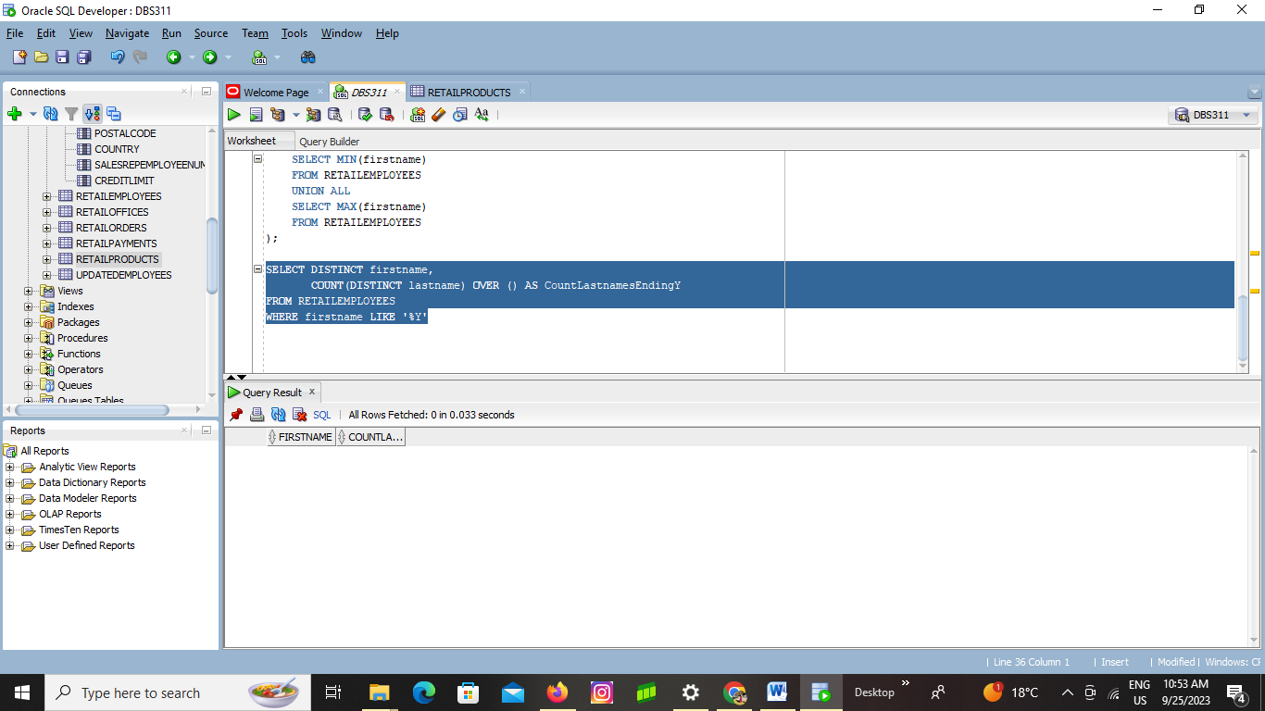

**QUESTION 7**

Write a SQL statement using group functions to display the order number and the count of order numbers in ORDERDETAILS table

**SELECT ordernumber, COUNT(ordernumber) AS order_count**

**FROM ORDERDETAILS**

**GROUP BY ordernumber;**

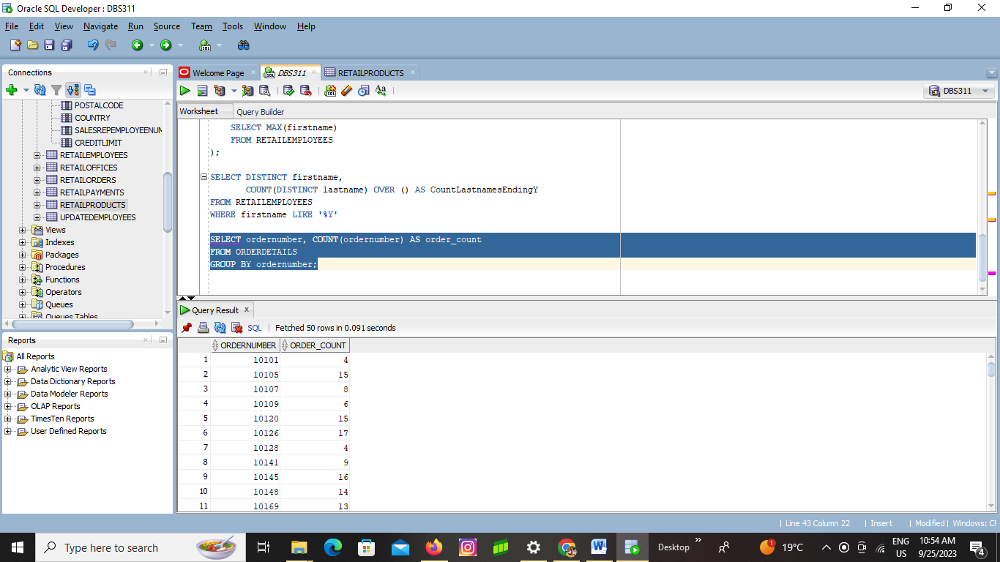

**QUESTION 8**

Write a SQL statement using group functions to display the sum and average of the price of each item in ORDERDETAILS when they are grouped by ordernumber.

**SELECT**

**ordernumber,**

**orderlinenumber,**

**SUM(priceeach) AS total_price,**

**AVG(priceeach) AS average_price**

**FROM**

**ORDERDETAILS**

**GROUP BY**

**ordernumber, orderlinenumber;**

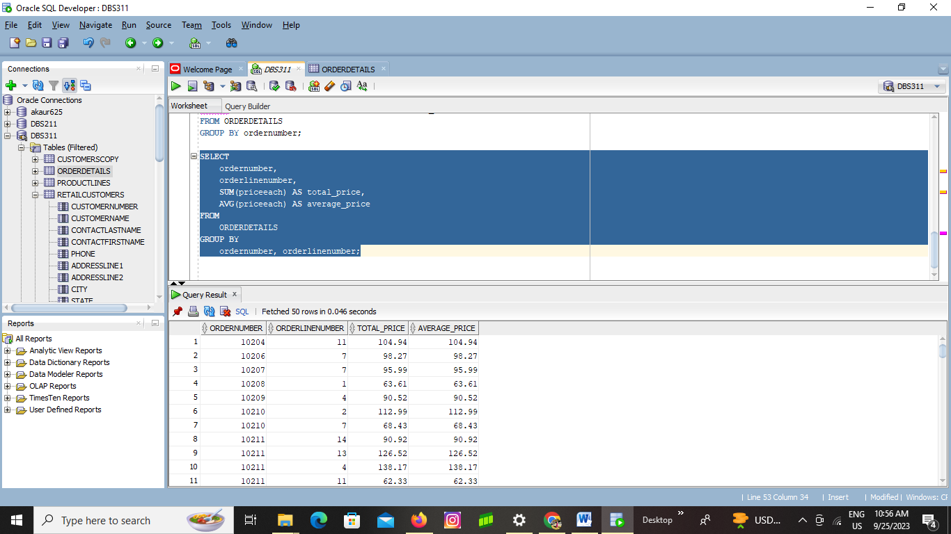

**QUESTION 9**

Write a SQL statement to display the office code and the number of employees working in each RETAILOFFICES.

**SELECT**

**officecode,**

**COUNT(*) AS num_employees**

**FROM**

**RETAILOFFICES**

**GROUP BY**

**officecode;**

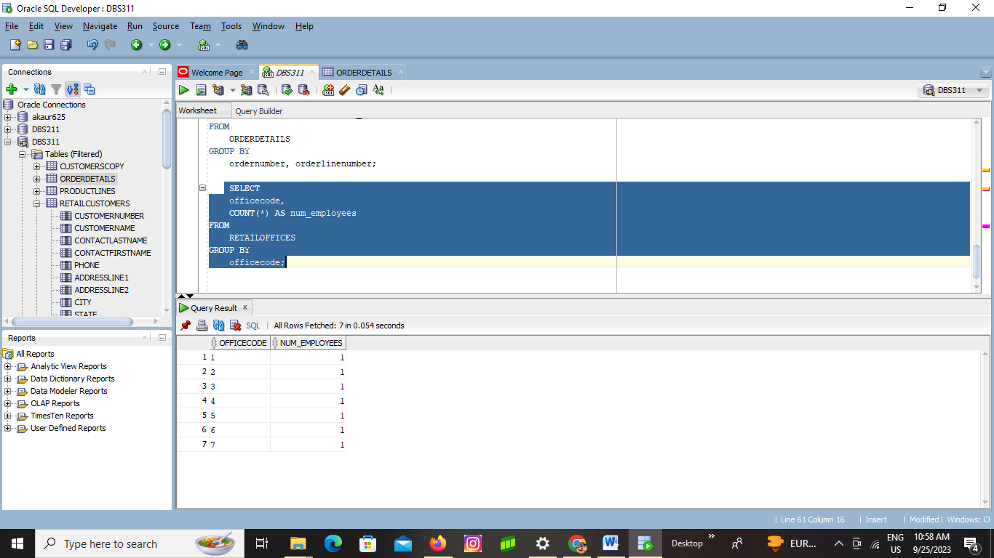

**QUESTION 10**

Write a SQL statement using group functions to display largest credit limit and the average credit limit of RETAILCUSTOMERS who have the same salesrep and show who have maximum credit limit above 140000. Display the above query sorted by salesrep in ascending order.

**SELECT SalesRepemployeenumber,**

**MAX(Creditlimit) AS LargestCreditLimit,**

**ROUND (AVG(Creditlimit) , 2) AS AverageCreditLimit**

**FROM RETAILCUSTOMERS**

**GROUP BY SalesRepemployeenumber**

**HAVING MAX(Creditlimit) > 140000**

**ORDER BY SalesRepemployeenumber ASC;**

