Join Task

CREATE Queries:-

CREATE TABLE employees(
id varchar(4) NOT NULL PRIMARY KEY,
name varchar(30),
salary int
);

CREATE TABLE departments(
id varchar(4) NOT NULL PRIMARY KEY,
name varchar(20)
);

CREATE TABLE managers(
id varchar(4) NOT NULL PRIMARY KEY,
name varchar(30),
dept_id varchar(4),
FOREIGN KEY (dept_id) REFERENCES departments(id)
);

CREATE TABLE Projects(
id varchar(4) NOT NULL,
name varchar(30),
team_member_id varchar(4),
FOREIGN KEY (team_member_id) REFERENCES employees(id)
);

CREATE TABLE family (
member_id varchar(4),
name varchar(20),
age int,
parent_id varchar(4)
);

ALTER Queries:-

ALTER TABLE employees
ADD dept_id varchar(4),
ADD manager_id varchar(4);

INSERT Queries:-

INSERT INTO departments VALUES
('D1', 'IT'),
('D2', 'HR'),
('D3', 'Finance'),
('D4', 'Admin');

INSERT INTO managers VALUES
('M1', 'Prem', 'D3'),
('M2', 'Andrew', 'D4'),
('M3', 'Nick', 'D1'),
('M4', 'Anderson', 'D1');

INSERT INTO employees VALUES
('E1', 'Shubham', 15000, 'D1', 'M1'),
('E2', 'Jaiki', 18000, 'D2', 'M1'),
('E3', 'Akhand', 20000, 'D1', 'M2'),
('E4', 'Rahul', 55000, 'D2', 'M2'),
('E5', 'Aayush', 22000, 'D10', 'M3'),
('E6', 'Shubham', 18000, 'D10', 'M3');

INSERT INTO Projects VALUES
('P1', 'Data Migration', 'E1'),
('P1', 'Data Migration', 'E2'),
('P1', 'Data Migration', 'M3'),
('P2', 'ETL Tool', 'E1'),
('P2', 'ETL Tool', 'M4');

INSERT INTO family VALUES
('F1', 'David', 4, 'F5'),
('F2', 'Carel', 10, 'F5'),
('F3', 'Michael', 12, 'F5');

INSERT INTO family (member_id, name, age) VALUES ('F4', 'Johnson', 36);
INSERT INTO family VALUES ('F5', 'Maryam', 40, 'F6');
INSERT INTO family (member_id, name, age) VALUES ('F6', 'Stewart', 70);

INSERT INTO family VALUES
('F7', 'Rohan', 8, 'F4'),
('F8', 'Asha', 8, 'F4');

Table Data:-

department table-
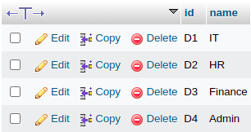

employeee table-
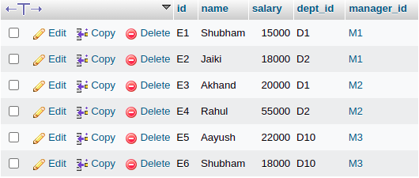

manager table-
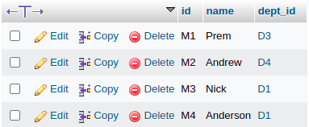

project table-
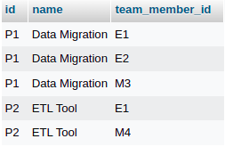

Family Table-
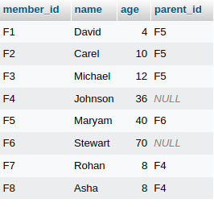

JOINS Queries:-

1. Fetch the employee name and the department name they belong to (Inner Join)

SELECT e.name, d.name
FROM employees e
JOIN departments d ON e.dept_id = d.id;

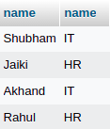

2. Fetch all the employee name and the department name they belong to (Left Join)

SELECT e.name, d.name
FROM employees e
LEFT JOIN departments d ON e.dept_id = d.id;

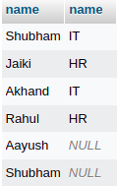

3. Fetch the employee name and all the department name they belong to (Right Join)

SELECT e.name, d.name
FROM employees e
Right JOIN departments d ON e.dept_id = d.id;

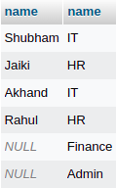

4. Fetch details of All employee, their manager, their department and the projetcs they work on.(Mixed Join Query)

SELECT e.name, d.name department_name, m.name manager_name, p.name project_name
FROM employees e
LEFT JOIN departments d ON e.dept_id = d.id
JOIN managers m ON e.manager_id = m.id
LEFT JOIN Projects p ON e.id = p.team_member_id;

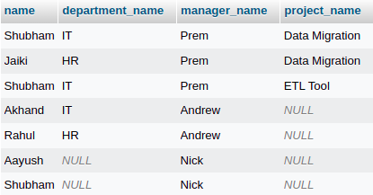

5. Cross Join-

SELECT e.id employee_id, e.name employee_name, d.id department_id, d.name department_name
FROM employees e
CROSS JOIN departments d;

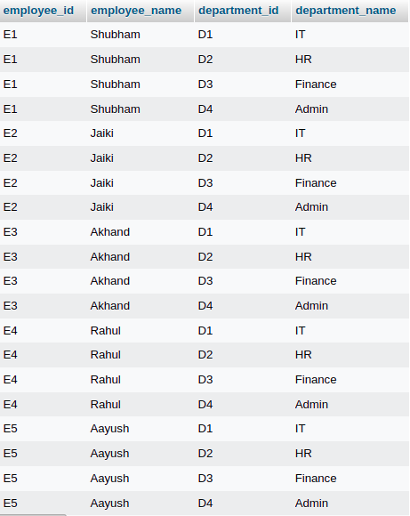

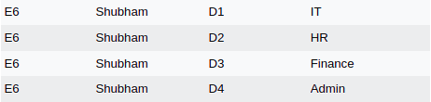

Natural Join-
- On Condition is decided by SQL Not by the USER itself.
- First it checks if any column name is same or not in both the tables, means perform the inner join.
- If there is not same column in both the tables, then it work as a cross join.
SELECT e.name, d.name
FROM employees e
NATURAL JOIN departments d ON e.dept_id = d.id;

Self Join-

Write a query to fetch the child and their age corresponding to their parent name and parent age.

SELECT child.name, child.age, parent.name, parent.age
FROM family child
JOIN family parent
ON child.parent_id = parent.member_id;
