Waste management

* Around 660 metric tonnes of municipal waste is generated every day in Noida.
* Which include wet waste, paper waste , plastic waste, electronic waste and all other kinds of waste too dumped together.
* Our team is working towards the solution of the waste problem, to provide some easy techniques and methods for the people .
* In regarding to this we have started two project for **paper waste&** **wet waste**

**1-Project S.M.I.L.E**

**s-** skilling the underprivileged

**m-** managing used paper

I-Instilling self confidence

L- liberating the minds

E- empowering the destitute

In this we have collected waste paper from many sectors of Noida , recycled it all from the factory and then the recycled paper along with the raw material for spiral notebooks were given to unemployed people.

At last A-4 size, recycled white sheet spiral copies were made and it was sold to schools & colleges ,the money was collected and given as a salary to these workers

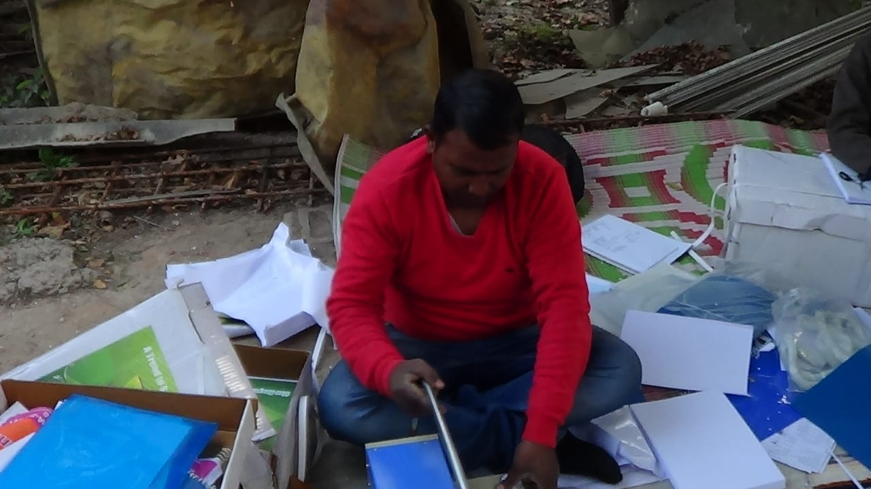

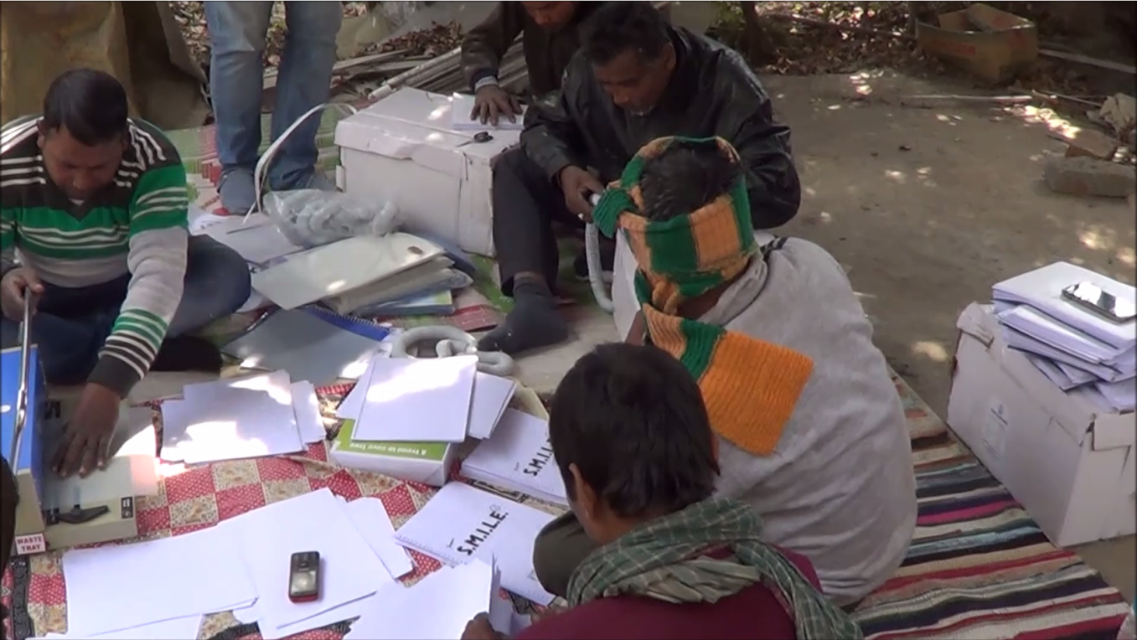

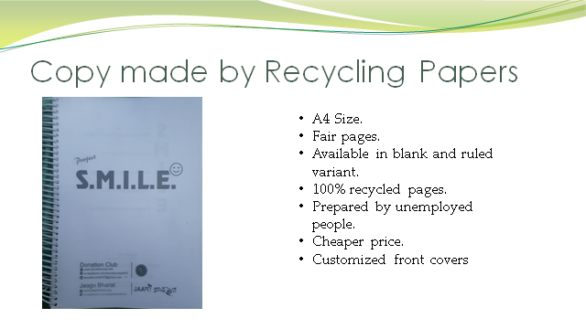

**2- MERA KACHRA MERI ZIMMEDARI**

Segregation is the major step in waste management, as we know in India the major problem is of wet waste as many deadly diseases like nausea, diarrhoea, and tuberculosis are caused by it

For this purpose we have made this composter which can easily convert the wet waste to pure organic manure within 25 days

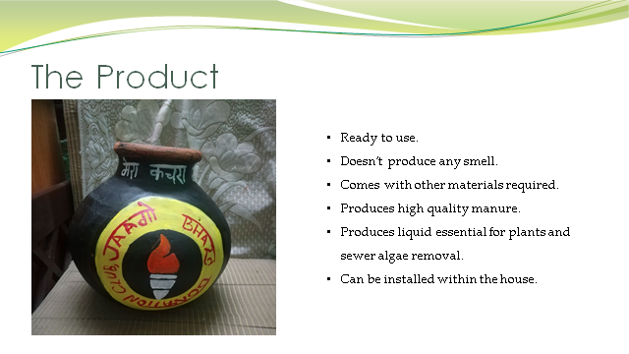

How it works ?

STEP 1:- Segregation is the first and key step

Keep the kitchen waste separate from the others.

STEP 2:- Put the dry leaves and garden soil into the composter.

STEP 3:- Now, put the wet kitchen waste into the composter.

STEP 4:- Now, put the remix powder.

And repeat this process for other kitchen waste.

STEP 5:- Once in a weak stir it from top to bot-tom

STEP 6:- When it is full, close it and keep it separate for up to 30 days.

And start using the other composter by ap-plying the same above steps.

***“After performing these six simple steps we will get the pure organic manure.”***



**BLOG**

**1)** Dharti MAA ki fikar hai toh jarur padiyega...  
Aap sb log shayd soch rahe hongey ki ham ( JAAGO BHARAT ) ne aj Vishv Paryavaran Diwas pe koi post kyu nahi dala??   
Kyu daltey aap hi bataye??  
Khud sochiye kya environment ka sanrakshan khali ek din ki baat hai ?? Aur baki ke 364 din aap kya karne wale hai ???  
Sirf kuch logo ko chod de toh sb wahi karengey jo vo baki ke 364 din kartey aye hai desh ganda aur paryavaran ko nuksan..  
Toh sbse phele khas kar unn logo se nivedan hai ki dikhawa na kare post dal kar kahi bhi!!

Aur jo log dil se hamara desh saaf aur swacch dekhna chahtey hai vo agey aye aur hamara sath milkr pure 365 din jud jaye hamare paryavaran ko shurakshit karne ke liye kyuki ye ek din mai kam pura hone wala nahi hai aur aj ka din sirf hamey ye yaad dilane ke liye hai ki pichle saal nahi toh iss bar toh jaag jao 'Before it's too late'.....  
[#jaagobharat](https://www.facebook.com/hashtag/jaagobharat?source=feed_text)  
[#swacchbharat](https://www.facebook.com/hashtag/swacchbharat?source=feed_text)

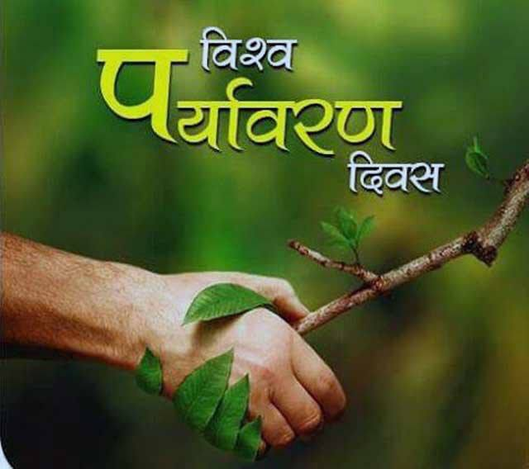

**2)** It was great honour today to present our Wet Waste Decomposer and our paper waste recycling solution in front of the residents of Sector 33 Noida . We got a overwhelming response from the people and also some of them bought our decomposer.  
With meeting people like them we get a immense confidence and motivation to keep our work going as the people their are also concern about the environment.  
And we want to extend our gratitude to Mrs. Kapoor Mam who have arranged this meeting with the residents and helped us throughout

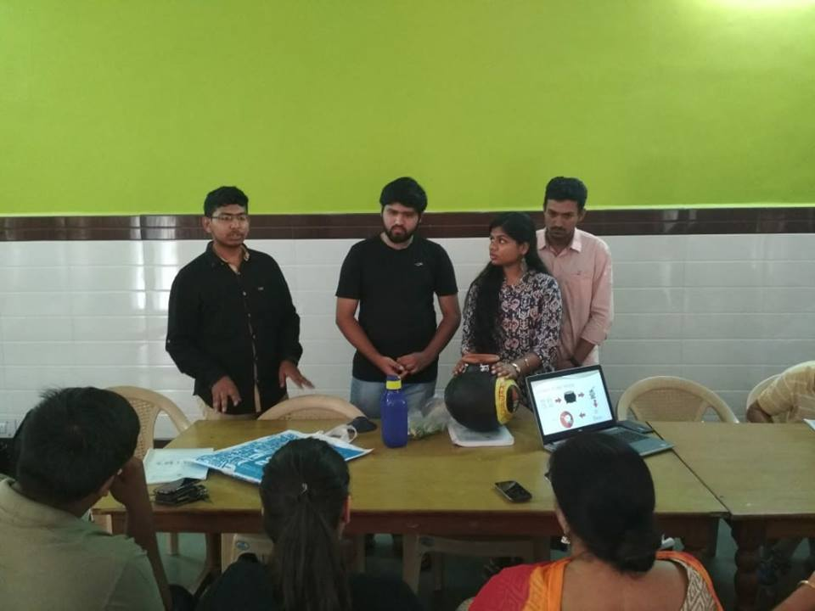

3) Bundelkhand and many parts of india is facing huge scarcity of water. Due to this the health conditions of people living nearby that area has also become worse.

It is evident that this is going to be an extremely difficult year for the people of Bundelkhand. How will the farmers face the looming hunger, with grain stocks having already dried up? What will be the impact of these conditions on women and children? People say it will be even more difficult to manage the shortage of drinking water and fodder. With debt levels already at a high, how will the farmers sow their next crop?

The time has come to realize the importance of saving water and we should all come together to discuss this issue and find possible solution as soon as possible

For more info visit our website and page:  
<https://m.facebook.com/jaagobharatfront>  
[http://jaagobharat.org](https://l.facebook.com/l.php?u=http%3A%2F%2Fjaagobharat.org%2F&h=AT04KmOX4CgyLxgspLz9ZU2zyt1bVyiETxKxy4_6cXWZXF3qg3xY7fu9YouqkunbVOlOFzYu5kvI3oMvBqi90o1N534eja0PwJn_61sDhpJilSv71G-PuEgag-D0lu475CvLzyV4yD1to6inGePDV1uMviU4q0yW7OvbTco)

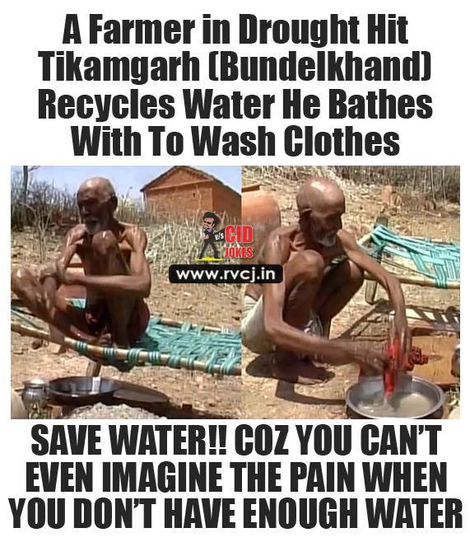

4)

For BHARAT to be a developed nation, we need High class, well acknowledged Public Education system. All shall be proud sending wards to govt schools. Existence and more than tht, primacy of private schools is the basis of "origin of inequality " in our society... its the time, when we need to make aware, every Indian, what do we need as a citizen!!!! Its caste, religion based polity or development oroented polity.

5) [#MEDIA](https://www.facebook.com/hashtag/media?source=feed_text) is known for its true and ideal news telecast about different topics of the world.But now a day it becomes the hand of powerfull person or Nation...They manipulate news to genrate the intrest of common mass and sometimes ignore the true news due to political reasons... They plays an important role in the field of knowledge over different topics like political,social,economical,etc....Our view about any topic is completly dependent over it,but due to the false news our mind also moves in the away direction....There are alot of examples in which the media's involvement was negative like France attack over syria,chennai's disaster...They engage the mass over non sens topics like love jihad,beaf ban,star talks,castism,etc...  
They should change its policy of money baked news and broadcast only truth and sensible news as the whole mass is dependent over it...

6) [#Education](https://www.facebook.com/hashtag/education?source=feed_text) is only way to acheive the mental,social,as well as economicap development of individual,society,country and world.  
Government plays an importan role in the development of each and every aspects of the society.But in our country the government as well as the commons are only focused on the development of infrastructure of the nation. No one talks about this primary path(education) of development...  
Not a singel government primary,secondry or high school which provide a quality of education.Every capable parent use to send their child to private school on a huge expense.We save this expense if government school's condition got updated.But not a single person is raising his voice or nither any government about this matter.  
Here higher education is limited to those branches where we can earn at the earliest because in our country there are only 2-5% of research colleges available.We are the one of the largest importers of the technology even we have a large force of engineers only due to the lack of research work.....

Challenges:-

The foremost challenges faced by the Education system are-   
1. Almost 80% of schools are managed by government. Private schools are way beyond the reach of the poor. Quality of teaching is way too low in government school.  
2. Mentality of people- Most unaware people think, more hands will serve more money to the family. So they engage there children in earning rather than studying.   
3. Poor infrastructure of all government schools. Poor quality of education. Only 3% of GDP is spend on education which is clearly insufficient.   
4. Teachers are not well qualified. They are also paid less so they show little interest on teaching.

25% of the Indian population is illiterate. Only 7% of the population that goes to school managed to graduate and only 15% of those who enrol manage to make it to high school.

SOLUTIONS:-

Now some steps that could be taken to improve the quality of education-

1. Rote learning- Interactive schools may have been introduced in India yet rote learning has its foot on majority of Indian schools. This restricts the student from strengthening the foundation of their concepts. This also shadows their imagination.

2. Marking system- Students are basically judged by 3 hours of their exam. But we don't understand that every child is different. As said by Einstein- "Everybody is a genius. But if you judge a fish by its

3. Respect all streams- We live in a egoistic society in which people who are not in so called proclaimed jobs ate considered less worthy. We should understand that a dancer is as sufficient as an Engineer.

4. Variety in education system- There are a lot of variety to choose from nowadays. Have a free will. Don't follow footsteps, make your own mark.

5. The system of tuition classes- Tuitions kills a lot of time of students which can be used for recreation. If things are clear in school there is no need to take additional classes.

DONATION

Wondering where to donate.??  
We are at your service

You can donate your old books, clothes, paper waste(newspapers, notebooks,etc)

* **For clothes**  the condition is it should not be dirty or torn out, as we give it to poor& underprivileged people
* 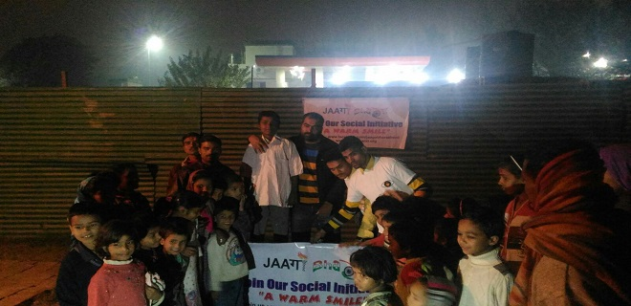

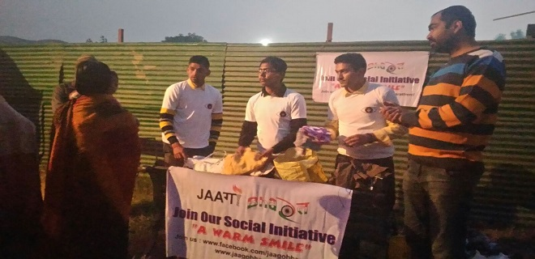

* **For paper waste(raddi)** we had started Project S.M.I.L.E in which we had given employment to weaker sections of society by making recycled notebooks by them from the waste paper collected from your house
* 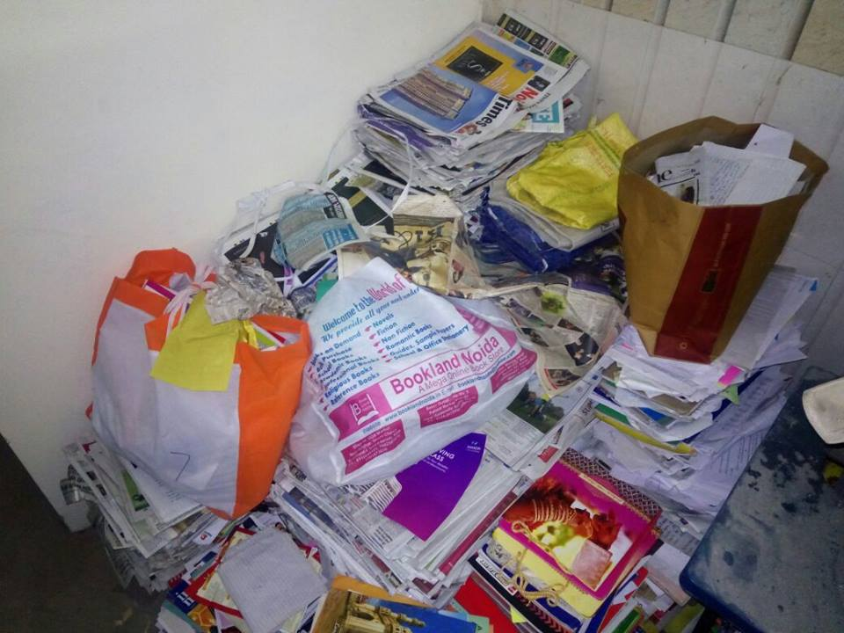
* you can also buy the notebooks at nominal rate as this money is given as salary to them
* 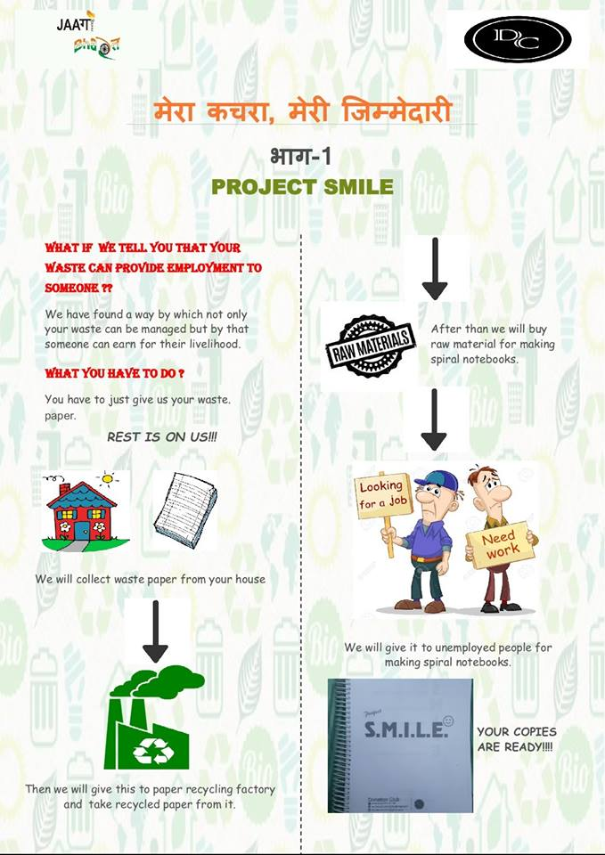
* 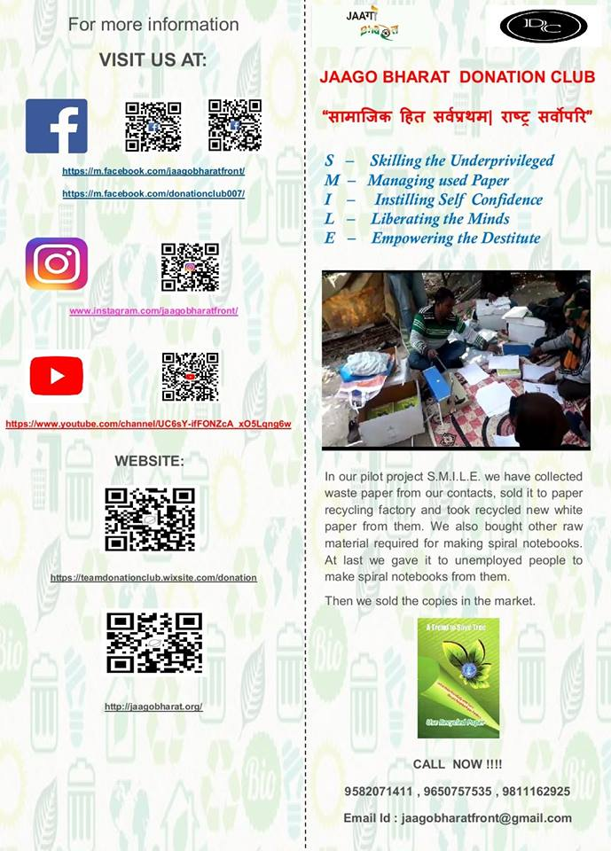
* **For old books**
* As we know after a year end most of schools& colleges books becomes scrap and are mostly selled to kabadi instead selling these we had decided to open a **library** in which you can donate your old books of previous class and in return you get second hand books of next class
* If you don’t have a old books you can get new books at nominal rate
* Books includes mostly ncert and guides& helping books from class 1to 12
* We have also some college books for mechanics, engineering mathematics, quantum
* 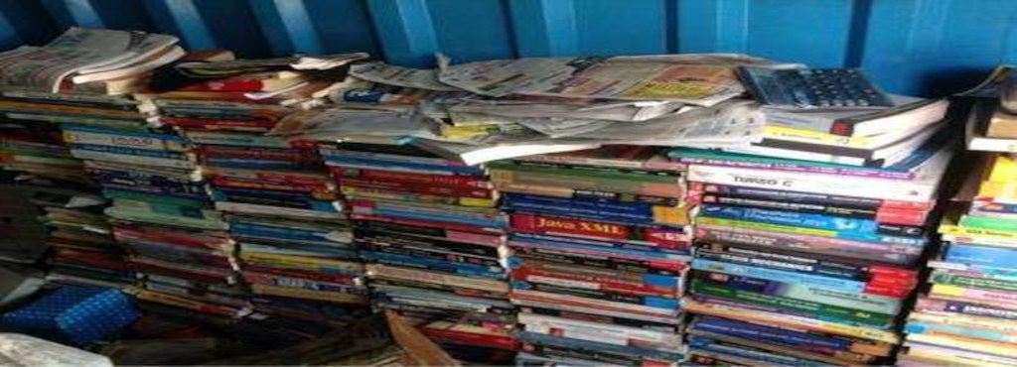
* Soon we gonna update the quantity and no. of the books available

Kindly fill out your details below and we will be happy to pickup up your donations at your convenience.  
<https://goo.gl/h8Jtgr>  
Contact/Whatsapp:  
Chirag : 9899668723  
Akash : 9582071411

**ABOUT**

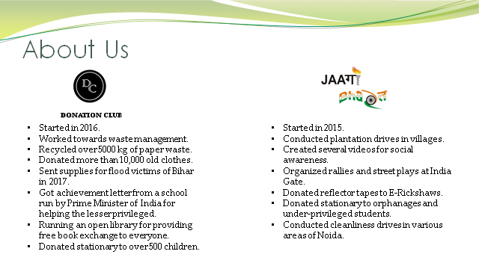

Isme dekh lena bhaiya jaago bhaarat ke khuch point agar add karne ho about me

**EVENTS**

Events me apne saare job hi update kiye the wo sab daal dena