|  |
| --- |
| XMLVALIDATOR |
| Question Type Plugin for LMS – User Doc |
| PRASHANT SANGTANI  MT2018082  SAGAR JHUNJHUNWALA  MT2018097  SHUBHAM DAROKAR  MT2018113 |

**Table of Contents**

XMLVALIDATOR– Plugin Overview 3

Login 4

Creating the “XMLVALIDATOR” question 5

Creating the question in LMS: Steps and Screenshots 5

# XMLVALIDATOR– Plugin Overview

The plugin ‘XMLVALIDATOR’ is a ‘question type’ plugin. With the help of this plugin, a question can be created which checks the validity of xml file uploaded by student against the xsd schema file uploaded by teacher or test creator. The creator of the question can supply one xsd file schema and can also supply grades for the questions.

**Evaluation Technique**: The plugin checks the validity of XML file submitted by student against the XSD schema given by teacher.

# Login

Login to Moodle:

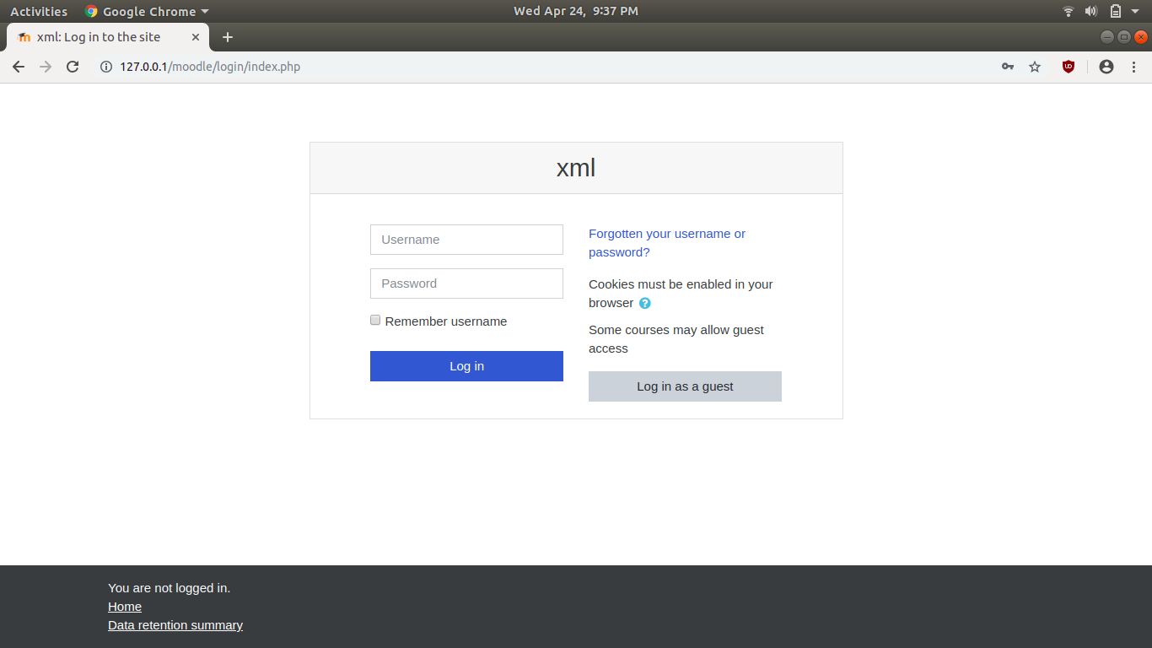

Click on the Course

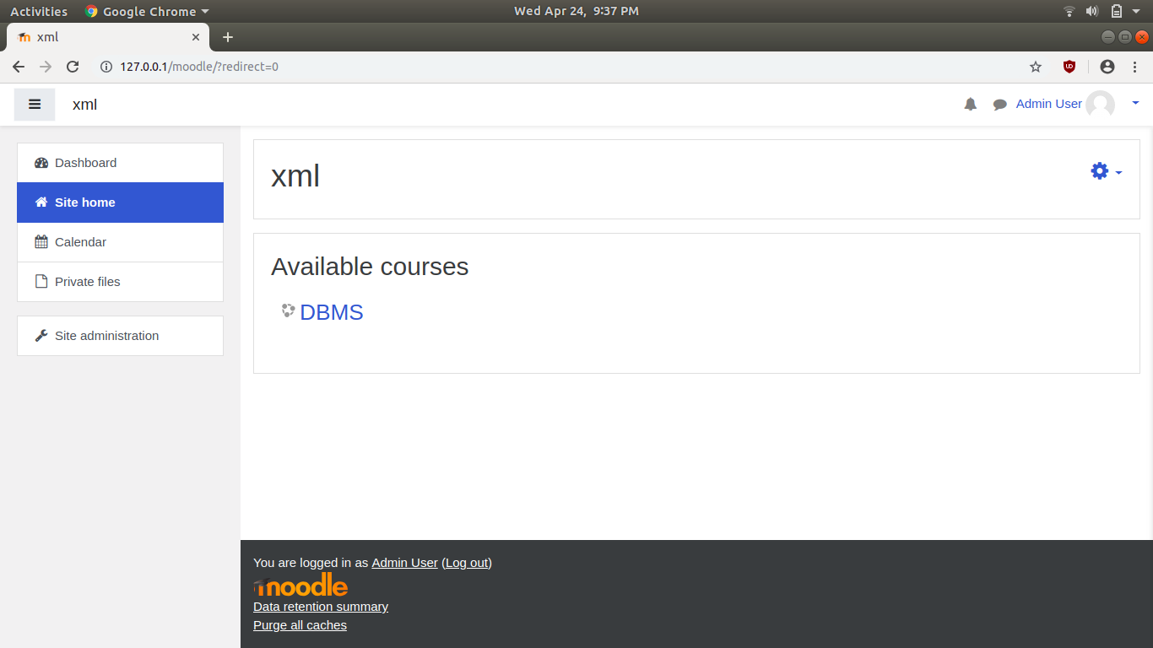

# Creating the “XMLVALIDATOR” question

## Creating the question in LMS: Steps and Screenshots

1. Click on “Turn Editing on” and add an activity. Here we are creating a quiz. A question can be created specifically for one quiz.

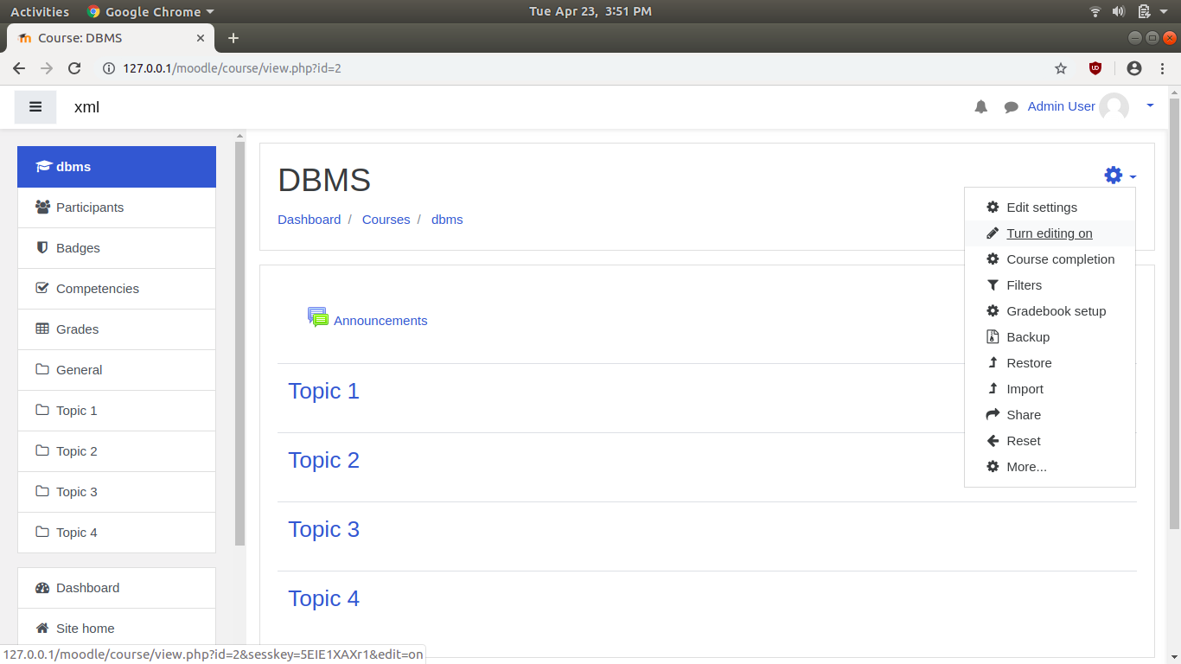

1. Select the question type “Quiz” as an activity to add and click on “Add”.

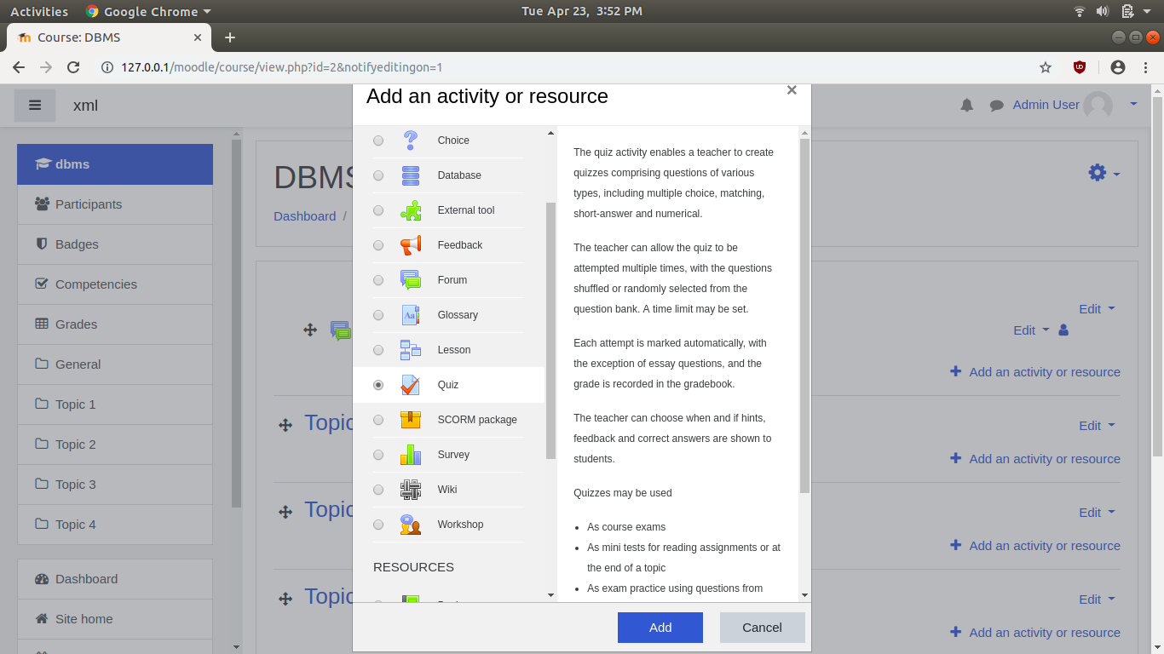

1. Enter the appropriate name and description for the quiz.

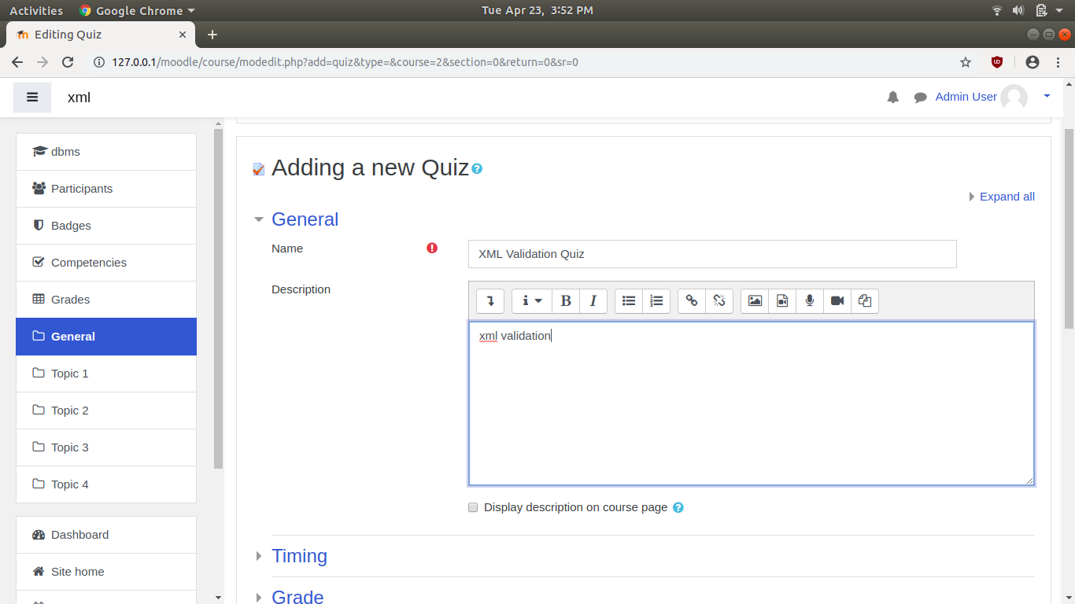

1. Once the quiz is created select the option “Edit quiz” to add questions.

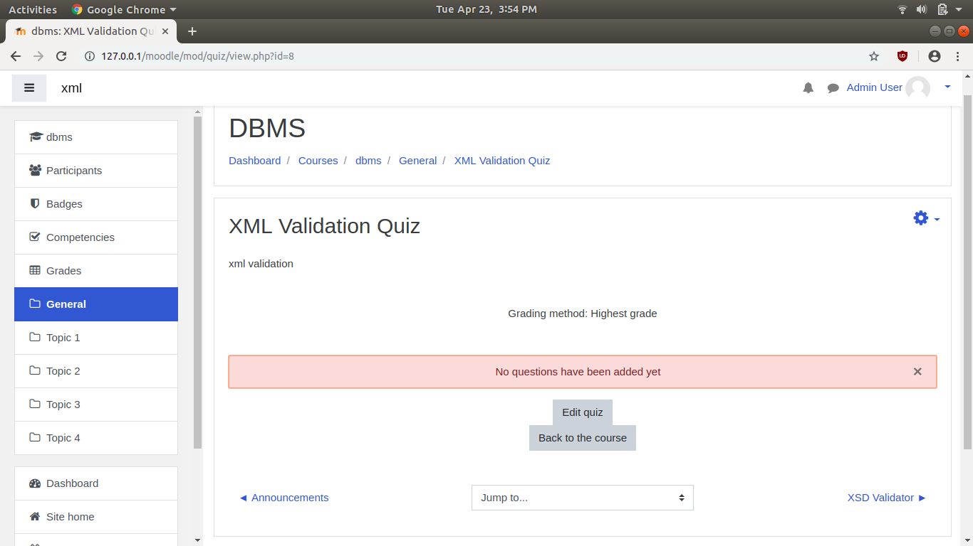

1. Click on the add option and select the option “a new question”.

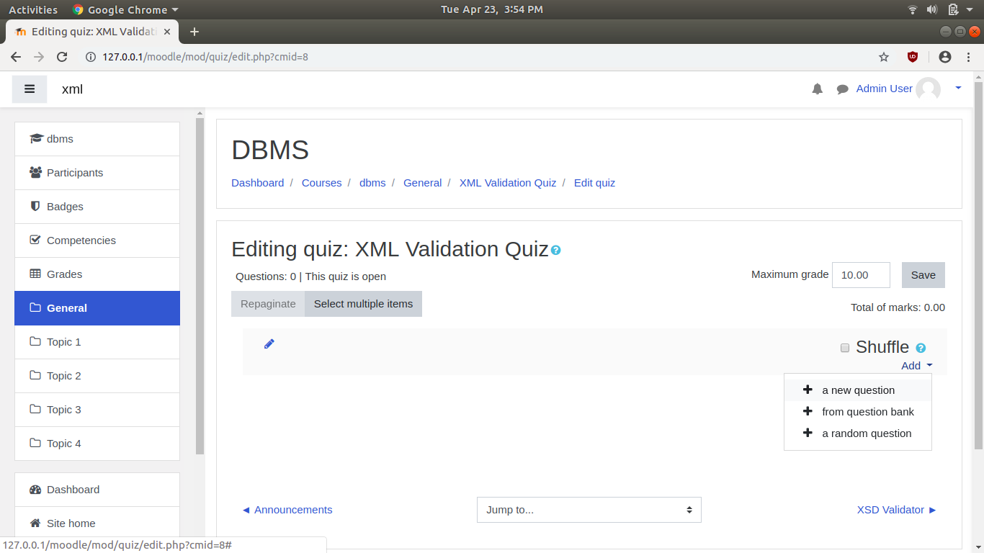

1. Select the question type as “xmlvalidator” and click on Add button.

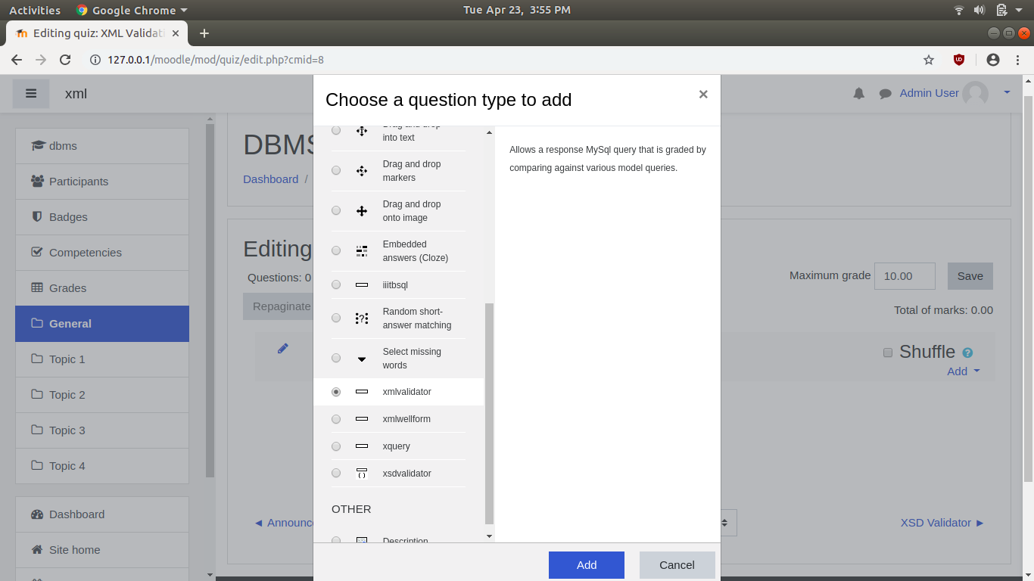

1. 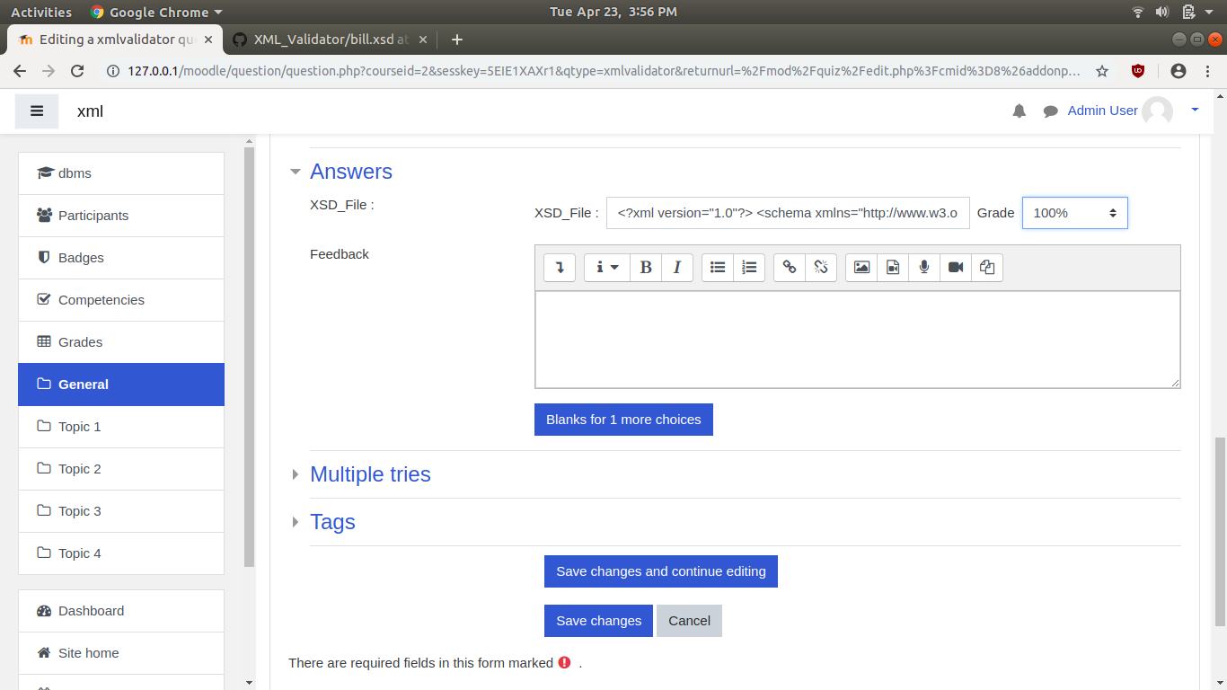Enter the appropriate question and write the appropriate xsd schema in XSD_File option. Enter the marks and select the grade option as “100%”. Click on “Save Changes”.
2. The saved question is now visible and is ready to be used.

