|  |
| --- |
| XSDVALIDATOR |
| Question Type Plugin Installation Manual |
| PRASHANT SANGTANI  MT2018082  SAGAR JHUNJHUNWALA  MT2018097  SHUBHAM DAROKAR  MT2018113 |

**Contents**

Before you do anything else… 3

Moodle Requirements 3

Plugin Code and Files 3

Installation Steps 3

Verifying the Installation 7

Uninstalling the Plugin 8

If you have problems... 8

XSDVALIDATOR– Question Type Plugin

This document gives some important advice you should consider before adding this plugin and general instructions on how to install it.

# Before you do anything else…

Before you start installing this plugin please ensure that the following requirements are met:

## Moodle Requirements

* You must have access to your Moodle code files to upload or install the plugin. If you installed Moodle in the first place, then you should be fine. There is no way to install plugins through the web interface.
* This plugin has been created and tested for Moodle version 3.3 with the new Question Type behavior. So, the target installation should preferably be 3.3 or greater.
* You should have access and permissions on the local MySql installation. You would be required to create a user and grant some privileges to the user.

# Plugin Code and Files

The required files are present in the folder ***xsdvalidator.zip***

# Installation Steps

Please follow the installation steps as given below:

1. Open Moodle site and select option **Site Administrator** from left side of the panel.

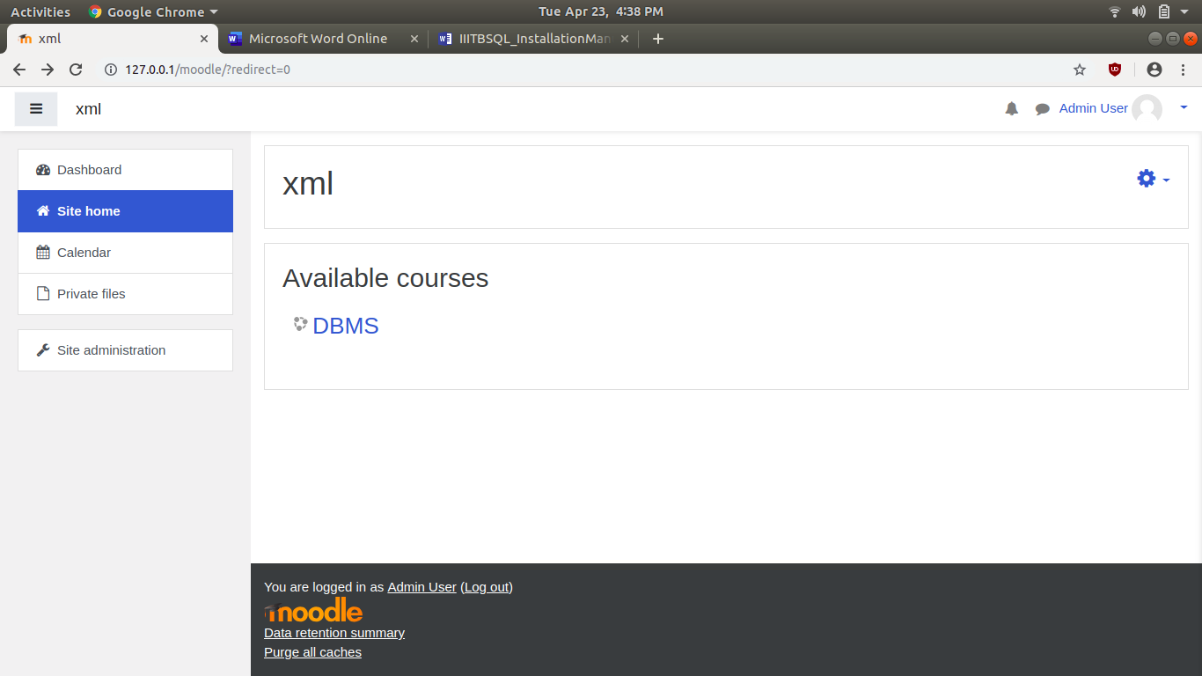

1. On the Site Administration page select option Plugins and click on Install Plugins.

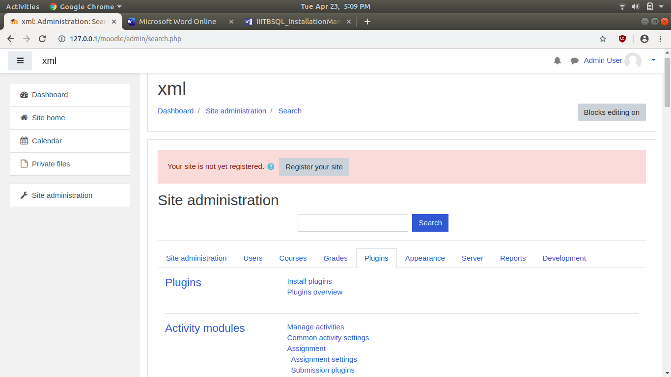

1. Select the ***xsdvalidator.zip*** file to install and click on **Upload this file** option.

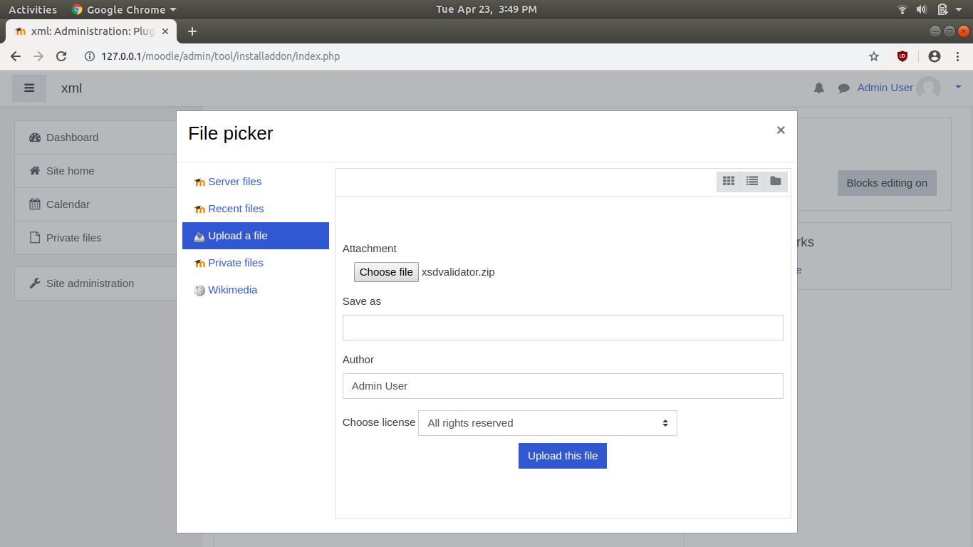

1. Click on option **Install plugin from Zip file** option.

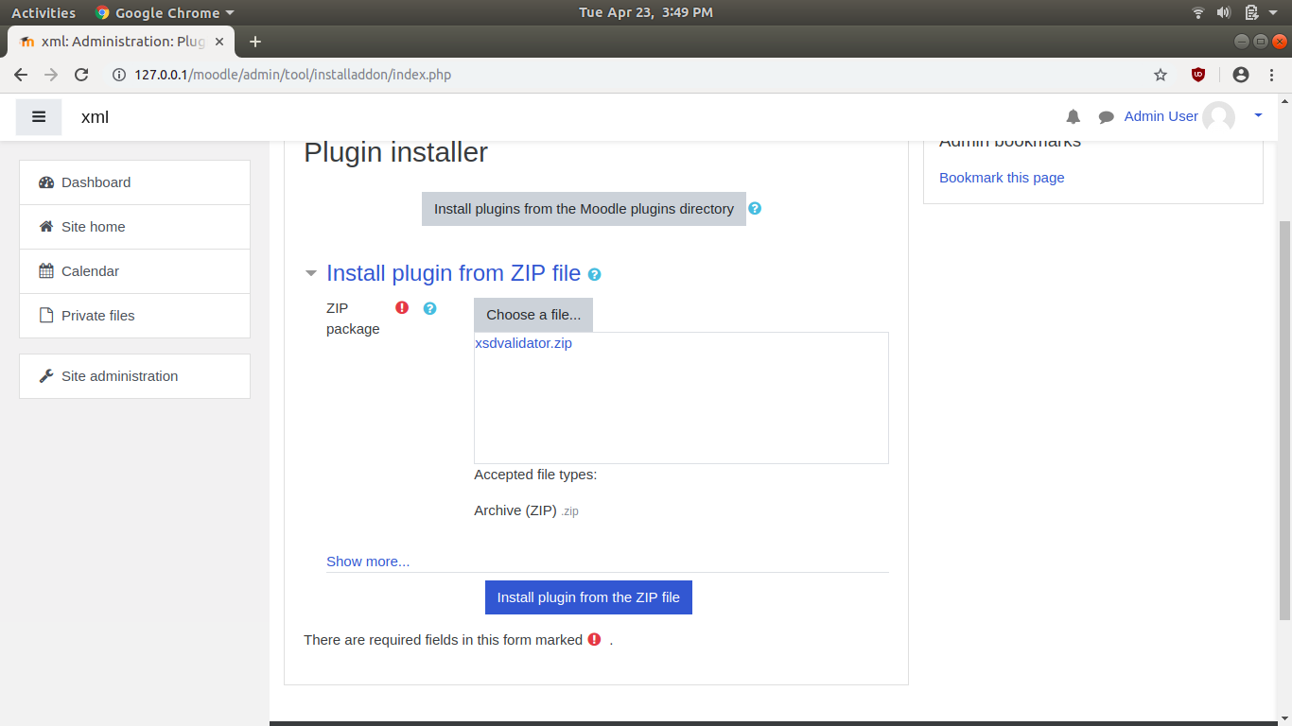

1. Validation Successful screen will appear. Click on **Continue** button.

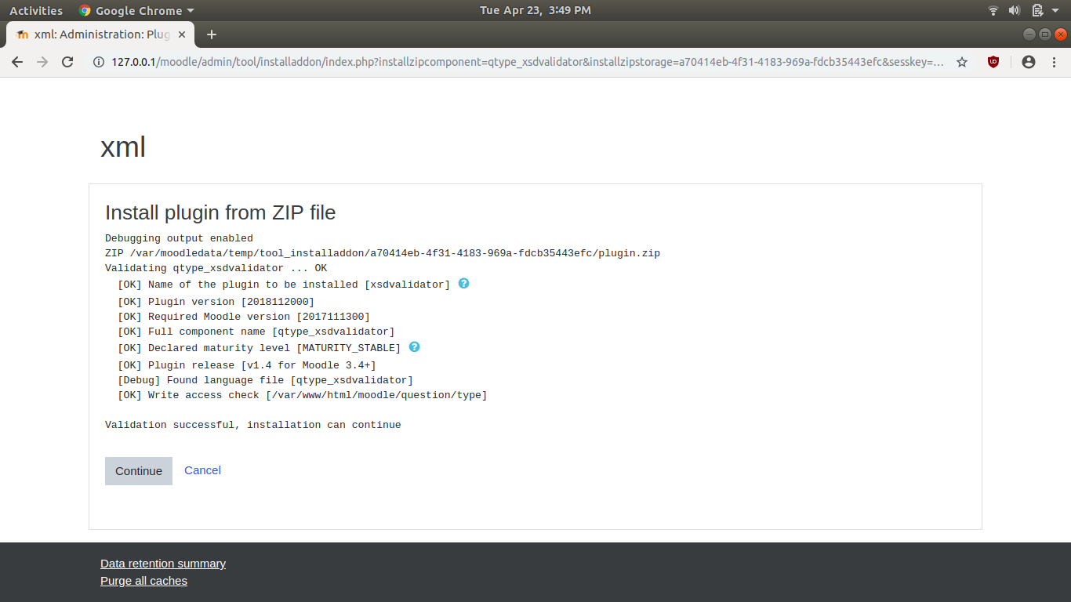

1. Now click on **Upgrade Moodle database now** button.

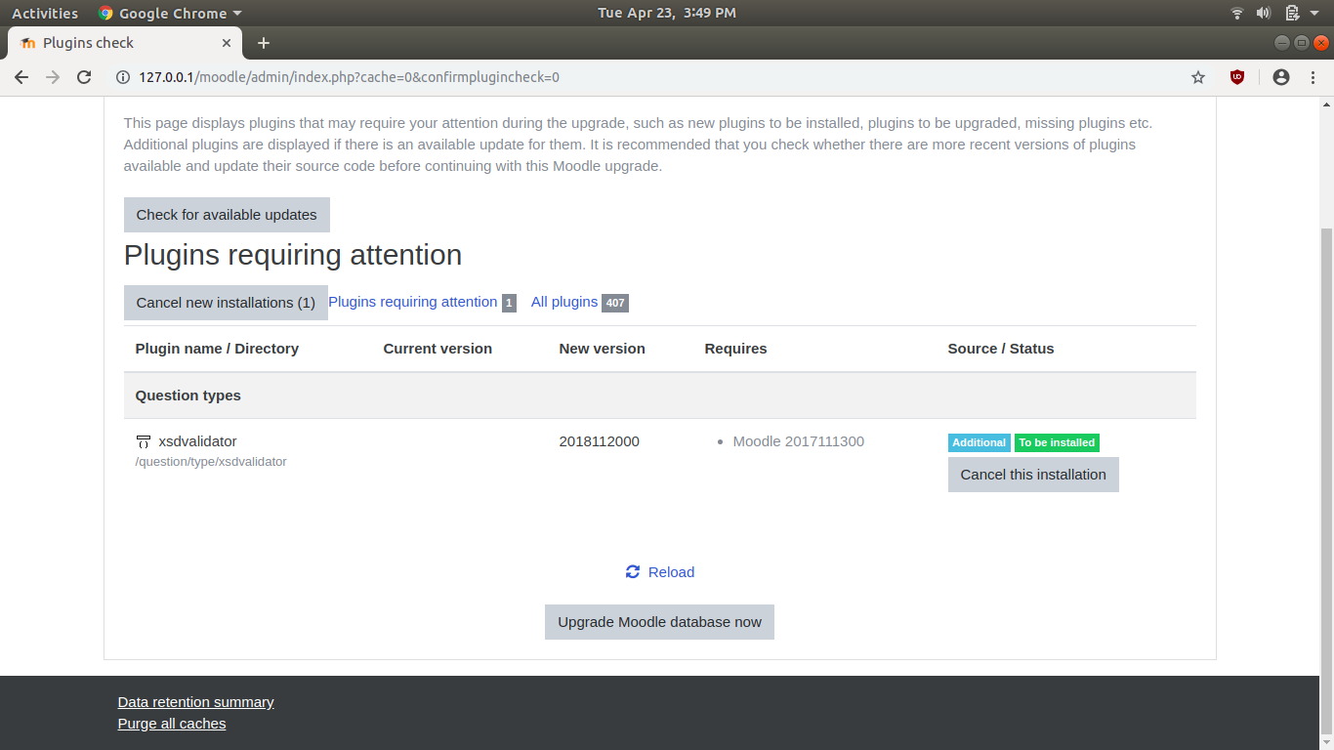

1. Installation Successful screen will appear and now click on **Continue**.

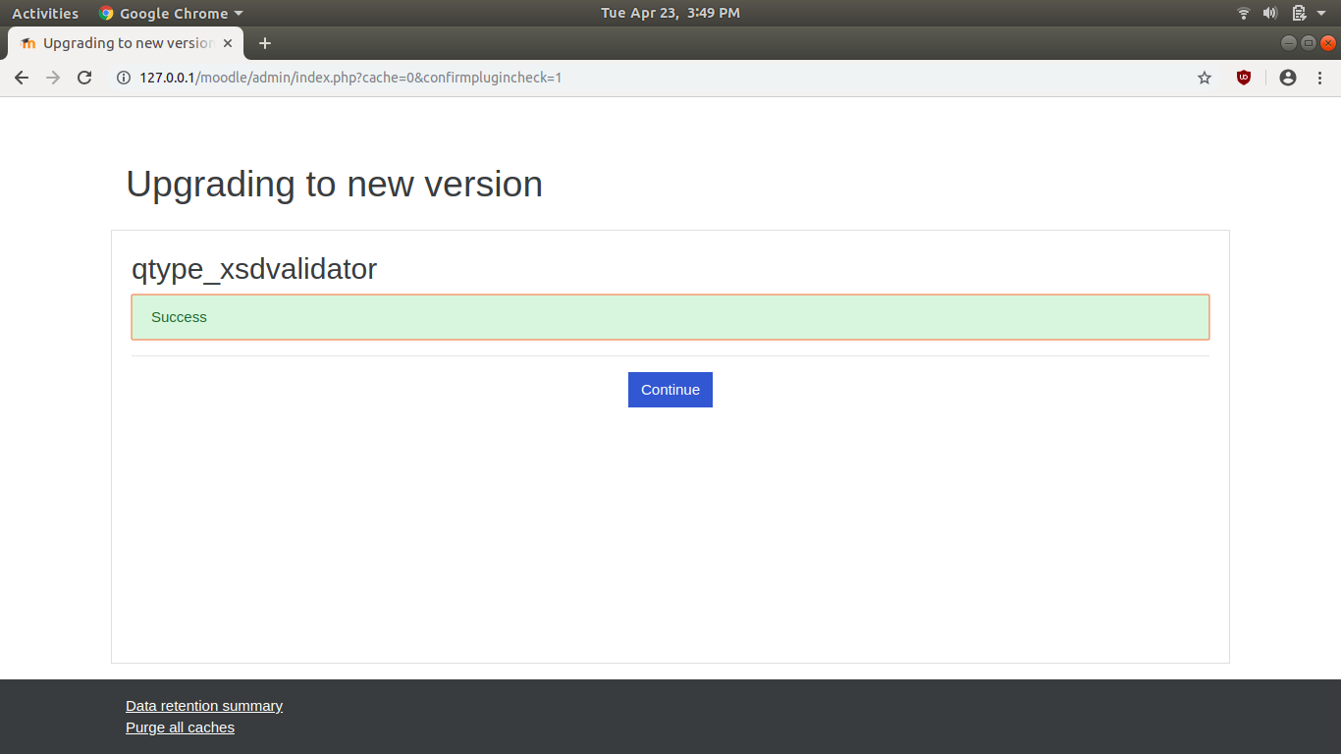

# Verifying the Installation

There are various ways to verify the installation of plugin, following are some of them.

* In the Moodle site (login as admin) and go to ***Site administration ► Plugins ► Plugins overview***

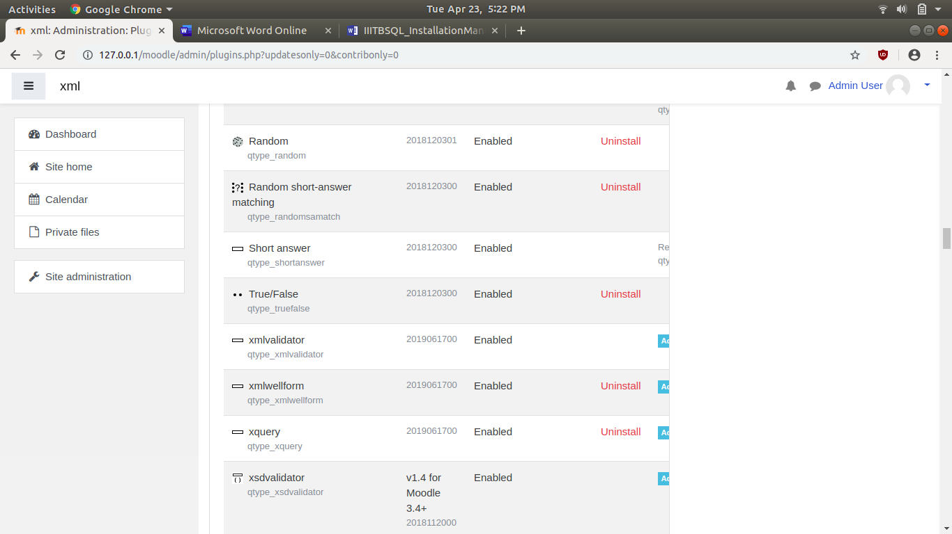

The plugin should be listed under the Question Type category.

* In the Moodle site go to Question Bank and click on “Create a new question”. The pop-up menu will display the option of **“xsdvalidator”** question type.

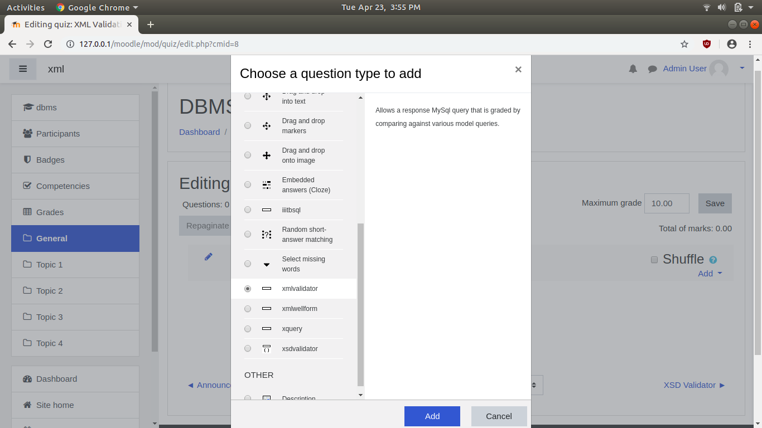

# Uninstalling the Plugin

To uninstall **xsdvalidator** plugin

* 1. Go to *Settings > Site Administration > Plugins > Plugins overview* and click the Uninstall link opposite to the xsdvalidator plugin.
  2. Use a file manager to remove/delete the actual plugin directory, otherwise Moodle will reinstall it next time you access the site administration.

# If you have problems...

* Check the file permissions. The web server needs to be able to read the plugin files. If the rest of Moodle works, then try to make the plugin permissions and ownership match.
* Did you **definitely** unzip or install the block in the correct place?
* Make sure the directory name for the plugin is correct. All the names **have** to match. If you change the name, then it won't work.
* Turn on [Debugging](http://docs.moodle.org/23/en/Debugging) - any error messages?