|  |
| --- |
| IIITBSQL |
| Question Type Plugin for LMS – User Doc |
| JATIN CHAUDHARY – MT2011050 |

**Table of Contents**

IIITBSQL – Plugin Overview 3

Login 4

Creating the “IIITBSQL” question 5

Creating the question in LMS : Steps and Screenshots 6

# IIITBSQL – Plugin Overview

The plugin ‘IIITBSQL’ is a ‘question type’ plugin. With the help of this plugin, a question can be created which expects a ‘Mysql’ query response. The creator of the question can supply one or more queries as answers and can also supply grades for the queries individually.

**Evaluation Technique**: The plugin first executes the “Correct Answer” (as supplied by the creator of the question) and obtains a result-set. Then the plugin executes the “Response Answer” and obtains the result-set. Both the result-sets are then compared and the grade is awarded.

**Result-set Comparison:** There can be many ways in which the result-sets can be compared. As of now, the plugin converts the result-sets to strings and does a string comparison. Exact match fetches a full fraction of the associated grade.

# Login

Login to moodle using the URL: <http://192.168.75.111/moodle/login/index.php>

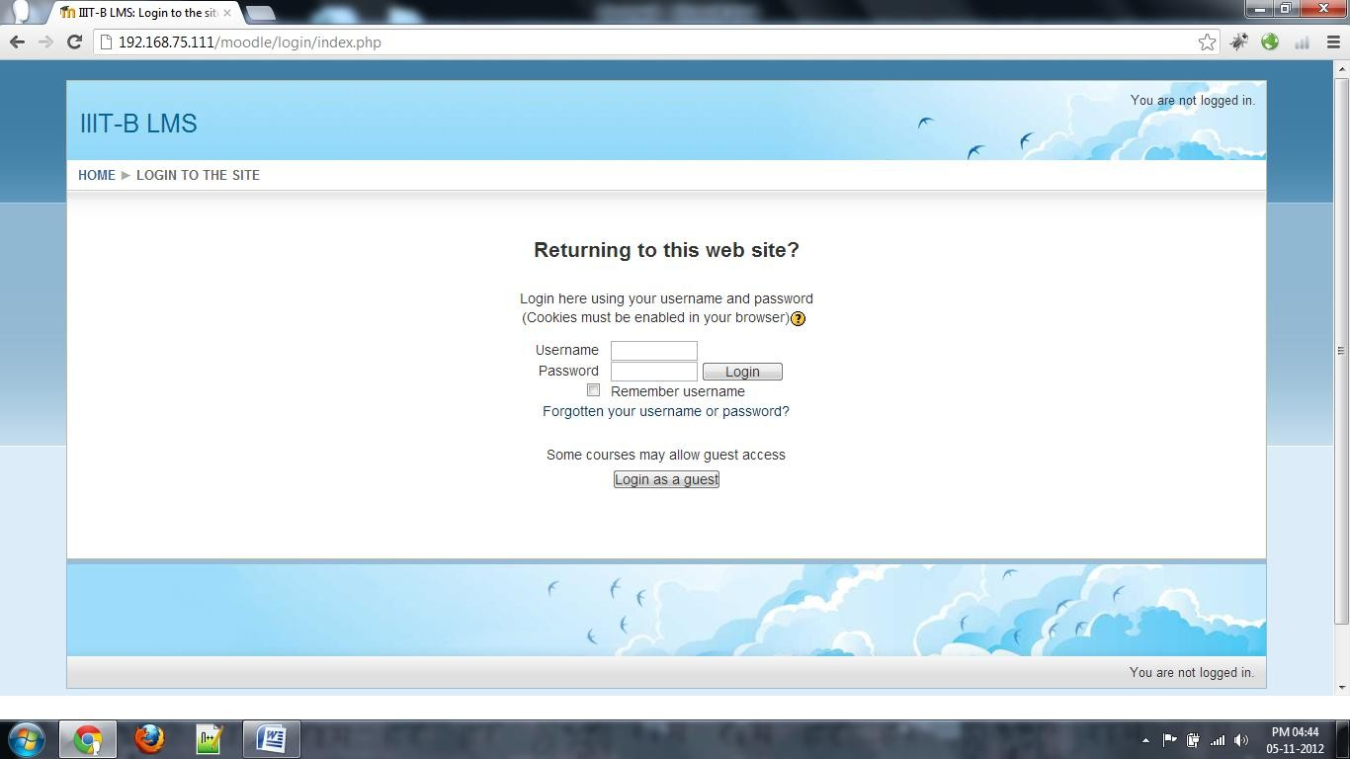

Click on the Course

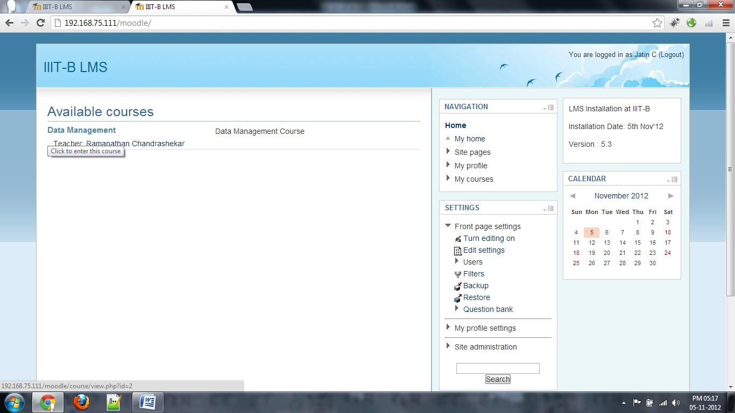

# Creating the “IIITBSQL” question

The process of creating the question can be broadly divided into two parts:

### Step 1. Setting up the database.

The “Teacher” or “TA” should first set up the database.

In this example, database “trial” was setup and used for creating the questions.

The exact name of the database should be supplied at the time of creating the question.

### Step 2. Creating the question in LMS.

The question type that is to be used to create the question is: **iiitbsql**

The questions can be created in the question bank, they can be created for a particular quiz or category. The steps for creating a question are shown with screenshots later in this document.

The question type provides the flexibility for supplying more than one “query” as expected answer for the question along with the “grade”.

Multiple Questions can be clubbed together to form a quiz.

## Creating the question in LMS: Steps and Screenshots

1. Click on “Create a new question”. Here we are creating a question directly in the question bank. A question can be created specifically for one quiz.

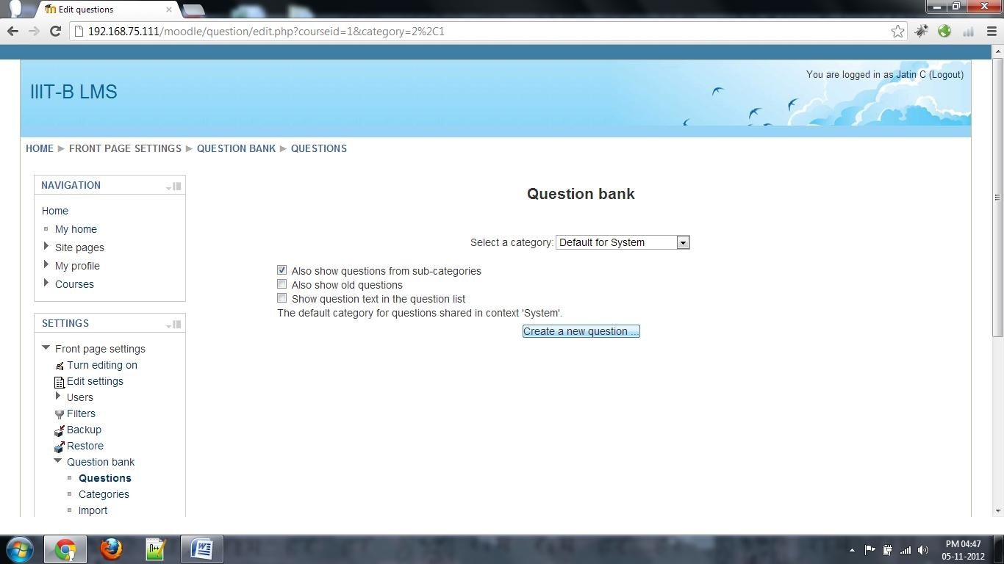

1. Select the question type “iiitbsql” and click on “Next”.

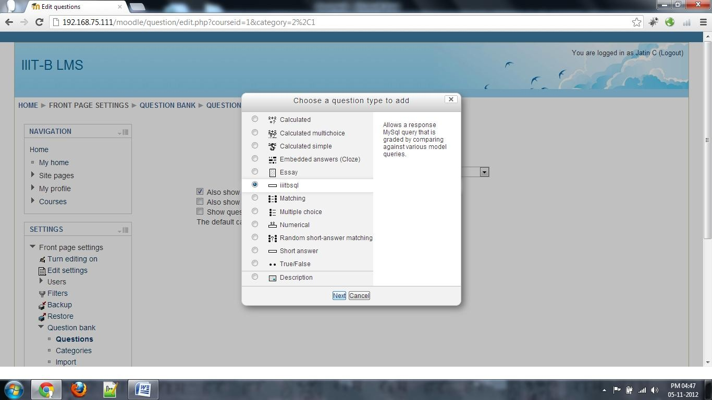

1. Select appropriate “Category”, give “Question Name” (this should be unique + meaningful), “Question Text”, “Default Marks” and “General Feedback” (optional).

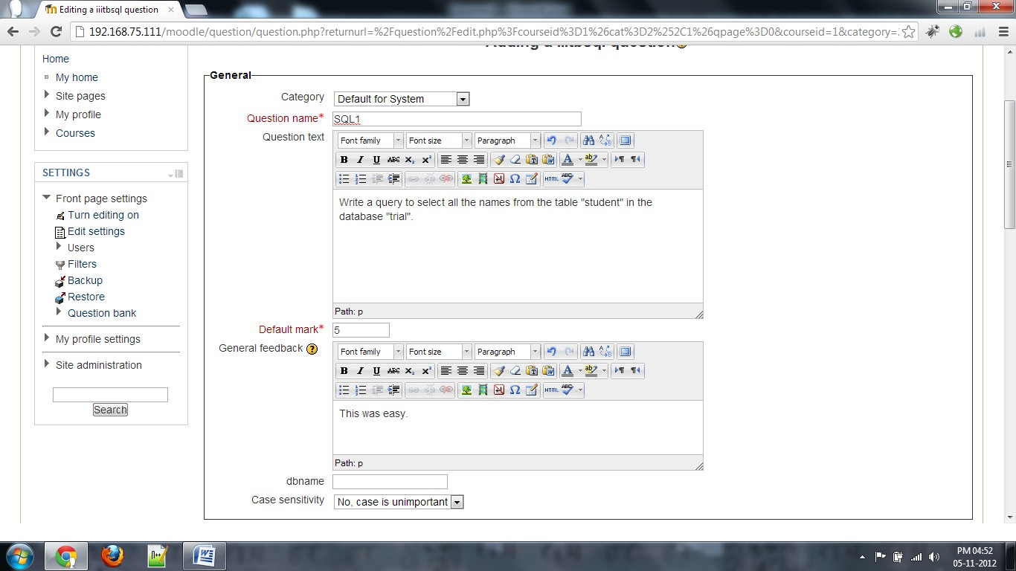

1. Give the name of the database that is to be used in this question. This is important and necessary. Leave the case sensitivity field to its default value “No, case is unimportant”.

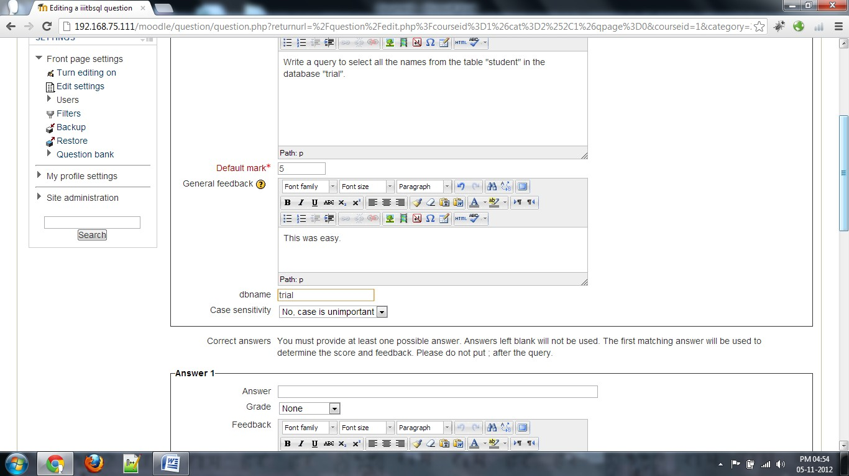

1. In the form with the header “Answer 1”, write the query that gives the expected answer. Select the “Grade” (normally 100%). Provide “Feedback” if any.

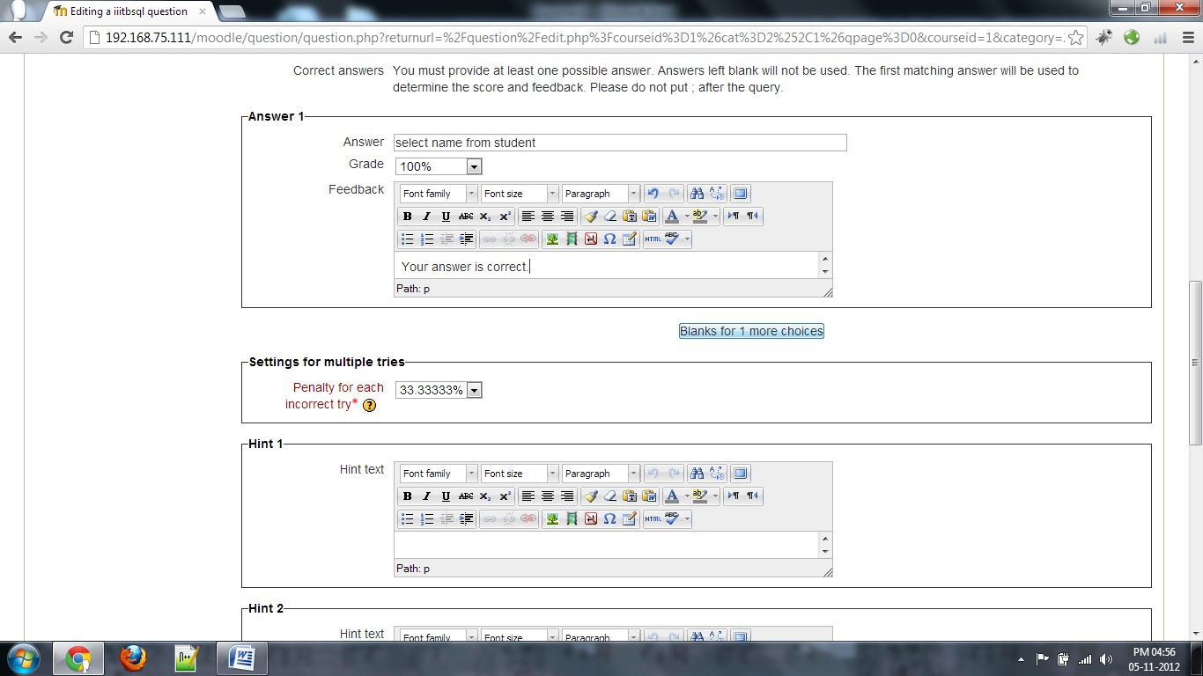

If you want to add more answers, click on “Blanks for 1 more answer”.

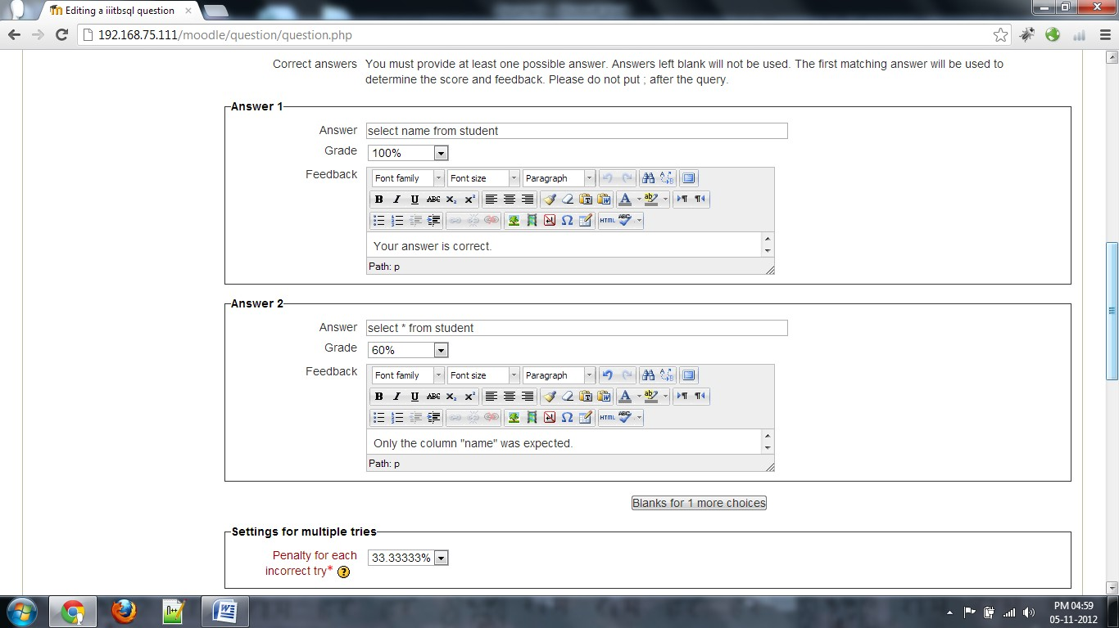

Leave the rest of the fields to their default values or customize as per need.

1. 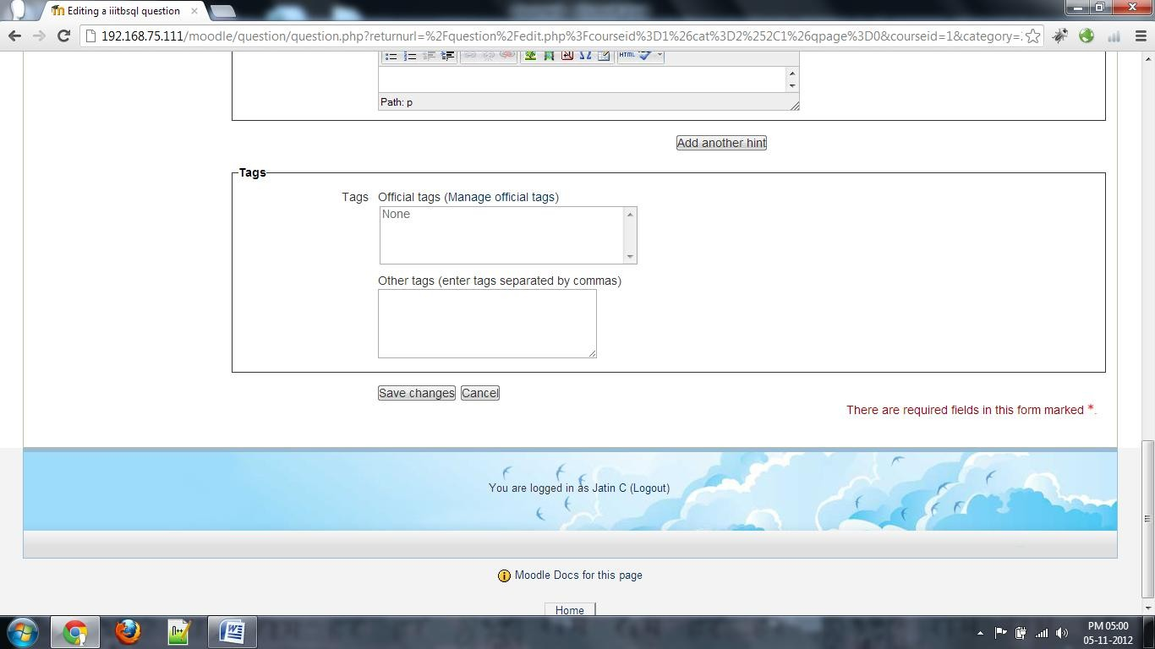Click on “Save Changes” at the bottom of the page.
2. The saved question is now visible and is ready to be used.

