Acknowledgements

The group is thank for the help of the teacher Ths. Đang Thanh Dung is university lecturer belong to information technology ,the teacher have guide the passion ,a lot of share for our knowledge and experience, with love of the teacher help our have full the knowledge ,complete the essay.

Athough the group have a lot of effort in carrying out the essay, with time is short and level research ourselves is shortage, so the website’s don’t avoid some short,the group expect to contribute the idea of the teacher and friends.

Students

# Summarize

Nowaday,information Technology is more and more development .A lot of website is make serve for people,special for students.The group is build a software auto evaluate the concept map.It will help the teacher is easy to teach and student is interested in the lesson .

Used as a learning and teaching technique, concept mapping visually illustrates the relationships between concepts and ideas. Often represented in circles or boxes, concepts are linked by words and phrases that explain the connection between the ideas, helping students organize and structure their thoughts to further understand information and discover new relationships. Most concept maps represent a hierarchical structure, with the overall, broad concept first with connected sub-topics.

When created correctly and thoroughly, concept mapping is a powerful way for students to reach high levels of cognitive performance. A concept map is also not just a learning tool, but an ideal evaluation tool for educators measuring the growth of and assessing student learning. As students create concept maps, they reiterate ideas using their own words and help identify incorrect ideas and concepts; educators are able to see what students do not understand, providing an accurate, objective way to evaluate areas in which students do not yet grasp concepts fully.

*Our Sofware serves several purposes for learners:*

* *Helping students brainstorm and generate new ideas*
* *Encouraging students to discover new concepts and the propositions that connect them.*
* *Allowing students to more clearly communicate ideas, thoughts and information*
* *Helping students integrate new concepts with older concepts*
* *Enabling students to gain enhanced knowledge of any topic and evaluate the information*

Chapter 1: Introduction Problem

## 1. Introduction

Today, in a context of increasing information and advertising products for very limited attention of each of us, to build an advertising program as an effective dialogue is not easy work and should must be very carefully prepared with a reasonable investment of time, people and money.

In the explanation, the groups will build auto to evaluate the concept map program, it will help people’s, special the student is easy to understand, remember the essential information in the lesson.

To build an advertisement campaign for a brand, the first thing to be done is to identify the target of this advertisement. An ad can be done with different intent as to increase person access in the web**.**

## *2. The current system*

In the project, the program is built based on concept maps. It will define the following:

A concept map is a diagram that depicts suggested relationships between concepts. It is a graphical tool that designers, engineers, technical writers, and others use to organize and structure knowledge.

A concept map typically represents ideas and information as boxes or circles, which it connects with labeled arrows in a downward-branching hierarchical structure. The relationship between concepts can be articulated in linking phrases such as causes, requires, or contributes to.

***3. Boundaries of the system***

To meet the needs of people special the student , the group has set requirements for the is to build a system so complete. Currently the program offers features to users as follows:

* Menu horizontal: 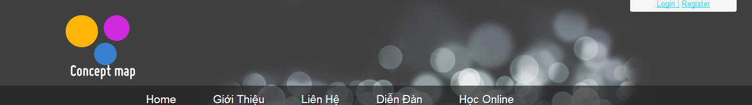

Menu horizontal

* *Contact*:
* Help
* Author’s information
* Forum
* Admin will answer some questions when user have agree
* Learn Online
* Students have study online in the web
* Login
* User name
* Password
* Login
* Register
* User name
* Email password
* Register
* Menu vertical:

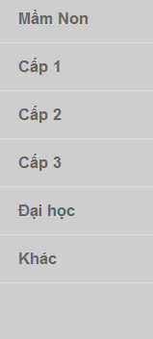

Menu vertical

* Kindergarten

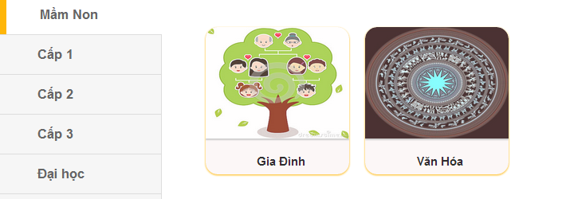

Interface Kindergarten

* *Primary*

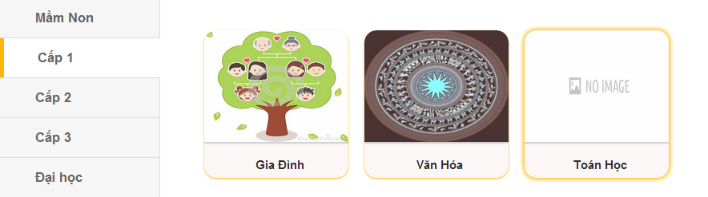

Interface Primary

* *Sencondary*

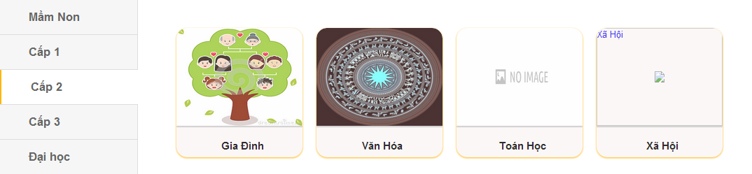

Interface Secondary

* *University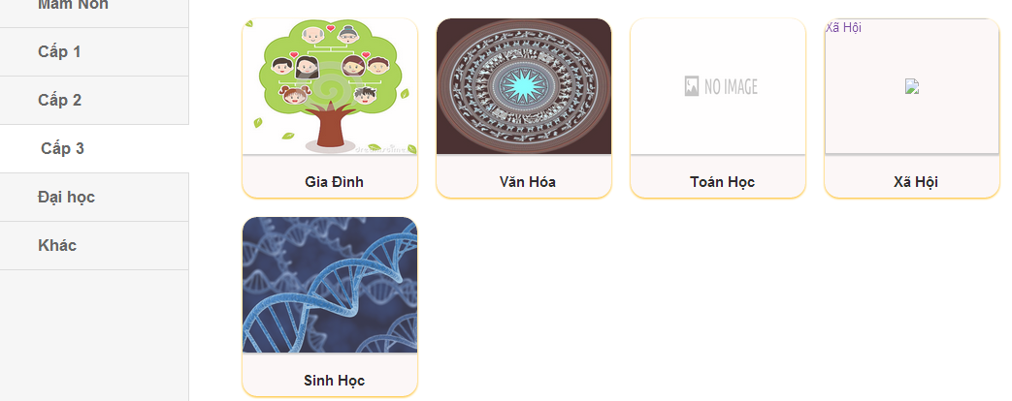*

**Interface Tertiary**

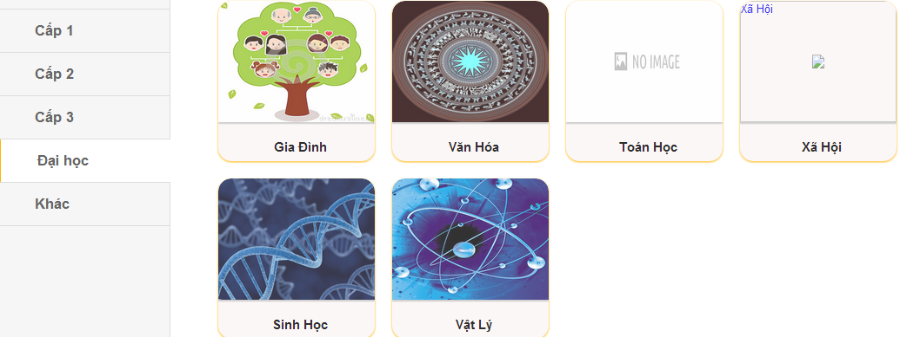

Interface University

1. Function of System

* 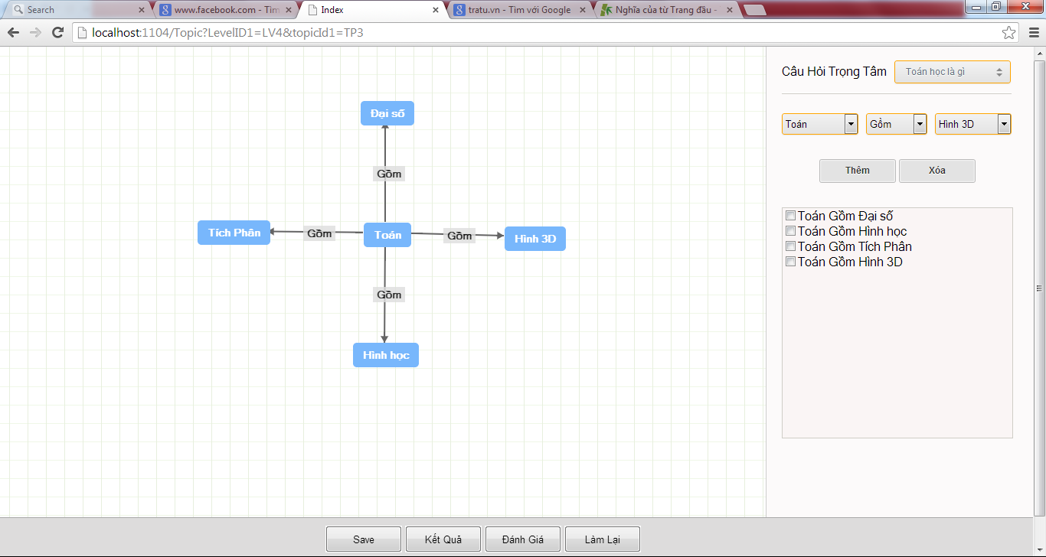Function of topic:

Function conceptMap about Math

* Concept Map :

+ Save maps

+ Show map

+Edit map

+ Evaluate maps

+ Result maps

* Concept:

Have function:

+ Drag concept in background

+ Drop a concept

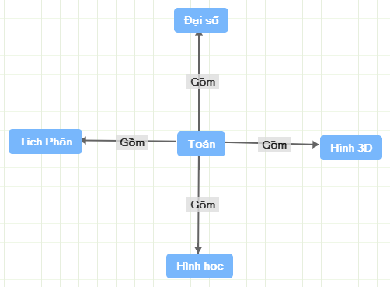

Image about Concept

Hinh cac c

* Link:

Have function:

* Link
* Have function:
* + drag link
* + drop link



Image about Link

# Chapter 2: Introduction about Technology

* 1. ***Introduction about MVC model***
     1. *Introduction*
* ASP.NET MVC 4 is a framework for building scalable, standards-based web applicationsusing well-established design patterns and the power of ASP.NET and the .NET Framework.In this article I will give an introduction to ASP.NET MVC4 from a **beginner’s**perspective.
* This article is meant for all kind of beginner users who wanted to get started with ASP.NET MVC 4. I have included a small comparison between ASP.NET MVC and ASP.NET Web forms for those who have already explored ASP.NET Web forms
* Currently ASPNET MVC 4 is supported in Visual Studio 2010 and Visual Studio 2012, previous versions of Visual Studio does not support ASP.NET MVC 4 as of now. If you don’t have ASP.NET MVC 4 in your box then install MVC 4 for Visual Studio 2010 or else use Visual Studio 2012 to get started with this article, You may refer  for more installation details/procedures.
  + ***MVC release history***
* The Current Version of ASP.NET MVC is 4 and it was released on 15th Aug 2012. ASP.NET MVC 4 is packaged with Visual Studio 2012 and MVC 4 can be installed for Visual Studio 2010. Below I have mentioned the release history of ASP.NET MVC.

|  |  |
| --- | --- |
| **Date** | **Version** |
| 10 Dec 07 | ASP.NET MVC CTP |
| 13 Mar 09 | ASP.NET MVC 1.0 |
| 16 Dec 09 | ASP.NET MVC 2 RC |
| 04 Feb 10 | ASP.NET MVC 2 RC 2 |
| 10 Mar 10 | ASP.NET MVC 2 |
| 06 Oct 10 | ASP.NET MVC 3 Beta |
| 09 Nov 10 | ASP.NET MVC 3 RC |
| 10 Dec 10 | ASP.NET MVC 3 RC 2 |
| 13 Jan 11 | ASP.NET MVC 3 |
| 20 Sep 11 | ASP.NET MVC 4 Developer Preview |
| 15 Feb 12 | ASP.NET MVC 4 Beta |
| 31 May 12 | ASP.NET MVC 4 RC |
| 15 Aug 12 | ASP.NET MVC 4 |

* + 1. ***What is ASP.NET MVC?***
* 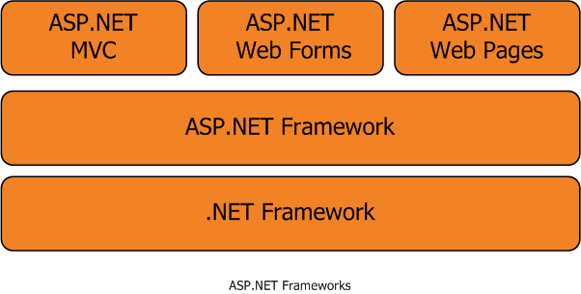ASP.NET MVC is a web application development framework built on top of Microsoft’s .NET Framework. ASP.NET Web Form was a replacement for Microsoft’s [Active Server Pages](http://en.wikipedia.org/wiki/Active_Server_Pages) (ASP) but ASP.NET MVC is not a replacement for ASP.NET Web Forms and it’s just an alternate way of making an ASP.NET website.
  + 1. ***Why MVC ?***
* ASP.NET MVC helps to reduce the complexity of the web application by dividing an application into three layers, Model, View and Controller. This separation (loose coupling) helps in some long term benefits like isolation of components while development and also this separation provides better support for test-driven development (TDD). ASP.NET MVC web site are good in performance and also easy to maintain.
  + 1. ***MVC architecture***
* The Model-View-Controller (MVC) pattern is an architectural design principle that separates the application components of a Web application into three layers. This separation gives you more control over the individual parts of the application, which lets you more easily develop, modify, and test them.

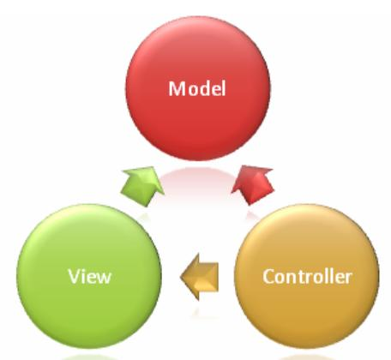

MVC_Architecture

* **The Model**
* Model contains and exposes the properties and application logic  In a better way we can say that The model represents core business logic and data.
* **The View**
* The View is responsible for creating the response HTML or any responses back to the browser like pdf, html or excel etc. In other way we can sat that the view is responsible for transforming a model or models into a visual representation.
* **The Controller**
* Controller is responsible for processing user inputs from view and give responses back to the view. It means that the controller decides the action and performs the tasks/logic based on the parameters.Controller acts as the coordinator between the view and the model.
  1. ConceptMap
     1. ***What is concept maps?***

A concept map is a [diagram](http://en.wikipedia.org/wiki/Diagram) that depicts suggested relationships between [concepts](http://en.wikipedia.org/wiki/Concept). It is a graphical tool that [designers](http://en.wikipedia.org/wiki/Designer), [engineers](http://en.wikipedia.org/wiki/Engineer), [technical writers](http://en.wikipedia.org/wiki/Technical_communication), and others use to organize and structure [knowledge](http://en.wikipedia.org/wiki/Knowledge).

A concept map typically represents ideas and information as boxes or circles, which it connects with labeled arrows in a downward-branching hierarchical structure. The relationship between concepts can be articulated in linking phrases such as causes, requires, or contributes to.

2.2.2 **How to Build a Concept Map**

Concept maps are typically hierarchical, with the subordinate concepts stemming from the main concept or idea.

* **Start with a main idea, topic, or issue to focus on.**

A helpful way to determine the context of your concept map is to ***choose a focus question***—something that needs to be solved or a conclusion that needs to be reached.

Once a topic or question is decided on, that will help with the hierarchical structure of the concept map.

* **Then determine the key concepts**

Find the key concepts that connect and relate to your main idea and rank them; most general, inclusive concepts come first, then link to smaller, more specific concepts.

* **Finish by connecting concepts--creating linking phrases and words**

Once the basic links between the concepts are created, add cross-links, which connect concepts in different areas of the map, to further illustrate the relationships and strengthen student’s understanding and knowledge on the topic.

Image’s Concept Map

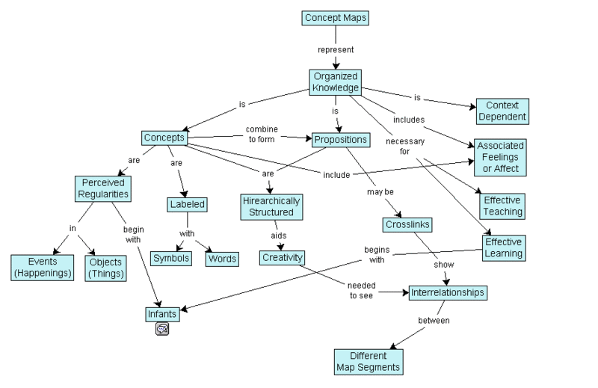

1. ***Tools software***

* Visual Studio 2012
* SQL Server 20012
* Entityframework 4.3

# Chapter 3: Design Interface’s Sofware

### 3.1 Login:

Interface Login

### 3.2 Register

Interface Register

### 3.3 Contact

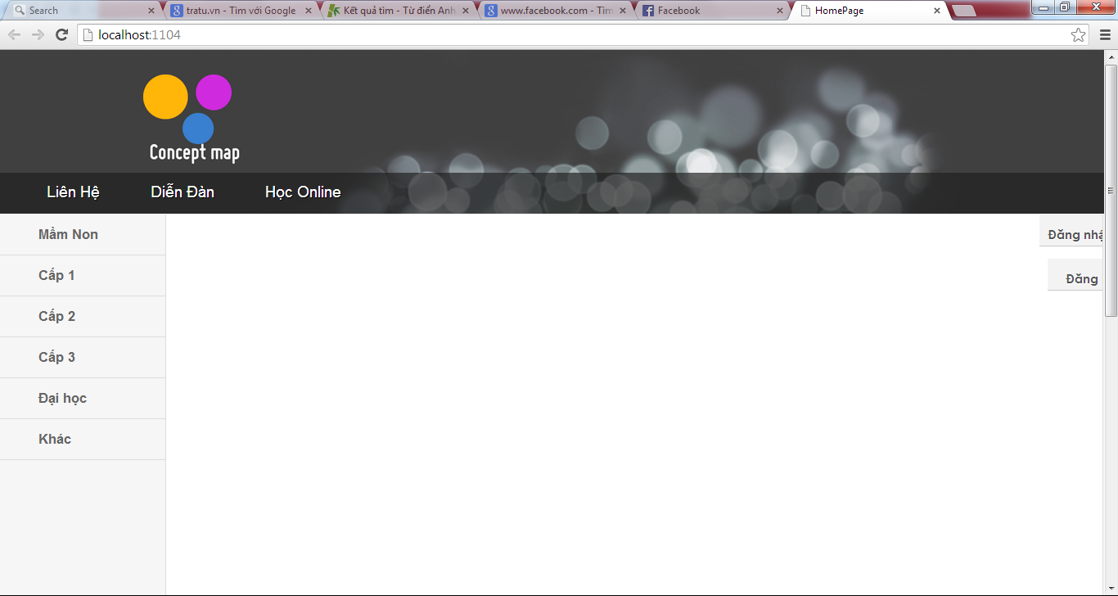

Interface Contact

### 3.4 Forum



Interface Forum

### 3.5 Learn online



Interface learn online

# Chapter 4: Design Database and Program

### *Usecase Diagram*

## 4.2.Database

### *Entity Relationship Diagram*

Database structure

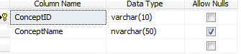

ConceptAll Table

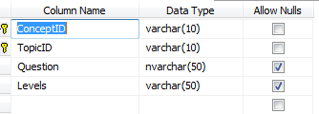

ConceptForTopic Table

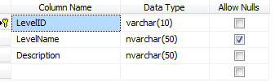

Level Table

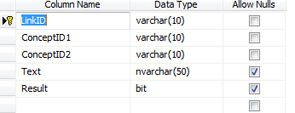

Link Table

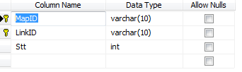

LinkOfMap Table

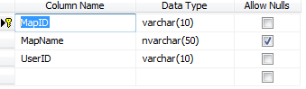

MapOfUser

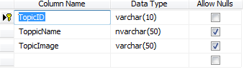

Topic Table

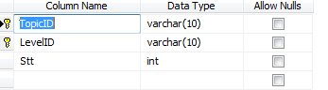

TopicOfLevel Table

User Table

# Chapter 5: Install Program and Demo

Step 1: Login with UserName and Password

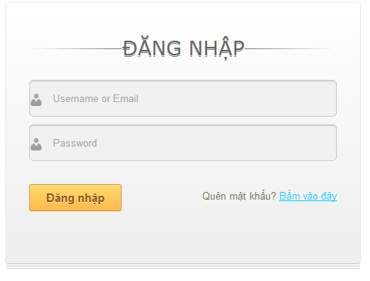

Interface Login

Step 2:Login success

……………………….

Step 3: Select level vertical menu.

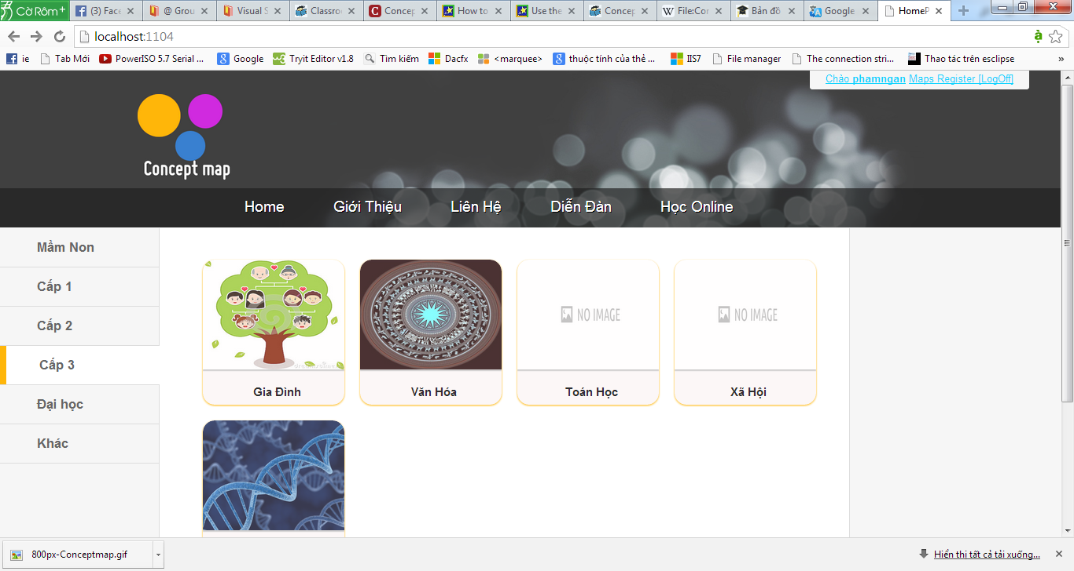

Step 4:Select Topic

Step 5:Select center question.Example:Toan hoc la gi ?

# Chapter 6: The Conclusion and Development

## 6.1 Conclusion

The essay is show clearly the basic about theory and some method resolve the problem in purpose build the website auto evaluate the conceptmap.

The website is built a system summarize the lesson about subject as math, culture, biology, physical, such as…It will help easily for student in learn.A project management all the system with function :save concept , result concept, evaluate concept, redo concept.With technology in MVC,it will help is easy maintain ,upgrade the project in the future.

## 6.2 Development

The group will build the website detail and deep in the future. It will assistance for the student . Special is problem some function to lack of project.

Tài liệu tham khảo

<http://www.codeproject.com/Articles/470107/ASP-NET-MVC-4-Part-1-Introduction>

Lời cảm ơn(acknowledgements)

The group is thank for the help of the teacher Ths. Đang Thanh Dung is university lecturer belong to information technology ,the teacher have guide the passion ,a lot of share for our knowledge and experience, with love of the teacher help our have full the knowledge ,complete the essay.

Athough the group have a lot of effort in carrying out the essay, with time is short and level research ourselves is shortage, so don’t avoid some short,the group expect to contribute the idea of the teacher and friend.