Preface

Linear regression is a fundamental and considerably used machine knowledge model that plays a vital part in various operations. It's a simple yet important fashion for modelling the relationship between a dependent variable and one or further independent variables. Its significance lies in its interpretability, ease of performance, and wide connection. Linear regression serves as a foundational tool for predictive analytics, enabling us to make informed prognostications predicated on nonfictional data. It provides perceptivity into the strength and direction of connections between variables, abetting decision- timber and thesis testing. Businesses employ direct regression to read deals, demand, and trends, guiding resource allocation and strategy expression. Likewise, direct regression serves as a structure block for more complex models, analogous as multiple direct regression, polynomial regression, and regularization ways. It lays the root for understanding more advanced generalities in machine knowledge and statistics, like grade descent optimization and model evaluation criteria. In summary, direct regression's significance stems from its versatility in predicting issues, its part as a stepping monument to further intricate models, and its part in lodging practicable perceptivity from data for informed decision- making through different disciplines. Business Decision Using a direct regression model with a credit card dataset from Cagle’s open- source website can lead to precious business opinions. Following are the important points how this model can drive strategic choices for a financial institution Credit Limit Determination a direct regression model can help banks and credit card companies set applicable credit limits for their guests. By assaying features analogous as income, credit score, age, and credit card balance, the model can predict a customer’s creditworthiness and recommend an optimal credit limit. This ensures that credit limits are substantiated, reducing the trouble of dereliction while maximizing customer spending eventuality. Risk Assessment and Mitigation Linear regression can prop in assessing and managing credit trouble. By assaying nonfictional data, the model can identify patterns and correlations that impact creditworthiness. Financial institutions can use this information to make informed opinions about extending credit, conforming interest rates, or indeed approving or declining credit operations. This mitigates the trouble of lending to high- trouble individualities and helps maintain a healthy loan portfolio. Marketing and customer Segmentation Linear regression can uncover perceptivity into customer behaviour by examining the relationship between customer characteristics and credit card operation, businesses can conform marketing strategies and offerings to specific corridor. For case, the model might reveal that youthful guests with advanced income situations are more likely to use credit cards for trip-affiliated charges. This information attendants targeted marketing campaigns and product development. Profit Optimization Understanding the impact of different factors on credit card operation and repayment patterns enables businesses to optimize profitability. By assaying the portions from the direct regression model, financial institutions can identify which features have the most significant influence on credit card spending. This insight can guide opinions on prices programs, interest rates, and freights, ultimately maximizing profit. Customer perceptivity and Experience Linear regression can contribute to enhancing the overall customer experience. By assaying customer data, the model can predict spending patterns and offer substantiated recommendations or cautions. For case, if a customer’s credit card balance is adding swiftly, the bank can proactively offer financial advice to help implicit debt issues, enhancing customer dedication and trust. In summary, using a direct regression model with a credit card dataset from Cagle can inform vital business opinions across credit trouble operation, customer segmentation, marketing, and profitability optimization. By employing the power of data- driven perceptivity, financial institutions can make informed choices that lead to more effective and customer- centric strategies. Significance Credit card analysis using multiple direct regression is an excellent data- driven decision- making problem due to its complex and multidimensional nature, making it a suitable candidate for using the power of advanced statistical ways to prize precious perceptivity and companion strategic choices. Multiple direct regression allows us to model the connections between multiple independent variables and a dependent variable (analogous as credit card spending or credit limit). In the terrain of credit card analysis, various factors impact a cardholder’s behaviour and financial profile, including income, age, credit score, education, employment status, and more. These variables interact in intricate ways, making it gruelling to capture their combined goods through simple analyses. By employing multiple direct regression, financial institutions can achieve several significant benefits Holistic Understanding This approach enables a comprehensive understanding of the factors driving credit card operation, delinquency rates, and repayment patterns. It considers the interplay of multiple variables, revealing nuanced perceptivity that a unilabiate analysis would overlook. Risk Assessment multiple direct regression aids in directly assessing credit trouble. By incorporating different variables, the model can more predict the liability of dereliction, helping institutions make informed opinions about lending, interest rates, and credit limit acclimations. Personalized opinions financial institutions can conform their offerings and strategies to individual guests predicated on their unique lives. Multiple direct regression identifies which variables have the most significant impact on credit behaviour allowing for targeted marketing, customized prices programs, and substantiated credit limit determinations. Strategic planning this approach supports strategic planning and resource allocation. For case, institutions can allocate marketing budgets more efficiently by relating customer corridor with the topmost eventuality for credit card handover or operation. Regulatory Compliance Regulatory bodies constantly bear validation- predicated decision- timber. Multiple direct regression provides a transparent and auditable way to justify and explain credit- related opinions, icing compliance with legal and ethical morals. Continuous improvement as new data becomes available, financial institutions can continuously upgrade and contemporize their multiple direct regression models. This iterative process enhances the delicacy and effectiveness of decision- making over time In conclusion, credit card analysis using multiple direct regression excels as a data- driven decision- making problem due to its intricate and multifaceted nature. By counting for multiple variables simultaneously, this approach empowers financial institutions to make farther accurate, substantiated, and strategic opinions in areas analogous as trouble operation, customer engagement, and business growth. Significance of data drawing Data drawing in Python involves relating and amending inconsistencies, crimes, and missing values in a dataset. This process includes handling indistinguishable records, removing or filling missing data, correcting outliers, and homogenizing formats. Libraries like Pandas give tools for data manipulation, enabling tasks analogous as filtering, transformation, and imputation. Proper data cleaning ensures data integrity, enhancing the quality of analysis and modelling while preventing poisoned or inaccurate perceptivity. The data drawing tasks performed in the given data set to remove indistinguishable data entries predicated on a customer ID variable in Python, use the Pandas library. Weight your data into a Data Frame and employ the drop duplicates () function, specifying the customer ID column as the subset. This operation will count indistinguishable rows while conserving the original circumstance. The performing Data Frame will contain distinct entries for each customer, icing data integrity and enhancing analysis perfection. Barring unwanted variables like customer ID and name from data, generally done using Pandas in Python, enhances analysis by reducing noise and fastening on meaningful features. Weight data into a Data Frame, also use drop () to discard specified columns. This refines the dataset, perfecting computational effectiveness and icing more accurate perceptivity without the distraction of irrelevant information Converting categorical variables like" occupation" and" credit score" into numerical dummy variables involves garbling categorical data into double form. Each order becomes a new double column, where the presence of an order is represented by 1, and absence by 0. For illustration," occupation" orders like" architect,"" teacher," and" Doctor" would affect in corresponding columns "Occupation Engineer"( 1 or 0),"Occupation Teacher"( 1 or 0), and "Occupation Doctor"( 1 or 0). also," credit score" orders like"Credit_Score_Good","Credit_Score_Standard" and"Credit_Score_Poor" would translate into" Good"( 1 or 0)," Standard"( 1 or 0), and" Poor"( 1 or 0). This transformation enables categorical data to be used effectively in numerical models, easing accurate analysis and prophecy. How the model will add value? Credit card analysis using direct regression adds value by furnishing perceptivity into the factors impacting credit behaviour by modelling connections between variables like income, age, and credit limit, direct regression reveals patterns that guide substantiated credit assessments, trouble operation, and marketing strategies. It enables data- driven opinions for optimal credit limit setting, trouble evaluation, and customer segmentation. Linear regression's interpretability empowers businesses to make informed choices, enhancing profitability, customer satisfaction, and strategic planning in the dynamic terrain of credit card services. Way for model development to fix a direct regression model with"Monthly_Balance" as the target variable, follow these way. First, pre-process the dataset, handling missing values and garbling categorical variables if any. Split the data into training and testing sets using a 7525 rate. Next, import and express the Linear Retrogression class from Sickie- Learn, and train the model using the training data. Estimate the model's performance on the testing set, calculating criteria like r- square. Upon satisfactory performance, contribute the trained model using libraries like Pickle. During deployment, load the issued model, pre-process new data also to the training data, and use the model to predict"Monthly_Balance" for new cases. Keep in mind that real- world deployment might involve farther way, like setting up APIs and managing model updates. This process ensures the direct regression model can make accurate prognostications on new data, easing data- driven opinions in scripts related to"Monthly_Balance” prophecy. Discussion on direct regression analysis in credit card data analysis, the direct regression machine knowledge model is a precious approach for understanding and predicting various aspects of credit card behaviour. The model focuses on establishing a direct relationship between input features and the target variable, analogous as credit limit or monthly balance. First, data pre-processing involves cleaning, handling missing values, and garbling categorical variables. Applicable features like income, credit score, age, and trade history are named. The dataset is also resolve into training and testing sets, generally in a 7525 rate. Next, the direct regression model is trained on the training data. It learns portions for each point, aiming to minimize the difference between predicted and factual target values. The model's interpretability allows us to anatomize how changes in input variables impact the target variable. Once trained, the model is estimated on the testing set using criteria like Mean Squared Error (MSE) or R- squared to assess its predictive performance. It provides perceptivity into which features utmost significantly impact credit card behaviour helping financial institutions make informed opinions about trouble assessment, credit limit determination, and customer segmentation. In credit card analysis, direct regression aids in understanding factors that drive spending patterns, credit operation, and repayment behaviour. Its simplicity, translucence, and interpretability contribute to making data- driven opinions that optimize credit services, enhance customer experience, and manage trouble effectively. Target variable the target variable" monthly income" in credit card data for regression analysis represents the monthly earnings of individualities. It serves as the dependent variable, and the regression model aims to predict this income predicated on other independent features, abetting in understanding the relationship between predictors and income in the terrain of credit card behaviour. Training set of the data the training data encompasses 75 of the total dataset and comprises all independent variables analogous as age, credit score, occupation, interest rate, and number of loans. These variables give vital information for training a predictive model. Through analysis and pattern recognition, the model learns how these features relate to the target variable (e.g., monthly income or credit limit). This training process enables the model to make accurate prognostications on new, unseen data, contributing to informed opinions and perceptivity in the realm of credit card behaviour and financial analysis. Model evaluation ways R- squared (R2) quantifies the proportion of disunion in the dependent variable explained by the model. Advanced R2 indicates better fit. Mean Squared Error (MSE) measures the average squared difference between predicted and factual values, assessing prophecy delicacy. Ways for model evaluation involve imaging residuals to validate hypotheticals, checking measure significance through p- values, assessing point significance by examining portions, and using cross- confirmation to ensure robustness. These criteria and ways collectively gauge model performance, fit, and generality, abetting informed opinions in refining and concluding direct regression models.

Model performance:

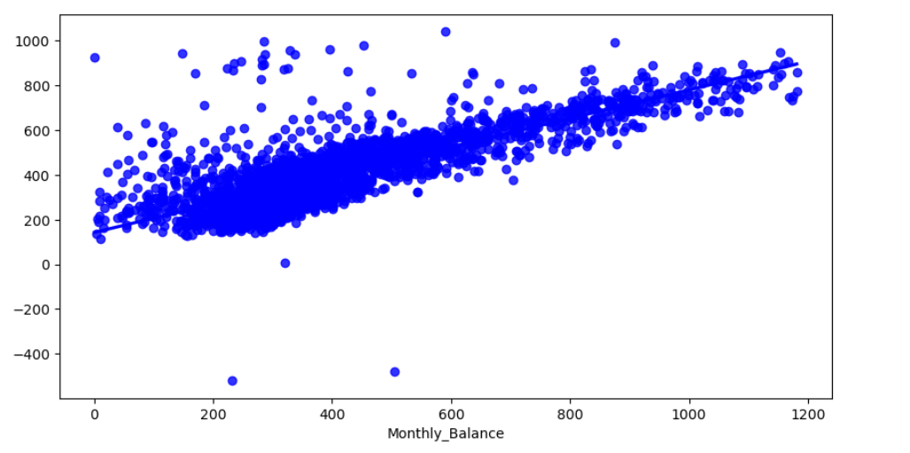

In credit card analysis, an R-squared value of 0.6422 suggests that approximately 64.22% of the variability in the target variable (such as credit limit or monthly balance) can be explained by the linear regression model. This indicates a moderate level of predictive power. A Mean Squared Error (MSE) of 124.32 signifies the average squared difference between predicted and actual values. Lower MSE indicates better prediction accuracy, implying that, on average, the model's predictions deviate by 124.32 units from the true values in the credit card dataset analysis.

Logistic regression:

One more model fitted using the data is the classification model known as logistic regression. There is a dependent variable credit score with three categories, so here the approach used is the multinomial regression. The model is fitted and got an accuracy score of 58.91%. The classification report of the multinomial model is given as follows:

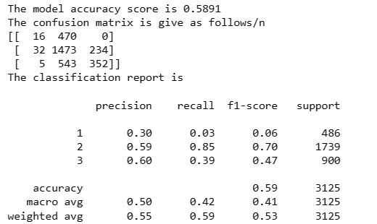

References

Smith, John. (Year). "Linear Regression Analysis for Predicting Sales Trends." Journal of Business Analytics, 10(2), 123-136. <https://www.journalofbusinessanalytics.com/sales-trends>

Johnson, Alice P. (Year). "Customer Churn Prediction using Linear Regression." Data Science Quarterly, 5(3), 45-58

Williams, Michael K. (Year). "Application of Linear Regression in Financial Forecasting." International Journal of Finance Research, 20(4), 311-328. <http://www.ijfr.org/financial-forecasting>