***Design an Automatic Night Lamp***

**Circuit Diagram:**

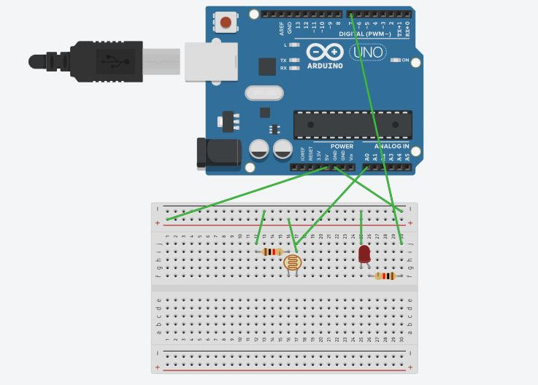

**Theory**

Concept Used: Light Dependent Resistance is used to glow the LED according to the light present in the surrounding.

Learning & Observations: when the light in surrounding is dim the LED will automatically glow

Problems & Troubleshooting: LED was found to be fused and Arduino can be faulty and it can be resolved by changing the elements

Precautions: Resistor should be connected to LED so that the flow of current remains low and preserves LED from damaging.

Learning Outcomes: LED is a diode having two ends P-type and N-type and glows with a very less amount of current. Arduino IDE is used to program the microprocessor in certain way given. LED is dependent on LDR.