***Design an obstacle detector and distance measuring device***

**Circuit Diagram:**

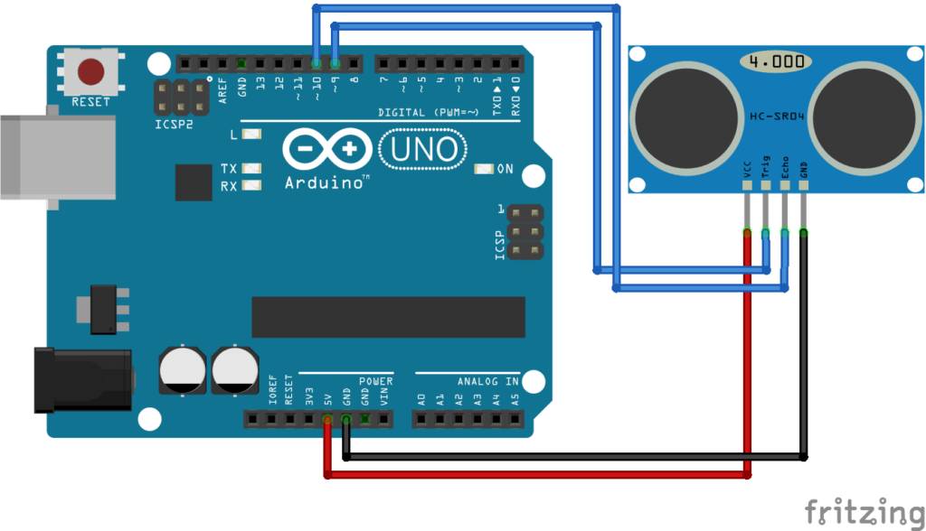

**Theory**

Concept Used: Ultrasonic sensor is used to display distance on IDE wrt the object placed in front .

Learning & Observations: when the object is placed in front of the sensor the sensor detects the distance using ultrasonic waves .

Problems & Troubleshooting: LED was found to be fused and Arduino can be faulty and it can be resolved by changing the elements

Precautions: Resistor should be connected to LED so that the flow of current remains low and preserves LED from damaging.