**CS 5050 Advanced Algorithms**

**Assignment 1: Shubham Swami – A02315672**

Win Function:

def win(n) -> bool:

        if n == 0:

            return False

        if n < 11:

            return True

        result = True

        for i in range(1,11):

            result &= win(n-i)

        return not result

Graphs:

1. Y-scale = ‘log’

time = 0.000002 1.922 ^ n

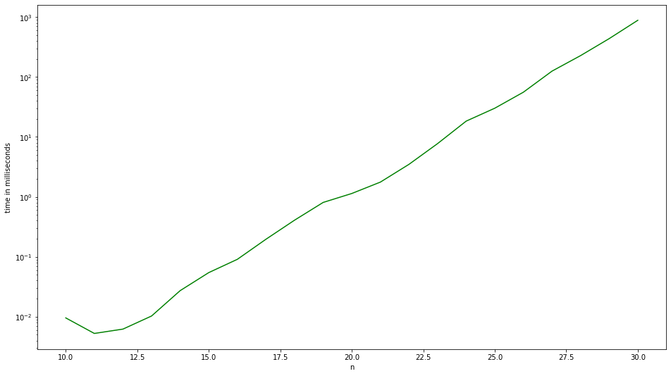

1. Y-scale = ‘linear’

time = 0.000001 1.969 ^ n

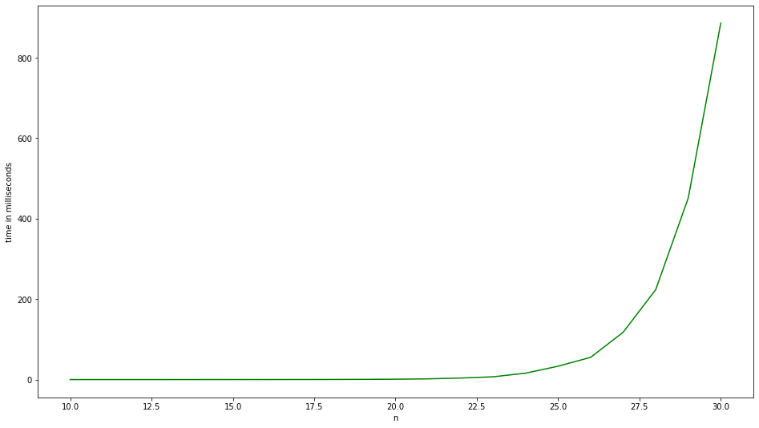

New base of exponential function:

2n/10 < f(n) < 2n

⇒ f(n) = can

⇒ log(f(n)) = n log a + log c

⇒ log2 a = slope (From log graph)

⇒ log2 a = (y2-y1)/(x2-x1)

⇒ log2 a = 0.83

⇒ a = 20.83

⇒ **a=1.777**

⇒ **f(n) = c*1.777n**