**Q6: Timing Study for Sequence 1 and Sequence 2**

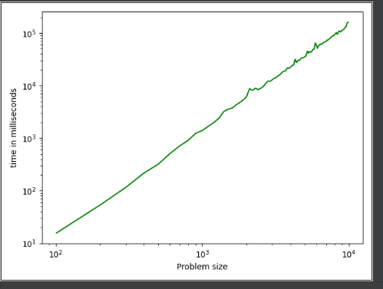

**time = 0.001361 n ^ 2.009**

Time for 10000 characters = 0.001361*(10000^2.009) = **147.86** seconds

If we estimate this for 30000 characters.

Time = 0.001361*(30000^2.009) = **1343** seconds (approximately)

**Time gets increased by 9 times.**

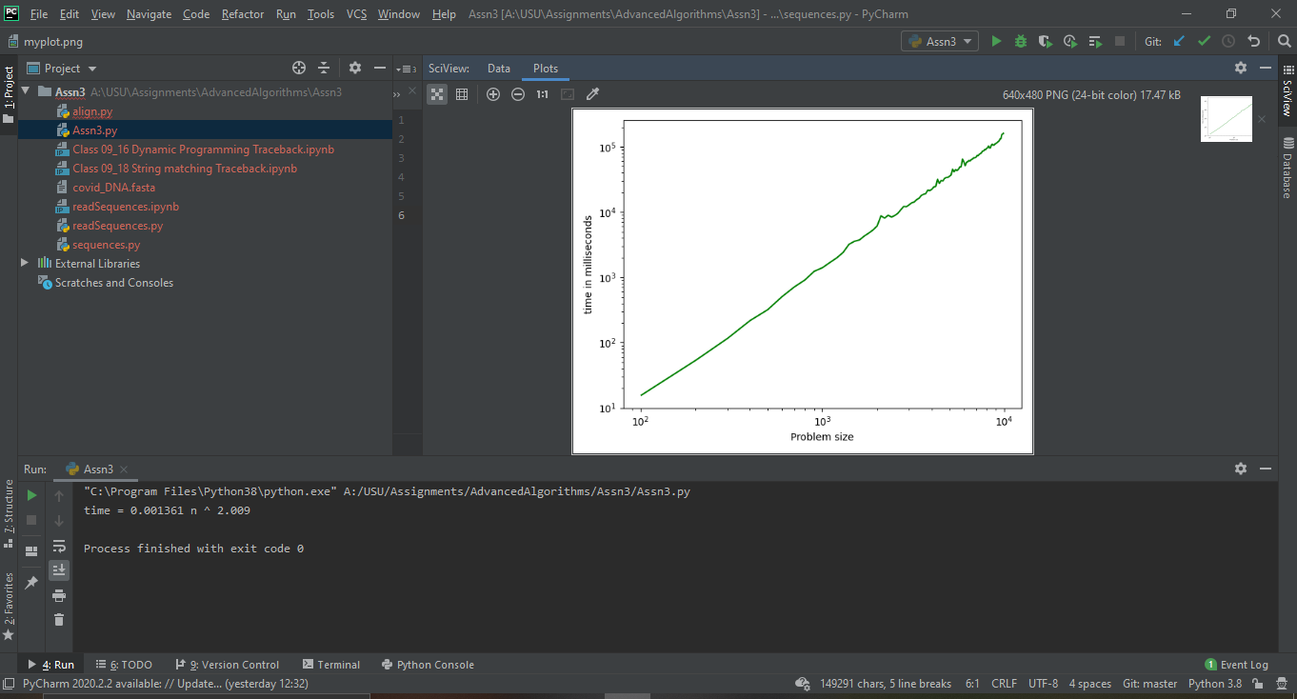

**Q7: Table for matching the first five sequences with all the other sequences.**

**Results: matchDP(A,B):**

|  |  |  |
| --- | --- | --- |
| **A** | **B** | **Score** |
| Sequence 1 | Sequence 2 | 24551 |
| Sequence 1 | Sequence 3 | 24502 |
| Sequence 1 | Sequence 4 | 24629 |
| Sequence 1 | Sequence 5 | 24962 |
| Sequence2 | Sequence 4 | 24913 |
| Sequence 3 | Sequence 2 | 24956 |
| Sequence 3 | Sequence 4 | 24864 |
| Sequence 5 | Sequence 2 | 24580 |
| Sequence 5 | Sequence 3 | 24531 |
| Sequence 5 | Sequence 4 | 24672 |
| Sequence 1 | Sequence 1 | 25000 |
| Sequence 2 | Sequence 2 | 25000 |
| Sequence 3 | Sequence 3 | 25000 |
| Sequence 4 | Sequence 4 | 25000 |
| Sequence 5 | Sequence 5 | 25000 |

Q8: For the matching and output file my code works fine, however colab takes forever to run long sequences. Even a small network failure leads to restart in execution so I’m submitting both .py files and. ipynb files.

Colab file has many small test cases.

I have submitted alignment for 50 chars and 100 chars, 500 and 800 all these ran so I moved to 30000. It is taking a lot of time so if it complies, I will email the file separately.