|  |  |  |
| --- | --- | --- |
|  | Name | Shubham Goel |
|  | Roll No | 2019130015 |
| **OOP Lab** | Batch | A |
| Exp 8: Access modifiers | Date | 22 Nov. 21 |
|  | Branch | COMPS |

**Aim:** Implement a access modifiers

**Theory**

The access modifiers in Java specifies the accessibility or scope of a field, method, constructor, or class. We can change the access level of fields, constructors, methods, and class by applying the access modifier on it.

There are four types of Java access modifiers:

1. **Private:** The access level of a private modifier is only within the class. It cannot be accessed from outside the class.
2. **Default**: The access level of a default modifier is only within the package. It cannot be accessed from outside the package. If you do not specify any access level, it will be the default.
3. **Protected**: The access level of a protected modifier is within the package and outside the package through child class. If you do not make the child class, it cannot be accessed from outside the package.
4. **Public**: The access level of a public modifier is everywhere. It can be accessed from within the class, outside the class, within the package and outside the package.

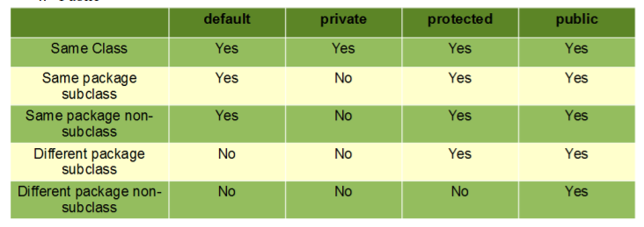

**Code:**

**Main.java**

package main;

import otherpackage.ProductInOtherPackage;

public class Main {

    public static void main(String[] args) {

        // same package

        ChildClass a = new ChildClass();

        a.printAvailableData();

        a.printFromSubClass();

        // new sub-class from different package

        class SubClassOfDiffPackage extends ProductInOtherPackage {

            int price = 12000; // default

            public int rating = 2;

            protected int cost_of_making = 10;

            private int quantity = 30;

            void printSubClass() {

                System.out.println("------------------------------------------");

                System.out.println("Access from different package, child of the Product class");

                System.out.println("------------------------------------------");

                System.out.println("private data variable:");

                System.out.println("quantity: ERROR");

                System.out.println("");

                System.out.println("protected data variable");

                System.out.println("cost_of_making: ERROR");

                System.out.println("");

                System.out.println("public data variable");

                System.out.println("rating: " + rating);

                System.out.println("");

                System.out.println("default data variable");

                System.out.println("price: " + price);

                System.out.println("------------------------------------------");

            }

        }

        SubClassOfDiffPackage b = new SubClassOfDiffPackage();

        b.printSubClass();

        // different package class

        ProductInOtherPackage otherPackageObject = new ProductInOtherPackage();

        System.out.println("------------------------------------------");

        System.out.println("Access from different package");

        System.out.println("------------------------------------------");

        System.out.println("private data variable:");

        System.out.println("quantity: ERROR");

        System.out.println("");

        System.out.println("protected data variable");

        System.out.println("cost_of_making: ERROR");

        System.out.println("");

        System.out.println("default data variable");

        System.out.println("rating: ERROR");

        System.out.println("");

        System.out.println("public data variable");

        System.out.println("rating: " + otherPackageObject.rating);

        System.out.println("");

        System.out.println("------------------------------------------");

    }

}

**ChildClass.java**

package main;

public class ChildClass extends Product {

    public void printFromSubClass() {

        System.out.println("------------------------------------------");

        System.out.println("Access from same package, child of the Product class");

        System.out.println("------------------------------------------");

        /*

         * int price = 12000; public int rating = 2; protected int cost_of_making = 10;

         * private int quantity = 30;

         */

        System.out.println("private data variable:");

        System.out.println("quantity: ERROR");

        System.out.println("");

        System.out.println("protected data variable");

        System.out.println("cost_of_making: " + cost_of_making);

        System.out.println("");

        System.out.println("public data variable");

        System.out.println("rating: " + rating);

        System.out.println("");

        System.out.println("default data variable");

        System.out.println("price: " + price);

        System.out.println("------------------------------------------");

    }

}

**Product.java**

package main;

public class Product {

    int price = 12000; // default

    public int rating = 2;

    protected int cost_of_making = 10;

    private int quantity = 30;

    void printAvailableData() {

        System.out.println("------------------------------------------");

        System.out.println("Access from the same class");

        System.out.println("------------------------------------------");

        System.out.println("private data variable:");

        System.out.println("quantity: " + quantity);

        System.out.println("");

        System.out.println("protected data variable");

        System.out.println("cost_of_making: " + cost_of_making);

        System.out.println("");

        System.out.println("public data variable");

        System.out.println("rating: " + rating);

        System.out.println("");

        System.out.println("default data variable");

        System.out.println("price: " + price);

        System.out.println("------------------------------------------");

    }

}

**ProductInOtherPackage.java**

package otherpackage;

public class ProductInOtherPackage {

    int price = 12000; // default

    public int rating = 2;

    protected int cost_of_making = 10;

    private int quantity = 30;

}

**Output:**

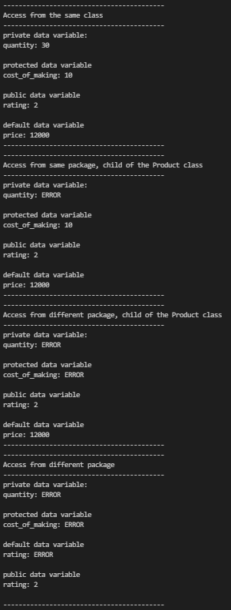

**Conclusion**

I have learnt and implemented access modifiers. I have also understood how the access change in different packages.

Reference:

https://www.javatpoint.com/access-modifiers