- WHAT IS DATA ANALYTICS ?
Data analytics (DA) is the process of examining data sets in order to draw conclusions about the information they contain, increasingly with the aid of specialized systems and software.
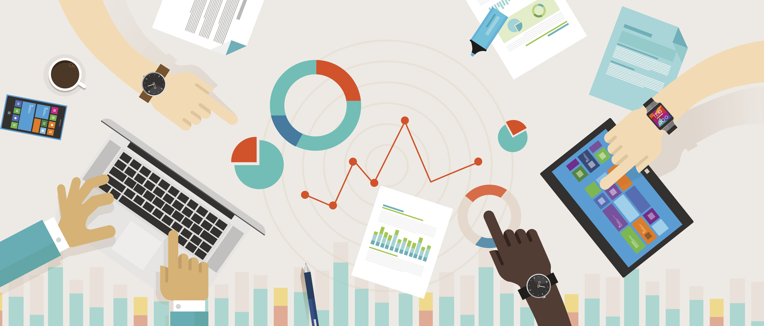
Data is information in raw format. With increasing data size, it has become need for inspecting, cleaning, transforming, and modeling data with the goal of finding useful information, making conclusions, and supporting decision making. This process is known as data analysis.
90% of the world’s data has been created in the last 2 years and it is expected to grow 50 times by 2020. So in the coming years, one who will have "Data" will be able to utilize the resources in the most efficient manner.

2- WHAT IS THE DIFFERENCE BETWEEN DATA ANALYTICS AND DATA SCIENCE?

DATA ANALYTICS | DATA SCIENCE
Data Analytics: Analytics is about applying a mechanical or algorithmic process to derive the insights for example running through various data sets looking for meaningful correlations between them. Looking at the weather data and pest data we see that there is a high correlation of a certain type of fungus when the humidity level reaches a certain point. The future weather projections for the next few months (during planting season) predict a low humidity level and therefore lowered risk of that fungus. For the farmer this might mean being able to plant a certain type of strawberry, higher yield, higher market price and not needing to purchase a certain fungicide. | Data Science: A combination of mathematics, statistics, programming, the context of the problem being solved, ingenious ways of capturing data that may not be being captured right now plus the ability to look at things ‘differently’ and of course the significant and necessary activity of cleansing, preparing and aligning the data. So in the strawberry industry we’re going to be building some models that tell us when the optimal time is to sell, which gives us the time to harvest which gives us a combination of breeds to plant at various times to maximize overall yield. We might be short of consumer demand data – so maybe we figure out that when strawberry recipes are published online or on television, then demand goes up – and Tweets and Instagram or Facebook likes provide an indicator of demand. Then we need to align demand data up with market price to give us the final insights and maybe to create a way to drive up demand by promoting certain social media activity.
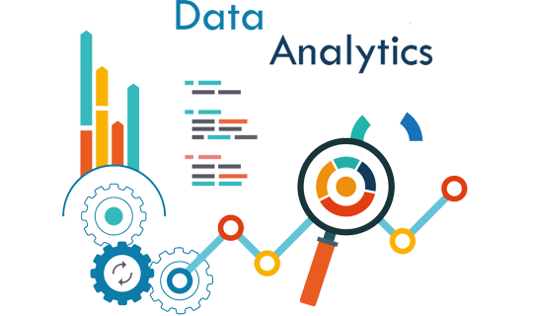 | 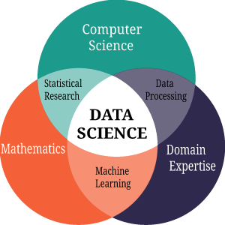

3-WHAT IS THE UTILITY OF DATA ANALYTICS IN GOVERNANCE, WHY IS IT NEEDED IN THE CURRENT TIMES?

Big data can be very well used for e governance.
MAJOR IMPICATIONS OF DATA ANALYTICS ARE:
EDUCATION: SCHOOLS, COLLEGES, INSTITUTIONS CAN BE MADE DEPENDING ON THE REQUIREMENT AND POPULATION OF A PARTICULAR REGION.PERFORMANCE ANALYSIS OF THE SCHOOLS CAN BE DONE AND THE DESERVED CAN BE ENCOURAGED TO PROMOTE HEALTHY COMPETITION AMONG TEACHERS AND STUDENTS.
HEALTHCARE: HOSPITALS, MOHALLA CLINICS, MEDICINE CENTRES CAN BE MADE DEPENDING ON THE VULNERABILITY OF A REGION TO DISEASES. ANALYSING THE PAST YEAR TRENDS, PRE-ARRANGEMENTS CAN BE DONE TO COPE UP WITH SEASONAL DISEASE LIKE DENGUE, CHICKENGUNIA, ETC.
DEFENCE: USING MACHINE LEARNING PROPER STRATAGIES CAN BE MADE.ANALYSING THE AVAILABLE RESOURCES OF THE ENEMY, REQUIRED PREPARATIONS CAN BE DONE FOR FUTURE.
Data can be used to capture a citizens complete activity from his online purchases and search queries to classify him as a regular tax payer/fraudulent/ anti social activity and stuff.
It can be used to identify the current buzz about the government or government facilities.
It can help government track tax defaulters. A lot service queues in government agencies can be reduced by servicing people online and this can only be done with utilisation of big data.
Data retrieval can be done at ease. i.e. a case history/missing person history can be done.
Identifying their criminals also can become easier.
Implementing law will also be done at ease. Terrorists can also be traced and tracked based on their tracking.
4- Define a USE-CASE according to your own understanding where data analytics can be used in Governance?

I have taken dataset from Data.Gov.in about the enrolment of students. It involves following parameters:
- Number of girl enrolment in class 9th.
- Number of girl enrolment in class 10th.
- Number of girl enrolment in class (9+10)^{th}.
- Number of girl enrolment in class (1 to 10)^{th}.
- Number of boy’s enrolments in class 9th.
- Number of boy’s enrolments in class 10th.
- Number of boy’s enrolment in class (9+10)^{th}.
- Number of boy’s enrolment in class (1 to 10)^{th}.
ALL THE DATA IS PRESENT FOR BOTH RURAL AND URBAN AREAS OF ALL THE STATES OF INDIA.
AFTER PERFORMING THIS RIGROUS ANALYSIS ON
THE DATA, FEW CONCLUSIONS CAN BE MADE
WHICH CAN BE USED FOR MAKING FURTHER
GOVERNMENT POLICIES:
1-IN URBAN CITIES, THE CONDITION OF EDUCATION
IS AT PAR FOR THE GIRLS. IT NEEDS TO BE
IMPROVED BUT OVERALL. NO SPECIFIC RESOURCE
ALLOCATION FOR GIRL EDUCATION IS
REQUIRED.
2-IN RURAL AREAS/VILLAGES, THE OVERALL
EDUCATION IS NOT AT PAR WITH URBAN.. BUT THE
MOST DISASTEROUS POINT IS THAT THERE IS A
STRONG DISCRIMINATION IN GIRLS AND BOYS WITH
REGARDS TO EDUCATION. HENCE GOVERNMENT
POLICIES IN VILLAGES SHOULD FOCUS MORE ON
GIRLS EDUCATION PRIOR TO OVERALL
EDUCATION.
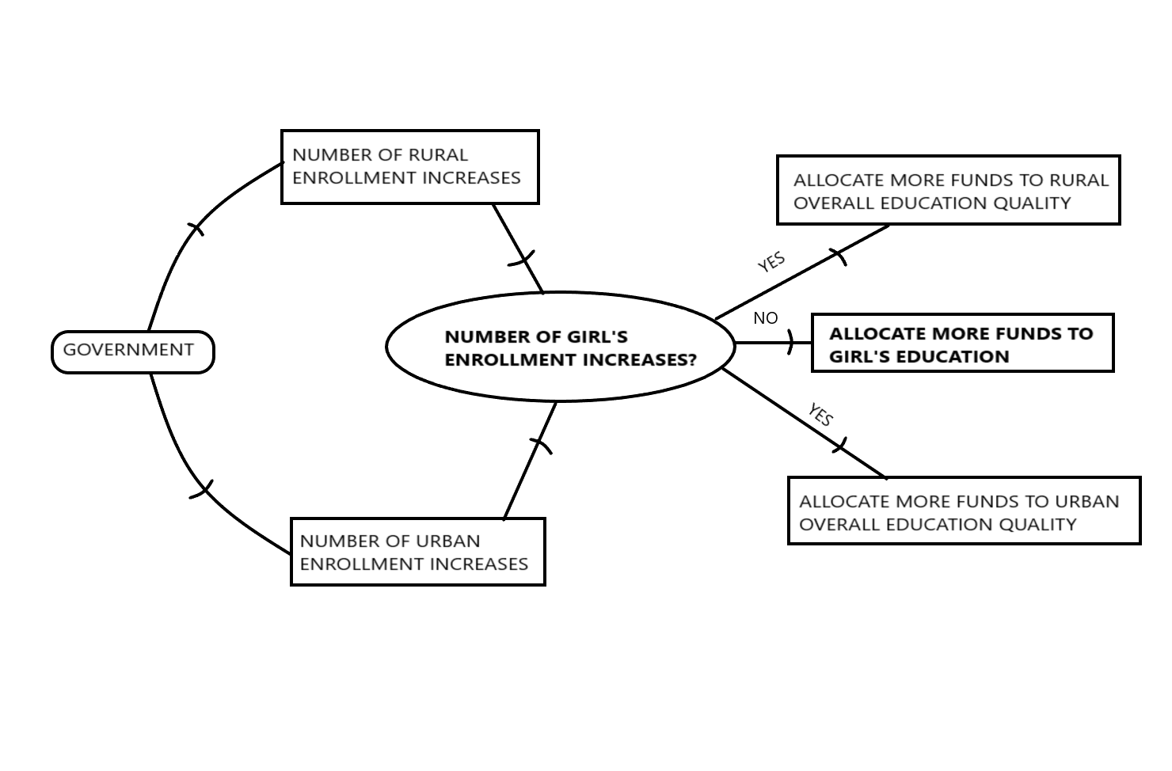

The detailed analysis of the dataset is attached in python notebook as well as in pdf format. Please look for it.

THANKYOU.
REGARDS,
SHUBHAM BANSAL
EMAIL-Shubham.bansal795@gmail.com
CONTACT- 9650335264

