Threonine
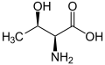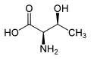
L-Threonine (2S,3R) and D-Threonine (2R,3S)
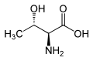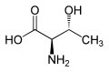
L-allo-Threonine (2S,3S) and D-allo-Threonine (2R,3R)
Threonine is one of two amino acids out of the twenty with two chiral centers. Threonine can exist in four possible stereoisomers with the following configurations: (2S,3R), (2R,3S), (2S,3S) and (2R,3R). However, the name L-threonine is used for one single enantiomer, (2S,3R)-2-amino-3-hydroxybutanoic acid. The second stereoisomer (2S,3S), which is rarely present in nature, is called L-allo-threonine. The two stereoisomers (2R,3S)- and (2R,3R)-2-amino-3-hydroxybutanoic acid are only of minor importance.

Isoleucine
Isoleucine (abbreviated as ile or I) is an α-amino acid with the chemical formula HO₂CCH(NH₂)CH(CH₃)CH₂CH₃. It is an essential amino acid, which means that humans cannot synthesize it, so it must be ingested. Its codons are AUU, AUC and AUA.
With a hydrocarbon side chain, isoleucine is classified as a hydrophobic amino acid. Together with threonine, isoleucine is one of two common amino acids that have a chiral side chain. Four stereoisomers of isoleucine are possible, including two possible diastereomers of L-isoleucine. However, isoleucine present in nature exists in one enantiomeric form, (2S,3S)-2-amino-3- methylpentanoic acid

.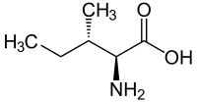 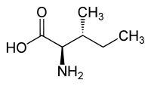
L-isoleucine (2S,3S) and D-isoleucine (2R,3R)
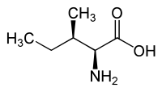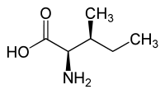
L-allo-isoleucine (2S,3R) and D-allo-isoleucine (2R,3S)

