SCIENCE-1 Project
Survival Probality of Blind Rat

YOUTUBE LINK: https://www.youtube.com/watch?v=EcC8MTA5Ybc&feature=youtu.be

COMPUTATIONAL:

For lattice grid:

import random
from matplotlib import pyplot as plt

# size of the grid
N = 8
# No of iterations
EXPERIMENTS = 1000

# No of steps
TIME =1000

time_array = [i for i in range(0, TIME)]

def valid(row, col):
if(row < 0 or row >= N or col < 0 or col >= N):
return False
return True

def solve(mouseStartRow, mouseStartCol, catStartRow, catStartY):

frq = [0] * TIME
probability = [0] * TIME
diff = [[1, 0], [-1, 0], [0, 1], [0, -1]]

for i in range(0, EXPERIMENTS):

mouseRow = mouseStartRow
mouseCol = mouseStartCol
catRow = catStartRow
catCol = catStartY

for j in range(1, TIME):

mouse_movement = []
cat_movement = []

mouse_movement = random.choice(diff)
cat_movement = random.choice(diff)

if(valid(mouseRow + mouse_movement[0], mouseCol + mouse_movement[1])):
mouseRow = mouseRow + mouse_movement[0]
mouseCol = mouseCol + mouse_movement[1]

if(valid(catRow + cat_movement[0], catCol + cat_movement[1])):
catRow = catRow + cat_movement[0]
catCol = catCol + cat_movement[1]

if(mouseRow == catRow and mouseCol == catCol):
frq[j] = frq[j] + 1
break

return [(frq[i] / EXPERIMENTS) for i in range(0, TIME)]

MID = N // 2
Opposite = solve(0, 0, N - 1, N - 1)
Center = solve(MID, MID, MID, MID)

plt.plot(time_array, Opposite, label = "Starting at Opposite Corners")
plt.plot(time_array, Center, label = "Starting at Center")
plt.legend()
plt.ylabel("Death Probability")
plt.xlabel("Time")
plt.show()
plt.savefig("Center_Grid.png")
plt.close()

For Sphre:

#include<stdio.h>
#include<stdlib.h>
#include<time.h>
#include<math.h>
#define PI 3.1415926
#define dbl double
dbl fn[100005];
dbl save[100005];
int main(){
dbl rad;
int i,j;
dbl count = 0.00,x,y,z;
dbl rats[3];
dbl cats[3],fl=0;
rep:
fprintf(stderr,"R??");
scanf("%lf",&rad);
dbl range = rad/10;
srand(time(0));
for(i=0;i<10000;i++){
rats[0] = -rad;
rats[1] = rats[2] = cats[1] = 0;
cats[0] = rad;
cats[2] = 1;
fprintf(stderr,"%d\n",i);
for(j=1;j<=10000;j++){
int flag=0;
do{
dbl theta = (dbl)rand()/(dbl)RAND_MAX;
theta*=PI;
dbl phi = (dbl)rand()/(dbl)RAND_MAX;
phi*=2*PI;
x = cos(theta);
y = sin(theta) * cos(phi);
z = sin(theta) * sin(phi);
if(sqrt(pow(rats[0]+x,2) + pow(rats[1]+y,2) + pow(rats[2]+z,2)) <= rad){
flag=1;
rats[0]+=x;
rats[1]+=y;
rats[2]+=z;
}
}
while(flag==0);
flag=0;
do{
dbl theta = (dbl)rand()/(dbl)RAND_MAX;
theta*=PI;
dbl phi = (dbl)rand()/(dbl)RAND_MAX;
phi*=2*PI;
x = cos(theta);
y = sin(theta) * cos(phi);
z = sin(theta) * sin(phi);
if(sqrt(pow(cats[0]+x,2) + pow(cats[1]+y,2) + pow(cats[2]+z,2)) <= rad){
flag=1;
cats[0]+=x;
cats[1]+=y;
cats[2]+=z;
}
}
while(flag==0);
if(sqrt(pow(cats[0]-rats[0],2) + pow(cats[1]-rats[1],2) +pow(cats[3]-rats[3],2)) < range) break;
else if(fl==0) fn[j]+=1.0;
else save[j]+=1.0;
}
}
if(fl==0){
fl=1;
goto rep;
}
for(i=1;i<=10000;i++){
printf("%d %lf %lf\n",i,(dbl)(fn[i]/10000.00),(dbl)(save[i]/10000.00));
}
return 0;
}

Probablity of Meet when CAT and RAT start at opposite ends
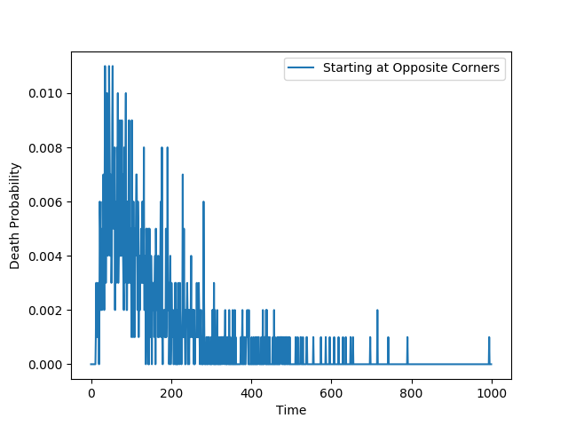
Probablity of Meet when CAT and RAT start at opposite ends
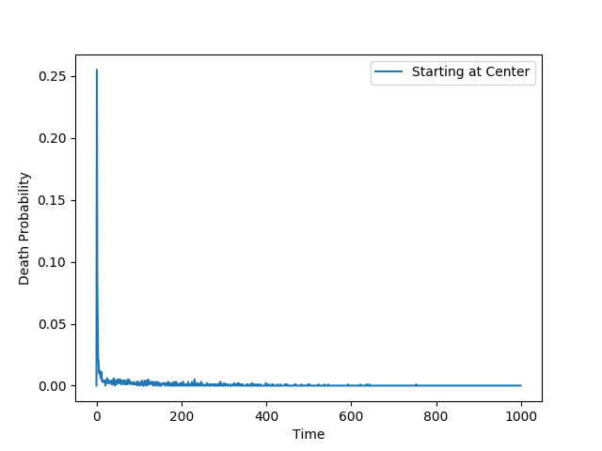
Probablity of Meet when CAT and RAT start at from center

