Feedback, Improvement and Suggestion

1. Form should allow user to save changes as the form is big and user might loss their changes.
2. Form should be section wise which should be visible under single page and user navigate to next by just click on next section on the same page.
3. Dropdown field should be as TypeAhead -values should be start displaying when user start typing(after 3 character) .
4. Placeholder should be used in input fields
5. Email verification can checked while entering itself and show if the user added valid email or not. (email verified text displayed)
6. There is too much to scroll down to see the section. We can make simpler and so that form does not look bigger.
7. Applicant Details fields should not use fully horizontal UI. Can Utilize space at the left.
8. 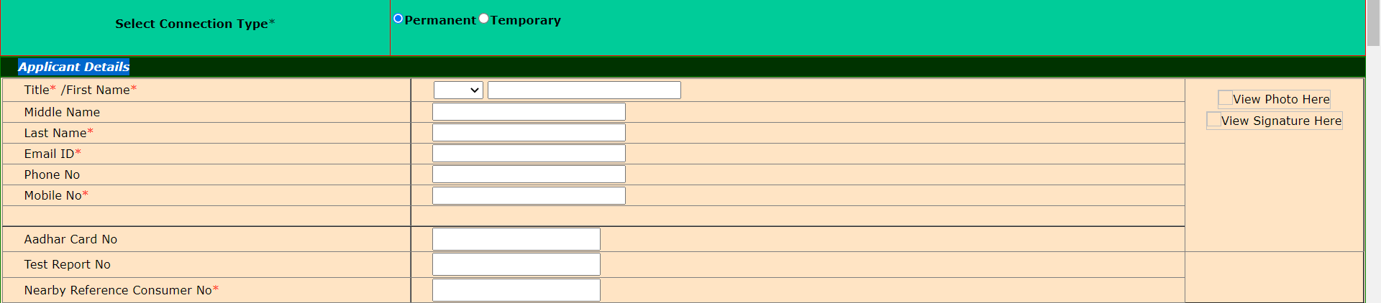
9. File format should be specified for uploads .e.g pdf jpeg jpg etc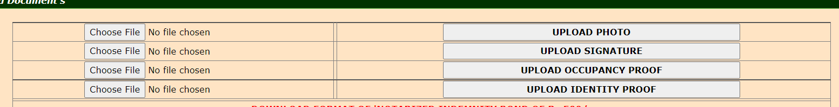
10. Buttons are tool large looks ugly. 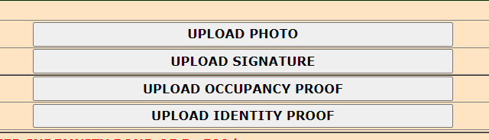
11. Color should be constant through out the application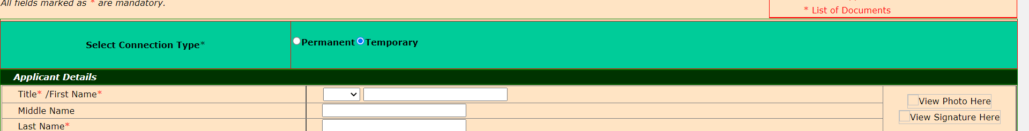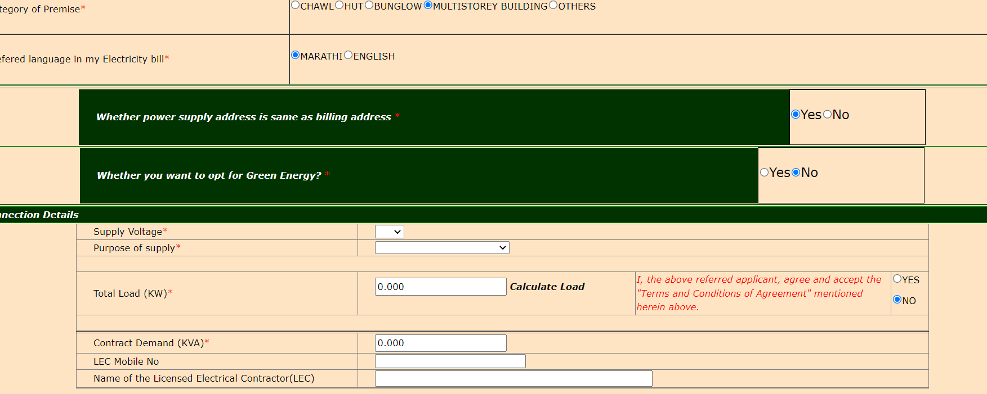
12. Big Black space before the footer can be removed