RECRUITMENT

Recruitment refers to the overall process of attracting, shortlisting, selecting and appointing suitable candidates for jobs (either permanent or temporary) within an organization. Recruitment can also refer to processes involved in choosing individuals for unpaid roles. Managers, human resource generalists and recruitment specialists may be tasked with carrying out recruitment, but in some cases public-sector employment agencies, commercial recruitment agencies, or specialist search consultancies are used to undertake parts of the process. Internet-based technologies which support all aspects of recruitment have become widespread.

## PROCESS OF RECRUITMENT

* Job analysis is a family of procedures to identify the content of a job in terms of activities involved and attributes or job requirements needed to perform the activities. Job analysis provides information of organizations which helps to determine which employees are best fit for specific jobs. Through job analysis, the analyst needs to understand what the important tasks of the job are, how they are carried out, and the necessary human qualities needed to complete the job successfully.
* Job analysis for new jobs or substantially changed jobs, a job analysis might be undertaken to document the knowledge, skills, abilities and other characteristics (KSAOs) required or sought for the job. From these the relevant information is captured in a person specification
* Sourcing is the process of attracting or identifying candidates. Sourcing is the use of one or more strategies to attract or identify candidates to fill job vacancies. It may involve internal and/or external recruitment advertising, using appropriate media, such as job portals, local or national newspapers, social media, business media, specialist recruitment media, professional publications, window advertisements, job centres, or in a variety of ways via the internet.
* Alternatively, employers may use recruitment consultancies or agencies to find otherwise scarce candidates—who, in many cases, may be content in the current positions and are not actively looking to move. This initial research for candidates—also called name generation—produces contact information for potential candidates, whom the recruiter can then discreetly contact and screen.
* **Referral recruitment programs: -** Referral recruitment programs allow both outsiders and employees to refer candidates for filling job openings. Online, they can be implemented by leveraging social networks.
* Screening and selection: Various psychological tests can assess a variety of KSAOs, including literacy. Assessments are also available to measure physical ability. Recruiters and agencies may use applicant tracking systems to filter candidates, along with software tools for psychometric testing and performance-based assessment. In many countries, employers are legally mandated to ensure their screening and selection processes meet equal opportunity and ethical standards.
* Employers are likely to recognize the value of candidates who encompass soft skills, such as interpersonal or team leadership, and the level of drive needed to stay engaged. In fact, many companies, including multinational organizations and those that recruit from a range of nationalities, are also often concerned about whether candidate fits the prevailing company culture and organization as a whole. Companies and recruitment agencies are now turning to video screening as a way to notice these skills without the need to invite the candidates in physical.[19] Screening as a practice for hiring has undergone continual change over the years and often organizations are using video to maintain the aforementioned standards they set for themselves and the industry.

# RECRUITMENT PROCESS OUTSOURCING

Recruitment process outsourcing (RPO) is a form of Business process outsourcing (BPO) where a company engages a third party provider to manage all or part of its recruitment process.

TYPES OF RECRUITMENT

For any organization, recruitment is a crucial part of developing and maintaining an effective and efficient team. A good recruitment strategy will cut down the wastage of time and money, which would have incurred for extensive training and development of unqualified resources.

Have you ever thought of, how a recruiter finds the right candidates? Recruiters use different methods to source, screen, shortlist, and select the resources as per the requirements of the organization. Recruitment types explain the means by which an organization reaches potential job seekers.

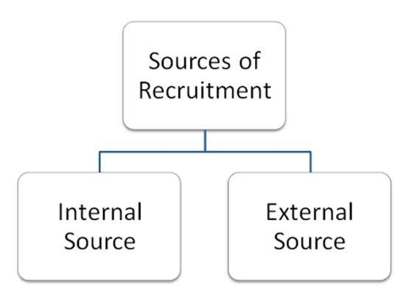

We will shed some light on the secrets of hiring and recruiting methods, used by the recruiters. Recruitment is broadly classified into two different categories − Internal Sources and External Sources.

Internal Sources of Recruitment

* Internal sources of recruitment refer to hiring employees within the organization internally. In other words, applicants seeking for the different positions are those who are currently employed with the same organization.
* At the time recruitment of employees, the initial consideration should be given to those employees who are currently working within the organization. This is an important source of recruitment, which provides the opportunities for the development and utilization of the existing resources within the organization.
* Internal sources of recruitment are the best and the easiest way of selecting resources as performance of their work is already known to the organization. Let us now discuss more on the various internal sources of recruitment.

External Sources of Recruitment

External sources of recruitment refer to hiring employees outside the organization externally. In other words, the applicants seeking job opportunities in this case are those who are external to the organization.

External employees bring innovativeness and fresh thoughts to the organization. Although hiring through external sources is a bit expensive and tough, it has tremendous potential of driving the organization forward in achieving its goals. Let us now discuss in detail the various external sources of recruitment.