Type 1:

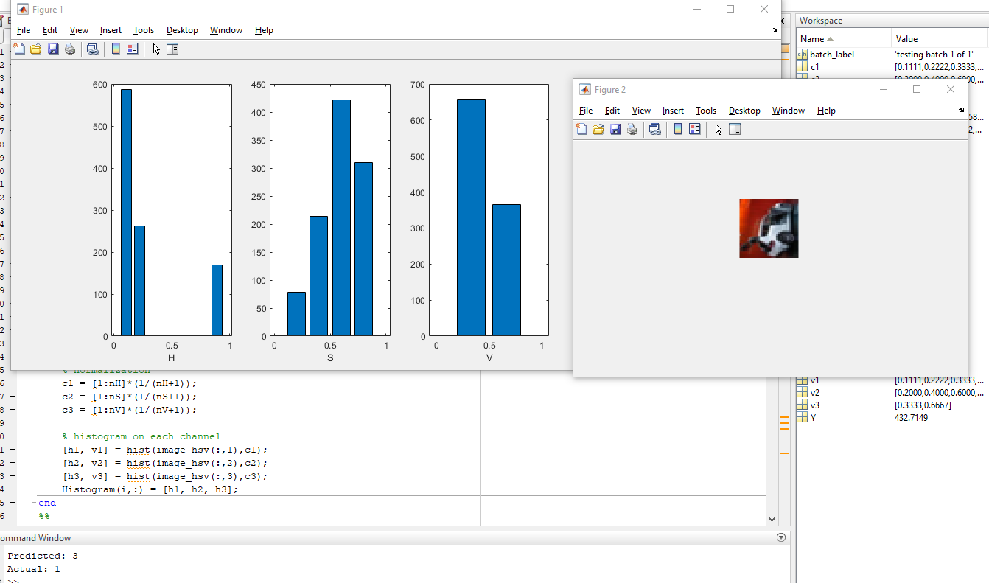Training sample size: 100, feature size: 14 (8 from H, 4 from S, 2 from V).

Object : Car

Actual class: 1

Predicted class : 3

**Status : Wrong prediction, limited training set size and limited training feature**

Type 2:

Training sample size: 1000, feature size: 14 (8 from H, 4 from S, 2 from V).

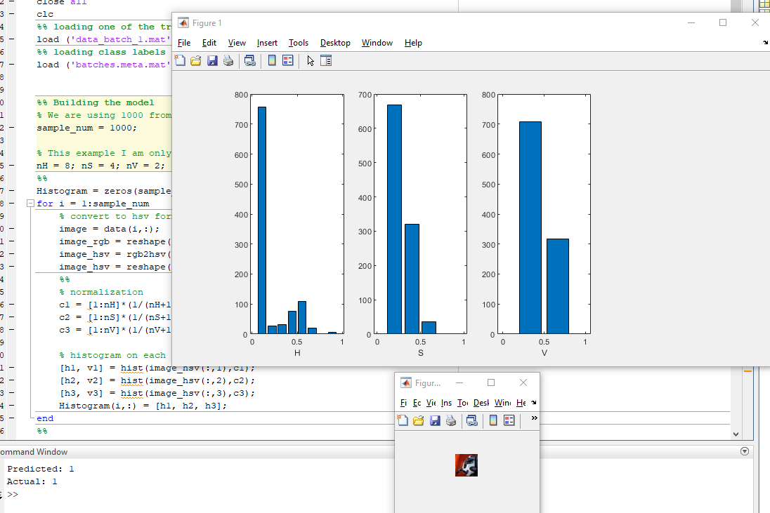

Object : Car

Actual class: 1

Predicted class : 1

**Status : Correct prediction, extended training set size and limited training feature**

Type 3:

Training sample size: 100, feature size: 64 (22 from H, 21 from S, 21 from V).

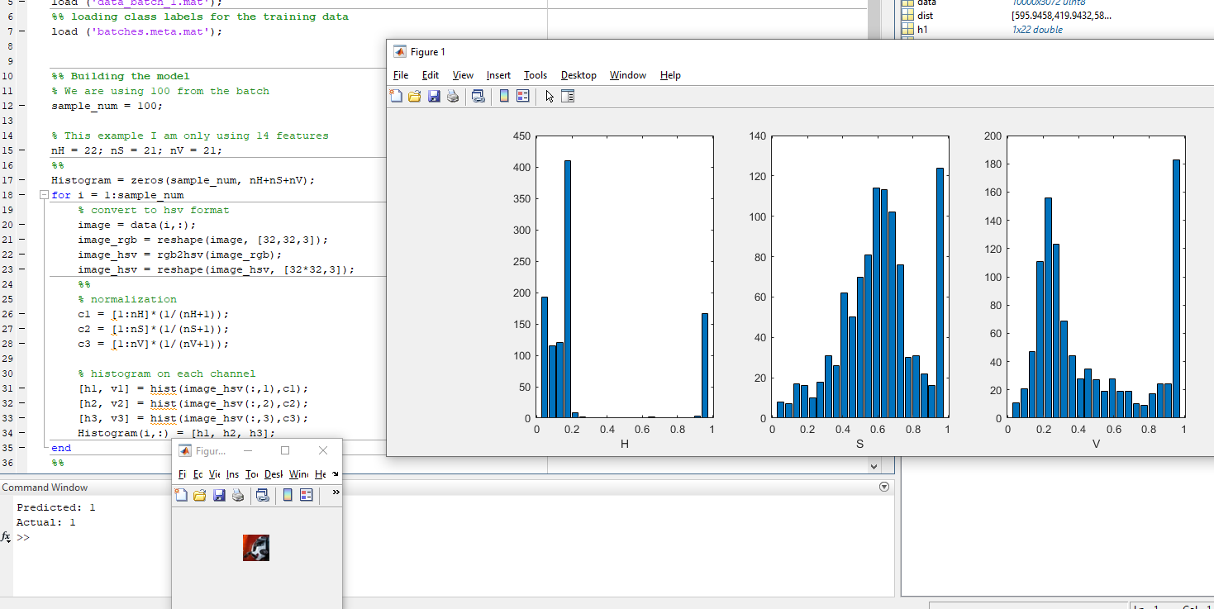

Object : Car

Actual class: 1

Predicted class : 1

**Status : Correct prediction, limited training set size and extended training feature.**