PROJECT DOCUMENTATION
CarbonX — Blockchain-Based Carbon Credit Trading Platform

1. Project Overview
CarbonX is a React and Solidity Web3 application developed for managing simulated digital carbon credits on a Hardhat local blockchain. The platform provides a decentralized environment where carbon credits can be issued, verified, owned, traded, transferred, and retired through blockchain-based operations.
The application uses smart contracts to manage credit information and enforce rules, while the React frontend provides an easy-to-use interface for users. MetaMask is used for wallet connection and transaction confirmation, and Ethers.js enables communication between the frontend and the deployed smart contract.
CarbonX demonstrates the complete lifecycle of a digital carbon credit, from issuance and ownership to marketplace trading, transfer, and permanent retirement. The project is designed as an educational prototype to demonstrate how blockchain technology can provide transparency, traceability, and tamper-resistant records for carbon-credit management..

2. Repository Structure
Blockchain-Carbon-Credit-Trading-Platform/
├── contracts/
│ └── CarbonCreditTrading.sol
├── scripts/
│ └── deploy.ts
├── frontend/src/
│ ├── App.jsx
│ ├── App.css
│ ├── index.css
│ └── main.jsx
├── screenshots/
├── reports/
├── docs/
├── hardhat.config.ts
├── package.json
└── README.md

3. Environment Setup
- Install Install Node.js and npm: Install Node.js, which includes npm (Node Package Manager). Node.js is required to run the Hardhat development environment and the React frontend.
- Open the Project in Visual Studio Code: Open the CarbonX project folder in Visual Studio Code. The project contains the Solidity smart contract, Hardhat configuration, deployment scripts, and React frontend.
- Install Root Dependencies: Open the terminal in the project root directory and run:
- npm install
This installs the required dependencies for Hardhat, Solidity development, deployment, and testing.
- Install Frontend Dependencies
Navigate to the frontend directory:
- cd frontend
Then install the React and frontend dependencies:
- npm install
After installation, return to the project root:
- cd ..
- Compile the Smart Contract: Compile the CarbonCreditTrading.sol smart contract using Hardhat:
- npx hardhat compile
This checks the Solidity contract for compilation errors and generates the required contract artifacts and ABI information that can be used by the frontend and deployment scripts.

4. Local Blockchain Setup
Start Hardhat with: npx hardhat node
Setting | Value
Network Name | Hardhat Localhost
RPC URL | http://127.0.0.1:8545
Chain ID | 31337
Currency | ETH

5. Contract Deployment
npx hardhat run scripts/deploy.ts --network localhost
Update the frontend with the deployed contract address and required ABI/function signatures.

6. Smart Contract Functions
Function | Purpose
registerIssuer(address) | Admin registers an authorized issuer.
removeIssuer(address) | Admin removes issuer authorization.
issueCarbonCredit(...) | Authorized issuer creates a credit.
getCreditDetails(uint256) | Reads complete credit data.
getCreditStatus(uint256) | Reads lifecycle status.
isCreditOwner(address,uint256) | Checks ownership.
listCreditForSale(uint256,uint256) | Creates a listing.
getListing(uint256) | Reads listing information.
cancelListing(uint256) | Cancels an active listing.
buyCredit(uint256) | Purchases an active listing.
transferCredit(uint256,address) | Transfers an eligible credit.
retireCredit(uint256,string) | Retires a credit.
getOwnerCredits(address) | Returns credit IDs owned by an address.
getPlatformStats() | Returns platform statistics.

7. Role-Based Operations
Administrator
- Register issuer
- Remove issuer
Authorized Issuer
- Issue carbon credit
Credit Owner
- List credit
- Cancel own listing
- Transfer eligible credit
- Retire eligible credit
Buyer
- Check listing
- Buy active listing

8. Marketplace Purchase Sequence
- Buyer enters Credit ID.
- Frontend calls getListing().
- Application checks that the listing is active.
- Application calls buyCredit() with the exact listing price.
- MetaMask asks the buyer to confirm.
- Smart contract updates ownership and closes the listing.
- Seller receives payment in the local test environment.

9. Listing Cancellation Sequence
- Seller enters Credit ID.
- Application calls cancelListing().
- Contract verifies the listing is active.
- Contract verifies the caller is the listing seller.
- MetaMask confirms the transaction.
- Listing becomes inactive and the credit returns to ACTIVE status.

10. Retirement Sequence
- Owner enters Credit ID and retirement reason.
- Contract verifies ownership.
- Contract rejects already retired or currently listed credits.
- MetaMask confirms the transaction.
- Credit status changes to RETIRED.
- Retirement timestamp and reason are stored.
- Retired supply is updated.

11. Validation / Error Cases
- Only admin can manage issuers.
- Only authorized issuers can issue credits.
- Invalid owner addresses are rejected.
- Zero tonnes are rejected.
- Zero listing price is rejected.
- Non-owners cannot list or transfer credits.
- Sellers cannot buy their own listing.
- Incorrect payment amount is rejected.
- Inactive listings cannot be purchased.
- Retired credits cannot be listed or transferred.
- Listed credits must be cancelled before transfer or retirement.

12. Evidence / Screenshot Guide
CarbonX Dashboard
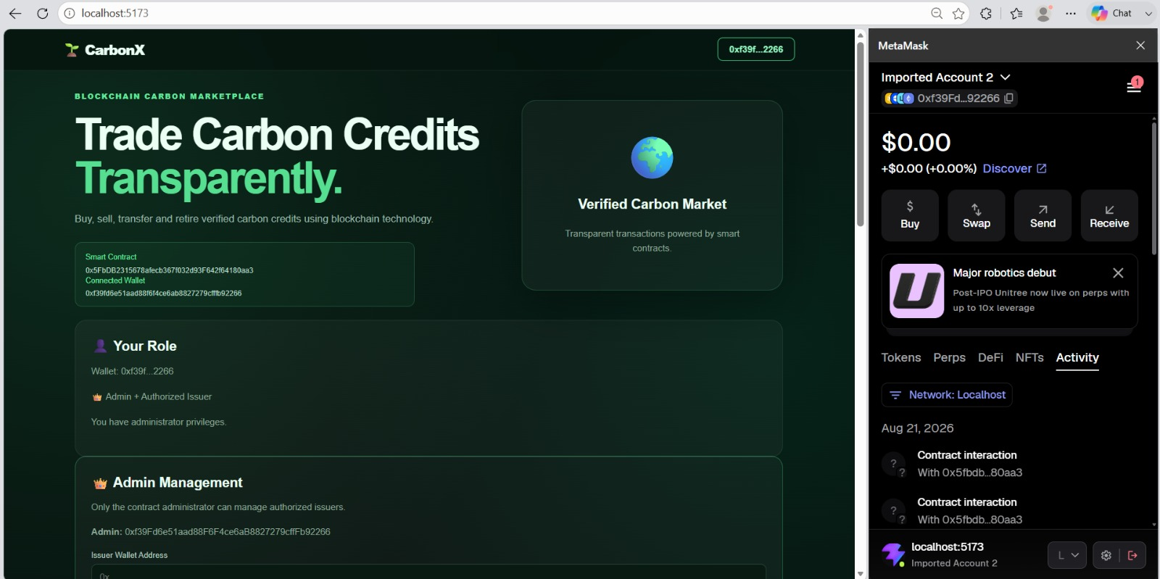

Admin and Authorized Issuer Role
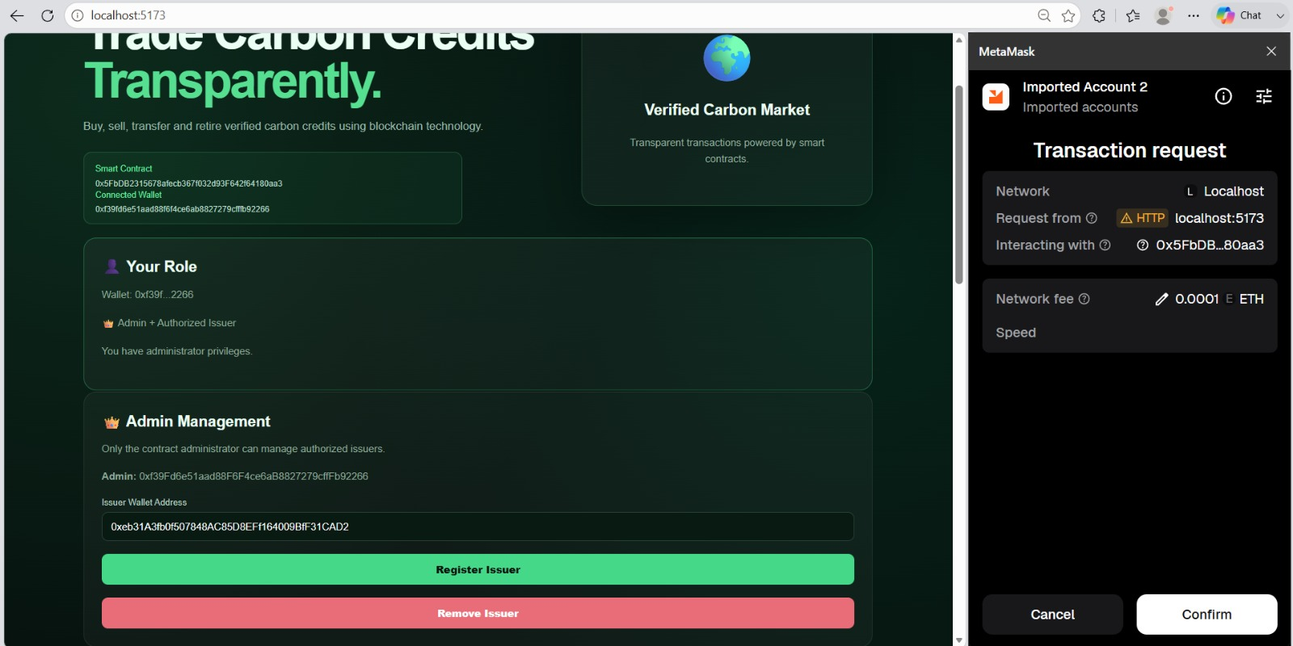

Issue Carbon Credit
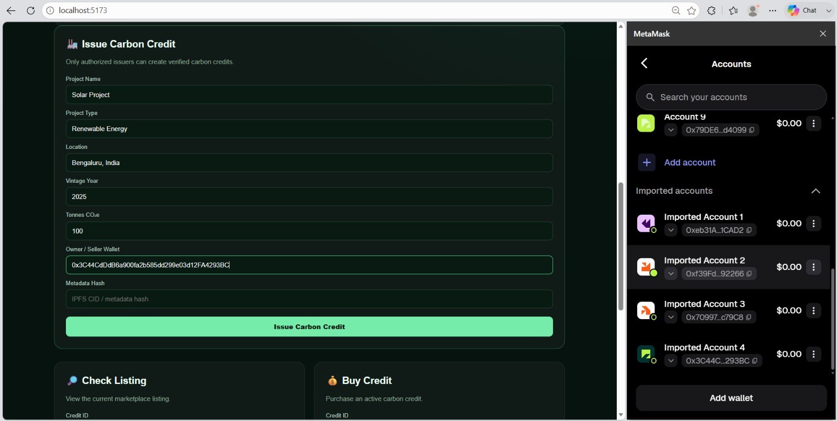

Check Carbon Credit
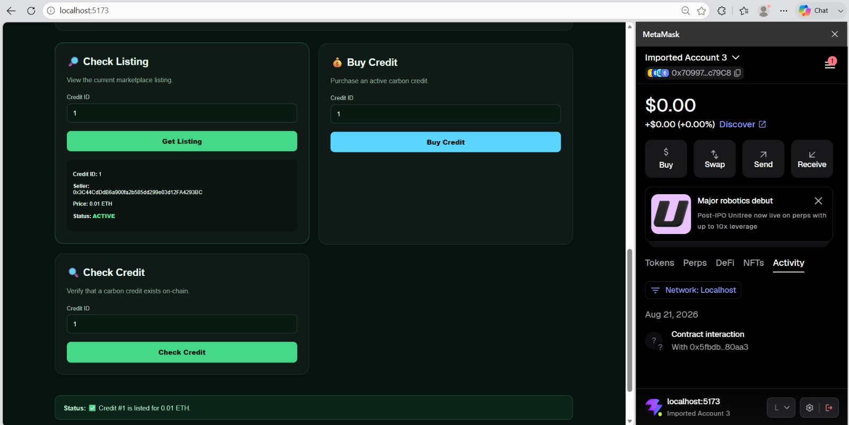

Sell / List Carbon Credit
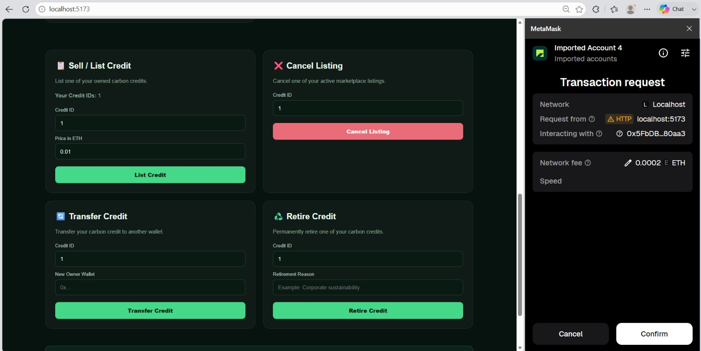

Successful Purchase
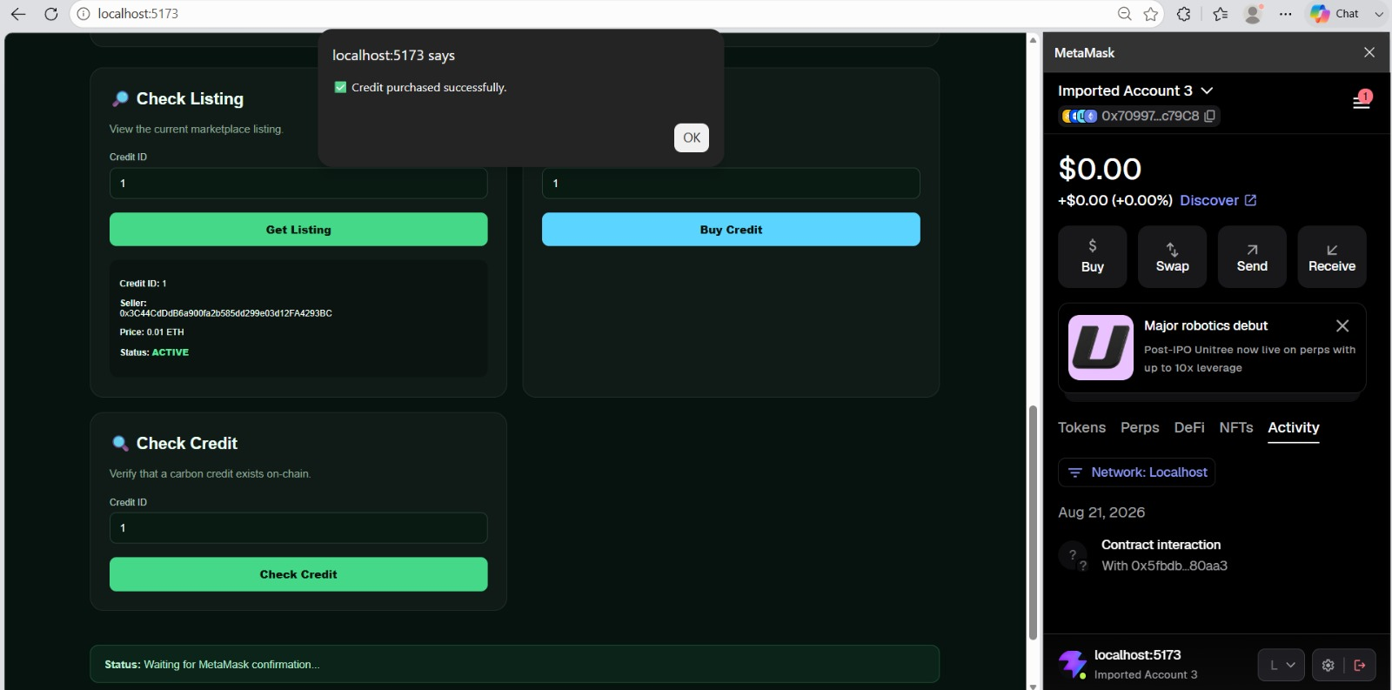

Cancel Listing
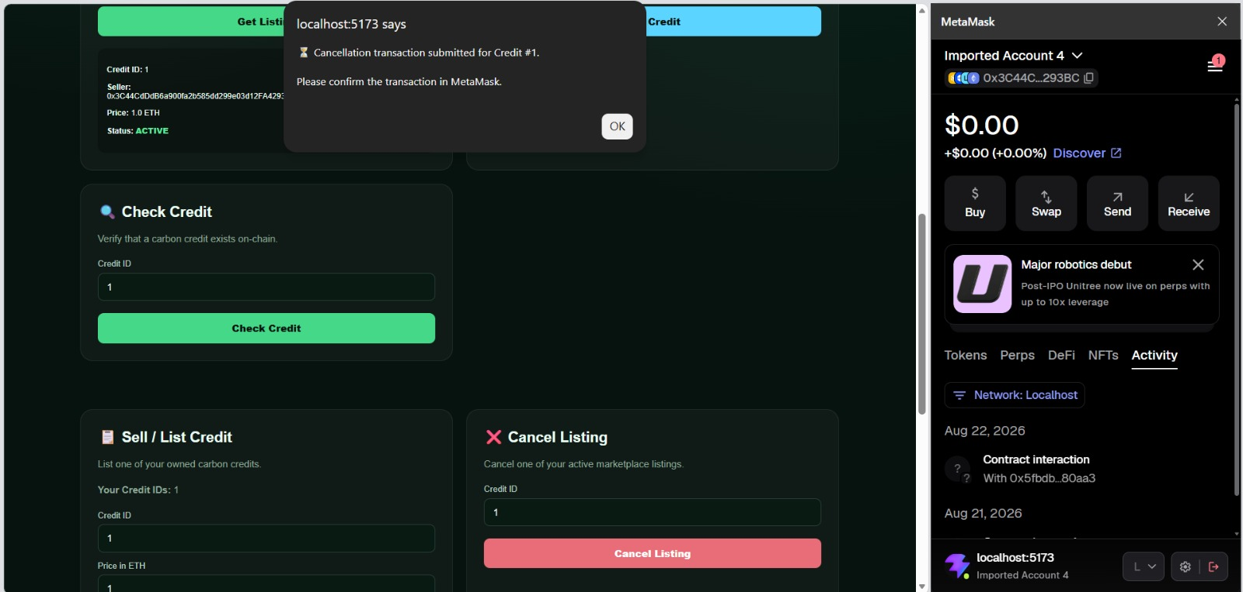

Transfer Carbon Credit
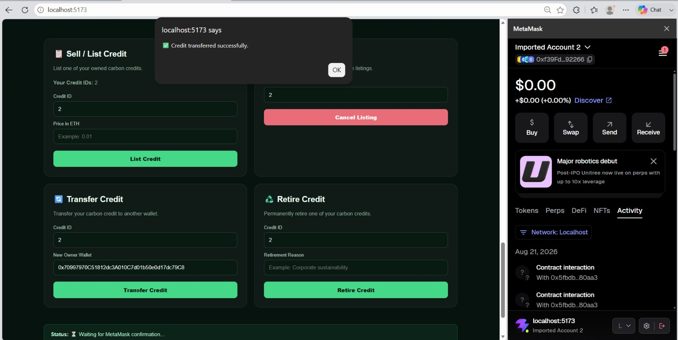

Successful Retirement
