PROJECT DOCUMENTATION
Decentralized Healthcare Data Exchange

1. Documentation Purpose
This document provides the complete setup, configuration, execution, testing, troubleshooting, and demonstration procedure for the Decentralized Healthcare Data Exchange. It explains how to run the Solidity smart contract with Hardhat, configure MetaMask, launch the React frontend, execute each user role, test patient-controlled access, verify record integrity, and demonstrate the complete healthcare data-sharing workflow.

2. Project Requirements
- Solidity — smart-contract development.
- Hardhat — local blockchain, compilation, deployment and testing.
- React — frontend user interface.
- Vite — frontend development server.
- Ethers.js — frontend-to-smart-contract communication.
- MetaMask — wallet connection and transaction confirmation.
- Node.js and npm — runtime and dependency management.
- Visual Studio Code — development environment.

3. Prerequisites
Before setting up the project, ensure that the following software and tools are installed:
- Node.js: A JavaScript runtime required to run the Hardhat development environment and the React/Vite frontend.
- npm: Node Package Manager, used to install, manage, and update the dependencies required by the blockchain and frontend projects. npm is installed automatically with Node.js.
- Git: A version-control system used to clone the project repository from GitHub and manage project changes.
- Visual Studio Code: The development environment used to edit Solidity smart contracts, React components, configuration files, scripts, and other project files.
- MetaMask: A Web3 wallet used to connect the application to the local blockchain, identify users through wallet addresses, and approve blockchain transactions.

Verify the Installations
- Open Command Prompt or VS Code Terminal and run the following commands:
- node --version
- This displays the installed Node.js version.
- npm --version
- This displays the installed npm version.
- git --version
- This confirms that Git is installed and displays its version.

4. Project Installation

4.1 Clone the Repository
Git clone shubha229/Blockchain-Based-Decentralized-Healthcare-Data-Exchange
cd Decentralized-Healthcare-Data-Exchange

4.2 Install Dependencies
npm install

4.3 Project Structure
Decentralized-Healthcare-Data-Exchange/
├── contracts/
├── scripts/
├── test/
├── frontend/
├── hashes/
├── sample_records/
├── screenshots/
├── reports/
├── docs/
├── hardhat.config.js
├── package.json
└── README.md

5. Start Hardhat Local Blockchain
Hardhat provides the local Ethereum-compatible blockchain used for development and demonstration.
- npx hardhat node
Keep this terminal running. The local RPC endpoint is normally:
- http://127.0.0.1:8545
Hardhat displays development accounts and private keys. These accounts are intended only for local testing.

6. Compile Smart Contract
npx hardhat compile
A successful compilation confirms that the Solidity smart contract compiles without errors.
contracts/HealthcareDataExchange.sol

7. Deploy Smart Contract
npx hardhat run scripts/deploy.js --network localhost
After deployment, copy the contract address and update the frontend configuration, for example:
frontend/src/contractConfig.js
Ensure the frontend uses the ABI matching the deployed contract.

8. MetaMask Configuration
Setting | Value
Network Name | Hardhat Local
RPC URL | http://127.0.0.1:8545
Chain ID | 31337
Currency | ETH
Import the required development accounts using the private keys shown by npx hardhat node. Never use these development keys for real funds.

9. Frontend Setup
cd frontend
npm install
npm run dev
Open the Vite URL shown in the terminal, normally:
http://localhost:5173

10. Administrator Execution
The Administrator manages registration and status of platform participants.
- Connect the Administrator wallet.
- Register the Patient wallet address and confirm MetaMask.
- Register the Doctor wallet address and confirm MetaMask.
- Register the Hospital wallet address and confirm MetaMask.
- Verify that each wallet is assigned the correct role.

11. Hospital Execution
The Hospital creates medical-record metadata for registered Patients.
- Switch to the registered Hospital wallet.
- Reconnect the application if required.
- Select the registered Patient.
- Select or enter the record type.
- Provide the SHA-256 hash of the synthetic record.
- Provide the storage reference.
- Select Add Medical Record.
- Confirm the MetaMask transaction.
- Verify that the record appears successfully.
Actual healthcare documents remain off-chain. The blockchain stores metadata needed for identification, verification and access control.

12. Patient Execution
The Patient controls access to their healthcare records.
- Switch to the registered Patient wallet.
- View the Patient's records.
- Select a record.
- Select the registered Doctor.
- Grant access and confirm the transaction.
- Verify the Doctor permission.
- When access is no longer required, select Revoke Access.
- Confirm the revocation transaction.
- Verify that the permission has been removed.

13. Doctor Execution

Unauthorized Access
1. Switch to the registered Doctor wallet.
- Attempt to access the Patient record before consent.
Expected result: Access Denied.

Authorized Access
- Have the Patient grant access.
- Switch to the Doctor wallet.
- Attempt to access the record.
Expected result: Access Granted.

13.3 Access After Revocation
- Have the Patient revoke access.
- Switch to the Doctor wallet.
- Attempt to access the record again.
Expected result: Access Denied.

14. Complete Access-Control Demonstration
Administrator
↓
Register Patient → Register Doctor → Register Hospital
↓
Hospital Adds Medical Record
↓
Patient Views Record
↓
Doctor Attempts Access → Access Denied
↓
Patient Grants Access
↓
Doctor Accesses Record → Access Granted
↓
Patient Revokes Access
↓
Doctor Attempts Access → Access Denied
This sequence demonstrates role-based access control, patient consent, authorization, access granting, access revocation, and unauthorized-access prevention.

15. Hash Generation and Verification
SHA-256 hashing is used as a reference for the integrity of an off-chain synthetic healthcare record.
Medical Record
↓
SHA-256
↓
File Hash
↓
Blockchain Metadata
If the file is unchanged, a newly calculated hash should match the stored hash. If the file is modified, the calculated hash should differ.
Original File → Hash A
Modified File → Hash B
Hash A ≠ Hash B
Hashing provides integrity verification; it does not encrypt the underlying document.

16. Remix Execution
- Open Remix IDE.
- Create or open HealthcareDataExchange.sol.
- Compile the contract.
- Select the appropriate Remix execution environment.
- Deploy HealthcareDataExchange.
- Register Patient, Doctor and Hospital accounts.
- Add a synthetic medical record.
- Test Doctor access before consent and verify denial.
- Grant Doctor access from the Patient account.
- Test authorized Doctor access.
- Revoke Doctor access from the Patient account.
- Test access again and verify denial.
- Inspect transactions and emitted events.

17. Screenshot Documentation

Home Page

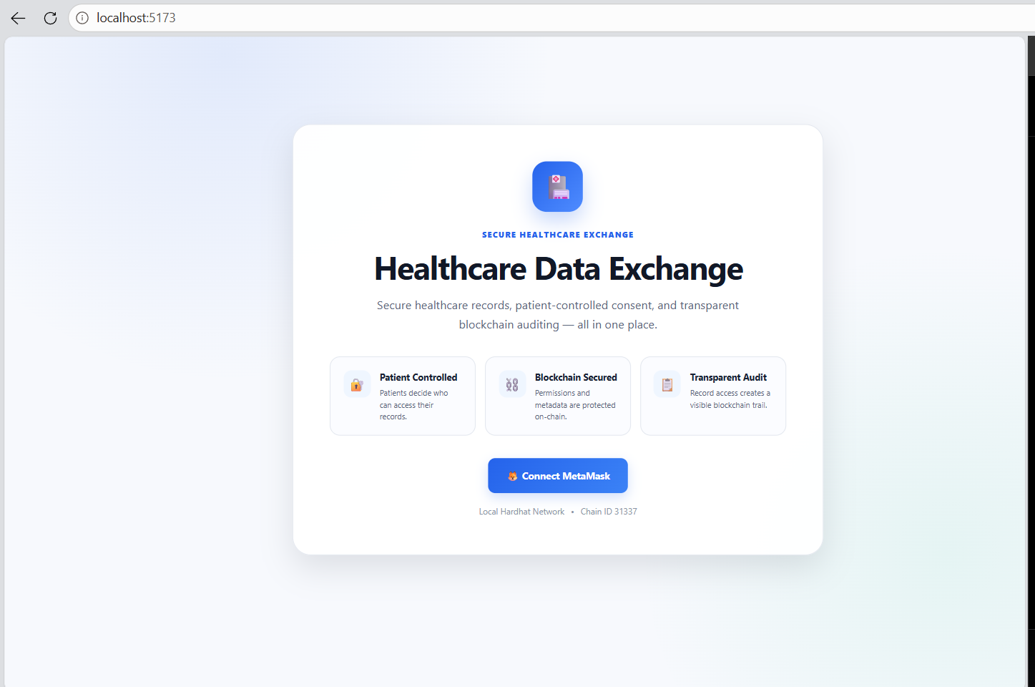
Admin Dashboard

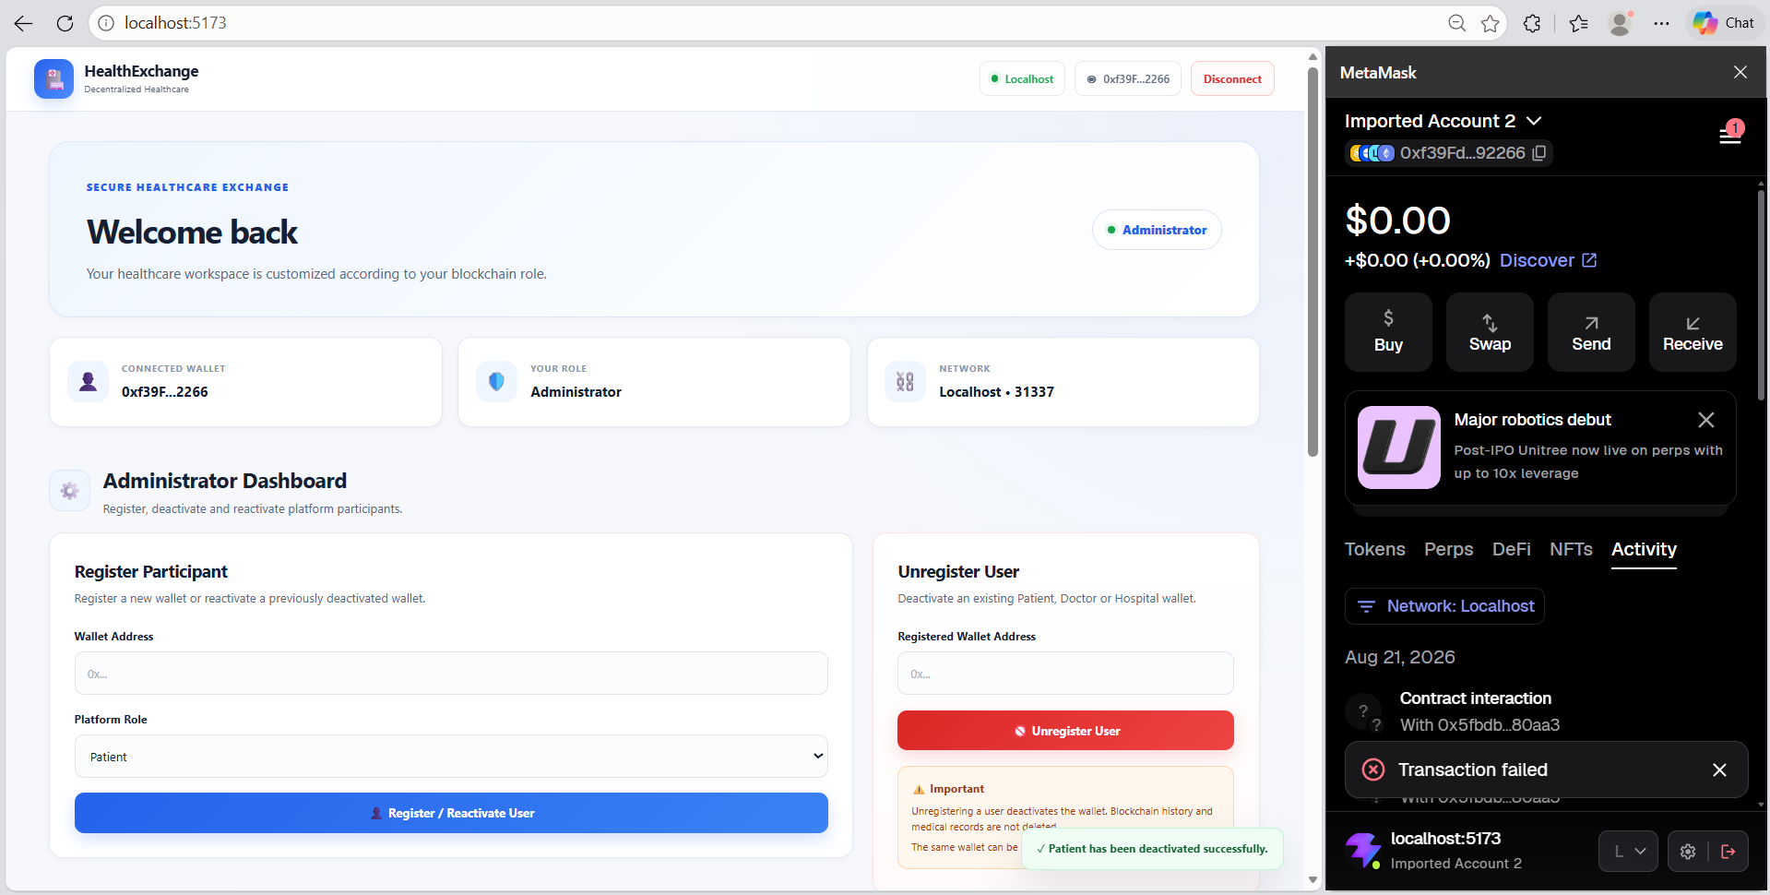

Transaction In Progress

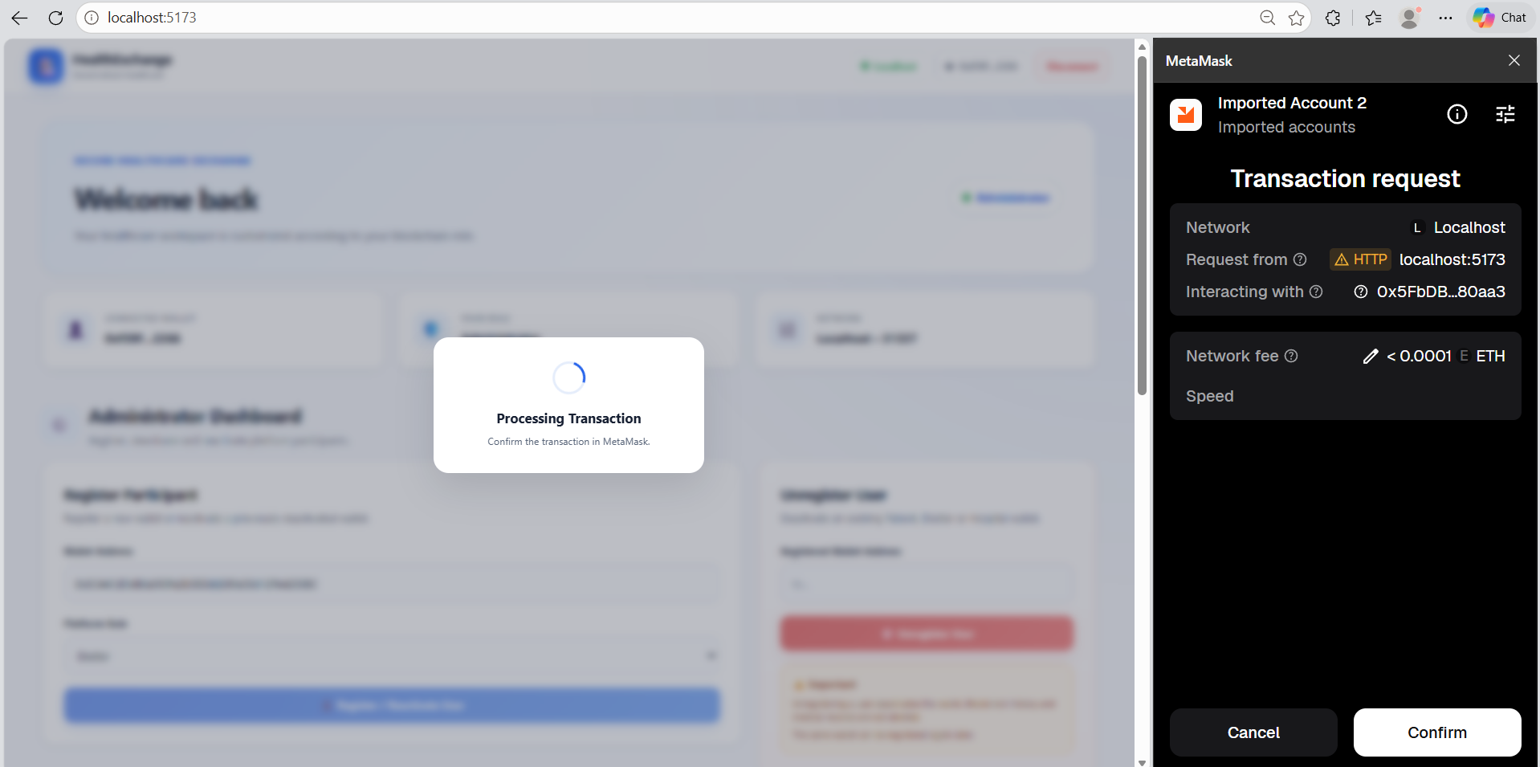

Patient Dashboard

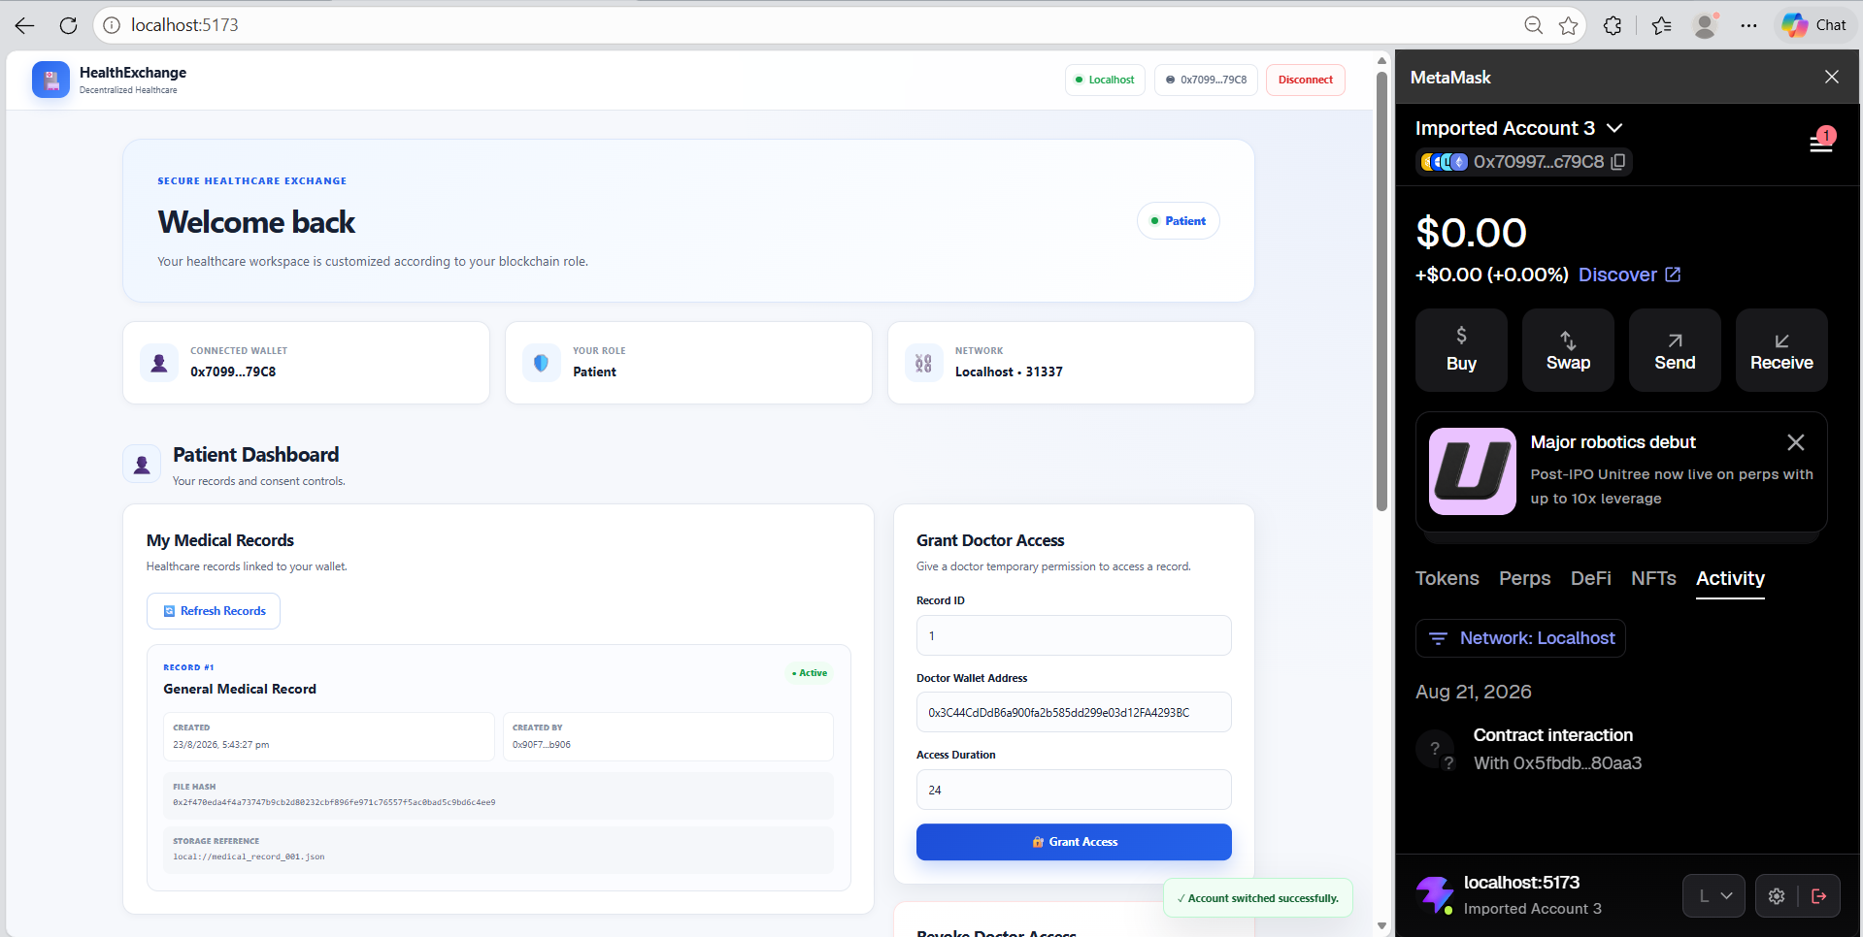

Hospital Dashboard

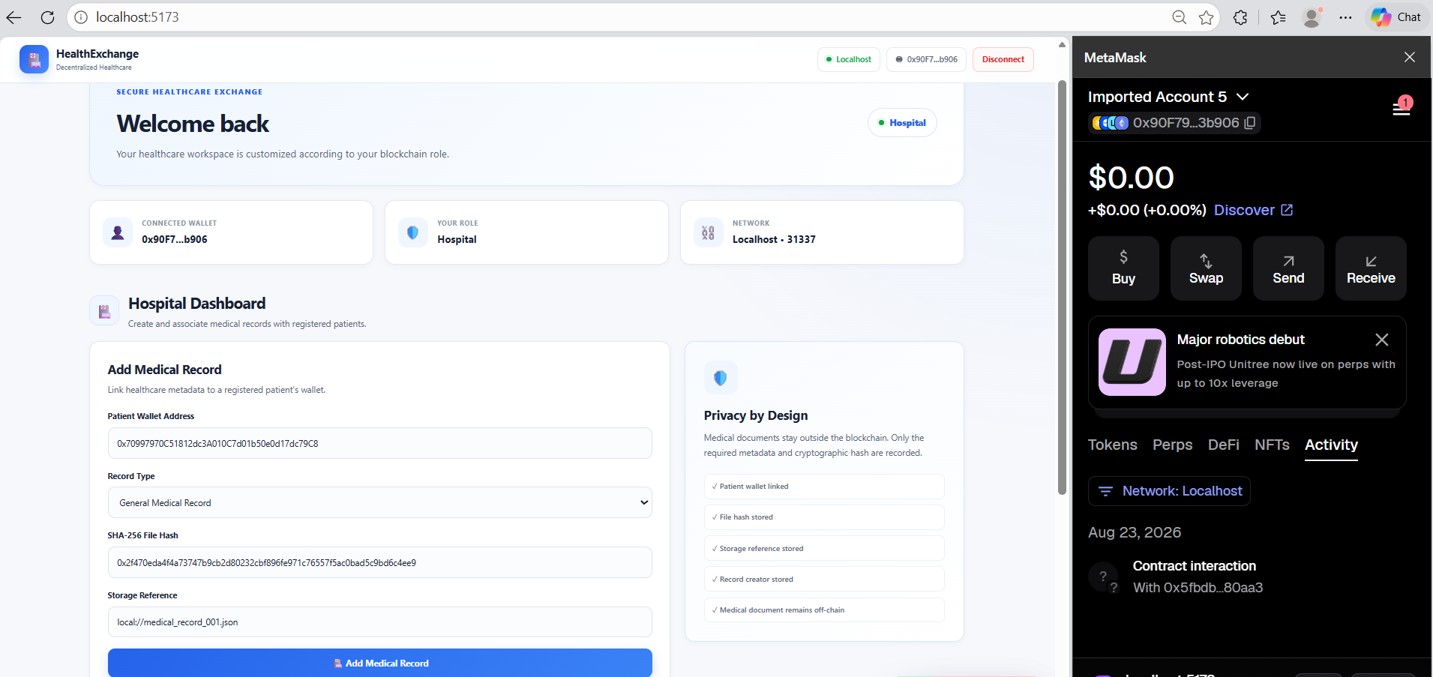

Doctor Dashboard

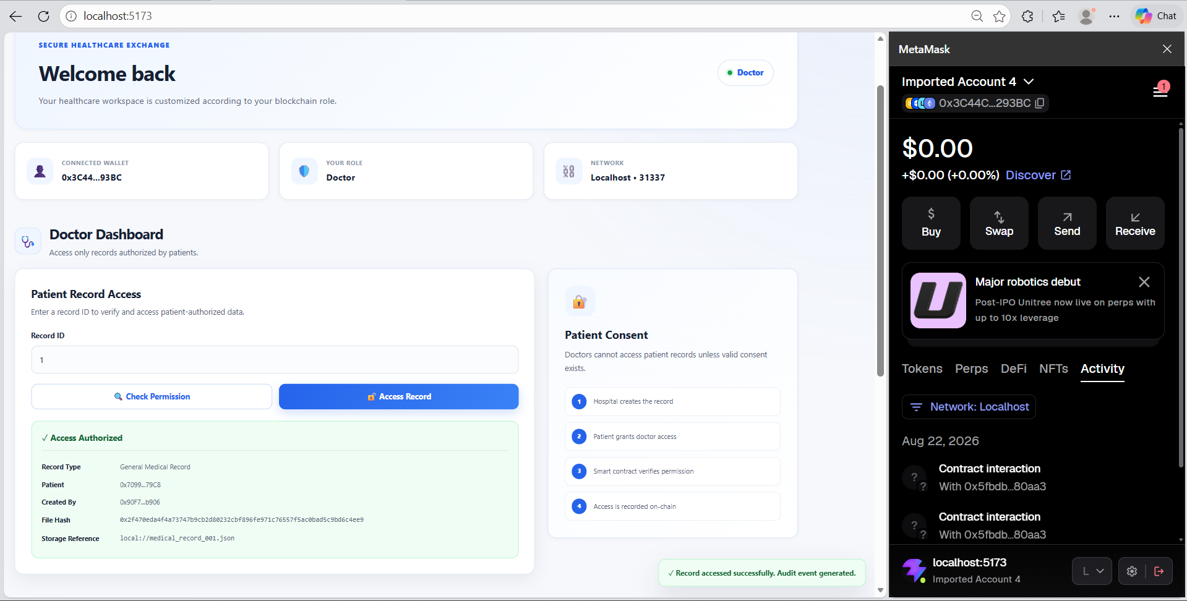

Events Audit Trial

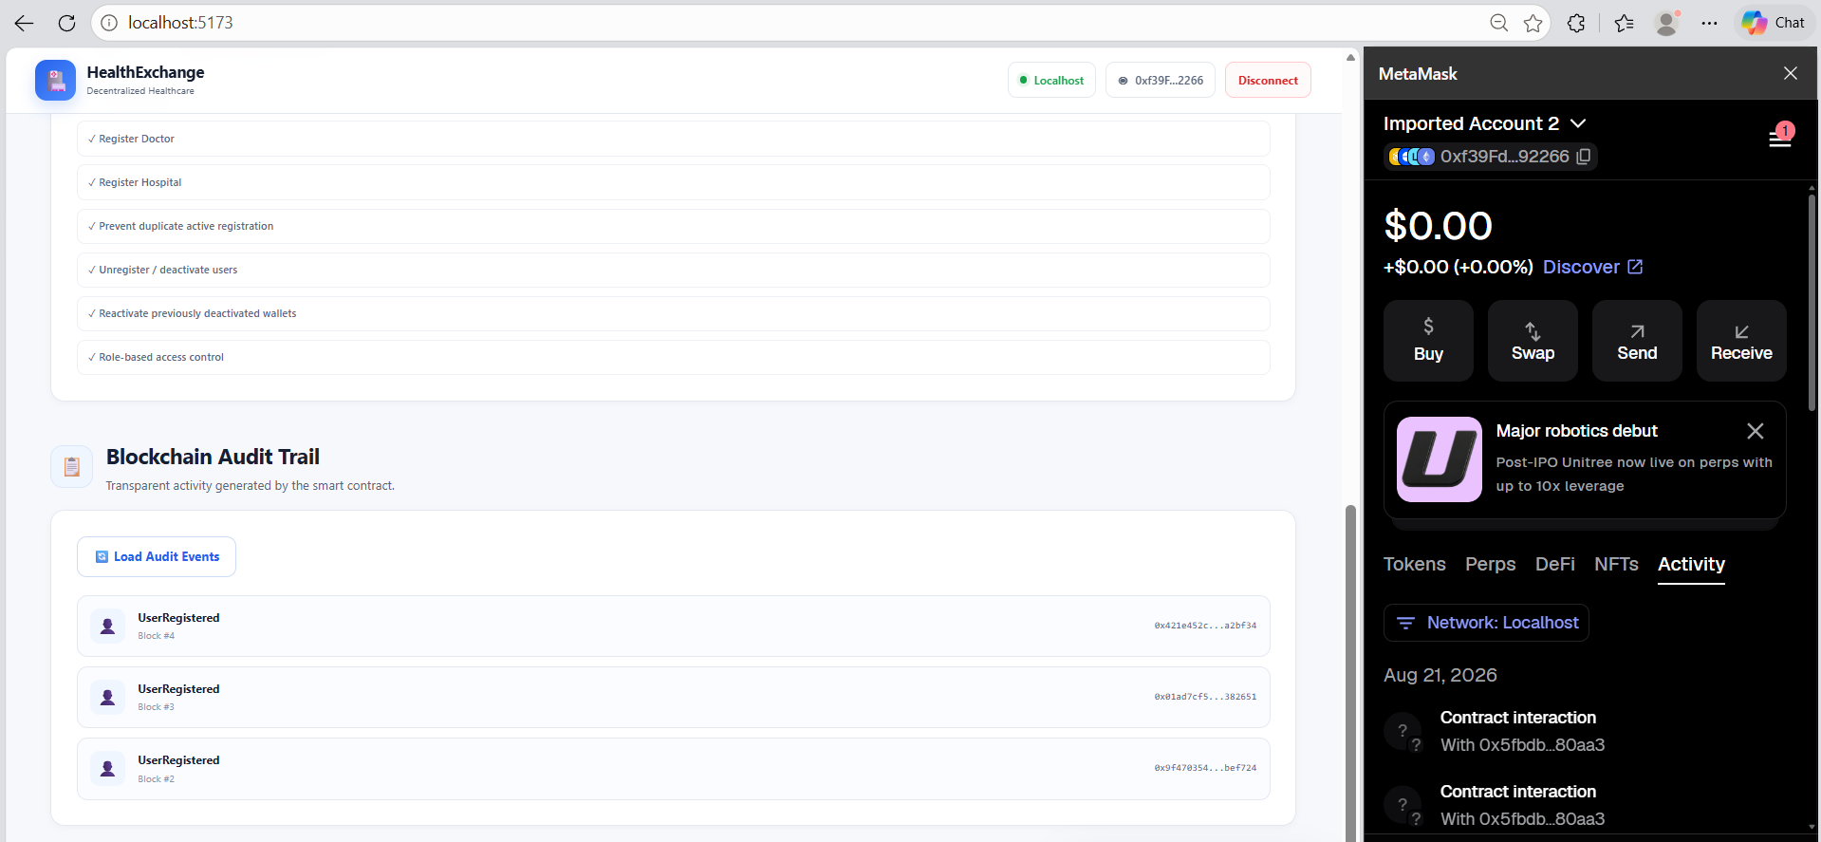

Patient Deactivation



18. Security Notes
- Use synthetic or dummy healthcare data only.
- Do not commit .env files, private keys, seed phrases, or wallet secrets.
- Do not use Hardhat development accounts with real funds.
- Do not upload real patient records to GitHub or a public blockchain.
- Hashing provides integrity verification and is not encryption.
- Access revocation prevents future authorized access through the application but cannot erase copies already downloaded by an authorized user.
- Check frontend contract configuration.

19. Conclusion
The Decentralized Healthcare Data Exchange demonstrates how blockchain can provide a trust and authorization layer for healthcare data sharing. The system combines role-based access control, patient-controlled consent, medical-record metadata, cryptographic hashing, smart-contract authorization, and blockchain audit events. The complete workflow demonstrates how an Administrator manages participants, Hospitals add records, Patients control Doctor access, and Doctors access records only when authorized. Actual healthcare documents remain off-chain while blockchain is used for access control, consent, verification, and auditability.

