LANDCHAIN
DECENTRALIZED LAND REGISTRY
& PROPERTY OWNERSHIP
A Blockchain-Based Web3 Application for Transparent Property Registration, Verification and Ownership Transfer

PROJECT REPORT
Student Name: SHUBHASHREE BABURAYA NAYAK
Department: CSE
College/Institution: SIR M VISVESVARAYA INSTITUTE OF TECHNOLOGY, BENGALURU
Guide/Mentor: Umesh Sir
Academic Year: 2026

ABSTRACT
LandChain is a decentralized land registry and property ownership management application built using blockchain technology. The project explores how smart contracts can maintain property records, control verification operations, and record ownership transfers in a transparent and tamper-resistant manner.
The system consists of a Solidity smart contract named LandRegistry, a Hardhat-based development and testing environment, and a React/Vite frontend connected through MetaMask and Ethers.js. The application implements three logical roles: Authority, Property Owner, and User. Authority accounts can register and verify properties, property owners can view their records and transfer ownership, and users can search and read property information.
The smart contract was tested with seven automated test cases covering administrator assignment, property registration, duplicate registration rejection, verification, unauthorized verification rejection, ownership transfer, and rejection of transfers by a previous owner after ownership has changed. The project is implemented primarily for educational and demonstration purposes on a local Hardhat blockchain.

Keywords
Blockchain, Web3, Solidity, Smart Contract, Land Registry, Property Ownership, Ethereum, Hardhat, Ethers.js, MetaMask, React, DApp

1. INTRODUCTION
Property ownership records are important because they establish information about land, property identity, location, ownership, and changes in ownership. Conventional record-management approaches commonly depend on centralized systems and administrative processes. Blockchain provides a distributed ledger where transactions can be recorded transparently and smart contracts can enforce predefined rules.
LandChain applies these concepts to a simplified property registry. The system stores property information in a Solidity smart contract and provides a Web3 interface through which authorized wallets can interact with the contract.

1.1 Project Overview
The project provides a complete local Web3 workflow: develop and compile a smart contract, test its behavior using Hardhat and Chai, deploy it to a local Hardhat blockchain, interact with it using TypeScript scripts, and connect a React frontend through MetaMask and Ethers.js.

1.2 Scope
The current implementation focuses on property registration, property verification, ownership transfer, property lookup, wallet-based role detection, and role-specific UI access. It is intentionally limited to a local blockchain demonstration rather than a production government registry.

2. PROBLEM STATEMENT
A conventional property-record system may rely on centralized storage and manual administrative verification. This can make it difficult for users to independently inspect ownership information, understand changes in ownership, and verify that a record has not been altered outside the authorized process.
- Dependence on centralized property records.
- Limited transparency of ownership changes.
- Manual or externally controlled verification processes.
- Difficulty maintaining a tamper-resistant history of ownership changes.
- Need for controlled access so participants can perform only authorized actions.

3. OBJECTIVES
The main objective is to demonstrate a decentralized property registry using smart contracts and a Web3 interface.
- Develop a blockchain-based property registry using Solidity.
- Register properties with structured information and a document hash.
- Allow an authorized Authority to verify properties.
- Allow only the current owner to transfer ownership.
- Preserve the previous owner after transfer.
- Provide wallet-based role detection and role-specific frontend access.
- Provide property search and read functionality.
- Test smart-contract rules using automated tests.
- Demonstrate deployment and interaction on a local Hardhat network.

4. EXISTING SYSTEM AND LIMITATIONS
Traditional property management commonly uses centralized databases, document repositories, and administrative offices. Such systems can be effective, but their architecture places trust in the organization operating the database and its update procedures.
- Central point of control over records.
- Users may have limited visibility into record history.
- Verification can depend on manual workflows.
- Ownership changes may require multiple administrative steps.
- Auditability depends on the organization's internal logging.

5. PROPOSED SYSTEM
LandChain proposes a simplified blockchain-backed registry in which core property and ownership operations are implemented as smart-contract functions. The frontend communicates with the contract through MetaMask and Ethers.js.

5.1 Main Components
Component | Purpose
LandRegistry.sol | Core Solidity smart contract storing property records and enforcing protected operations.
Hardhat 3 | Blockchain development, compilation, deployment and testing environment.
Ethers.js | Library for interacting with Ethereum-compatible contracts.
MetaMask | Wallet used to connect accounts and approve transactions.
React + Vite | Frontend framework and development/build tooling.
Chai | Assertion library used by automated smart-contract tests.

6. SYSTEM ARCHITECTURE
The overall architecture is:
User / Authority / Owner
↓
React + Vite Frontend
↓
MetaMask Wallet
↓
Ethers.js
↓
LandRegistry Smart Contract
↓
Hardhat Local Blockchain

6.1 Data Flow
A user connects a wallet through MetaMask. The frontend identifies the connected address and determines the applicable role. Read operations query the deployed contract. State-changing operations request a transaction through MetaMask and are executed by the blockchain.

7. FUNCTIONAL REQUIREMENTS
The system implements the following functional requirements.
ID | Function | Requirement
FR-01 | Property Registration | Authority can register a property using a unique property ID and associated details.
FR-02 | Duplicate Prevention | The contract rejects registration when the same property ID already exists.
FR-03 | Property Verification | Only the designated Authority can verify an existing property.
FR-04 | Property Lookup | Connected users can retrieve property details using a property ID.
FR-05 | Current Owner Lookup | The application can retrieve the current owner.
FR-06 | Ownership Transfer | Only the current owner can transfer ownership.
FR-07 | Previous Owner Tracking | The previous owner is preserved after transfer.
FR-08 | Wallet Connection | The frontend can connect to MetaMask.
FR-09 | Role-Based UI | The frontend reflects permissions according to the connected role.

8. ROLE-BASED ACCESS CONTROL
The application provides three logical roles. The smart contract enforces protected on-chain operations, while the frontend reflects these permissions in the user interface.
Feature | Authority | Property Owner | User
View Properties | Yes | Yes | Yes
Read Ownership | Yes | Yes | Yes
Register Property | Yes | No | No
Verify Property | Yes | No | No
Transfer Ownership | No | Yes | No

8.1 Authority
The deployer is assigned as administrator. The Authority workflow supports property registration and verification.

8.2 Property Owner
The current owner can view property information and transfer ownership to another wallet address.

8.3 User
A normal connected user can search and read property information but cannot register, verify, or transfer properties.

9. SMART CONTRACT DESIGN
The core contract is implemented in contracts/LandRegistry.sol. It stores property information and provides functions for registration, verification, lookup, current-owner retrieval, and ownership transfer.

9.1 Property Record
The property record used by the application includes property ID, property number, location, area, property type, current owner, previous owner, verification state/status, and document hash.
Function | Purpose
registerProperty() | Creates a new property record.
verifyProperty() | Marks an existing property as verified.
getProperty() | Returns the stored property record.
getCurrentOwner() | Returns the current owner address.
transferOwnership() | Transfers ownership and records the previous owner.

9.2 Document Hash
The property record stores a document hash string. During testing, a sample value such as QmDummyPropertyDocument001 is used. Full decentralized document storage such as IPFS is future scope.

10. APPLICATION WORKFLOW
The major workflows are described below.

10.1 Property Registration
Authority → Enter property details → Confirm transaction in MetaMask → Smart contract stores the property record.

10.2 Property Verification
Authority → Search property → Verify property → Confirm transaction → Contract marks the property verified.

10.3 Ownership Transfer
Current Owner → Enter new owner wallet address → Confirm transaction → Contract updates current owner and preserves previous owner.

10.4 Property Lookup
Connected user → Enter Property ID → Frontend calls getProperty() → Property information is displayed.

11. FRONTEND DESIGN
The frontend is implemented using React and Vite. The interface follows a dark Web3 dashboard style and provides wallet status, role information, property search, property details, access-control information, and activity information.
- MetaMask wallet connection.
- Connected wallet address display.
- Local blockchain/network status.
- Role-specific navigation and permissions.
- Property search by Property ID.
- Property information and ownership display.
- Authority controls for registration and verification.
- Owner controls for ownership transfer.
- Recent activity for connected-wallet actions.

12. TESTING AND RESULTS
Automated tests were implemented in test/LandRegistry.test.ts. The final test run completed successfully with seven passing tests.
Test | Test Case | Result
1 | Deployer becomes admin | PASS
2 | Property registration | PASS
3 | Duplicate property rejection | PASS
4 | Property verification | PASS
5 | Unauthorized verification rejection | PASS
6 | Ownership transfer | PASS
7 | Previous owner cannot transfer after ownership changes | PASS
FINAL RESULT: 7 PASSING

13. SCREENSHOTS AND DEMONSTRATION
Insert the actual application screenshots from the screenshots/ directory into the final report.

Figure 1 — Main Dashboard
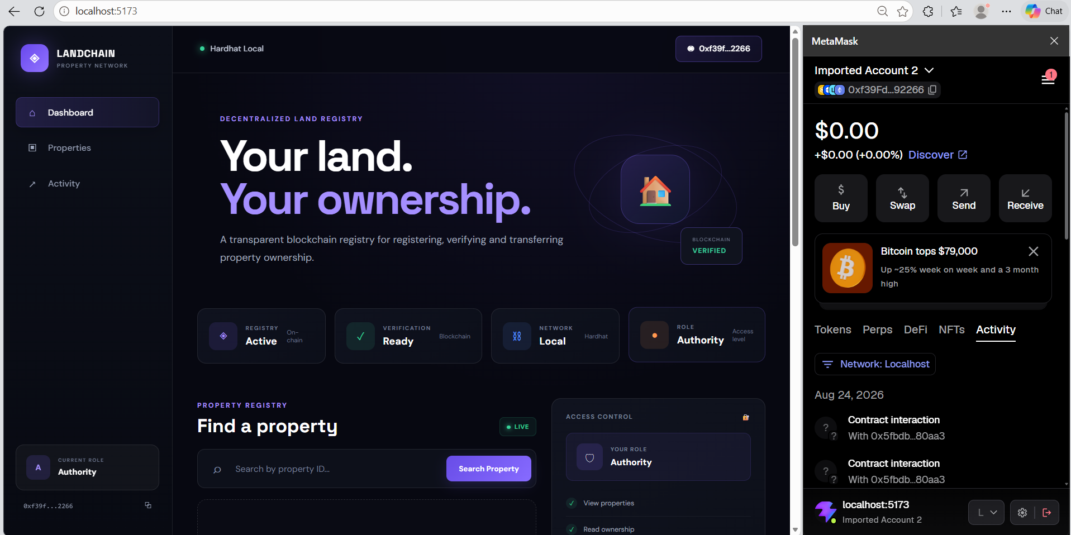
Figure 2 — Authority Dashboard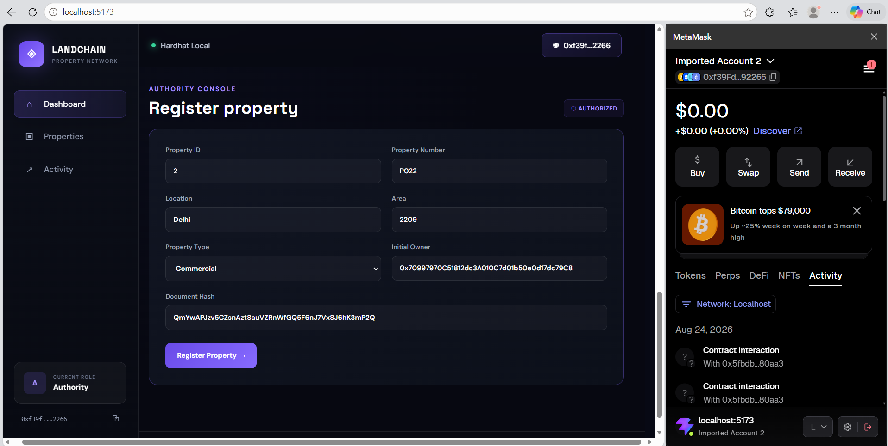

Figure 3 — Property Registration 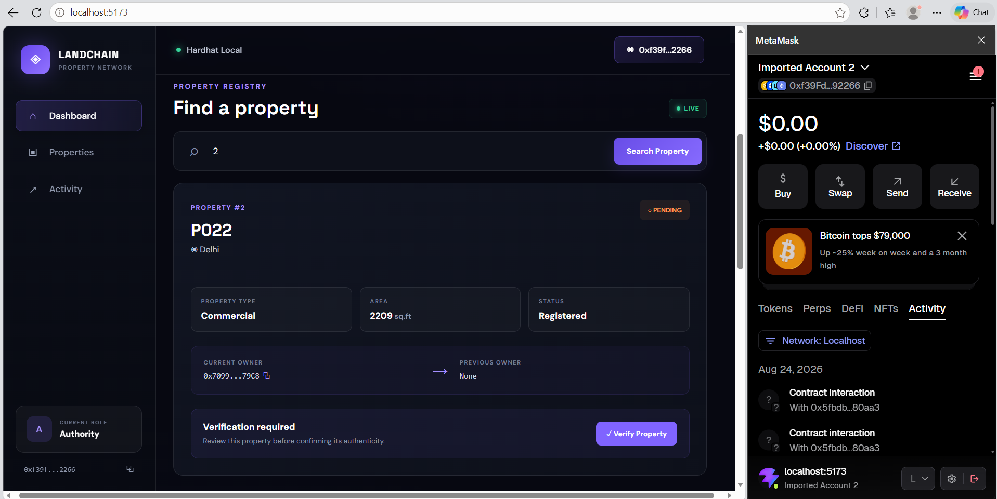

Figure 4 — Property Verification
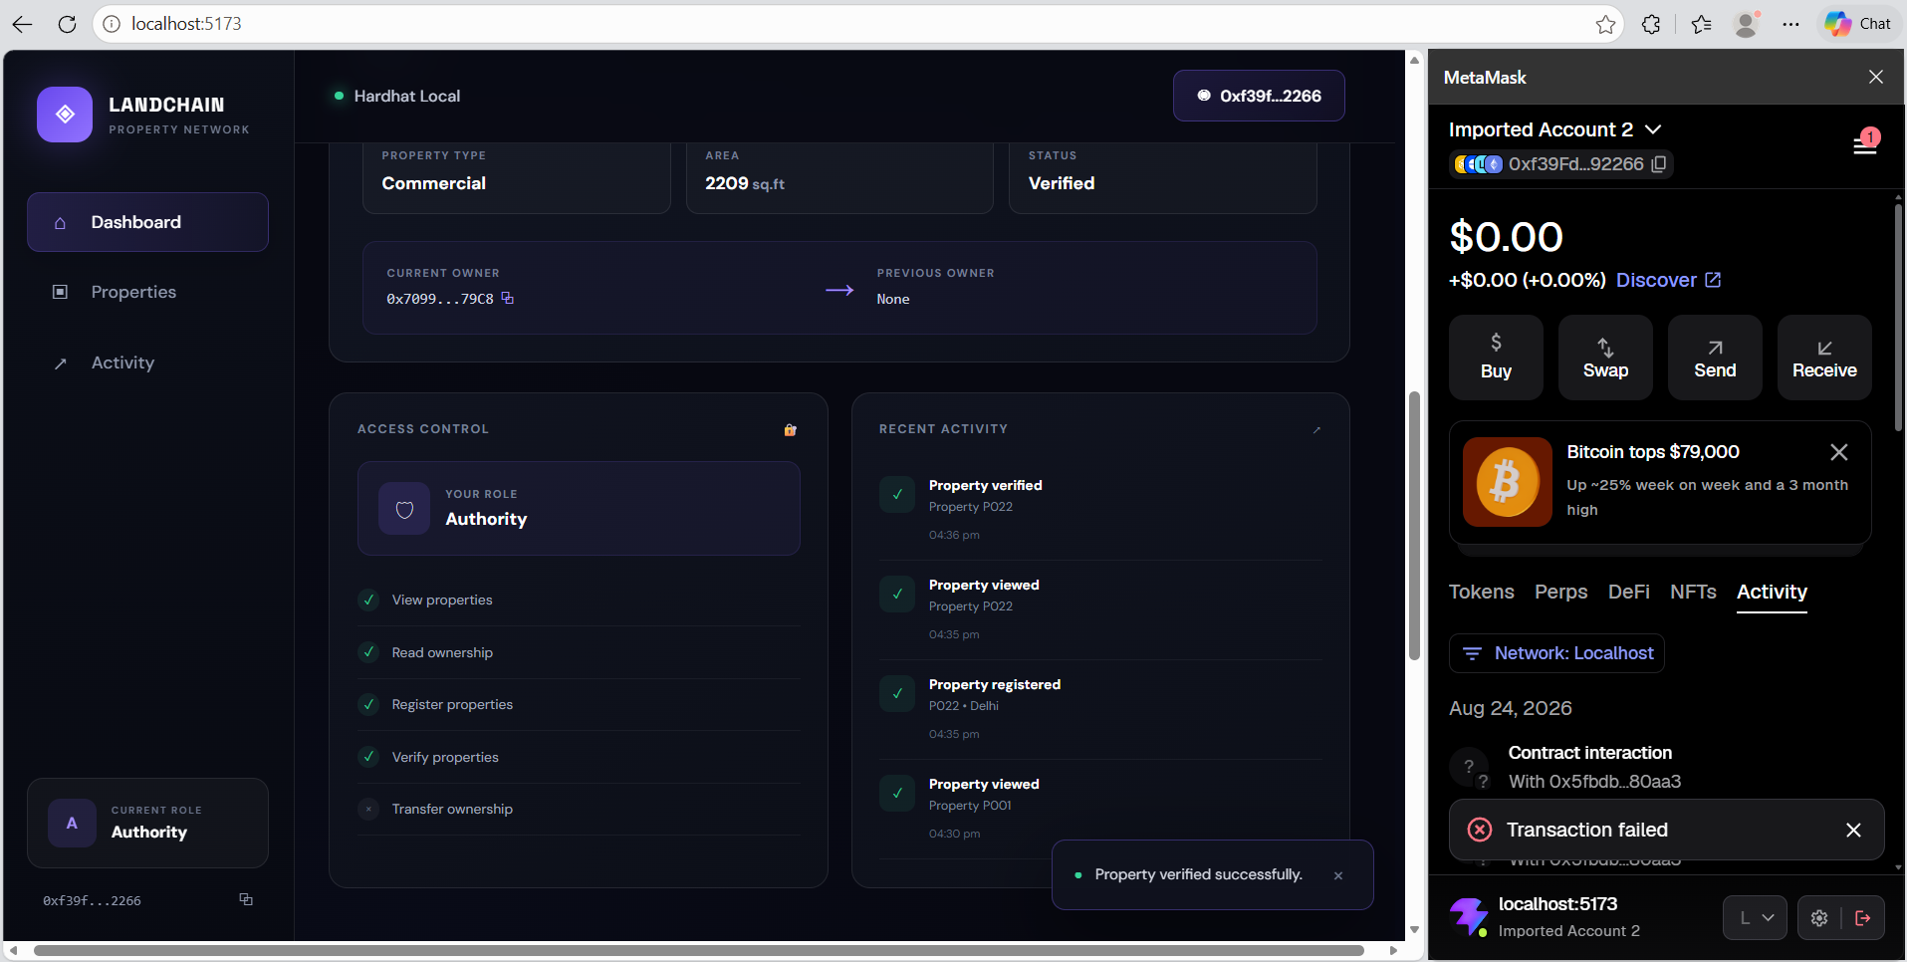

Figure 5 — Property Details
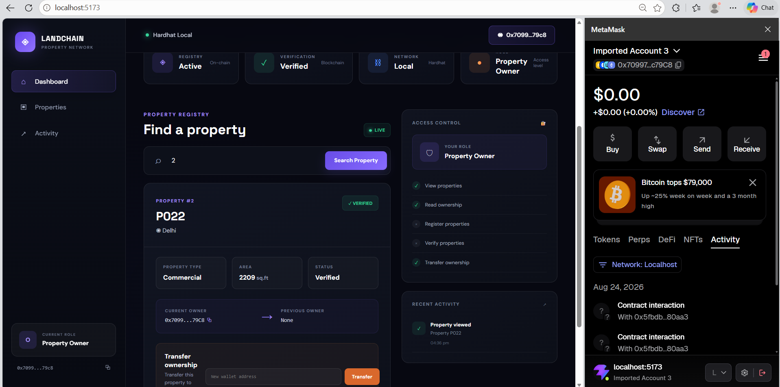

Figure 6 — Transfer Success
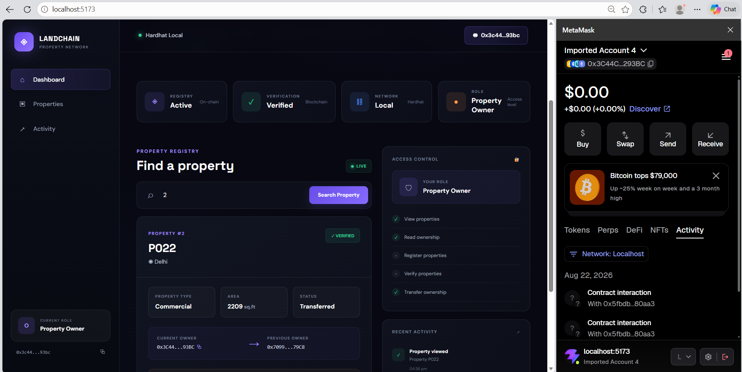

14. SECURITY CONSIDERATIONS
The project implements basic smart-contract access restrictions.
- Only the designated Authority can verify properties.
- Only the current property owner can transfer ownership.
- Duplicate property registration is rejected.
- Ownership changes preserve the previous owner.
- Wallet addresses are used for role and ownership identification.
- Frontend permissions improve usability while protected contract functions enforce critical authorization rules.
Security note: this is an educational/demo implementation. It has not undergone a professional smart-contract audit and should not be treated as a production legal land registry without additional security, identity, legal, and infrastructure controls.

15. LIMITATIONS
The current implementation has the following limitations.
- Demonstrated on a local Hardhat blockchain.
- Educational prototype rather than a government/production land registry.
- Document hash is stored as a string; decentralized document storage is not included.
- Advanced identity verification is outside the current scope.
- No professional smart-contract security audit has been performed.

16. FUTURE SCOPE
The project can be extended with the following capabilities.
- Production Ethereum-compatible or Layer-2 deployment.
- Blockchain event indexing and richer transaction history.
- Property maps and geospatial information.
- Multi-signature verification.
- Integration with authorized government land-record systems.
- Professional smart-contract security auditing.

17. CONCLUSION
LandChain demonstrates how blockchain and smart contracts can be applied to a simplified property registry workflow. The project combines a Solidity LandRegistry contract with automated testing, local blockchain deployment, TypeScript interaction scripts, MetaMask wallet connectivity, and a React/Vite frontend.
The implementation demonstrates Web3 principles including on-chain record keeping, wallet-based identity, role-specific access, transaction confirmation, and ownership state changes. The seven automated tests validate the main contract rules, while the frontend provides a practical interface for interacting with them.
Overall, the project provides a practical learning implementation of decentralized property management and establishes a foundation that can be extended with decentralized storage, production deployment, stronger identity controls, event indexing, and additional security mechanisms.

