VoteChain – Blockchain-Based Voting System
Technical Documentation

1. Introduction
VoteChain is a decentralized voting application using an Ethereum-compatible smart contract as its voting layer. The frontend provides administrator and voter interfaces, while MetaMask authorizes blockchain transactions.

2. Architecture
- Frontend: React + TypeScript + Vite
- Wallet: MetaMask
- Blockchain interaction: Ethers.js
- Smart contract: contracts/VotingSystem.sol
- Local development network: Hardhat

3. Main Components

Smart Contract
VotingSystem.sol manages election information, candidates, registered voters, voting, election status, results and winner determination.

Frontend
The frontend provides the election dashboard, administrator controls, voter registration, candidate management, voting interface, status messages, results and winner display.

Scripts
The scripts directory contains utilities for deployment, candidate management, voting, election start/end operations, administrative actions and result retrieval.

4. Project Structure
Blockchain-Based-Voting-System/
├── contracts/VotingSystem.sol
├── frontend/
│ ├── src/App.tsx
│ ├── src/App.css
│ ├── src/contract.ts
│ └── src/main.tsx
├── ignition/
├── scripts/
├── types/
├── hardhat.config.ts
├── package.json
└── README.md

5. Installation and Setup
- Clone the repository.
- Run npm install in the project root.
- Run npm install inside frontend/.
- Start the local Hardhat blockchain.
- Deploy the VotingSystem contract.
- Update the frontend contract address if required.
- Start the Vite frontend with npm run dev.
- Connect MetaMask to the Localhost/Hardhat network.

6. Useful Commands
- npm install
- npx hardhat node
- npx hardhat test
- npx hardhat ignition deploy ignition/modules/VotingSystem.ts --network localhost
- cd frontend
- npm install
- npm run dev

7. Administrator Workflow
- Connect administrator MetaMask account.
- Create an election.
- Register a voter wallet address.
- Add candidates and parties.
- Start the election.
- End the election after voting.
- View final results and winner.

8. Voter Workflow
- Connect a registered MetaMask account.
- Open the active election.
- Review candidates.
- Select a candidate.
- Confirm the transaction in MetaMask.
- Wait for confirmation.
- Verify the VOTED status.

9. Election States
- Not Started: voters can be registered and candidates can be managed.
- Active: registered voters can cast votes.
- Closed: voting is finished and final results are displayed.

10. Validation and Security Concepts
- Administrator-only election management actions.
- Wallet-address-based voter registration.
- One-vote-per-voter validation.
- Blockchain transaction records for state-changing operations.
- Frontend success and error feedback.

11. Results and Winner
After the election ends, the application displays candidate vote counts and highlights the candidate with the highest recorded vote count. The interface can also present tied winners when applicable.

12. Troubleshooting
- Verify MetaMask is connected to Localhost/Hardhat.
- Verify the connected account is authorized for the requested action.
- Verify the frontend uses the current deployed contract address.
- After restarting and redeploying the local blockchain, update contract addresses as required.
- Keep the Hardhat node running while using the local application.

13. Demonstration Flow
Create Election → Register Voter → Add Candidates → Start Election → Connect Voter → Cast Vote → Verify Vote → End Election → View Results → Declare Winner

14. Screenshot Files

Initial Dashboard
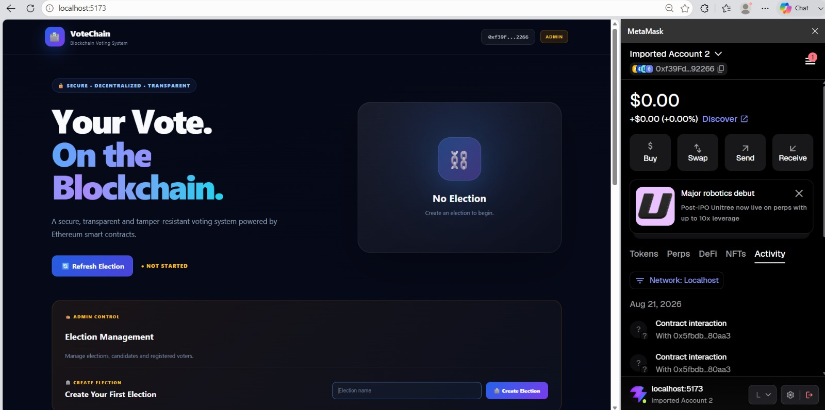

Creating an Election
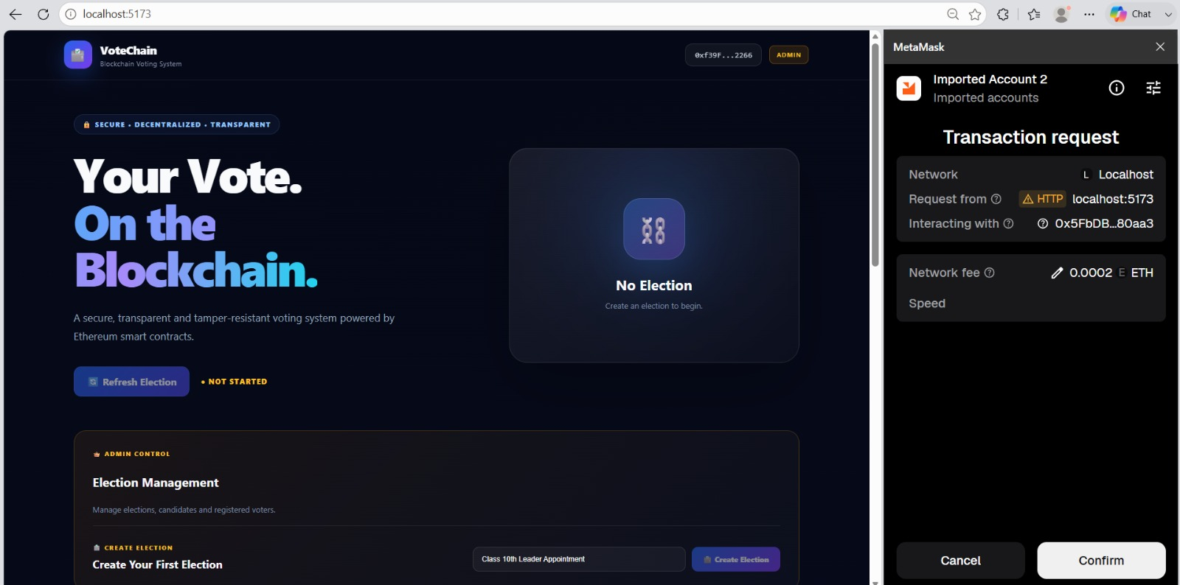

Voter Registration
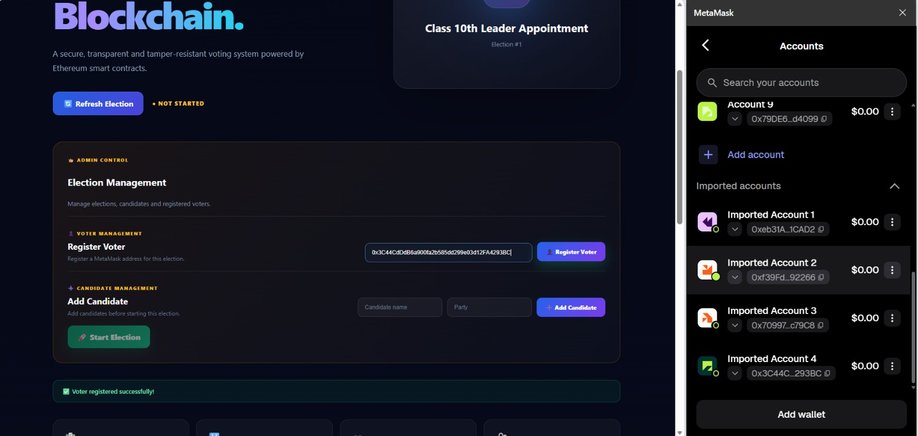

Adding a Candidate
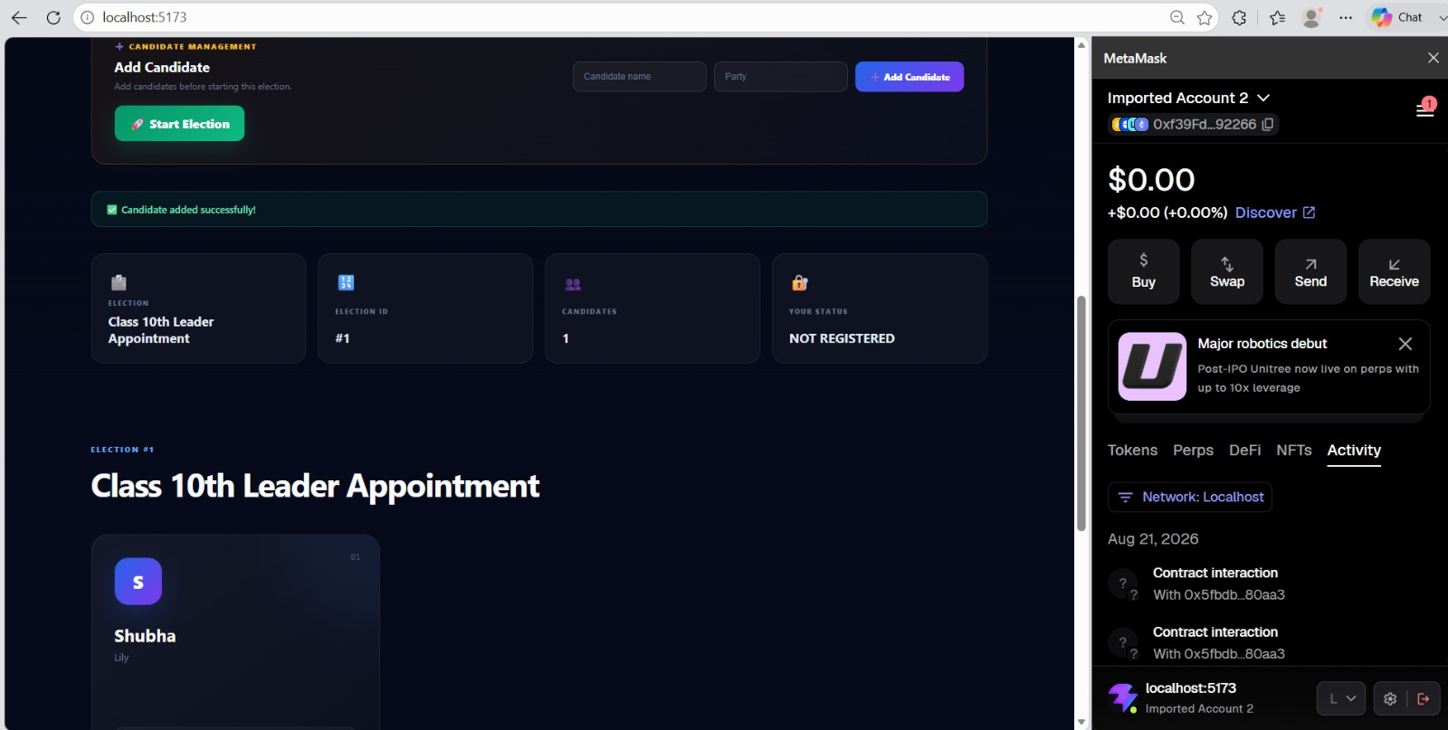

Ending the Election
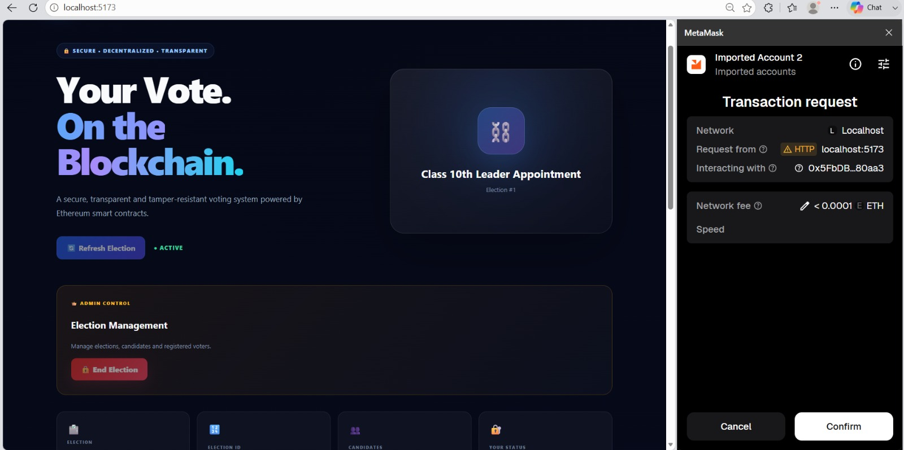

Final Election Results & Winner
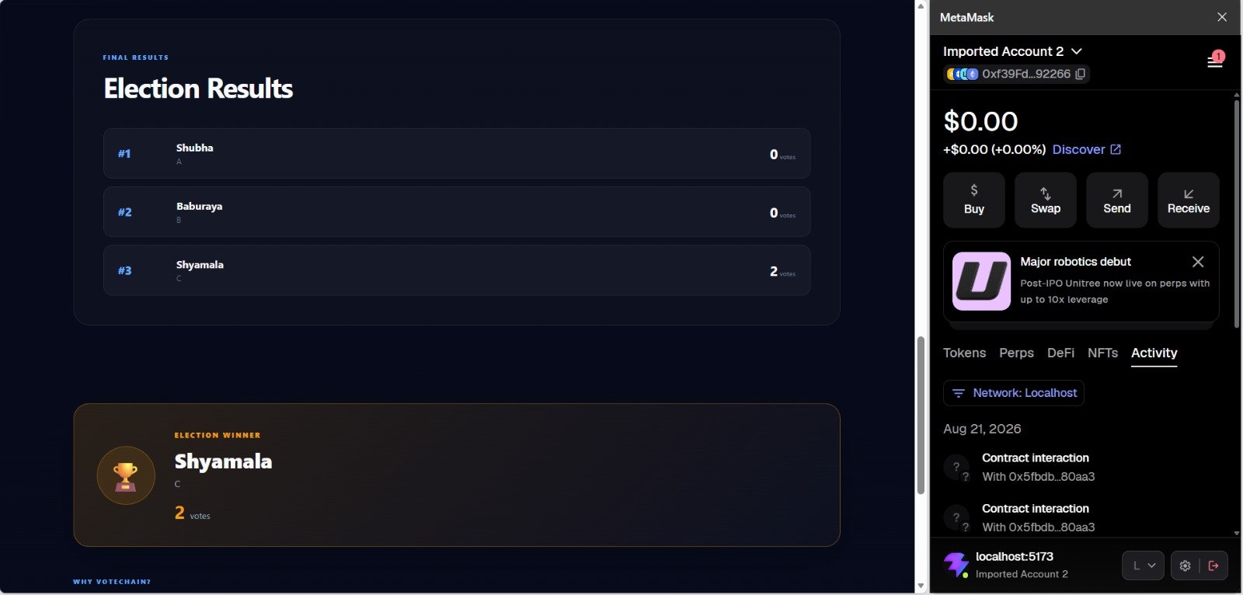

15. Repository
https://github.com/shubha229/Blockchain-Based-Voting-System

