VoteChain – Blockchain-Based Voting System
Project Report

1. Project Overview
VoteChain is a blockchain-based decentralized voting application designed to provide a secure, transparent, and tamper-resistant voting process. The system uses Ethereum smart contracts to manage elections, voter registration, candidates, voting, and election results.
The application combines a React and TypeScript frontend with a Solidity smart contract. Ethers.js is used to communicate between the frontend and blockchain, while MetaMask enables users to connect their Ethereum accounts and approve transactions.
By recording important voting operations on the blockchain, VoteChain demonstrates how decentralized technology can improve transparency, integrity, and trust in digital voting systems.

2. Problem Statement
Traditional and centralized digital voting systems may face challenges related to transparency, centralized control, data manipulation, duplicate voting, and verification of election records.
A voting system should ensure that only eligible participants can vote, that each participant can vote only once, and that the final results can be verified reliably.
VoteChain addresses these challenges as an educational prototype by moving important election rules and vote-counting logic to a blockchain smart contract.

3. Proposed Solution
VoteChain uses a Solidity smart contract to manage the core election logic.
The administrator manages candidates and eligible voter wallet addresses before voting begins. Once the election becomes active, registered voters can cast one vote using their connected MetaMask wallet.
The smart contract validates the voter, checks whether the voter has already voted, validates the selected candidate, records the vote, and updates the candidate's vote count.
After the administrator ends the election, voting is disabled and the final results and winner can be displayed.

4. Objectives
The main objectives of the VoteChain project are:
- Create and Manage Elections: Allow the administrator to create an election and control its different stages.
- Register Voters: Enable the administrator to register eligible voters using their MetaMask wallet addresses.
- Manage Candidates: Allow candidates and their respective parties to be added before the election begins.
- Control Election Status: Provide administrator controls to start and end an election at the appropriate time.
- Enable Blockchain Voting: Allow registered voters to cast their votes through MetaMask, with the transaction processed by the smart contract.
- Prevent Duplicate Voting: Ensure that each registered voter can vote only once in an election.
- Provide Transparent Results: Display the number of votes received by each candidate after the election.
- Determine the Winner: Identify and display the candidate receiving the highest number of votes.

5. Technology Stack
- React: Used to build the interactive user interface of the voting application.
- TypeScript: Provides type-safe frontend development and improves code maintainability.
- Vite: Used as the frontend development and build tool for fast application execution.
- CSS: Used to design and style the VoteChain user interface.
- Solidity: Used to develop the VotingSystem smart contract containing the core election and voting logic.
- Hardhat: Provides the blockchain development environment used to compile, deploy, and test the smart contract.
- Ethers.js: Connects the React frontend with the deployed Ethereum smart contract.
- MetaMask: Provides wallet connectivity and allows administrators and voters to approve blockchain transactions.
- Git & GitHub: Used for source-code version control, project management, and repository hosting.

6. System Architecture
The VoteChain system consists of a frontend application, wallet, Web3 communication layer, and blockchain smart contract.

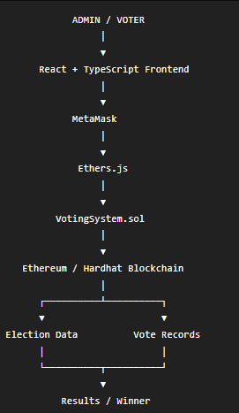
The frontend provides the user interface, MetaMask handles wallet authentication and transaction confirmation, Ethers.js communicates with the smart contract, and the smart contract enforces the election rules.

7. Demonstrated Workflow
1. Create Election
The administrator enters an election name and creates a new election. The operation is submitted as a blockchain transaction through MetaMask.
2. Register Voter
Before voting begins, the administrator registers eligible voters using their MetaMask wallet addresses. Only registered voters are permitted to participate in the election.
3. Add Candidates
The administrator adds candidates along with their respective party names. Candidates must be added before the election is started.
4. Start Election
After voter registration and candidate setup are complete, the administrator starts the election. The election status changes from NOT STARTED to ACTIVE.
5. Select a Registered Voter Account
A registered voter connects or selects their MetaMask account. The application checks the connected wallet's registration and voting status.
6. Cast Vote Through MetaMask
The registered voter selects a candidate and casts their vote. MetaMask requests confirmation before the transaction is submitted to the blockchain.
7. Verify Vote and VOTED Status
After successful transaction confirmation, the application displays a success message. The voter's status changes to VOTED, preventing another vote from the same wallet.
8. End Election
Once voting is complete, the administrator selects End Election and confirms the blockchain transaction through MetaMask. Further voting is then stopped.
9. View Results and Winner
After the election ends, VoteChain displays the final vote count for each candidate. The candidate receiving the highest number of votes is highlighted as the Election Winner.

8. Screenshots / Evidence
Initial Dashboard
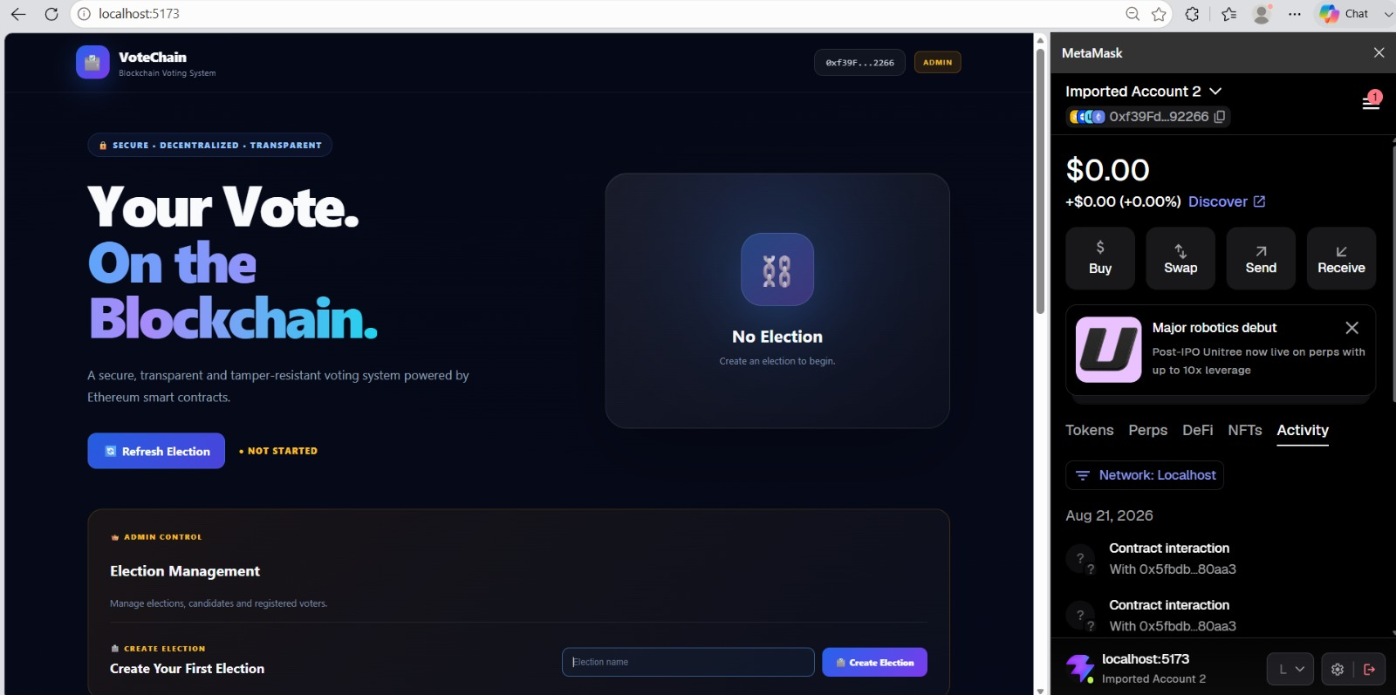

Creating an Election
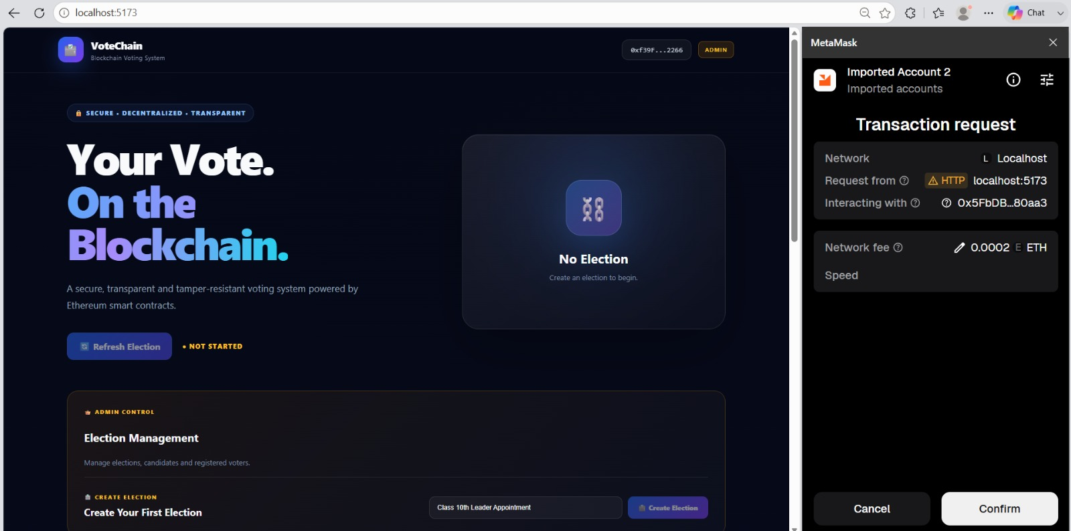

Voter Registration
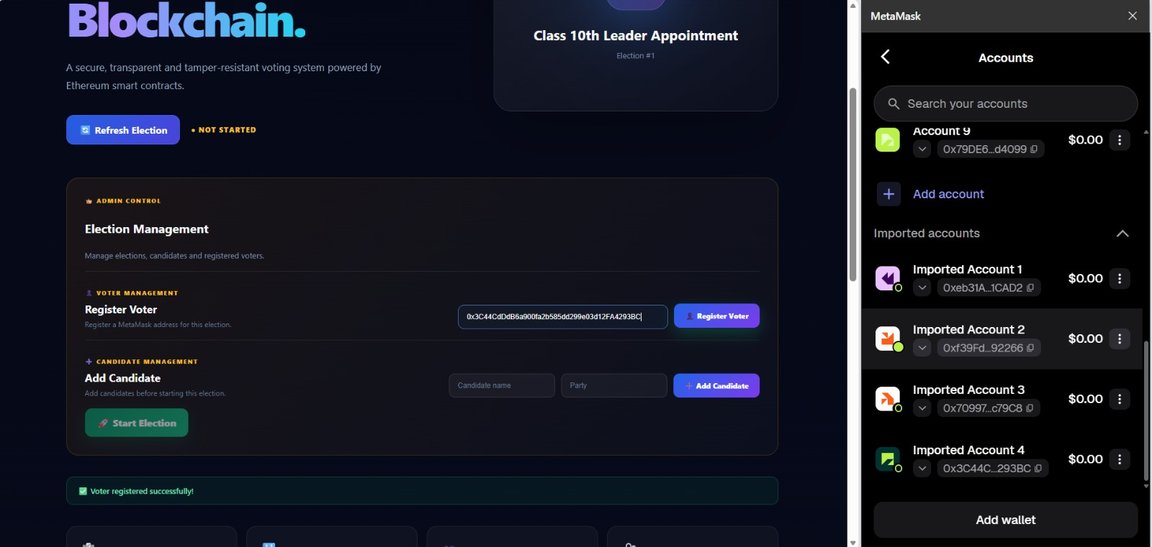

Adding a Candidate
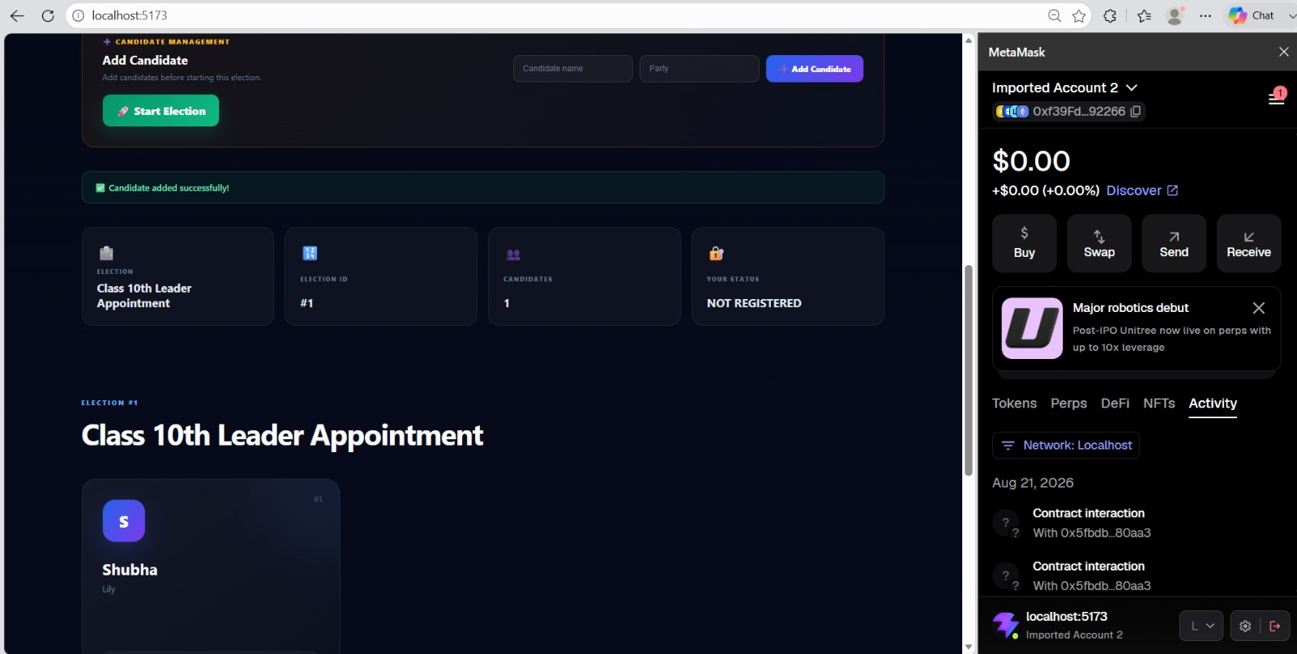

Ending the Election
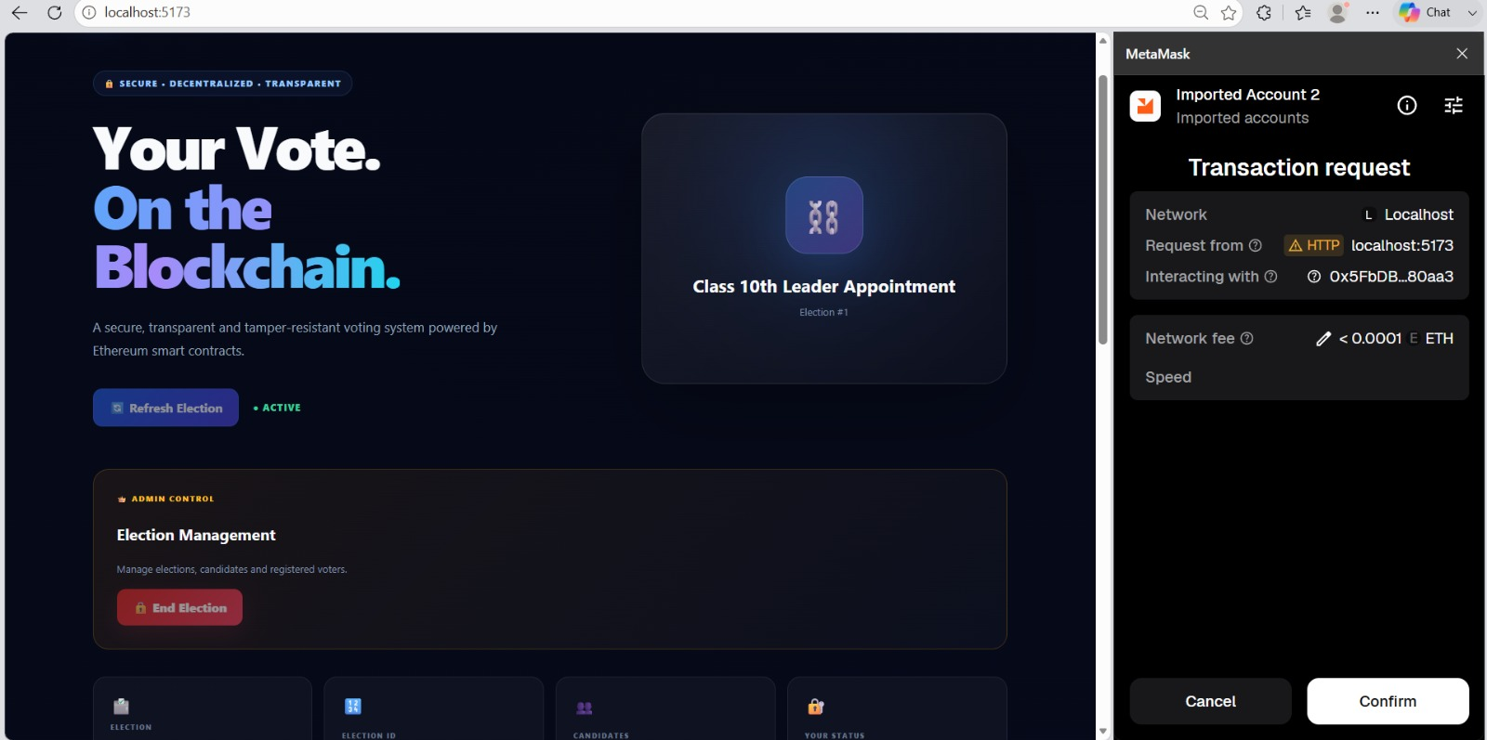

Final Election Results & Winner
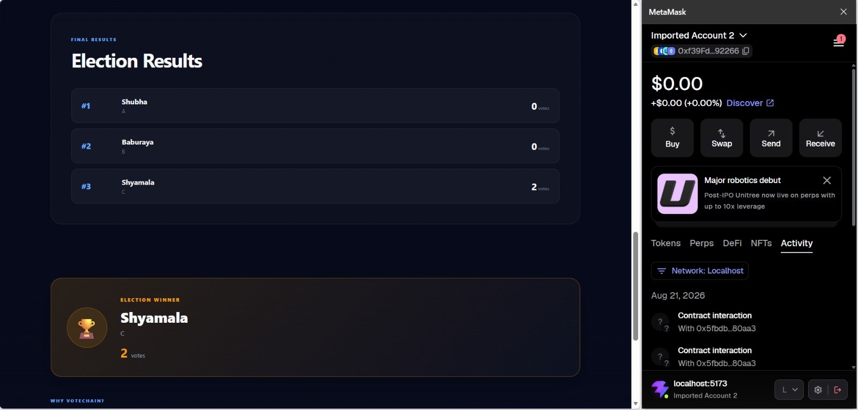

9. Functional Modules
- Election Management
- Voter Management
- Candidate Management
- Voting through MetaMask
- Results and Winner Calculation
- Wallet and Transaction Integration

10. Testing Summary
- Election creation was demonstrated successfully.
- Voter registration was demonstrated successfully.
- Candidates were added successfully.
- The election was started successfully.
- A vote was recorded through MetaMask.
- The voter status changed to VOTED after voting.
- The election was ended successfully.
- Final vote counts and the winner were displayed.

11. Conclusion
The project demonstrates practical integration of blockchain technology with a modern web application. It provides hands-on experience with Solidity, Hardhat, Ethers.js, React, TypeScript, MetaMask and decentralized application development.

12. Repository
https://github.com/shubha229/Blockchain-Based-Voting-System

13. Note
This project is intended for educational and demonstration purposes. A production election system would require extensive security auditing, identity verification, privacy, accessibility and formal election-security controls.

