

An Oozie workflow is a collection of actions arranged in a directed acyclic graph (DAG). This graph can contain two types of nodes: control nodes and action nodes. *Control nodes*, which are used to define job chronology, provide the rules for beginning and ending a workflow and control the workflow execution path with possible decision points known as fork and join nodes. *Action nodes* are used to trigger the execution of tasks. In particular, an action node can be a MapReduce job, a Pig application, a file system task, or a Java application. (The shell and ssh actions have been deprecated).

Oozie is a native Hadoop stack integration that supports all types of Hadoop jobs and is integrated with the Hadoop stack. In particular, Oozie is responsible for triggering the workflow actions, while the actual execution of the tasks is done using Hadoop MapReduce. Therefore, Oozie becomes able to leverage existing Hadoop machinery for load balancing, fail-over, etc. Oozie detects completion of tasks through callback and polling. When Oozie starts a task, it provides a unique callback HTTP URL to the task, and notifies that URL when it is complete. If the task fails to invoke the callback URL, Oozie can poll the task for completion. Figure 1 illustrates a sample Oozie workflow that combines six action nodes (Pig scrip, MapReduce jobs, Java code, and HDFS task) and five control nodes (Start, Decision control, Fork, Join, and End). Oozie workflows can be also parameterized. When submitting a workflow job, values for the parameters must be provided. If the appropriate parameters are used, several identical workflow jobs can occur concurrently.

**Figure 1. Sample Oozie workflow**

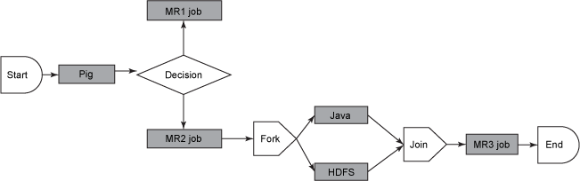

In practice, it is sometimes necessary to run Oozie workflows on regular time intervals, but in coordination with other conditions, such as the availability of specific data or the completion of any other events or tasks. In these situations, Oozie Coordinator jobs allow the user to model workflow execution triggers in the form of the data, time, or event predicates where the workflow job is started after those predicates get satisfied. The Oozie Coordinator can also manage multiple workflows that are dependent on the outcome of subsequent workflows. The outputs of subsequent workflows become the input to the next workflow. This chain is called a *data application pipeline*.

Oozie workflow definition language is XML-based and it is called the *Hadoop Process Definition Language.* Oozie comes with a command-line program for submitting jobs. This command-line program interacts with the Oozie server using REST. To submit or run a job using the Oozie client, give Oozie the full path to your workflow.xml file in HDFS as a parameter to the client. Oozie does not have a notion of global properties. All properties, including the *jobtracker* and the *namenode*, must be submitted as part of every job run. Oozie uses an RDBMS for storing state.

Benefits:

Oozie offers the ability to combine multiple jobs sequentially into one logical unit of work. One advantage of the Oozie framework is that it is fully integrated with the Apache Hadoop stack and supports Hadoop jobs for Apache MapReduce, Pig, Hive, and Sqoop. In addition, it can be used to schedule jobs specific to a system, such as Java programs. Therefore, using Oozie, Hadoop administrators are able to build complex data transformations that can combine the processing of different individual tasks and even sub-workflows. This ability allows for greater control over complex jobs and makes it easier to repeat those jobs at predetermined periods.



The Sqoop action requires Apache Hadoop 0.23.

The sqoop action runs a Sqoop job.

The workflow job will wait until the Sqoop job completes before continuing to the next action.

To run the Sqoop job, you have to configure the sqoop action with the =job-tracker=, name-node and Sqoop command or arg elements as well as configuration.

A sqoop action can be configured to create or delete HDFS directories before starting the Sqoop job.

Sqoop configuration can be specified with a file, using the job-xml element, and inline, using the configuration elements.

Oozie EL expressions can be used in the inline configuration. Property values specified in the configuration element override values specified in the job-xml file.

Note that Hadoop mapred.job.tracker and fs.default.name properties must not be present in the inline configuration.

As with Hadoop map-reduce jobs, it is possible to add files and archives in order to make them available to the Sqoop job.

Benefits: Apache Sqoop(TM) is a tool designed for efficiently transferring bulk data from Hadoop into structured data stores such as relational databases. Apache Sqoop can efficiently import and export data from structured data sources like MySQL and put them in Hadoop data stores like HDFS and vice versa.