Values in emp1 table of mysql

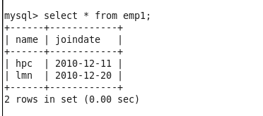

Initial load in hive

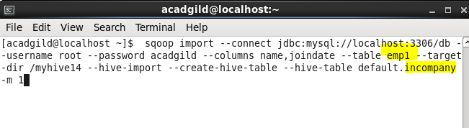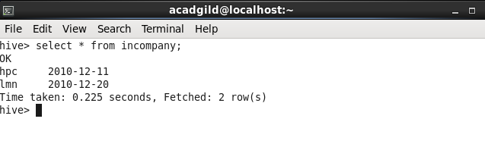

Added new data to mysql table emp1

Added 2 new rows to emp1

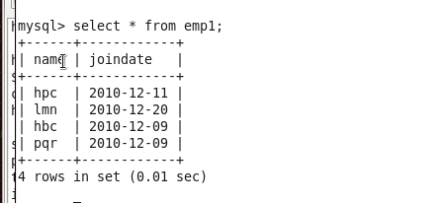

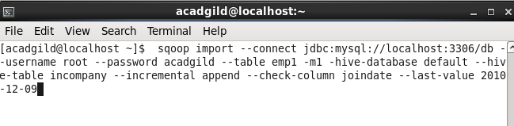

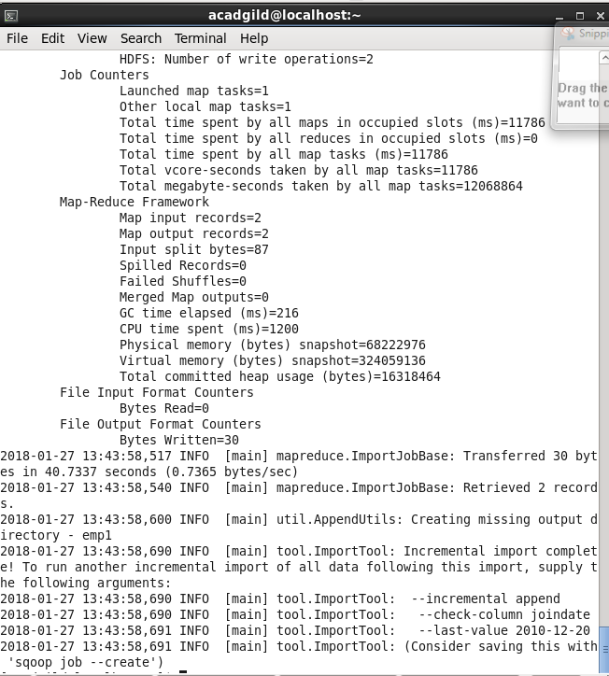

After incremental load data in table incompany is

