Steps to import acadgild vm:

Open the virtual box and then follow the below steps:

Click on File --→ Import Appliance.

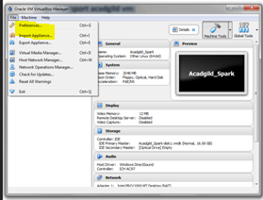

**Click on the Folder option as shown in the below screenshot to browse to the location where hadoop vm is present.**

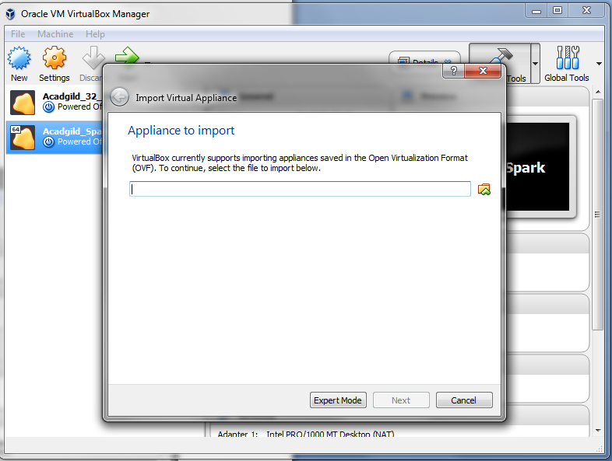

**Click on Next to proceed to next step:**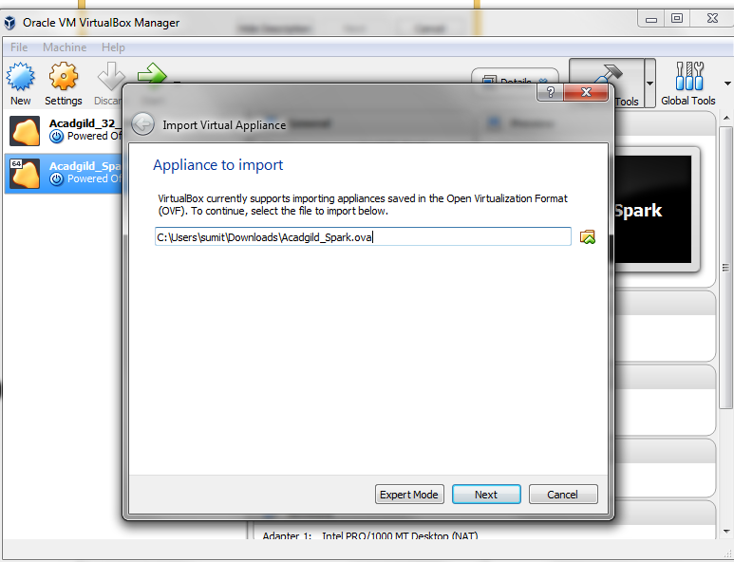

**Click on import button to start importing the acadgild VM**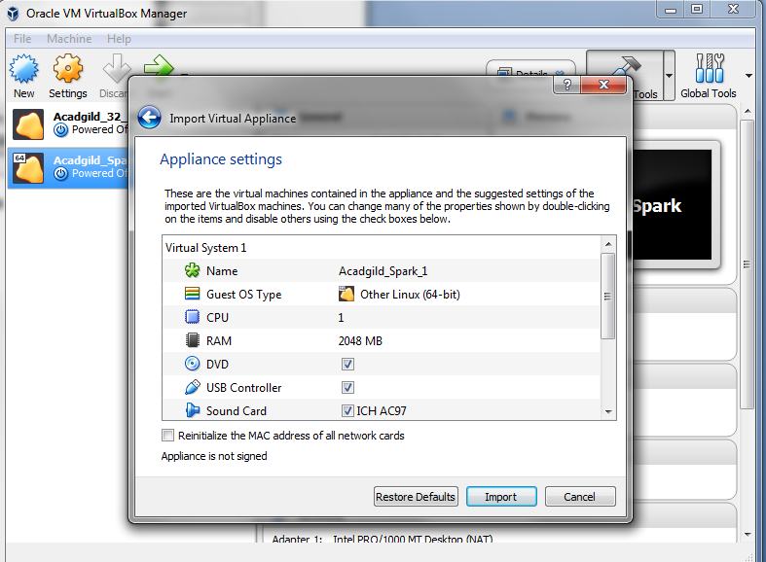

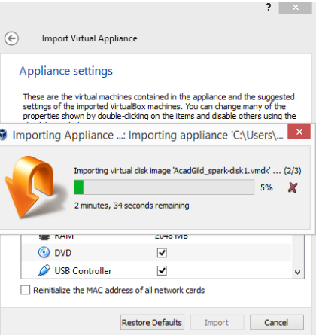

Once the importing gets finished, we need to click

on the start button

We need to give the password as acadgild.

Password: acadgild