

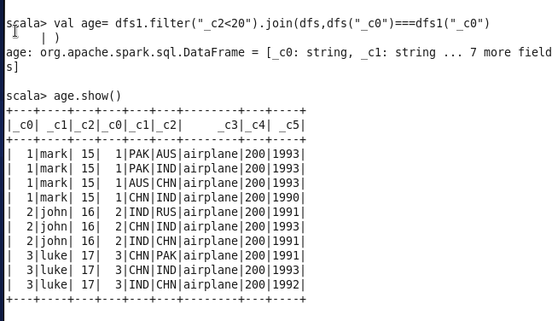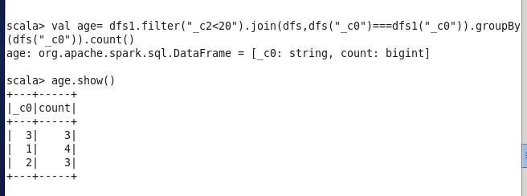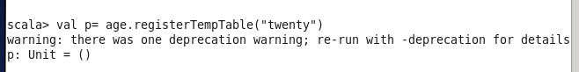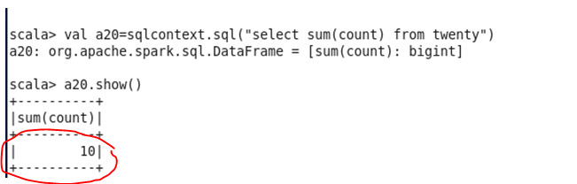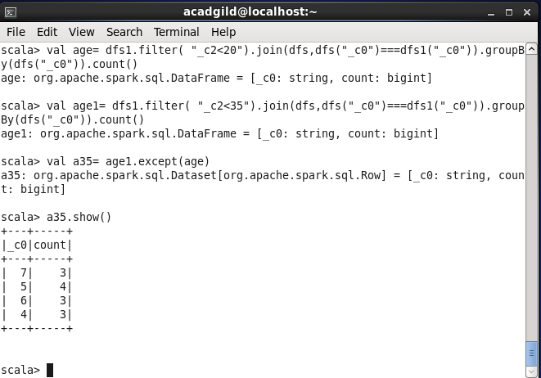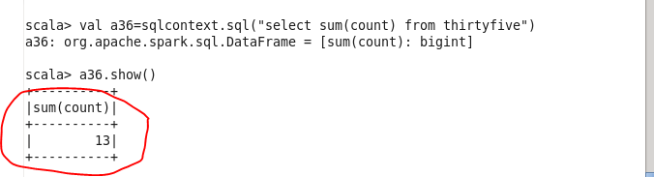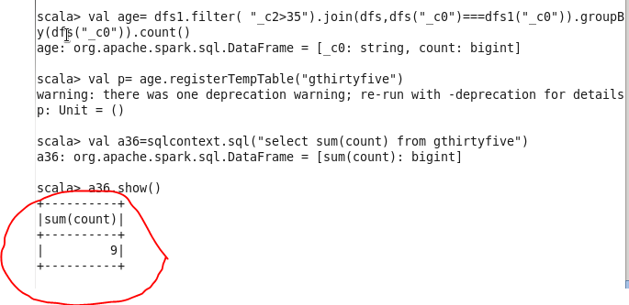

People with age group >35 spend most amount of money travelling



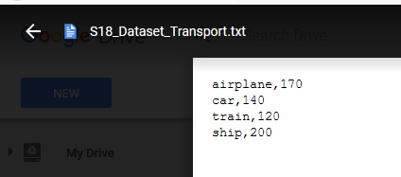

Multiply above results manually

A20=10

Airplane cost=170 (as per given dataset)

10*170=1700**(Amount spent by people with age group less than 20)**

A36=13

13*170=2210**(Amount spent by people with age group > 20 and <35)**

A36=9

13*9=117**(Amount spent by people with age group >35)**