**PWD**

**Description**

**pwd** prints the full pathname of the current working [directory](https://www.computerhope.com/jargon/d/director.htm).

**pwd syntax**

**pwd** [*OPTION*]...

**Options**

|  |  |
| --- | --- |
| **-L**, **--logical** | If the **PWD** environment variable contains an absolute name of the current directory with no "**.**" or "**..**" components, then output those contents, even if they contain symbolic links Otherwise, fall back to default (**-P**) behavior. |
| **-P**, **--physical** | Print a fully resolved name for the current directory, in which all components of the name are actual directory names, and not symbolic links. |
| **--help** | Display a help message, and exit. |
| **--version** | Display version information, and exit. |

**Screenshot**

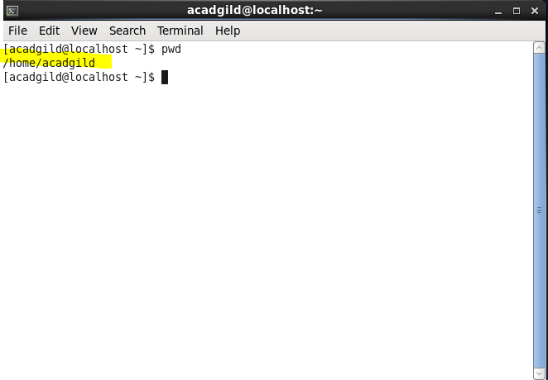

Vi

**Description**

Vi is a command line text editor. Vi is intended as a plain text editor (similar to Notepad on Windows, or Textedit on Mac) as opposed to a word processing suite such as Word or Pages. It does, however have a lot more power compared to Notepad or Textedit.

**vi syntax**

vi filename

**To exit vi and save changes:** ZZ or :wq  
**To exit vi without saving changes:** :q!  
**To enter vi command mode:** *[esc]*

**Screenshot**

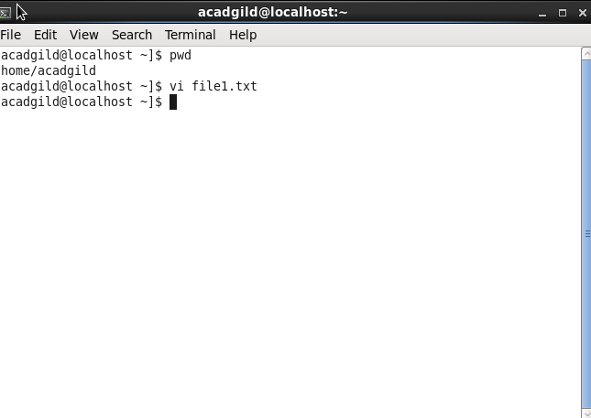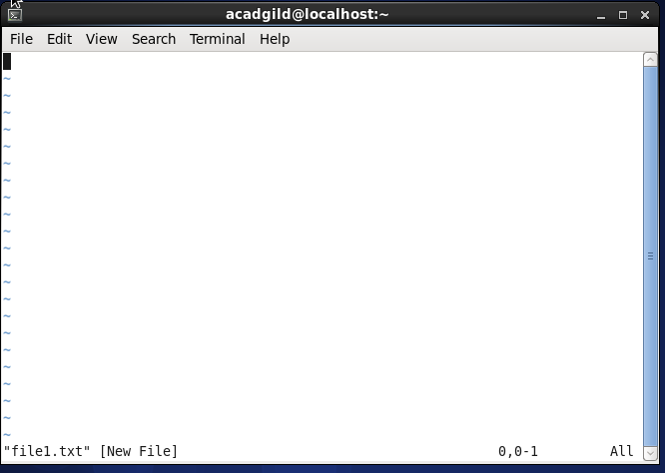

**Touch**

**Description**

The touch [command](http://www.linfo.org/command.html) is the easiest way to create new, empty [files](http://www.linfo.org/file.html). It is also used to change the timestamps (i.e., dates and times of the most recent access and modification) on existing files and [directories](http://www.linfo.org/directory.html).

**Touch syntax**

touch [option] file_name(s)

**Options**

|  |  |
| --- | --- |
| **am** | the *-a* option changes only the access time, while the *-m* option changes only the modification time. The use of both of these options together changes both the access and modification times to the current time, |
| **-r** | The *-r* (i.e., *reference*) option followed directly by a space and then by a file name tells touch to use that file's time stamps instead of current time.. |
| **--B** | The *-B* option modifies the timestamps by going back the specified number of seconds. |
| **-F** | *-F* option modifies the time by going forward the specified number of seconds. |
| **-d -t** | The *-d* and *-t* options allow the user to add a specific last access time. |

**Screenshot**

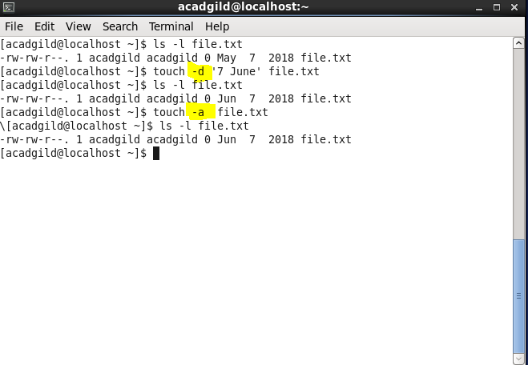

**mkdir**

**Description**

The mkdir command is to create new directories.

**Touch syntax**

mkdir [option] directory_name(s)

**Options**

|  |  |
| --- | --- |
| **-m** | mkdir's *-m* option is used to control the permissions of new directories. New directories are by default created with the read, write and *execute* (i.e., run as a program if a program) permissions enabled for the *owner* (i.e., the creator of the directory by default)  mkdir -m 777 dir_4  The first digit represents the owner, the second represents the group and the third represents other users. The number 7 represents all three types of permission (i.e., read, write and execute), 6 stands for read and write only, 5 stands for read and execute, 4 is read only, 3 is write and execute, 2 is write only, 1 is execute only and 0 is no permissions. |
| **-p** | The *-p* (i.e., *parents*) option creates the specified intermediate directories for a new directory if they do not already exist. |

**Screenshot**

