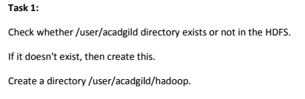

**Answer**

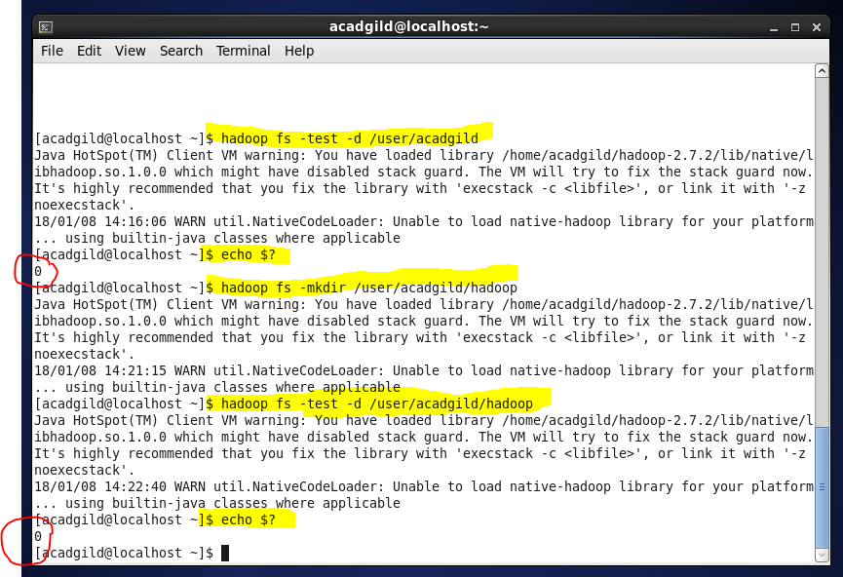

**Syntax:**

hadoop fs -test -d directoryname

and then $ echo?

Returns 0 if directory exists.

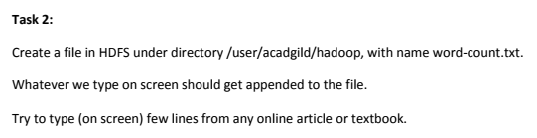

**Answer**

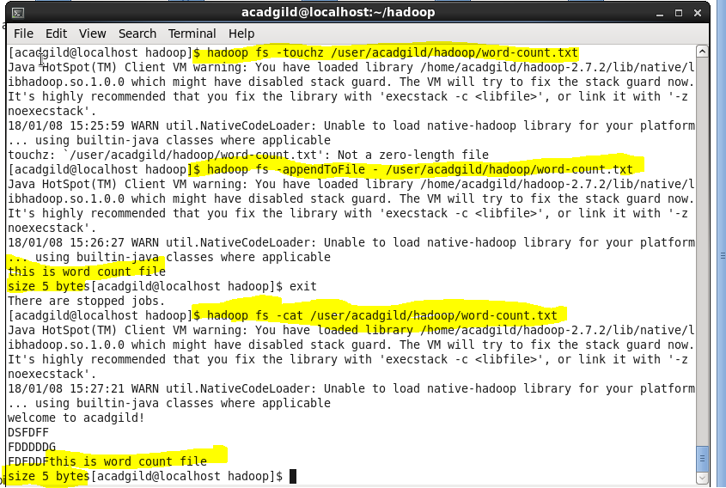

1. Create file in hdfs using command

hadoop fs –touchz filename

1. Then use command

Hadoop fs –appendToFile - filepath

1. Type the text and then press ctrl+D to exit
2. Display contents using command,

hadoop fs –cat filepath