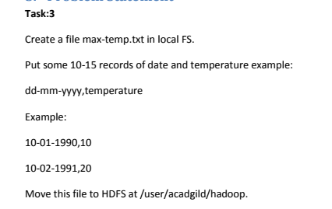

**Answer**

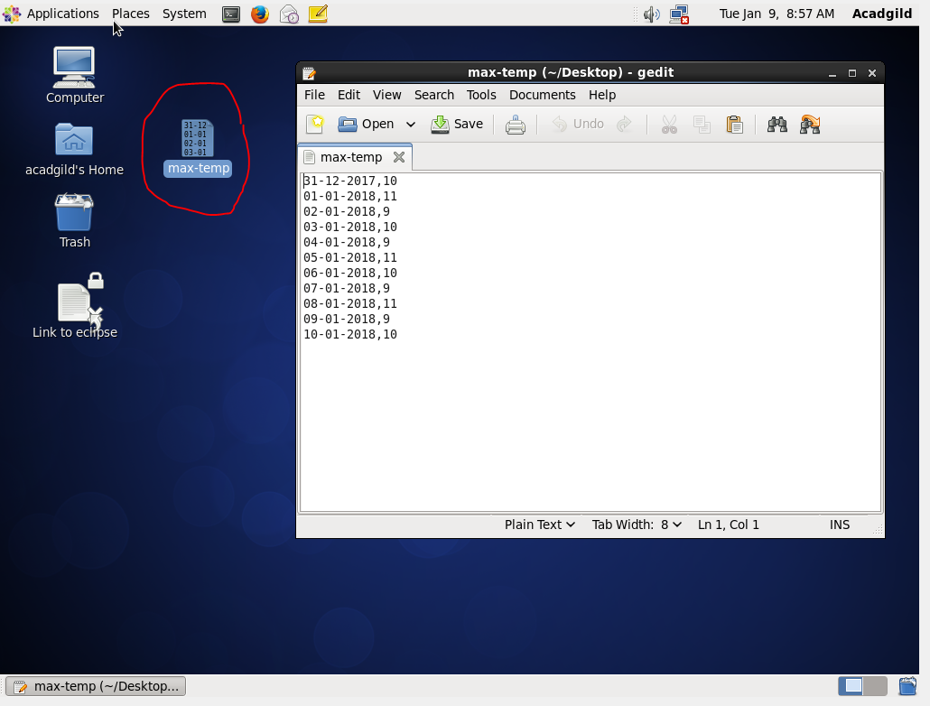

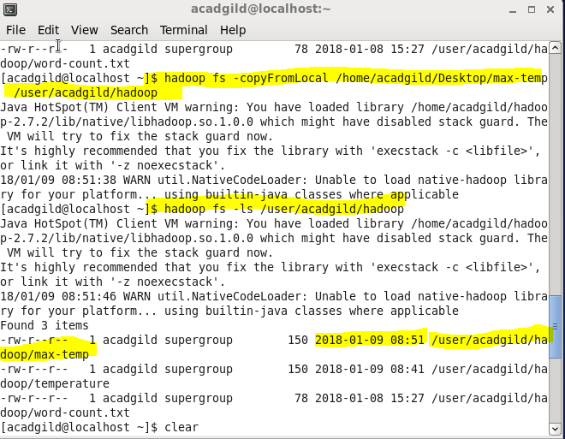

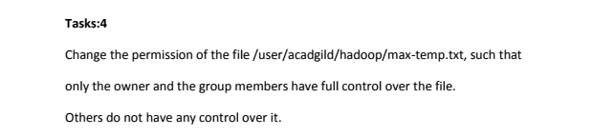

**Answer**

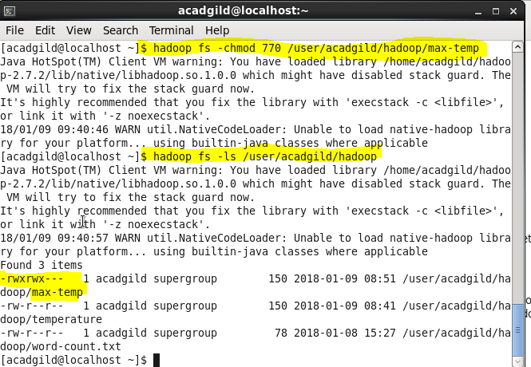

1. Use –chmod command to set full control for user and group.

-chmod 770

7- read, write and execute for user.

7- read, write and execute for group

0- No control to any other user

2. verify output using –ls command.