**What is ACID?**

ACID stands for Atomicity, Consistency, Isolation, and Durability.

Atomicity means, a transaction should complete successfully or else it should fail completely i.e. it should not be left partially. Consistency ensures that any transaction will bring the database from one valid state to another state. Isolation states that every transaction should be independent of each other i.e. one transaction should not affect another. And Durability states that if a transaction is completed, it should be preserved in the database even if the machine state is lost or a system failure might occur.

These ACID properties are essential for a transaction and every transaction should ensure that these properties are met.

**Transactions in Hive**

Transactions in Hive are introduced in Hive 0.13, but they only partially fulfill the ACID properties like atomicity, consistency, durability, at the partition level. Here, Isolation can be provided by turning on one of the locking mechanisms available with zookeeper or in memory.

But in Hive 0.14, new API’s have been added to completely fulfill the ACID properties while performing any transaction.

Transactions are provided at the row-level in Hive 0.14. The different row-level transactions available in Hive 0.14 are as follows:

1. Insert
2. Delete
3. Update

There are numerous limitations with the present transactions available in Hive 0.14. ORC is the file format supported by Hive transaction. It is now essential to have ORC file format for performing transactions in Hive. The table needs to be bucketed in order to support transactions.

**Row-level Transactions Available in Hive 0.14**

Before creating a Hive table that supports transactions, the transaction features present in Hive needs to be turned on, as by default they are turned off. If the above properties are not set properly, the ‘Insert’ operation will work but ‘Update’ and ‘Delete’ will not work and you will receive the following error:

FAILED: SemanticException [Error 10294]: Attempt to do update or delete usingtransaction manager thatdoes not support these operations.

The below properties needs to be set appropriately in ***hive shell*** , order-wise to work with transactions in Hive: 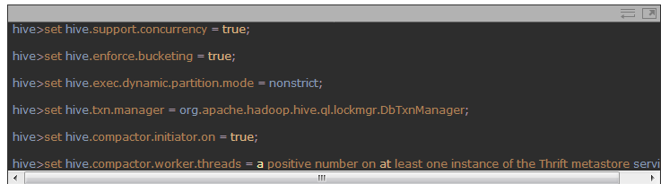

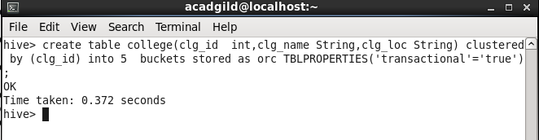The above syntax will create a table with name ‘*college’* and the columns present in the table are ‘*clg_id, clg_name, clg_loc’. W*e are *bucketing* the table by ‘*clg_id’* and the table format is ‘*orc’,* also we are enabling the transactions in the table by specifying it inside the *TBLPROPERTIES* as *‘transactional’=’true’*



The above command is used to insert row wise data into the Hive table. Here, each row is seperated by ‘*( )’ brackets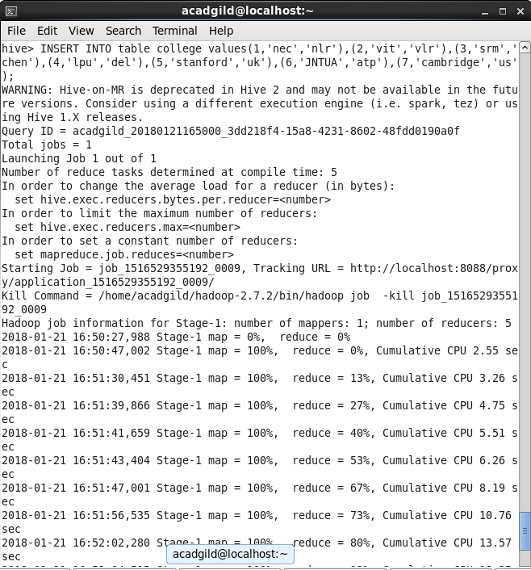*

*The updated data can be checked using the command* ***select * from college.***

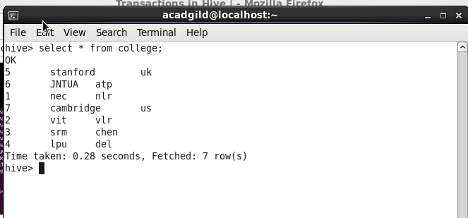

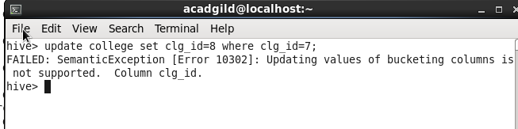

*From the above image, we can see that we have received an error message. This means that the Update command is not supported on the columns that are bucketed.*

In this table, we have bucketed the ***‘clg_id’*** column and performing the Update operation on the same column, so we have go the error

***FAILED: SemanticException[Error 10302]: Updating values of bucketing columns is not supported. Column clg_id***

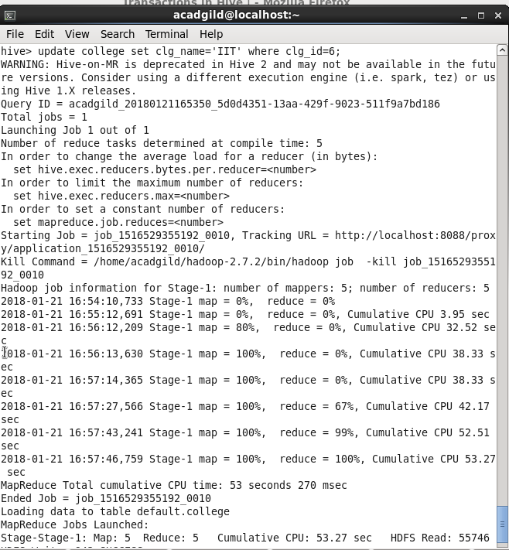The updated data can be checked using the command ***select * from college.*** 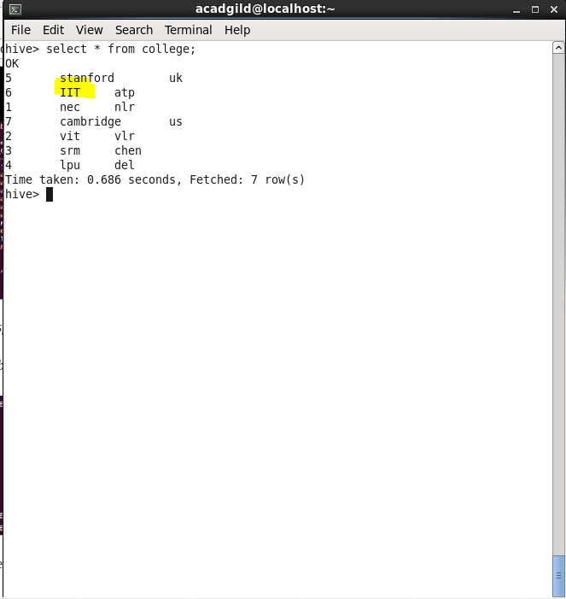

***The above command will delete a single row in the Hive table***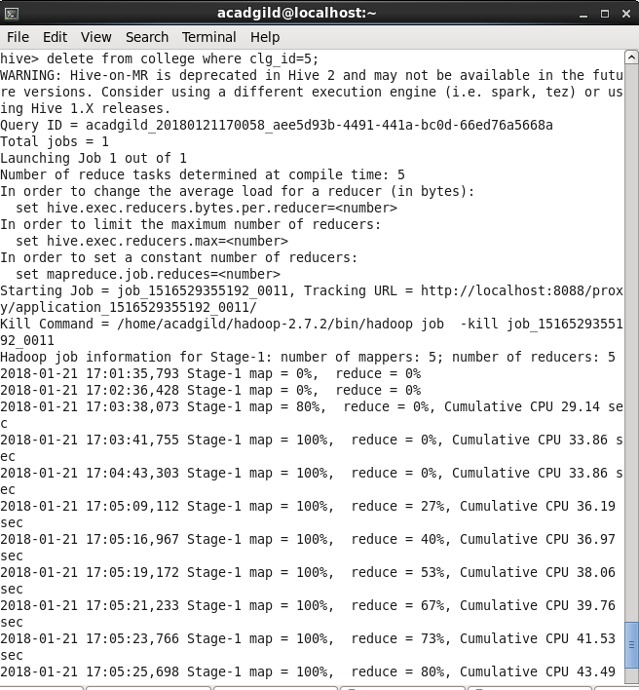

successfully deleted a row from the Hive table. This can be checked using the command **select * from college.** 