CGW application
Git repository: ssh://git@git.ssd-tech.local:22311/cgw

Banglalink sms-gateway
Branch: cgw_documented

Running instances:
- 192.168.241.112 (two instances is running in this machine, HTTP)
- 192.168.241.113 (one instance is running in this machine, HTTP)

Banglalink sms-gateway
Branch: develop

Running instances:
- 10.231.0.19 (one instances is running in this machine for promotional (outgoing) SMSs, SMPP)
- 10.231.0.28 (one instance is running in this machine for service (incoming & outgoing) SMSs, SMPP)

Robi sms-gateway
Branch: develop

Running instances:
- 10.101.60.12 (one instances is running in this machine for promotional (outgoing) SMSs, SMPP)
- 10.101.60.14 (one instance is running in this machine for service (incoming & outgoing) SMSs, SMPP)

Telenor Digital (Digi) sms-gateway
Branch: develop_digi

Running instances:
- 10.10.100.187 (one instances is running in this machine for promotional and service (incoming & outgoing) SMSs, HTTP)

Telenor Myanmar sms-gateway
Branch: Telenor_myanmar

Running instances:
- 192.168.242.44 (one instances is running in this machine for promotional and service (incoming & outgoing) SMSs, SMPP)

Data Flow cgw

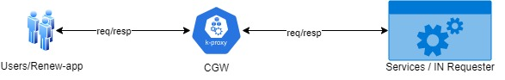

Functional Flow sms-gateway

