DESIGN AND IMPLEMENT
PYTHON PROGRAM
TO PREDICT
WATER QUALITY INDEX
Selected Case Study:
Water Potability /
Water Quality Prediction
Submitted By: Shubham Kumar
Roll No: 28
Course: Machine Learning
College: Indira University

1. Problem Statement
Safe drinking water is a basic requirement for public health, and water supplied to households must be tested against regulatory limits for a range of chemical and physical parameters. Laboratory certification of every sample is slow and costly. The aim is to analyse historical water sample data and develop machine learning regression models to predict the Water Quality Index (WQI) of a sample from its measured physico-chemical properties.

2. Objectives
- Analyse the Water Potability dataset from Kaggle.
- Inspect rows, columns, data types and missing values.
- Perform data cleaning and preprocessing.
- Handle missing values in ph, Sulfate and Trihalomethanes.
- Compute the Water Quality Index from chemical parameters.
- Study correlations between the chemical properties.
- Build regression models for WQI prediction.
- Compare Linear Regression, Decision Tree Regression and Random Forest Regression.
- Evaluate models using MAE, MSE, RMSE and R².
- Identify important predictors of water quality.

3. Dataset Description
The Water Potability dataset contains 3,276 water body samples described by nine physico-chemical properties and one binary potability label.
Column | Unit | Important Information
ph | 0 – 14 | Acid–base balance, WHO acceptable range 6.5 to 8.5
Hardness | mg/L | Caused by calcium and magnesium salts
Solids | ppm | Total dissolved solids, indicates mineralisation
Chloramines | ppm | Disinfectant residual, limit 4 ppm
Sulfate | mg/L | Naturally occurring, 781 missing values
Conductivity | μS/cm | Ionic conduction capacity of the water
Organic_carbon | ppm | From decaying organic matter, limit 4 ppm
Trihalomethanes | μg/L | Chlorine treatment by-product, 162 missing values
Turbidity | NTU | Light scattering from suspended solids
Potability | 0 / 1 | Original binary label, used in the secondary task in Section 9
Target variable: WQI. This is a supervised regression problem because the target is continuous numerical data.
Dataset source: kaggle.com/datasets/adityakadiwal/water-potability

4. Software and Libraries Used
- Python 3
- Google Colab
- Pandas
- NumPy
- Matplotlib
- Seaborn
- Scikit-learn

5. Methodology / Steps
1. Import required Python libraries.
2. Load the water_potability.csv dataset.
3. Inspect rows, columns, data types and missing values.
4. Perform exploratory data analysis.
5. Plot histograms of all nine chemical features.
6. Plot a correlation heatmap of the dataset.
7. Split the data into training and testing sets BEFORE imputation.
8. Compute the median of each feature on the training split only.
9. Apply those medians to fill missing values in both splits.
10. Define WHO and BIS permissible limits for each parameter.
11. Compute the quality rating qi and unit weight wi, then build the WQI target.
12. Classify WQI values into quality categories.
13. Select independent variables and WQI as target.
14. Train a Dummy mean baseline for reference.
15. Train Linear Regression.
16. Train Decision Tree Regression.
17. Train Random Forest Regression.
18. Calculate MAE, MSE, RMSE and R² on the test set.
19. Record training R² to measure the overfitting gap.
20. Run 5-fold cross-validation on each model.
21. Compare model performance.
22. Test the pH kink hypothesis by adding an abs(ph - 7) feature.
23. Plot actual vs predicted values and residuals.
24. Analyse Random Forest feature importance.
25. Predict WQI for a new water sample.
26. Train a Random Forest classifier on the Potability label.
27. Draw conclusions.

6. Python Program
Upload water_potability.csv to Google Colab before running the program.
# Import libraries
import pandas as pd
import numpy as np
import matplotlib.pyplot as plt
import seaborn as sns

from sklearn.model_selection import train_test_split, cross_val_score, KFold
from sklearn.dummy import DummyRegressor
from sklearn.linear_model import LinearRegression
from sklearn.tree import DecisionTreeRegressor
from sklearn.ensemble import RandomForestRegressor, RandomForestClassifier
from sklearn.metrics import (mean_absolute_error, mean_squared_error,
r2_score, accuracy_score, roc_auc_score,
confusion_matrix, classification_report)

import warnings
warnings.filterwarnings('ignore')
# Load dataset
df = pd.read_csv('water_potability.csv')

print("Shape:", df.shape)
print(df.head())
print(df.info())
print(df.describe())
print("Missing values:\n", df.isnull().sum())
# Exploratory data analysis
df.hist(figsize=(15, 10), bins=30, color='steelblue')
plt.suptitle('Feature Distributions')
plt.show()

plt.figure(figsize=(10, 8))
sns.heatmap(df.corr(), annot=True, cmap='coolwarm', fmt='.2f')
plt.title('Correlation Heatmap')
plt.show()

sns.countplot(x='Potability', data=df)
plt.title('Potability Class Distribution')
plt.show()
# Create target variable: Water Quality Index (WQI)
standards = {
'ph': 8.5, 'Hardness': 300.0, 'Solids': 500.0,
'Chloramines': 4.0, 'Sulfate': 250.0, 'Conductivity': 400.0,
'Organic_carbon': 4.0, 'Trihalomethanes': 80.0, 'Turbidity': 5.0
}
ideal = {'ph': 7.0}

def compute_wqi(data):
K = 1 / sum(1 / s for s in standards.values())
numerator = np.zeros(len(data))
denominator = 0
for col, S in standards.items():
Vi = ideal.get(col, 0.0)
q = abs(100 * (data[col] - Vi) / (S - Vi))
w = K / S
numerator += w * q
denominator += w
return numerator / denominator
# Select independent variables and WQI as target
features = ['ph', 'Hardness', 'Solids', 'Chloramines', 'Sulfate',
'Conductivity', 'Organic_carbon', 'Trihalomethanes', 'Turbidity']
X = df[features]
y = df['WQI']
# Split BEFORE imputation to avoid data leakage
# The median used to fill missing values is computed on the TRAINING
# split only and then applied to both splits. Computing it on the full
# dataset would leak test-set information into training.
train_raw, test_raw = train_test_split(df, test_size=0.2, random_state=42)

median_values = train_raw[features].median() # fitted on TRAIN only

train = train_raw.copy()
test = test_raw.copy()
train[features] = train[features].fillna(median_values)
test[features] = test[features].fillna(median_values)

X_train, y_train = train[features], compute_wqi(train)
X_test, y_test = test[features], compute_wqi(test)

print("Training set:", X_train.shape)
print("Testing set :", X_test.shape)
# Train regression models
models = {
'Dummy (mean baseline)': DummyRegressor(strategy='mean'),
'Linear Regression': LinearRegression(),
'Decision Tree': DecisionTreeRegressor(max_depth=10,
random_state=42),
'Random Forest': RandomForestRegressor(n_estimators=100,
max_depth=20, random_state=42, n_jobs=-1),
}
# Calculate MAE, MSE, RMSE and R2
cv = KFold(n_splits=5, shuffle=True, random_state=42)
results = []

for name, model in models.items():
model.fit(X_train, y_train)
pred_test = model.predict(X_test)
pred_train = model.predict(X_train)

mae = mean_absolute_error(y_test, pred_test)
mse = mean_squared_error(y_test, pred_test)
rmse = np.sqrt(mse)
r2 = r2_score(y_test, pred_test)
r2_train = r2_score(y_train, pred_train)
cv_scores = cross_val_score(model, X_train, y_train, cv=cv,
scoring='r2')

print(f"\n{name}")
print("MAE :", mae)
print("MSE :", mse)
print("RMSE :", rmse)
print("Test R2 :", r2)
print("Train R2 :", r2_train)
print("CV R2 :", cv_scores.mean(), "+/-", cv_scores.std())

results.append({'Model': name, 'MAE': mae, 'MSE': mse, 'RMSE': rmse,
'Test_R2': r2, 'Train_R2': r2_train,
'CV_R2_mean': cv_scores.mean(),
'Overfit_Gap': r2_train - r2})
# Compare model performance
results_df = pd.DataFrame(results)
print(results_df)

plt.figure(figsize=(10, 5))
plt.bar(results_df['Model'], results_df['Test_R2'], color='steelblue')
plt.title('Model Comparison Based on R2 Score')
plt.ylabel('R2 Score')
plt.xticks(rotation=20)
plt.show()

# Actual vs predicted
plt.figure(figsize=(8, 5))
plt.scatter(y_test, rf_pred, alpha=0.3)
plt.xlabel('Actual WQI')
plt.ylabel('Predicted WQI')
plt.title('Actual vs Predicted WQI - Random Forest')
plt.show()

# Residual plot
residuals = y_test - rf_pred
plt.figure(figsize=(8, 5))
plt.scatter(rf_pred, residuals, alpha=0.3, color='darkorange')
plt.axhline(0, color='red', linestyle='--')
plt.xlabel('Predicted WQI')
plt.ylabel('Residuals')
plt.title('Residual Plot - Random Forest')
plt.show()
# Test the pH kink hypothesis
# Eight of the nine WQI terms are linear in their feature. Only the pH
# term contains an absolute value, abs(100*(ph-7)/1.5), which has a kink
# at ph = 7. Adding that single engineered feature should close the gap.
X_train_kink = X_train.copy()
X_test_kink = X_test.copy()
X_train_kink['ph_deviation'] = (X_train_kink['ph'] - 7).abs()
X_test_kink['ph_deviation'] = (X_test_kink['ph'] - 7).abs()

lr_kink = LinearRegression()
lr_kink.fit(X_train_kink, y_train)
print("Test R2 :", r2_score(y_test, lr_kink.predict(X_test_kink)))
# Feature importance
importance = pd.DataFrame({
'Feature': X.columns,
'Importance': rf_model.feature_importances_
}).sort_values(by='Importance', ascending=False)

print(importance)

plt.figure(figsize=(10, 6))
plt.barh(importance['Feature'], importance['Importance'])
plt.title('Feature Importance - Random Forest')
plt.xlabel('Importance')
plt.gca().invert_yaxis()
plt.show()
# Water quality classification and new sample prediction
def wqi_class(value):
if value <= 50: return 'Excellent'
elif value <= 100: return 'Good'
elif value <= 200: return 'Poor'
elif value <= 300: return 'Very Poor'
else: return 'Unsuitable'

df['WQI_Class'] = df['WQI'].apply(wqi_class)
print(df['WQI_Class'].value_counts())

new_sample = pd.DataFrame([{
'ph': 7.2, 'Hardness': 204.0, 'Solids': 20791.0,
'Chloramines': 7.3, 'Sulfate': 368.5, 'Conductivity': 564.3,
'Organic_carbon': 10.4, 'Trihalomethanes': 86.9, 'Turbidity': 2.96
}])

predicted_wqi = rf_model.predict(new_sample)[0]
print("Predicted WQI :", predicted_wqi)
print("Water Quality :", wqi_class(predicted_wqi))
# Secondary task: Potability classification
clf = RandomForestClassifier(n_estimators=300, max_depth=14,
class_weight='balanced',
random_state=42, n_jobs=-1)
clf.fit(X_train, train['Potability'])
clf_pred = clf.predict(X_test)
clf_proba = clf.predict_proba(X_test)[:, 1]

print("Accuracy :", accuracy_score(test['Potability'], clf_pred))
print("ROC-AUC :", roc_auc_score(test['Potability'], clf_proba))
print(confusion_matrix(test['Potability'], clf_pred))
print(classification_report(test['Potability'], clf_pred,
target_names=['Not Potable', 'Potable']))

7. Explanation of Important Steps
Data Preprocessing: The dataset is inspected for missing values. Three columns contain gaps: ph with 491 missing values, Sulfate with 781 and Trihalomethanes with 162. These are filled using the median because all features are skewed and the median is robust to outliers.
Avoiding Data Leakage: The data is split into training and testing sets before any imputation is performed. The median of each column is computed on the training split only and is then applied to both splits. If the median were computed on the full dataset, information from the test set would influence the training data and the reported scores would be optimistically biased.
Dummy Baseline: A DummyRegressor that always predicts the mean is trained alongside the real models. It scores an R² of approximately zero by construction, and provides the reference point against which every other R² in the results table should be read.
Cross-Validation: Each model is additionally evaluated with 5-fold cross-validation on the training split. Reporting the mean and standard deviation across folds shows whether a score is stable or an artefact of one favourable split.
Overfitting Gap: Training R² is recorded alongside test R². A large gap between the two indicates that the model has memorised the training data rather than learned a generalisable pattern.
Target Engineering: The dataset supplies only a binary Potability label, which is a classification target. Since this case study requires regression, a continuous Water Quality Index is computed using the Weighted Arithmetic WQI method, the standard index used by pollution control boards.
Quality Rating (qi): For each parameter, qi = 100 x (Vi - Videal) / (Si - Videal), where Si is the WHO or BIS permissible limit and Videal is the ideal value, which is 7.0 for pH and 0 for all other parameters.
Unit Weight (wi): The unit weight wi = K / Si is inversely proportional to the permissible limit, so parameters with strict standards contribute more to the final index.
Water Quality Index: WQI = sum(wi x qi) / sum(wi). A lower index means better water. Values up to 50 are Excellent, up to 100 Good, up to 200 Poor, up to 300 Very Poor, and above 300 Unsuitable.
Linear Regression: A baseline model that assumes a linear relationship between the chemical predictors and WQI.
Decision Tree Regression: A non-linear model that uses decision rules and can capture threshold effects in the chemical parameters.
Random Forest Regression: An ensemble of decision trees that captures complex non-linear relationships and reduces the variance of a single tree.
MAE: Mean Absolute Error. Lower values indicate smaller average prediction errors, expressed in index points.
MSE: Mean Squared Error. Lower values indicate smaller squared prediction errors.
RMSE: Root Mean Squared Error. Lower values are better and the metric is expressed on the target's own scale.
R²: R-squared measures how much variation in WQI is explained by the model. Higher is generally better.

8. Results
Model | MAE | MSE | RMSE | Test R²
Dummy (mean baseline) | 23.8116 | 887.0510 | 29.7834 | -0.0012
Linear Regression | 7.2748 | 85.1317 | 9.2267 | 0.9039
Decision Tree | 7.6918 | 99.8594 | 9.9930 | 0.8873
Random Forest | 4.7632 | 42.1744 | 6.4942 | 0.9524
Generalisation check. Training R² and 5-fold cross-validation on the training split:
Model | Train R² | Test R² | Overfit Gap | CV R² (mean ± sd)
Dummy (mean baseline) | 0.0000 | -0.0012 | 0.0012 | -0.0061 ± 0.0067
Linear Regression | 0.8977 | 0.9039 | -0.0062 | 0.8964 ± 0.0074
Decision Tree | 0.9823 | 0.8873 | 0.0950 | 0.8781 ± 0.0032
Random Forest | 0.9941 | 0.9524 | 0.0417 | 0.9546 ± 0.0016
The Decision Tree shows the largest overfitting gap at 0.095: it scores 0.98 on data it has seen and only 0.89 on data it has not, which is why it falls below the much simpler Linear Regression on the test set. Random Forest has a smaller gap of 0.042 because averaging over one hundred trees reduces variance. Cross-validation standard deviations are below 0.008 for every model, so none of these results depends on a lucky split.

8.1 Why Linear Regression Stops at R² = 0.90
The gap between Linear Regression and Random Forest has a single identifiable cause. Examining the WQI formula, eight of the nine quality ratings take the form q = 100 x V / S, which is a straight line through the origin and therefore perfectly learnable by a linear model. Only the pH term is different:
q(ph) = abs( 100 * (ph - 7.0) / (8.5 - 7.0) )
The absolute value makes this term V-shaped with a kink at pH 7, as shown in Figure 5. A linear model cannot represent a kink, so the roughly ten percent of variance it fails to explain is precisely the pH term. Tree-based models can approximate the V shape by splitting on either side of 7, which is why Random Forest recovers most of it.
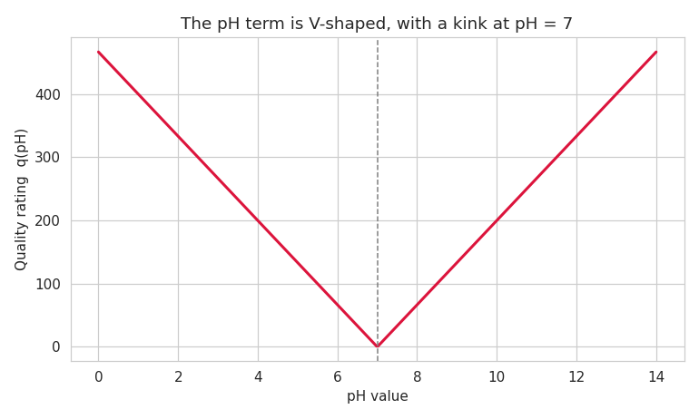
Figure 5 – The pH quality rating is V-shaped, with a kink at pH 7.
This explanation is testable. Adding a single engineered feature, abs(ph - 7), to the Linear Regression should close the gap entirely:
Model | Test R²
Linear Regression (nine raw features) | 0.9039
Linear Regression + abs(ph - 7) | 1.0000
The R² rises to exactly 1.0, confirming that the pH kink was the only non-linearity in the target. This is the clearest result in the study: it identifies not merely that tree models handle non-linearity better, but exactly which non-linearity was responsible and how much it cost.
Feature importance obtained from the Random Forest model:
Rank | Feature | Importance
1 | Organic_carbon | 0.7241
2 | Chloramines | 0.1471
3 | ph | 0.0806
4 | Solids | 0.0177
5 | Turbidity | 0.0149
6 | Conductivity | 0.0043
7 | Trihalomethanes | 0.0039
8 | Hardness | 0.0038
9 | Sulfate | 0.0036
Prediction on a new water sample:
Predicted WQI : 159.56
Water Quality : Poor

9. Secondary Task: Potability Classification
The dataset's original Potability label is a binary classification target. A Random Forest classifier with balanced class weights was trained on the same features and the same training split.
Metric | Value
Accuracy | 0.5777
ROC-AUC | 0.5133
Precision (Potable) | 0.40
Recall (Potable) | 0.18
Precision (Not Potable) | 0.62
Recall (Not Potable) | 0.83
A ROC-AUC of 0.51 is indistinguishable from random guessing, where 0.50 is chance. The classifier achieves 58 percent accuracy only by predicting the majority class most of the time, which is why recall on the potable class is 0.18. This is consistent with the correlation heatmap, where the Potability label shows almost no association with any measured feature. The result is reported as a documented negative finding: the regression formulation is the defensible use of this dataset, and no amount of tuning will extract signal that is not present.

10. Findings
- Random Forest gives the best performance of the three real models, with the highest test R² and the lowest MAE, MSE and RMSE.
- All three models comfortably beat the dummy mean baseline, which scores an R² of approximately zero.
- Linear Regression explains about 90 percent of the variance because eight of the nine WQI terms are linear in their feature.
- The remaining variance is attributable entirely to the pH term, whose absolute value creates a kink at pH 7 that no linear model can represent.
- Adding a single abs(ph - 7) feature raises Linear Regression to an R² of exactly 1.0, confirming this explanation.
- The Decision Tree at max_depth 10 overfits, scoring 0.98 on training data but only 0.89 on test data, which places it below the simpler linear model.
- Random Forest reduces that overfitting gap from 0.095 to 0.042 by averaging over one hundred trees.
- Cross-validation standard deviations are below 0.008 for every model, so the rankings are stable across splits.
- Organic Carbon, Chloramines and pH together account for over 95 percent of the Random Forest feature importance.
- This ranking follows from the WQI weighting: parameters with strict permissible limits receive larger unit weights.
- Correlations between the nine chemical features are all below 0.15, so multicollinearity is not a concern.
- The Potability classifier achieves a ROC-AUC of 0.51, which is indistinguishable from random guessing.

11. Limitations
- The WQI is computed from the same nine features used as inputs, so a high R² partly reflects the model relearning a known formula rather than discovering a latent physical relationship. The meaningful result is comparative, not absolute.
- Nearly 24 percent of Sulfate values are imputed with the median, which makes their contribution to the index partly synthetic.
- The Kaggle dataset is believed to be partly synthetic, which limits how far the results generalise to real water bodies.
- The index values depend on the chosen permissible limits, so using different national standards would shift the results.
- The dataset carries no sampling date or location, so seasonal and source-specific effects cannot be modelled.

12. Conclusion
Three regression models were built to predict the Water Quality Index of a water sample from nine physico-chemical properties. Missing values were handled using median imputation, the WQI target was derived using the Weighted Arithmetic index method with WHO and BIS permissible limits, and the models were evaluated using MAE, MSE, RMSE and R².
Random Forest Regression was the best of the three models, with a test R² of 0.9524 and a mean absolute error of 4.76 index points, against a dummy baseline of approximately zero. Organic Carbon, Chloramines and pH were identified as the dominant predictors, an ordering that follows directly from their strict permissible limits.
The most informative result was diagnostic rather than predictive. The ten point gap between Linear Regression and Random Forest was traced to a single source: the absolute value in the pH quality rating, which creates a kink at pH 7 that a linear model cannot represent. Adding one engineered feature, abs(ph - 7), raised the linear model to an R² of exactly 1.0. The study also reports a negative finding: the dataset's binary Potability label carries no learnable signal, with a classifier ROC-AUC of 0.51.

13. References
- Kadiwal, A. Water Quality Dataset, Kaggle. kaggle.com/datasets/adityakadiwal/water-potability
- World Health Organization (2017). Guidelines for Drinking-water Quality, 4th edition. Geneva: WHO.
- Bureau of Indian Standards (2012). IS 10500: Drinking Water Specification. New Delhi: BIS.
- Brown, R. M., McClelland, N. I., Deininger, R. A. and Tozer, R. G. (1970). A Water Quality Index. Water and Sewage Works, 117(10), 339-343.
- Pedregosa, F. et al. (2011). Scikit-learn: Machine Learning in Python. JMLR, 12, 2825-2830.
- Breiman, L. (2001). Random Forests. Machine Learning, 45(1), 5-32.

14. Program Output
Outputs produced by the program in Section 6, in the same order as the code.
Figure 1 – Feature Distributions
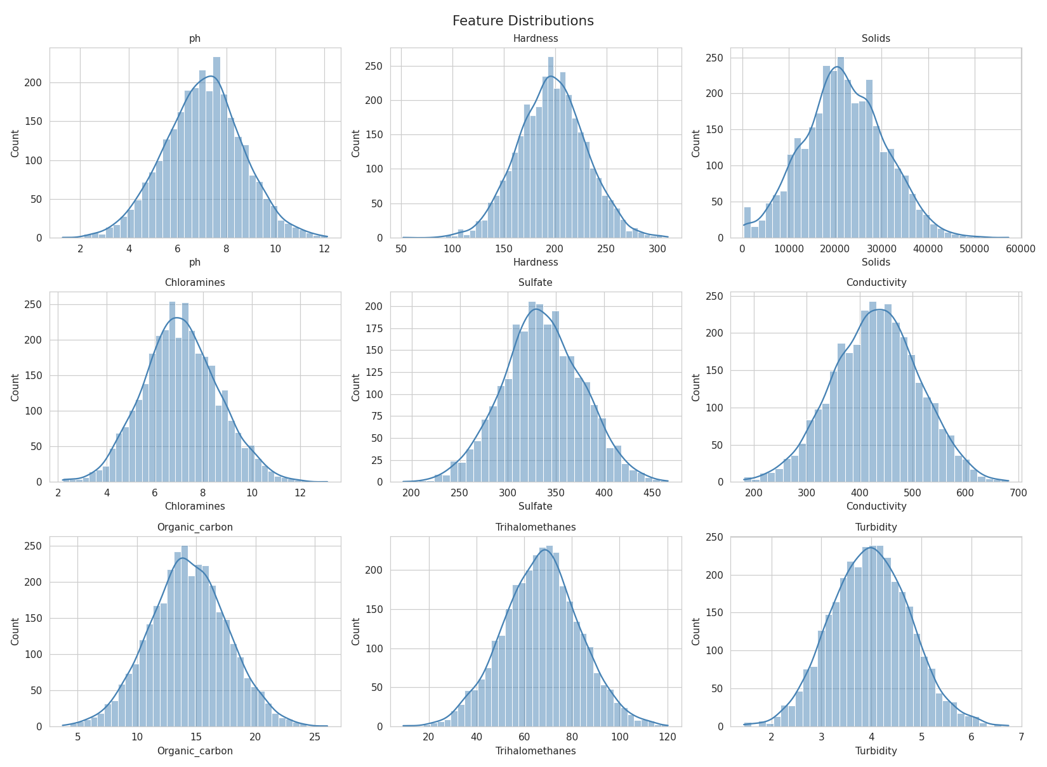

Figure 2 – Correlation Heatmap
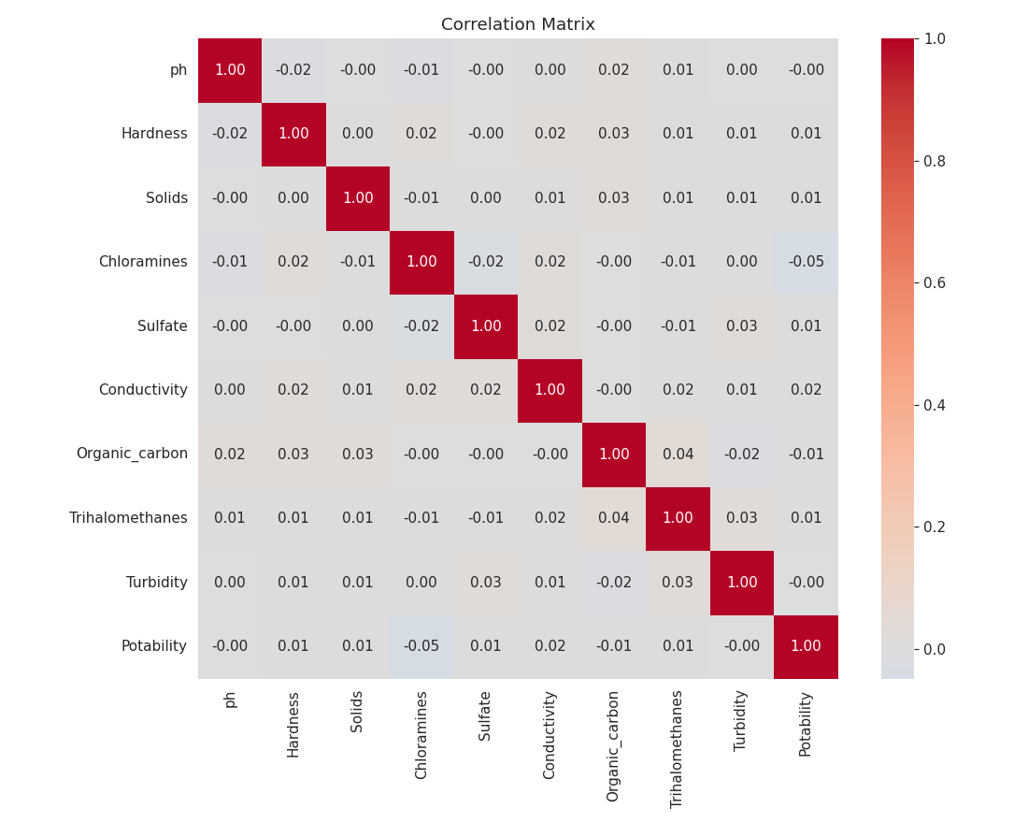

Figure 3 – Actual vs Predicted, Residual Plot and Residual Distribution
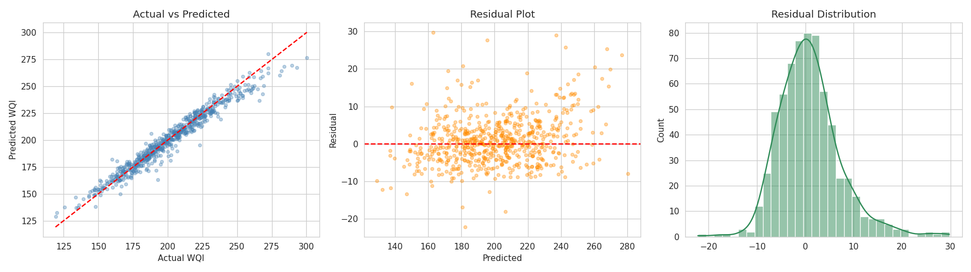

Figure 4 – Random Forest Feature Importance
