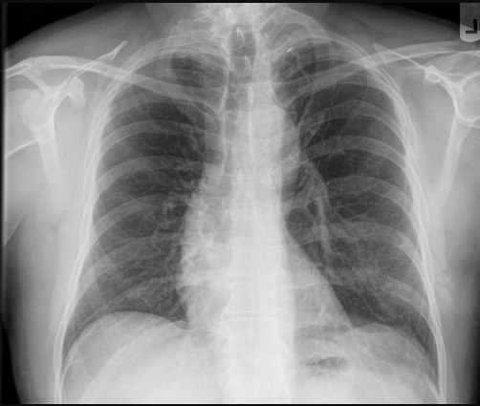
gpt-4.1-mini
CLINICAL HISTORY:
No specific clinical history provided.

TECHNIQUE:
Anteroposterior (AP) chest radiograph was obtained. Image quality is adequate with mild rotation, adequate inspiration and penetration, and no motion artifact.

FINDINGS:
- No post-surgical changes identified.
- No spinal abnormalities noted.
- The bilateral lung fields are clear without evidence of consolidation, pneumonia, atelectasis, pulmonary edema, or pneumothorax.
- No pleural effusions are present in the bilateral pleural spaces.
- The cardiac silhouette and mediastinum are within normal limits without cardiomegaly or mediastinal widening.
- No hilar abnormalities are seen.
- No lines, tubes, or foreign bodies are identified.
- The ribs and bony thorax show no bone lesions or rib fractures.

IMPRESSION:
Normal chest radiograph without acute cardiopulmonary or bony abnormalities. No evidence of pulmonary, pleural, cardiac, mediastinal, spinal, or post-surgical changes.

DIFFERENTIAL (RANKED):
1. Normal chest radiograph – no acute cardiopulmonary process.
2. No radiographic evidence of infection, edema, pneumothorax, or effusion.
3. No signs of chronic or acute bony or spinal pathology.

RECOMMENDATIONS:
- Correlate clinically; if symptoms persist or worsen, consider further imaging or evaluation based on clinical suspicion.
- Routine follow-up imaging is not indicated in the absence of clinical concerns.

LIMITATIONS:
- Single AP view may limit full assessment of some mediastinal and pulmonary structures compared to PA and lateral views.
- Mild rotation may slightly affect evaluation of cardiac silhouette and mediastinum.
- Radiograph is a snapshot in time; clinical correlation and additional imaging may be necessary if new symptoms develop.

GPT-5-MINI
CLINICAL HISTORY:
Not provided.

TECHNIQUE:
PA chest radiograph (single frontal view). Image quality: no rotation; adequate inspiration and penetration; no motion.

FINDINGS:
- Lungs/airspaces: No focal air‑space consolidation to suggest lobar pneumonia identified in the visualized lungs. (confidence 0.90)
- Pleura: No pleural effusion; costophrenic angles sharp bilaterally. (confidence 0.90)
- Pneumothorax: No pneumothorax identified. (confidence 0.95)
- Interstitium/edema: No radiographic evidence of pulmonary interstitial or alveolar edema. (confidence 0.88)
- Atelectasis/volume loss: No acute lobar or segmental atelectasis identified. (confidence 0.85)
- Cardiomediastinal silhouette: Cardiomediastinal silhouette within expected size limits for a PA radiograph; no cardiomegaly or mediastinal widening identified. (confidence 0.90)
- Hila: No focal hilar enlargement or acute hilar abnormality identified. (confidence 0.85)
- Lines/hardware: No lines, tubes, sternal wires, or other surgical hardware identified. (confidence 0.98)
- Osseous structures: No acute osseous abnormality or displaced rib fracture identified in the visualized bony thorax. (confidence 0.85)
- Foreign body: No foreign body identified on this frontal view. (confidence 0.95)
- Post‑surgical changes: None identified. Details: none. (present: false; confidence 0.98)
- Spinal abnormalities: None identified. Details: none. (present: false; confidence 0.85)

IMPRESSION:
1) PA chest radiograph without acute cardiopulmonary disease identified — no focal air‑space consolidation to suggest lobar pneumonia, no pleural effusion, no pneumothorax, and no cardiomegaly.
2) No acute osseous abnormality identified on this frontal study.
3) No post‑surgical changes or spinal abnormality identified on this view.

DIFFERENTIAL (RANKED):
1) No acute radiographic cardiopulmonary disease — most likely given the absence of consolidation, effusion, edema, pneumothorax, or cardiomegaly on a PA film. (highest likelihood)
- Rationale: Plain radiograph shows no focal air‑space opacity, no cardiomegaly, and no pleural effusion — findings that, when present, are commonly associated with moderate-to-severe pneumonia or cardiogenic pulmonary edema (RAG refs: chunk 1; chunk 7).
2) Early or atypical/viral airway infection not yet manifest on radiograph — possible if clinical symptoms are present despite a normal film. Radiographs can be normal early in infection or in immunocompromised/atypical presentations. (intermediate likelihood)
- Rationale: Small or early parenchymal infections may be radiographically occult on a single frontal view; follow-up imaging or CT may reveal changes if clinical suspicion persists (RAG refs: chunk 1; chunk 2).
3) Early cardiogenic pulmonary edema unlikely but not absolutely excluded — absence of cardiomegaly, perihilar alveolar opacities, and pleural effusions argues against clinically significant cardiogenic edema on this study. (low likelihood)
- Rationale: Cardiogenic edema classically shows cardiomegaly and bilateral perihilar alveolar/ interstitial markings; their absence lowers the probability on a single PA radiograph (RAG ref: chunk 7).
4) Small pneumothorax unlikely on this upright PA film but very small or loculated collections can be occult — correlate clinically if concern persists. (low likelihood)
- Rationale: Upright PA view is generally sensitive for pneumothorax; supine or atypical presentations may obscure small collections (RAG refs: chunks 13, 14).

RECOMMENDATIONS:
- Correlate with clinical presentation. If the patient has persistent or progressive respiratory symptoms, fever, hypoxia, or leukocytosis despite this normal PA film, consider:
- PA and lateral chest radiographs for improved detection of small effusions or posterior/lower‑lobe processes.
- Chest CT (noncontrast or contrast as clinically indicated) for greater sensitivity to early/occult parenchymal disease, small effusions, or alternative pathology.
- If concern for heart failure persists despite a normal radiograph (clinical signs of volume overload), correlate with bedside echocardiography, BNP, and clinical exam.
- If suspected pneumothorax with discordant clinical signs, obtain additional radiographic views (upright expiratory or decubitus) or manage emergently per clinical urgency.

LIMITATIONS:
- Single frontal (PA) view only; no lateral view available. Small effusions, localized posterior lower‑lobe consolidation, or subtle pleural/parenchymal abnormalities may be occult on a single frontal projection.
- Chest radiography has limited sensitivity for early or small‑volume disease (early infection, small edema, early interstitial disease). CT is more sensitive when clinical suspicion remains high.

