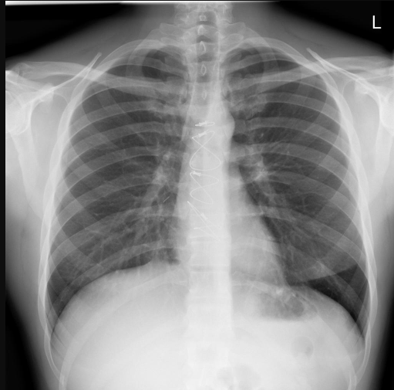
gpt-4.1-mini
CLINICAL HISTORY:
No specific clinical history provided.

TECHNIQUE:
Posteroanterior (PA) chest radiograph was obtained. Image quality is adequate with mild rotation, adequate inspiration and penetration, and no motion artifact.

FINDINGS:
- Post-surgical changes are present, demonstrated by sternal wires consistent with prior median sternotomy.
- No spinal abnormalities identified.
- Cardiac silhouette demonstrates mild cardiomegaly (probable).
- No consolidation, pleural effusion, pneumothorax, pulmonary edema, atelectasis, hilar abnormalities, foreign bodies, or bone lesions/rib fractures identified.
- Lines/tubes are present in the midline chest.
- Mediastinal contour is within normal limits without widening.
- No acute pulmonary or pleural abnormalities are seen.

IMPRESSION:
1. Mild cardiomegaly.
2. Post-surgical changes with sternal wires consistent with prior median sternotomy.
3. No radiographic evidence of acute pulmonary pathology including consolidation, pleural effusion, pneumothorax, pulmonary edema, or atelectasis.
4. Presence of midline lines/tubes without radiographic complication.

DIFFERENTIAL (RANKED):
1. Mild cardiomegaly likely related to underlying cardiac condition; no signs of congestive heart failure or pulmonary edema on this study (RAG chunk #7, #8).
2. Post-surgical status post median sternotomy without evidence of complications such as infection or mediastinitis.
3. Absence of atelectasis or lung collapse excludes acute airway obstruction or significant post-operative pulmonary complications (RAG chunk #5).
4. No evidence of pneumothorax or pleural effusion excludes acute pleural pathology (RAG chunk #13, #14).

RECOMMENDATIONS:
- Correlate clinically with cardiac status and prior surgical history.
- Continue routine monitoring; no acute intervention indicated based on current imaging.
- If clinical suspicion for cardiac decompensation or pulmonary complications arises, consider further evaluation with echocardiography or chest CT.
- Maintain vigilance for potential post-operative pulmonary complications in the clinical context.

LIMITATIONS:
- Single PA view; lateral or additional views may provide further detail if clinically indicated.
- Mild rotation may slightly limit assessment of mediastinal contours.
- No clinical history provided to correlate with imaging findings.
- Lines/tubes present but their exact type and position should be clinically correlated.

Gpt-5-mini
CLINICAL HISTORY:
Not provided

TECHNIQUE:
Frontal chest radiograph, PA view. Single frontal projection. No rotation. Inspiratory effort and penetration adequate.

FINDINGS:
- Post-surgical changes: median sternotomy wires and mediastinal surgical clips projecting over the midline.
- Cardiomediastinal silhouette within expected size for technique; no mediastinal widening.
- No focal air‑space consolidation to suggest lobar pneumonia.
- No pleural effusion identified.
- No pneumothorax identified.
- No radiographic evidence of pulmonary interstitial or alveolar edema.
- Minimal linear/plate‑like subsegmental scarring or atelectasis in the dependent/basilar regions, greater on the left (possible, mild).
- Hilar regions without focal enlargement or acute abnormality.
- No acute displaced rib fracture or suspicious osseous lytic lesion identified. No acute spinal abnormality identified.

IMPRESSION:
1) No acute cardiopulmonary disease identified on this frontal PA chest radiograph — no focal lobar consolidation, pleural effusion, pneumothorax, or pulmonary edema detected.
2) Median sternotomy wires and mediastinal surgical clips consistent with prior median sternotomy/CABG.
3) Minimal, probable subsegmental/plate‑like atelectatic scarring at the bases, greater on the left.

DIFFERENTIAL (RANKED):
1) Subsegmental plate‑like atelectasis/scar (most likely) — typical dependent/basilar linear opacities, often seen post‑operatively or with shallow breathing.
2) Chronic scarring/fibrotic change at the left base (possible) — chronic cicatricial change can appear similar to linear atelectasis.
3) Atypical or early/viral pneumonia (less likely) — interstitial/patchy patterns can represent atypical infection even when lobar consolidation is absent; correlate clinically.
4) Lobar collapse from central obstruction (unlikely given only minimal subsegmental change) — would be considered if progressive volume loss or more extensive lobar opacity develops; further evaluation with CT/bronchoscopy may be indicated in that scenario.
5) Pulmonary edema (unlikely) — not supported radiographically on this study (no interstitial/alveolar edema pattern, no pleural effusions, cardiomediastinal size within expected limits).

RECOMMENDATIONS:
- Correlate with clinical presentation (fever, cough, leukocytosis, recent surgery, symptoms).
- If post‑operative or with shallow respirations, consider conservative measures such as incentive spirometry, early mobilization, and chest physiotherapy to help resolve subsegmental atelectasis.
- If clinical concern for infection or worsening respiratory status, consider repeat chest radiograph including lateral view or chest CT for greater sensitivity and anatomic detail.
- If progressive or lobar collapse develops, consider urgent contrast‑enhanced chest CT and possible diagnostic/therapeutic bronchoscopy to exclude endobronchial obstruction.

LIMITATIONS:
- Single frontal (PA) view only; no lateral view available. Small posterior or retrocardiac opacities, small effusions, and some mediastinal details may be occult on a single frontal view.
- Chest radiography is less sensitive than CT for early/atypical pneumonia, small areas of collapse, and mediastinal/vascular abnormalities.
- Median sternotomy wires and mediastinal clips project over the mediastinum and can obscure adjacent structures.

